Merrowland Statistics | Labour Market Statistics
To | Shane Turner, Government Statistician
From | Raewyn Bailey, Head of Labour Market Statistics
Date | 23 October 2026
Reference | MS-LMS-2026-031
Subject | HLS July to September 2026: what the three-visit cap does to the published rates

Almost all of the July to September rise in unemployment is the visit cap, and the cap stays in the published rates until September 2027 even if six visits return in January
The published unemployment rate rose 0.27 point to 5.27 per cent between April to June and July to September. The three-visit cap on first interviews accounts for 0.22 point of that rise and the labour market for 0.05 point: had first interviews kept six visits, the rate would have been 5.04 per cent. The employment rate fell 0.65 point to 59.36 per cent; the cap took 0.74 point off it, so with six visits it would have been 60.10 per cent, 0.09 point above April to June.
The cap removes the households we find only at a fourth, fifth or sixth visit: adults out by day, most of them in work. We recruit a household once and keep it for five quarters, so the households the July to September and October to December intakes did not recruit are missing from the sample in every quarter those intakes stay in it, interviewed or not by telephone. Their lower unemployment fades as their circumstances change and as some of them would have left the panel, but it does not go: the gap is largest in October to December, when both capped intakes are in the sample, and it is still there in July to September 2027, when the first capped intake is at its fifth wave and the second at its fourth.
If first interviews go back to six visits from January 2027, the published unemployment rate will sit above the six-visit rate by 0.37 point in October to December 2026, 0.25 in January to March 2027, 0.19 in April to June and 0.07 in July to September 2027. The employment rate will sit below it by 1.37, 1.11, 0.93 and 0.63 point in the same quarters (0.74 in July to September 2026). The rates are back on the six-visit basis from January to March 2028, once the October to December 2026 intake has left the sample.
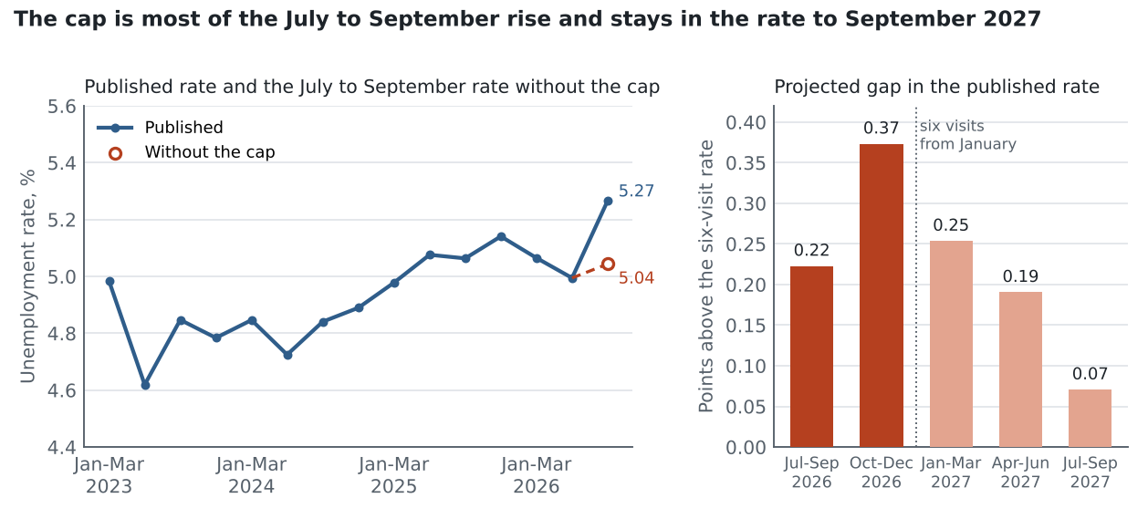
Published unemployment rate, people aged 15 and over, not seasonally adjusted. Gap: published rate less the rate with six first-interview visits throughout.
Gap in the published rates, percentage points (published less six visits)
Quarter | Capped intakes in the sample | Unemployment rate | Employment rate
Jul-Sep 2026 | Jul-Sep 2026 intake at wave 1 | +0.22 | -0.74
Oct-Dec 2026 | Jul-Sep intake at wave 2; Oct-Dec at wave 1 | +0.37 | -1.37
Jan-Mar 2027 | waves 3 and 2 | +0.25 | -1.11
Apr-Jun 2027 | waves 4 and 3 | +0.19 | -0.93
Jul-Sep 2027 | waves 5 and 4 | +0.07 | -0.63

How the gap is measured. As section 5 of the methods note sets out, the cap is applied to April to June 2026, the last full quarter before it: for each quarter, the households first interviewed at a fourth to sixth visit are taken out of the waves the capped intakes will occupy, the remaining sample is raked again to the April to June controls, and the gap is the change in each rate. Taking the cap out of wave 1 alone would show no gap from January 2027, and carrying the wave-1 gap unchanged into the later waves would overstate every 2027 quarter, because the missing households' unemployment and employment move back towards the rest of the sample after their first interview.
Regional field and flow figures for the quarter's quality report (first-interview visits to the July to September intake, the share of April to June's unemployed respondents in work by July to September, and total weekly hours actually worked) are in the accompanying workbook.
Raewyn Bailey
Head of Labour Market Statistics

