MSP26 go-live: about 300 more override reviews in the first 13 weeks
To: Override Review Service Manager From: Desk Planning Date: 28 October 2026 Ref: CR-2291
When both MSP26 rules go live on every adult ward on 4 January 2027, the desk should plan for about 300 more override reviews from Quillfield over the thirteen weeks to 4 April 2027 than it would get without the go-live (Schedule B 4.3).
The background log's QT combination alerts, overridden at the pilot units' 58 per cent, add about 500 reviews. Against that, the duplicate PRN opioid alert is answered on the pilot units by removing the new order 49 per cent of the time, and a removed order no longer carries its own alerts or has severe interaction alerts fire against it later in the stay. Tying each background duplicate-opioid alert to the overridden alerts today on that order, or naming it as the interacting order, takes about 200 current reviews off the desk. The base period is 6 July to 25 October 2026, scaled to the volume plan's admissions for the thirteen weeks.
Thirteen weeks from 4 January 2027 | Reviews
Added by the QT combination alert | +500
Current reviews no longer reaching the desk | -200
Net change | +300
Source: Quillfield medication alert history and MSP26 background log to 25 October 2026; FY2027 inpatient volume plan. Reviews from 7W, 5E and 8N do not change: the package has run live there since September 2024.
For the shift mix, the desk signed off these Quillfield reviews last quarter:
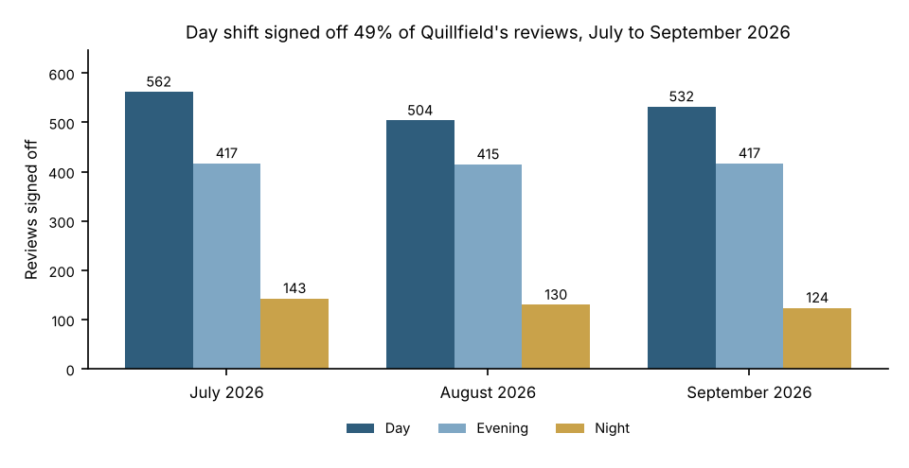
3244 reviews in all from July to September 2026, one per overridden alert, by the shift and month of sign-off (Eastern time). Source: Corvane queue export, matched to the alert history.

