Director of Public Health, 8 December 2026
Carrier screening panel for 2027/28: add ARSACS, Joubert syndrome type 2 and diastrophic dysplasia; keep the other eleven
From: Abbie North, Panel Review Group. Paper DPH/26/41. Decision required.

Recommendation
The 2027/28 panel should carry 14 conditions from 1 April 2027: the eleven on the current panel, all of which stay above the policy's line of one carrier in 200, and three that join: ARSACS, spastic ataxia of Charlevoix-Saguenay (SACS, 7 per 1,000), Diastrophic dysplasia (SLC26A2, 6 per 1,000), Joubert syndrome type 2 (TMEM216, 6 per 1,000). No condition leaves. Of the 30 conditions reviewed, the other 16 have carrier frequencies between 0 and 4 per 1,000.

Why the three founder conditions join
The reference cohort is 25,694 members of the Ardvenny Genome Study with consent in force and a released genotype on 1 November 2026 (7,945 from phase 1 in the Morvaig Isles and Glenhaskel, 17,749 from phase 2 on the mainland). The two phases were sequenced on different capture kits and called with different rules, and phase 1's kit read the founder variants of the three conditions at only 8 to 16 reads, most of them 8 to 11. At that depth the phase 1 calling rule (at least five reads carrying the variant, a quarter of the reads) catches about half of the people who carry it, so a member with no call there is often a carrier who was missed. We therefore estimated each condition's carriers phase by phase, dividing each phase's calls by the sum of its members' chances of being called given their read count at the variant. Counted as calls, the three conditions sit at 3.8, 3.4, 3.5 per 1,000; corrected, at 7, 6, 6.
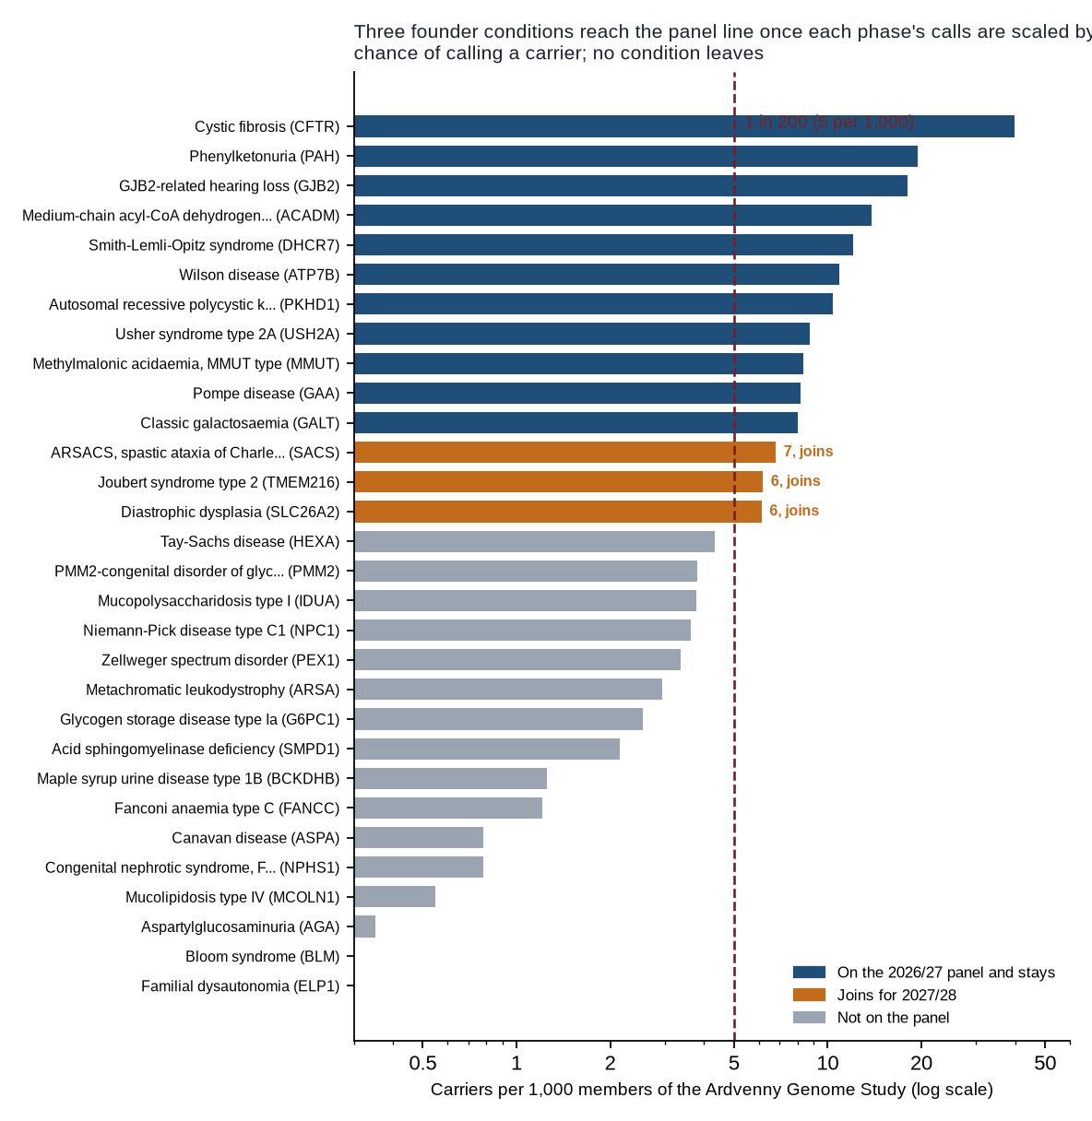
Figure 1. Carrier frequency per 1,000 Study members for the 30 conditions reviewed, against the panel line.

The programme's experience in 2025/26
Couples told that one or both partners carry each condition on the current panel, by the half of the screening year in which the couple's report went.
Condition | Apr to Sep 2025 | Oct 2025 to Mar 2026 | Year
Cystic fibrosis (CFTR) | 88 | 98 | 186
Phenylketonuria (PAH) | 34 | 45 | 79
GJB2-related hearing loss (GJB2) | 57 | 58 | 115
Medium-chain acyl-CoA dehydrogenase deficiency (ACADM) | 27 | 37 | 64
Smith-Lemli-Opitz syndrome (DHCR7) | 30 | 43 | 73
Classic galactosaemia (GALT) | 23 | 22 | 45
Wilson disease (ATP7B) | 37 | 33 | 70
Autosomal recessive polycystic kidney disease (PKHD1) | 35 | 30 | 65
Methylmalonic acidaemia, MMUT type (MMUT) | 15 | 27 | 42
Pompe disease (GAA) | 37 | 30 | 67
Usher syndrome type 2A (USH2A) | 18 | 10 | 28

Notes. Carrier frequencies use the register's classifications on the census date and count a member once per condition (policy 2.3, 2.4). The programme's figures use the classification each result was authorised with (policy 4.3).

