To: Aaron Bradley, Director, Community Screening Program
Cc: Ariel Tucker, MD, Medical Director
From: Matthew Garcia, program analyst
Date: 22 January 2027
Re: Referral rule for the 2027 season (protocol 2026-27, section 6)
HbA1c of 5.7% or higher, or a random glucose of 120 mg/dL or higher, is the rule for 2027
Load rule A57G120 into the tablets: refer every adult with an HbA1c of 5.7% or higher or a random glucose of 120 mg/dL or higher. Among everyone we screened in 2026 it would have referred 90% of the adults with undiagnosed diabetes, above the protocol's 85%, while referring 36.3% of the adults screened. No rule that refers fewer adults reaches 85%: an HbA1c of 5.7% or higher alone finds 80%, and the 2026 rule plus an HbA1c of 6.0% or higher 79%.
Candidate rule | Adults screened referred | Undiagnosed diabetes referred | Meets 85%
HbA1c of 6.0% or higher (A60) | 8.4% | 51% | No
2026 rule, or HbA1c of 6.0% or higher (R26A60) | 24.9% | 79% | No
HbA1c of 5.7% or higher (A57) | 28.2% | 80% | No
Risk score of 5 or higher (SC5) | 35.9% | 62% | No
HbA1c of 5.7% or higher, or random glucose of 120 mg/dL or higher (A57G120) | 36.3% | 90% | Yes
HbA1c of 5.5% or higher (A55) | 49.3% | 93% | Yes
Source: screening encounters and the OGTT results from Thessler Laboratories, 2026 season; 37,269 adults screened, 10,715 with a complete OGTT.
Most of the season's OGTTs went to adults the 2026 rule referred; the evaluation draw offered the test to one in five of everyone else. Read among the adults who were tested, the 2026 rule plus an HbA1c of 6.0% or higher finds 94% of the diabetes, because nearly every tested case was one the 2026 rule had already flagged. Once each tested adult stands for the adults of their own group, 33% of the adults with undiagnosed diabetes were among those the 2026 rule did not refer, milder cases that an HbA1c of 6.0% misses, and that rule falls to 79%.
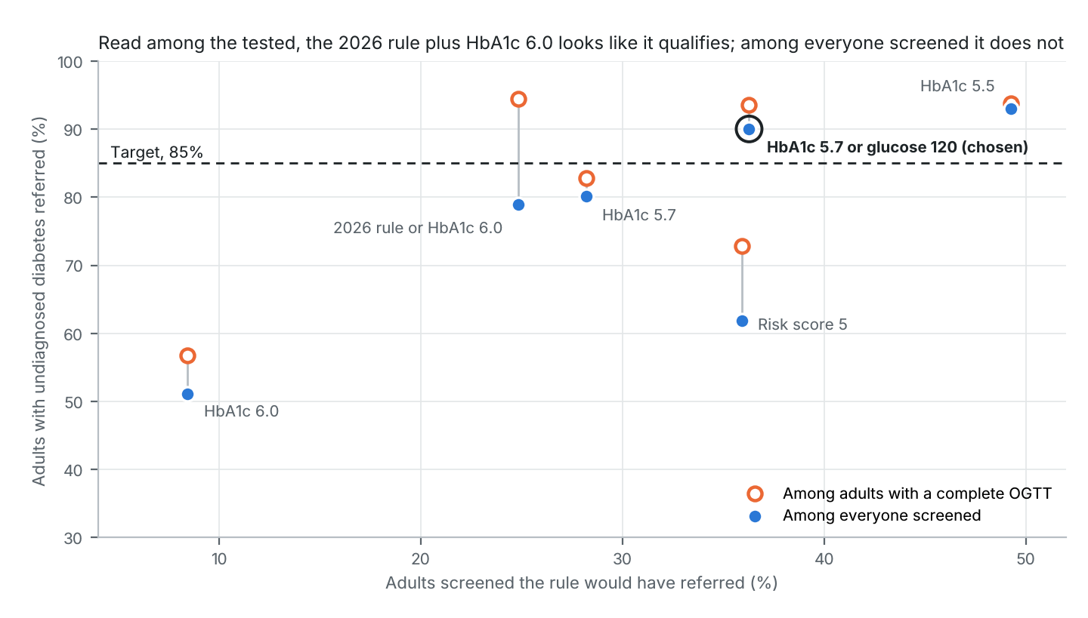
The season's records are in the review workbook: the HbA1c cartridges each analyzer used, 40,248 in all with the replaced units and the loaner counted on the tags they served, and Thessler Laboratories' billing by month, $415,800.00 net for the season's OGTTs, $409,255.00 of it for adults we screened.
Each adult counts once, at the first screening of the season. Shares of the adults with undiagnosed diabetes are estimates, given to the whole percent; the target is compared unrounded.

