Peak 2027: evening shifts in weeks 47 to 50, 8 390 agency hours
To: the management team, Telkkä Logistics Oy
From: Helena Korhonen, operations director
Date: 10 November 2026
Subject: Saarnela peak plan 2027, evening-shift agreement and agency booking
Recommendation. Agree the evening shift in weeks 47 to 50 in both small-parts zones, P1 and P2, and book 8 390 agency picker hours over the peak (week 46 760; week 47 1 910; week 48 1 930; week 49 1 760; week 50 2 030). Week 46 runs on day shifts only.
Week | P1 hours (80% range) | P2 hours (80% range) | B1 hours (80% range) | Evening P1 | Evening P2 | Agency hours
46 | 780 (710 to 880) | 690 (620 to 780) | 490 (460 to 520) | no | no | 760
47 | 1 300 (1 230 to 1 360) | 1 200 (1 150 to 1 260) | 610 (570 to 660) | yes | yes | 1 910
48 | 1 320 (1 250 to 1 390) | 1 220 (1 160 to 1 280) | 590 (550 to 630) | yes | yes | 1 930
49 | 1 140 (1 090 to 1 200) | 1 060 (1 010 to 1 110) | 520 (490 to 560) | yes | yes | 1 760
50 | 1 360 (1 290 to 1 430) | 1 250 (1 190 to 1 310) | 610 (580 to 660) | yes | yes | 2 030
Picker hours are paid hours to the nearest 10 (planning standard 2.2); ranges at 80 per cent (3.5). Week 49 has five day shifts (Independence Day, Monday 6 December).
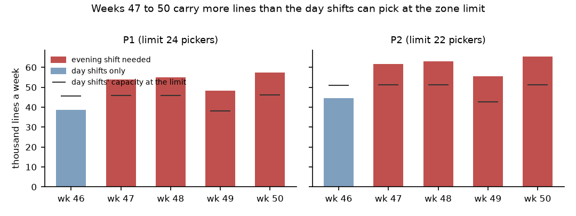
The zones slow as they fill. With the mix of lines held fixed, a line takes 0.46 minutes longer at 1.8 pickers logged in an aisle than on an empty floor; the 2025 peak ran its day shifts well below the limit, so its hours a line do not carry to 2027's day shifts at 24 and 22 pickers.
Huippu Sport's lines are heavier than the pilot's. The pilot carried polybag apparel only; at the full assortment's peak mix (footwear boxes, boots, multi-unit lines) a Huippu Sport line takes 0.13 minutes longer than a Kotikaari line.
The budgets overstate by more when they plan more. Kotikaari's budgets have overstated the peak's lines by 10.0 per cent on average (2022 to 2025); the 2027 budget's 7 per cent plan for Kotikaari small parts points to 3.7 per cent, its 26 per cent plan for Huippu Sport to 14.1.
Black Friday is in week 47. The budget phases 2027 by 2025's week numbers and 2026 has 53 ISO weeks; week 47 of 2027 carries 21.4 per cent of the peak's Kotikaari small-parts lines, not the budget's 14.0.
The draft's route. The budget as issued, the 2025 hours a line and the pilot's time a line open the evening shift in P1 week 48 and P2 week 48 and book 5 320 agency hours.

