AUT26 re-run: do not book on the same terms
To Caroline Ritter. From Marit Klemt. 6 November 2026. Data cut 31 October 2026.
Decision
Do not book the January and February re-run of AUT26 on the same terms. The campaign is expected to cost EUR 900 per member still paying in their twelfth month (80% range EUR 850 to 975, 90% range EUR 825 to 1,000), above the EUR 800 bar across both ranges. The retention curve we usually project with puts it at EUR 725 and would clear the bar; it misses what happens to members when their tutor stops teaching.
The numbers
AUT26 brought in 3,534 paid members (first charge from 1 September to 31 October, Berlin time, AUT26 code on the sign-up). It cost EUR 868,150: EUR 825,075 of media net of VAT and of the EUR 14,250 credit note, and EUR 43,075 of first-month discounts, or EUR 250 per paid member. We expect about 950 of these members to pay a twelfth monthly charge (27.1%), about 450 of the 1,718 who joined in September and 500 of the 1,816 who joined in October. The ranges allow for the fact that every member of one tutor shares that tutor's chance of stopping, which widens them well beyond what members taken one at a time would give. Members like these would have met EUR 800 exactly at about EUR 225 per paid member.
Why the usual curve is too high
Projected on our retention curve by membership month, 33.8% of AUT26 members (1,200) would reach the twelfth charge. The curve has not been optimistic before: it ran low on the spring 2025 campaign (28.7% projected from June 2025 against 33.3% kept) and on last autumn's joiners (30.6% against 33.5%). AUT26 is a different mix: 172 tutors began teaching in September and October, against 7 from March to August, and 2,757 of the 3,013 AUT26 members still paying on 31 October (91.5%) are with them.
That matters for two reasons the lesson log shows. A member whose tutor stops teaching cancels 61.7% of the time in the first month without that tutor and 26.7% the month after, against 5.5% in an ordinary month (7,900 member months with a tutor stop since 2022). And tutors stop early: of tutors who have taught four, five and six months, 21.3%, 26.0% and 24.8% do not teach the next month, against 0.8% a month for tutors past their first year (798 tutors on record). Carrying each member through their own tutor's odds of stopping gives 950 twelfth-month members. Over six-month windows the curve under-predicts the cancellations of members whose tutor is in their first three months of teaching by a factor of 1.22 and in their fourth to ninth months by 1.19, and over-predicts members of tutors past their first year (0.85); the tutor-linked projection carries that difference.
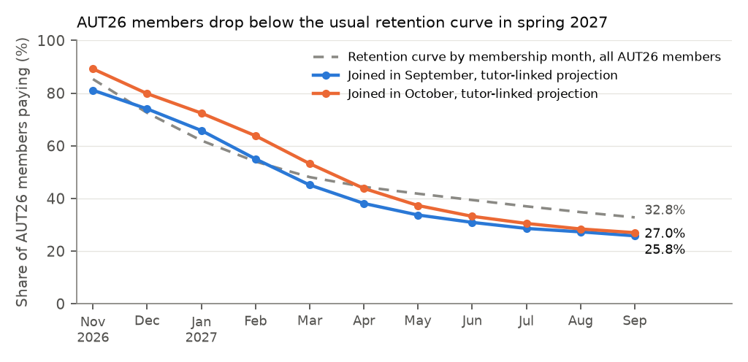
Expected share of AUT26 members paying each month, by joining month, against the retention curve. The AUT26 lines stay above the curve through the winter and fall below it from March (September joiners) and April (October joiners), once their tutors reach the months in which tutors most often stop.
Source: billing events and lesson activity to 31 October 2026; tutor directory of 3 November 2026. Campaign members, cost and twelfth charges as defined in the growth review standard, section 3.
The month-by-month projection, the cost build-up and each member's projection are in aut26_member_forecast.xlsx.

