11 zones for the 2027 lightning protection refit
To: Lucas Ramirez, Technical Services Department Manager
From: Donna Rodriguez, Reliability and Protection
Date: 10 November 2026
Subject: 2027 Lightning Protection Refit, the zones the referral rule names and the rule itself
Refit these 11 zones before the 2027 lightning season. By substation: Malinao MLN-F2, MLN-F4 and MLN-F4-R2; Calabasa CLB-F1, CLB-F2 and CLB-F2-R1; Tagumpay TGP-F3-R1; Pinagpala PGP-F2 and PGP-F4-R3; Lourdes LRD-F1-R2; Bagong Sikat BGS-F3-R1.
How the rule works. A lightning fault is a fault whose first trip lines up with a ground stroke the Kidlat service located within 400 m of the zone's lines, counted once against the zone it was on (terms 2(c)). The breakers and the radio reclosers report in SCADA time. The 32 reclosers read on site keep their own clocks, which drift between visits and are reset at each read, so each one's clock is fitted read by read from its own trips against the strokes. What a zone's lines would have with sound protection has two parts: the lightning near them times a rate for their construction, area, arrester cover and transformers, and the zone's own level, which stays with it whatever the state of its protection (the soil its grounds are driven into, its hardware and its route). Both are learned only from the 779 zone-seasons a later cyclic inspection found sound, each zone's level from its own such seasons and never from the seasons being judged. The levels spread with a coefficient of variation of 0.42 across zones, far more than a zone moves from season to season, so a zone that runs high when sound runs high every season and is not a failure. After each season the rule refers a zone when its faults since its last cyclic inspection are more than that expectation by more than chance explains, with its level as uncertain as its confirmed seasons leave it, at a chance below 1 in 715 a zone a season: across 143 zones, one sound zone referred in five seasons, the limit in terms 3(b). For the reclosers read on site the comparison runs over the months each memory holds.
Alert load. Run as it stands after each season, the rule would have referred 2 zones after 2022, 2 after 2023, 4 after 2024, 8 after 2025 and 11 after 2026. Summing each zone's chance at the count it would first be referred at, about 0.14 of a season's referrals should be zones with sound protection, one in about seven seasons. Taking each zone's level as if it were known would refer 17 zones after 2026, and would refer a sound zone about 1.2 times a season, against the once in five seasons terms 3(b) allows.
Against the inspections. The cyclic rounds of 2022-23 to 2025-26 inspected 5 zones the rule had referred after the season before, and confirmed 5 of those referrals. They found failed protection on 21 zones the rule had not referred, mostly failures too recent to have run up enough faults since the zone's last inspection.
Lightning faults by season. The network had 561 lightning faults in 2022, 413 in 2023, 593 in 2024, 620 in 2025 and 655 in 2026. Of 2026's, 130 were on the zones whose reclosers are read on site; their memories held 87, and the rest are the months they overwrote or nobody has read since the last visit, taken at each zone's own rate. With every zone's protection sound the 2026 season would have had 469, so failed protection caused 186.
The refit. Restoring the 11 zones avoids about 116 lightning faults in a season with the average lightning of 2022 to 2026, with their protection as it stood at the end of the 2026 season (terms 4(c)). Most of them failed partway through their record since inspection: 9 of them ran, in their first season after it, at less than half the multiple of their own sound level they reached in 2026, and all 11 ran above twice that level in 2026. So the refit is valued on each zone's 2026 season above its own sound level, taken at that lightning; the seasons since each failure began give 115. The record since each inspection, averaged, would put it at 72, because it mixes in the seasons before the failure.
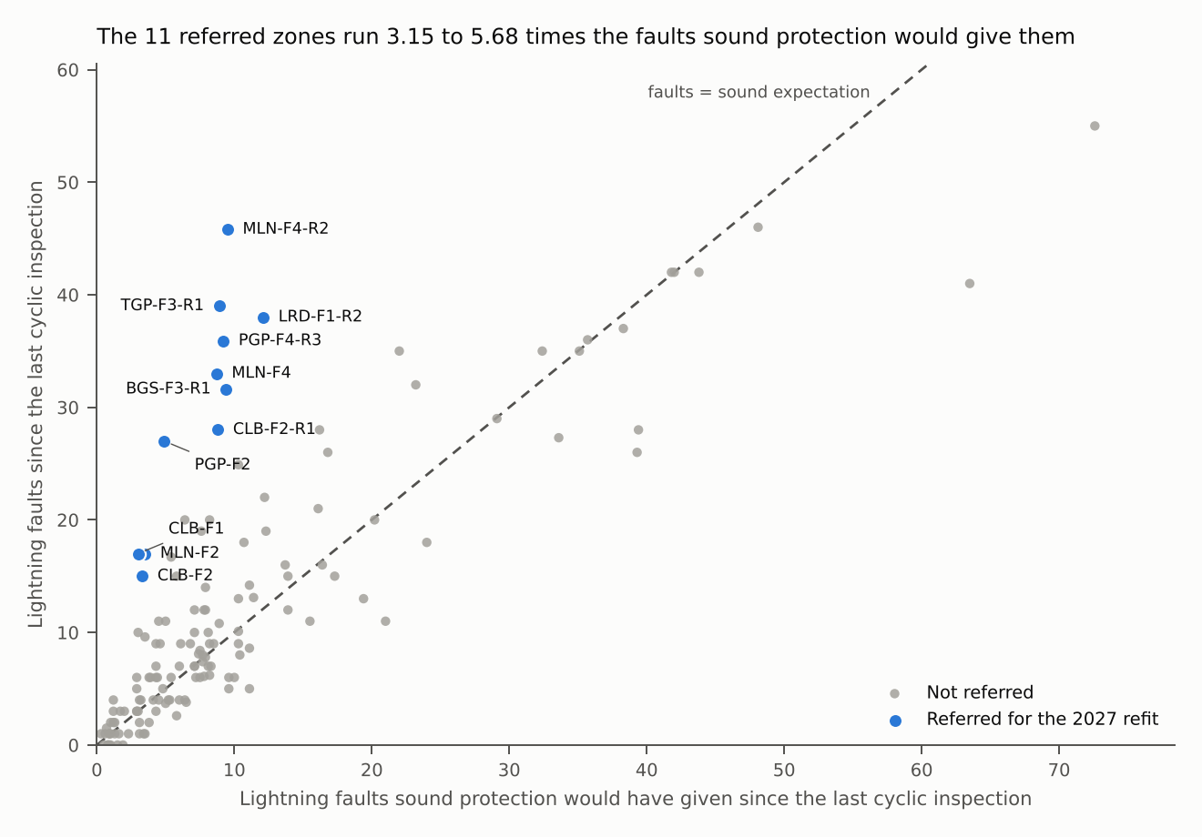
Figure 1. Each of the 143 zones' lightning faults since its last cyclic inspection against what sound protection would have given it.

Table 1. The referred zones
Zone | Faults since inspection | Sound expectation | Ratio
MLN-F2 | 17.0 | 3.5 | 4.84
MLN-F4 | 33.0 | 8.7 | 3.81
MLN-F4-R2 | 45.8 | 9.5 | 4.82
CLB-F1 | 17.0 | 3.0 | 5.68
CLB-F2 | 15.0 | 3.3 | 4.59
CLB-F2-R1 | 28.0 | 8.8 | 3.19
TGP-F3-R1 | 39.0 | 8.9 | 4.37
PGP-F2 | 27.0 | 4.9 | 5.55
PGP-F4-R3 | 35.9 | 9.2 | 3.92
LRD-F1-R2 | 38.0 | 12.1 | 3.15
BGS-F3-R1 | 31.6 | 9.4 | 3.38
Source: SCADA event history and recloser memory downloads to October 2026, Kidlat stroke extract November 2016 to October 2026, cyclic inspection log through the 2025-26 round.

Table 2. What simpler versions of the rule would have given, on the same files
Version | Zones referred after 2026 | Referrals the next inspection found sound | 2026 lightning faults | Caused by failed protection | Avoided, average season
This rule | 11 | 0 | 655 | 186 | 116
Each season's scatter taken on its own (quasi-Poisson) | 13 | 1 | 655 | 204 | 117
Each zone's own level taken as known | 17 | 1 | 655 | 186 | 142
Every zone at the network rate, with no level of its own | 8 | 0 | 655 | 204 | 83
Avoided faults averaged over the record since inspection | 11 | 0 | 655 | 186 | 72
The controllers' logs as recorded (a ten-minute window, only the events kept) | 9 | 0 | 630 | 124 | 90
Sound rate from every season no inspection has found failed | 11 | 0 | 655 | 165 | 114
Chance taken as Poisson | 22 | 5 | 655 | 204 | 174
Faults over the whole record, not since the last inspection | 7 | 0 | 655 | 186 | 20

Notes. Seasons run 1 April to 31 October (terms 2(b)). A zone's record since its last inspection starts the day after that inspection's repairs were completed (terms 2(e)). Reclosers with no radio link were last read between May 2026 and October 2026, so their unread months differ zone by zone.

