Cedar Brake Electric Cooperative, Energy Programs
To: the board of directors From: Renee Henry, manager of energy programs Date: 9 November 2026
Peak Partners provider renewals for summer 2027
Renew Corvane, Ardena and Kitebrook; do not renew Lumivale, Ondera or Pinecrest Home.
Under Board Policy 412 a provider is worth renewing when its devices take enough off our load in ERCOT's four coincident-peak intervals to save more transmission cost, at $54.80 per kW, than its quote costs us. In a summer like 2024 to 2026 the three renewed providers' devices would take 3.76 MW off our 4CP load and save $206,000, $42,500 more than we would pay them.
Provider | kW per 2027 device at the 4CP intervals | kW its price needs | Devices on 1 July 2027 | Quote's cost | Renew
Corvane | 0.630 | 0.529 | 2,127 | $61,683 | yes
Lumivale | 0.306 | 0.431 | 1,984 | $46,822 | no
Ardena | 1.015 | 0.748 | 1,268 | $51,988 | yes
Ondera | -0.125 | 0.474 | 1,253 | $32,578 | no
Kitebrook | 0.749 | 0.602 | 1,511 | $49,863 | yes
Pinecrest Home | 0.306 | 0.380 | 2,760 | $57,408 | no
Each figure is per device enrolled on 1 July 2027, averaged over the twelve 4CP intervals of 2024 to 2026 with our alerts as we called them (none on 18 September 2025).
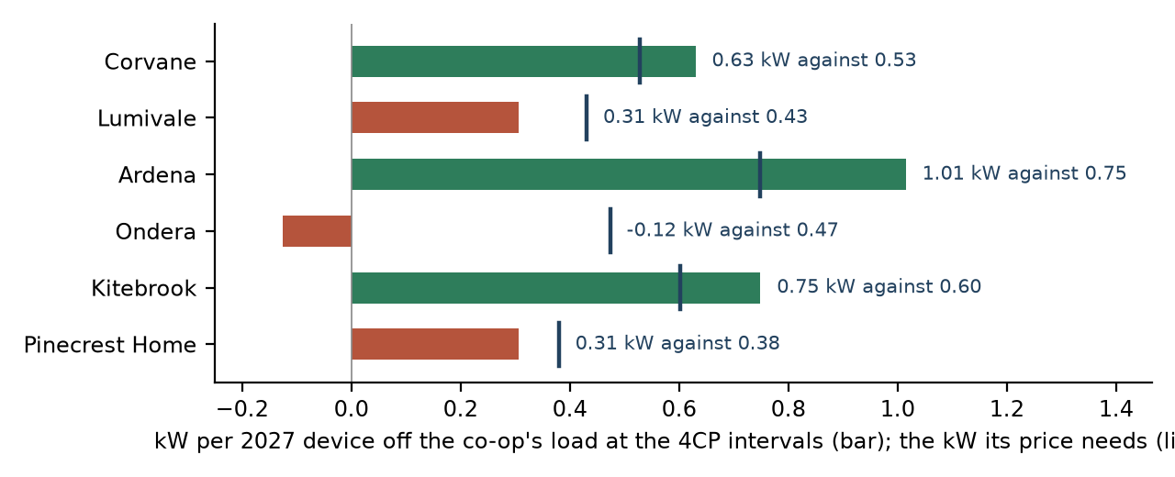
Why the test events overstate Lumivale and Pinecrest Home, and understate Kitebrook
Our test events are single hot days. The 4CP intervals fall on the hottest day of a heat wave, after two or more alert days in a row, when members leave events: on those days 33% of Lumivale's enrolled devices were still in its long, deep event at the 4CP interval, against 64% on the test events at 17:30. Pinecrest Home's 2027 fleet will be 65% retail-rebate devices, which are often offline and leave events: its fleet would keep 59% in the event at the 4CP intervals against today's 85%. The research sample's homes are in the north and newer; Kitebrook's fleet is mostly in larger, older homes in the south, which shed 54% more than its sample devices.
Ondera's event ends at 17:00, before 10 of the twelve 4CP intervals, and its homes are recovering then: its devices add load at the 4CP intervals.
Read straight off the test events, Lumivale and Pinecrest Home would be renewed and Kitebrook dropped. The workbook carries the twelve intervals, the shares in the event, the 2027 fleets, the homes and the other routes.

