Tamsett County Roads Division
To: State floodplain review From: Lisa Horne, hydraulics engineer Date: 12 January 2026
Ref: RD-2026-07, Kinnard Road over Ollery Creek, design flow memorandum (Drainage Standard 4.6)
Alternative B carries Kinnard Road over the design flood
The design flow at Kinnard Road is 10,570 cfs, the peak with a 1 per cent chance of being equalled or exceeded in any year of the crossing's first ten years. Alternative B (triple 10 ft x 9 ft box, capacity 13,380 cfs, USD 2,480,000) is the least costly alternative that passes it; Alternative A (capacity 7,460 cfs) would overtop.
The gauge's 70 annual peaks (1956 to 2025) show no trend (Kendall's tau 0.02, p = 0.79) and a log-Pearson III fit to them gives 5,090 cfs. That figure describes the watershed the record came from, not the one the culvert will serve. Over the record the paved area grew from 6 to 30 per cent of the 11.5 square miles, with storm drains in every subdivision, while the storms of the last three decades ran lighter than those of the 1960s to 80s; the two cancel in the annual peaks, so the record reads as if nothing had changed.
Set against the storm that made it, each flood shows the change. Pairing the 312 peaks above base made by storms of an inch or more with the rain gauge's totals for the storm (the peak day and the two days before), the log peak rises by 2.96 per unit of paved fraction at a fixed storm: the same storm makes about 2.0 times the peak on today's watershed that it made in 1960. Each year's peak was put on today's watershed by that rise and the series refitted; every sound pairing (windows of two to four days, storms of half an inch to three inches, the annual peaks against their own storms, decade effects; log-Pearson III or the generalized extreme value) gives 9,570 to 11,250 cfs.
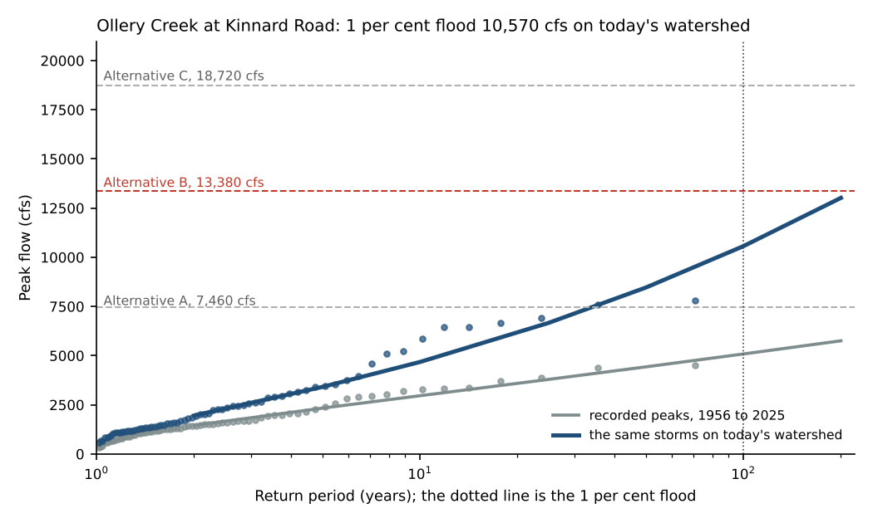
Dots are the 70 annual peaks by plotting position (Weibull); the dashed lines are the three alternatives' capacities.
Floods of the record on today's watershed
Rank | Water year | Recorded peak (cfs) | On today's watershed (cfs)
1 | 1968 | 3,880 | 7,810
2 | 1983 | 4,400 | 7,590
3 | 1978 | 3,690 | 6,930
4 | 1962 | 3,270 | 6,660
Source: ollery_creek_annual_peak_flows.csv, ollery_creek_peaks_above_base_1956-2025.csv, tamsett_rain_gauge_daily_1956-2025.csv and tamsett_stormwater_impervious_parcels.xlsx. The record's largest recorded flood, water year 1990 (4,510 cfs), falls out of the four largest on today's watershed; water year 1968's, 3,880 cfs as recorded, would run at about 7,810 cfs.
Records and conventions
Rain: the gauge in service (TAM-RG-01 to its move in June 1987, then TAM-RG-02); weekend readings accumulated into Monday's through 1978 spread over the days they cover. Peaks: the 2009 and 2010 water years' duplicate export counted once. Paved fraction: the stormwater utility's Ollery basin parcels by the year their impervious area was built, a split parcel carried under both numbers counted once, over the basin's area. The 2027 to 2036 service years are taken on the 2025 watershed; the basin's parcels have added under a tenth of a percentage point a year since 2015.
Flows are rounded to the nearest 10 cfs; the table of annual peaks is filed beside this memorandum as ollery_creek_design_peak_table.csv.

