Stadtwerke Haldenau, Energy Services
Fund insulation and heating controls in 2026, not heating optimisation
To the Committee for Climate and Environment, for its meeting of 9 July 2026. From Torben Römer, head of Energy Services. 24 June 2026. Subject: the 2026 efficiency grant round (climate action plan, section 4).
Fund insulation and heating controls in the 2026 round; do not fund heating optimisation. On the applications received by 12 June, insulation comes to €108.74 and heating controls to €103.79 of grant per lifetime tonne of CO2, under the €120 limit, and heating optimisation to €196.03.
This year's owners chose their measures knowing their buildings, and the pilot shows each measure saving with what suits it. Heating controls save nothing until about 40% of the week is empty and 3.06 points more for each further tenth (9.02% of the gas at seven tenths); this year's controls applications stand empty 68.15% of the week, the pilot's controls buildings 38.38%. Roof insulation saves 23.98% of the heating where the roof is as large as the floor and 6.11% at a quarter; this year's insulation applications have 1.13 square metres of roof per square metre of floor, the pilot's 0.79 (applications weighted by reference consumption, the pilot's buildings by their 2018/19 gas). Priced at its own use's saving instead, insulation would come to €132.06 and controls to €128.67, and the round would fund nothing.
Heating optimisation saved 12.27% of the gas its buildings would have used in its first winter, 1.74% by the fourth and 0.90% in 2025/26, settling towards about 0.69%: carried over its fifteen-year life it saves 2.12%, and it fails the limit by a wide margin.
Measure | Saving over its life, pilot | Saving rate on this year's applications | Grant per tonne | 90% range | Flips at a saving of | Fund
Insulation | 17.32% | 22.44% | €108.74 | €103.54 to €114.44 | 20.34% | yes
Heating optimisation | 2.12% | 1.95% | €196.03 | €152.00 to €264.64 | 3.18% | no
Heating controls | 4.58% | 8.60% | €103.79 | €94.63 to €112.94 | 7.44% | yes
Applications received by 12 June 2026, a revised application in place of the one it replaces. Reference consumption is the notice's normalised use per square metre times the register's heated floor area (plan 4.5); lifetime tonnes at 0.201 t of CO2 per MWh over 30, 15 and 10 years (plan 4.4).
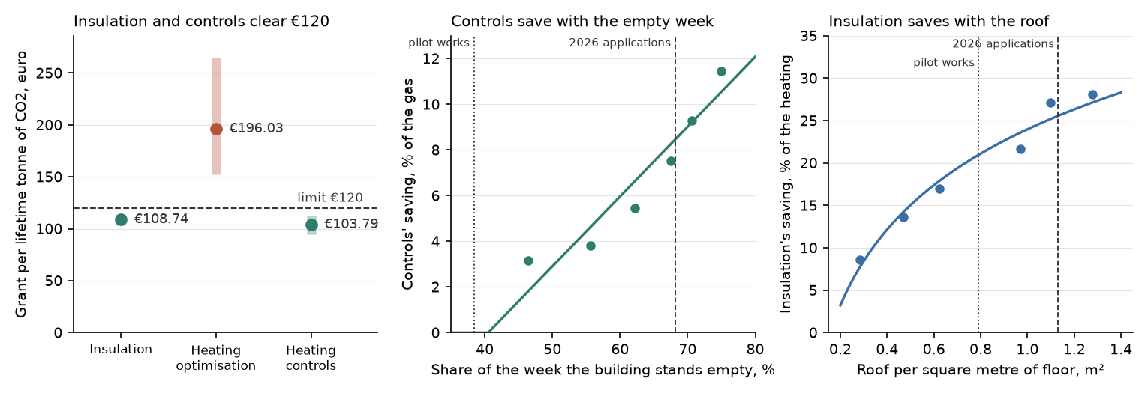
Savings are against the owners the 2019 draw passed over, measure by measure, each building against its own 2018/19 season, in normal weather. A building's empty week is read off the meter operator's 2025 typical week of its electricity (the hours under half-way from its lowest to its highest), every hotel and care home taken as lived in round the clock; its roof is the solar cadastre's roof faces at its address over the register's floor area.
What the round will pay
102 insulation and 365 heating controls applications were in by 12 June. In 2019 only 34.71% of the insulation answers and 79.46% of the controls answers had come in by the same day after the notice, the late insulation answers ran 27.83% larger, and 8.57% of the late insulation places were withdrawn against 2.36% of the early ones. On that record the funded round's applications will ask for €11,451,661 once the offer closes and it will pay €10,759,494 once the works are done; heating optimisation's applications would ask for and be paid the amounts below only if it were funded.
Measure | Applications at close | Grant asked | Paid once the works are done
Insulation | about 294 | €9,933,668 | €9,263,399
Heating optimisation (not funded) | about 692 | €1,674,379 | €1,641,474
Heating controls | about 459 | €1,517,993 | €1,496,095
The 2019 answers' dates, quotes and withdrawals from the pilot's response file; works to be done by 30 September 2026 and paid on completion (terms of the 2026 offer, 4).
For the annual report
The pilot's works saved 3,216 tonnes of CO2 in the season to April 2026: the gas the works buildings would have used that season without the works, less what they used, in normal weather.
How the quicker readings land
Reading of the pilot | Insulation | Heating optimisation | Heating controls | Funds
This appraisal | €108.74 | €196.03 | €103.79 | insulation, heating controls
Each application at its own use's saving, faded | €132.06 | €196.03 | €128.67 | none
The pilot's saving over each life, at the pilot's own mix | €140.94 | €179.86 | €195.06 | none
The pilot's seven-season saving, carried flat | €142.01 | €101.94 | €187.44 | heating optimisation
Controls on the empty week, insulation by use | €132.06 | €196.03 | €103.79 | heating controls
Insulation on the roof, controls by use | €108.74 | €196.03 | €128.67 | insulation
The works buildings' before and after, no comparison | €91.76 | €27.94 | €58.66 | insulation, heating optimisation, heating controls
Each reading run on the same applications and the same pilot record; only the way the pilot is read changes.
Torben Römer, head of Energy Services

