To: Board of trustees, Stichting Pensioenfonds Havenbedrijf en Logistiek, through the investment committee
From: Ilse Lips, head of credit, Kadeweg Fiduciair Beheer
Date: 18 February 2027, for the investment committee of 25 February and the board of 4 March 2027
Subject: Class A senior notes offered by Kestrel Lane and Ostvale, under MP-RN-2
Buy neither note; both fail MP-RN-2's test
We recommend declining both offers and leaving the allocation in the cash and government bond sleeve until the next round, as MP-RN-2 2.2 provides. Over 2027 to 2031 Kestrel Lane's Class A note has a 3.9 per cent chance of losing principal and Ostvale's a 7.8 per cent chance, against the standard's test of 1 per cent. Kestrel Lane's note looks the safer of the two on its borrowers' ratings, but its loans sit with seven sponsor houses, and the defaults that cluster in a house's bad year are the ones that recover least. We expect credit losses over the five years of 5.7 per cent of par on Kestrel Lane's portfolio and 8.2 per cent on Ostvale's.
Table 1. The two notes under MP-RN-2
Note | Loans | Par, EUR m | Subordination | Chance of loss 2027-31 | Expected loss 2027-31 | Needed for 1.0% | for 0.5%
Kestrel Lane | 98 | 1,880 | 15.0% | 3.9% | 5.7% | 20% | 22%
Ostvale | 100 | 1,853 | 13.0% | 7.8% | 8.2% | 17% | 18%
Par converted at the ECB reference rate of 31 December 2026. Chances and expected losses from 1,000,000 simulated five-year paths, the expected loss as a share of the portfolio's par; subordination needed in whole per cent of par, rounded up.
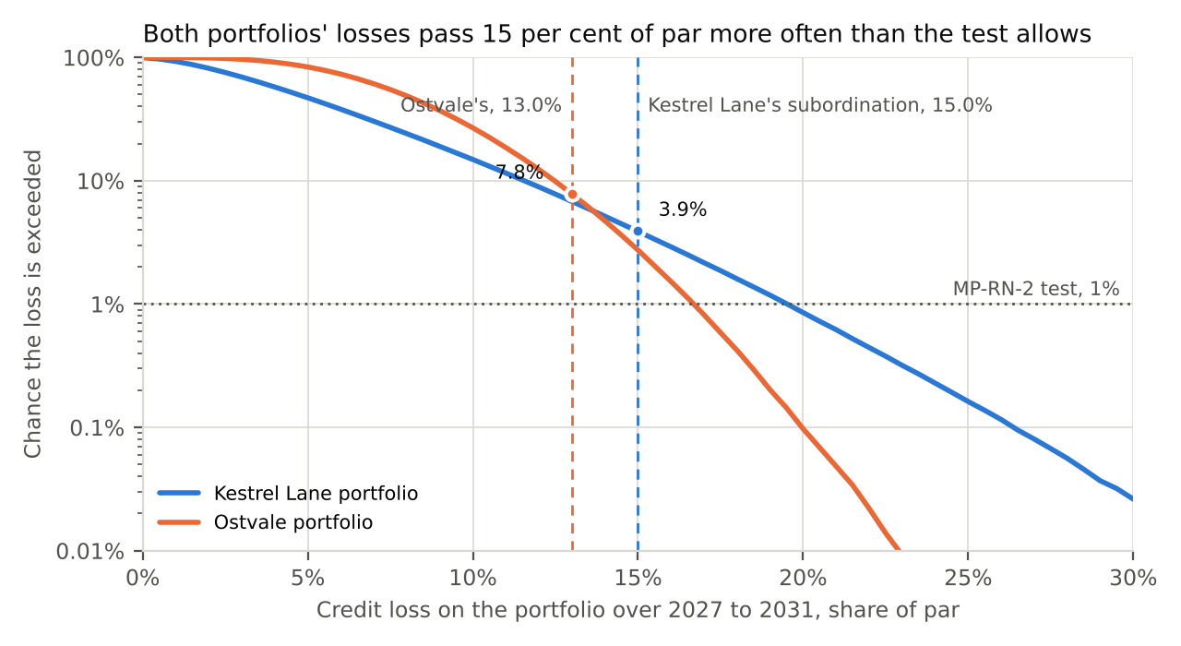
Figure 1. Chance that each portfolio's credit loss over 2027 to 2031 exceeds a given share of par. Kestrel Lane's note starts losing principal at 15.0 per cent and Ostvale's at 13.0 per cent.
Defaults cluster by sponsor house
Lenderbase records 16,712 company-years of European sponsor-backed first-lien loans from 2008 to 2026, with 578 defaults. Joined to Dealtrail's buyout records, every loan traces to the sponsor house whose fund held the company. Pairs in the same house, sector and year defaulted together 0.84 per cent of the time against 0.25 per cent for pairs in the same sector and year under different houses; pairs in the same house in different years sit at the independence rate. The economy's year carries 0.109 of the variance of a borrower's standing, the sector's year 0.059, and the house's year 0.503 of what those leave. Kestrel Lane's 98 loans sit with seven houses and Ostvale's 100 with 66.
The clustered defaults recover least
A house in a bad year stops putting money into its companies' restructurings, so lenders sell or wind up the businesses instead. On the 2008 to 2019 defaults, whose workouts have all closed, a default with no other default in its house that year recovered 74.9 per cent of the loan; one with three or more others recovered 44.1 per cent. The recent clustered defaults are not yet in that comparison: they take longer to work out, and 78 workouts are still open. Inferring each house-year's shock from its own defaults against what its companies' ratings, ages and sector-year expected, and the year's shock from the year's default rate, recovery on the closed cohorts runs 0.953 plus 0.000 per unit of the year's shock and 0.298 per unit of the house-year's shock.
The comparison counts each default's companions across its house's whole book: a default in the record shared its house-year with a median of 13 of the house's companies. Ostvale's tape holds two companies of each house and Kestrel Lane's 14. Counted among each note's own loans, Ostvale's defaults would nearly always look like lone ones and its note would pass at 0.1 per cent, while Kestrel Lane's would fail at 1.8; but what a default recovers depends on the year its house is having, not on how many of the house's loans a note happens to hold, so the house-year's shock carries it into the simulation.
Simulated with each default recovering on the shocks that drew it, both notes fail. With one average loss of 42.7 per cent for every default, as the closed workouts give it, Kestrel Lane's note would pass at 0.7 per cent and be bought (Ostvale's is at 6.2); tying recovery to the economy's year leaves Kestrel Lane at 0.2 per cent, because a default recovers no less in the economy's bad years. It is the house's year, which also clusters Kestrel Lane's defaults, that takes its tail past the test.
Estimated other ways, the default rates from a cohort table, the dependence from pair counts, or each house-year's shock read against the year's rates rather than the sector-year's, the chances run 1.5 to 4.0 per cent for Kestrel Lane and 2.3 to 7.8 per cent for Ostvale; the record's co-default counts taken over each house's whole book give 2.2 and 5.7 per cent. No sound estimate brings either note under the test. Fitting the link on every closed workout instead of the closed cohorts would leave out the open workouts, which MP-RN-2 4.1 keeps and which are the clustered defaults' long ones.
Table 2. Chance that the note has taken a loss by the end of each year
 | 2027 | 2028 | 2029 | 2030 | 2031
Kestrel Lane | 0.2% | 0.6% | 1.4% | 2.5% | 3.9%
Ostvale | 0.0% | 0.2% | 1.0% | 3.5% | 7.8%
Portfolios held as they stood on 31 December 2026 with repaid loans replaced, as MP-RN-2 3.2 sets out. Sources: Lenderbase extract of 16 February 2027 and its workout file, Dealtrail extract of 15 February 2027, managers' tapes at 31 December 2026.
To meet the test, Kestrel Lane's note would need 20 per cent subordination against the 15.0 it offers, and Ostvale's 17 per cent against its 13.0. Either manager may re-offer at that level in the next round.

