Name option B for the February slot: expected benchmark log loss 0.625, four in five between 0.604 and 0.645
To: Helene Svendsen
From: Magne Aas
Date: 9 November 2026
Re: which configuration the proposal names, and the loss and range it states

Name option B, the 512-wide model on our 128,000 expert labels and Lyngvær's 128,000, at the learning rate we already took for that width. I expect its final checkpoint to score 0.625 on the benchmark, and one run to land between 0.604 and 0.645 four times in five. The other three options come out at 0.661 (A), 0.670 (C) and 0.680 (D), all at least 0.036 behind on this forecast, and behind under every reading of the pilot I can defend.
Option C is the one our own tracking plots favour, and it is the one to leave out. The logged development loss puts it first by a wide margin, but that loss is scored on a split a quarter of whose items carry a vendor's label, so a model trained on a vendor's labels is partly marked against them. Scored on the expert-labelled items and carried to the benchmark on the 28 final checkpoints the programme scored, a single scaling curve through all the pilot runs still puts C first, at 0.624 against 0.635 for B. That curve does not survive its own check: built without the pilot's configurations above 256,000 examples it misses them by 0.027, every one on the optimistic side.
The large trials sit above the size ladder for two reasons at once, and they have to be separated before anything is carried further. Read from mixes at the same size, width and learning rate, contractor labels cost 0.0020 for each tenth of the training set they replace and map-transfer labels 0.0114. With those costs taken out of the trials at 256,000 and 512,000 examples, expert-quality labels would give 0.625 and 0.600 at width 128: a doubling that returned about 0.062 up to the expert pool returns 0.050 and then 0.025. Carrying that on, and checking it the same way, misses the held-back configurations by 0.0132.
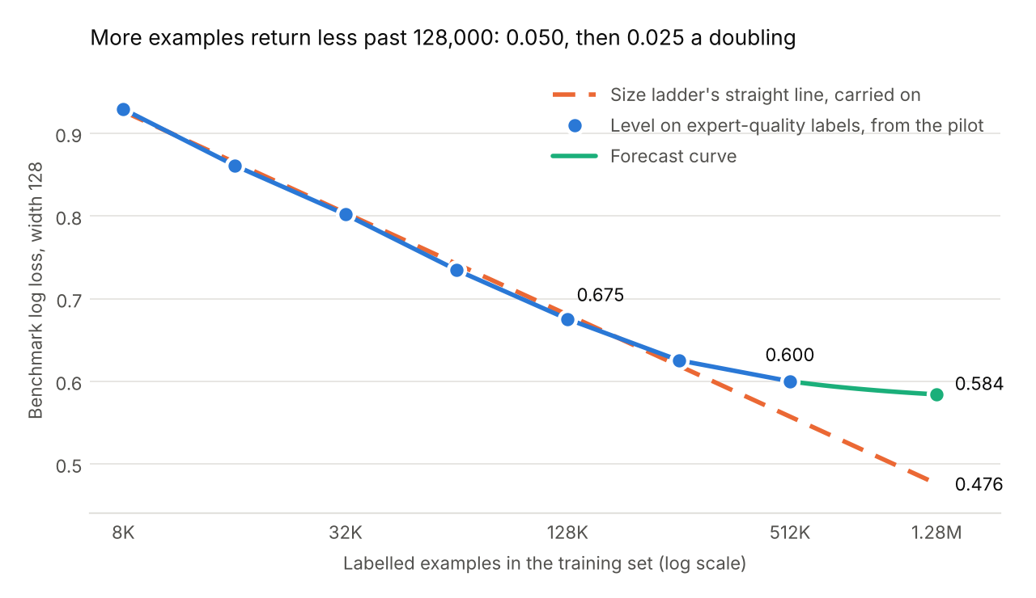
Benchmark log loss on expert-quality labels at width 128 and learning rate 0.002. Points to 32,000 examples are expert-label runs; from 64,000 on they are the trials at that size with each route's cost taken out.
So the million map-transfer labels buy less than they cost: at option C's mix they add about 0.093 to the loss while the extra examples take off about 0.041. Option A needs a learning rate; the best rate falls with width and the rule gives 2.7e-4 for 1,024. The range round B combines the spread between runs (0.0051), the forecast's error on the held-back runs (0.0140) and the error of carrying expert-item loss to the benchmark (0.0059). Four things the pilot cannot tell us: no vendor-label run was ever scored by the benchmark; no run used Lyngvær's lot together with the map labels, so C rests on the two costs adding; no run took B's labels to width 512, and the step I carry (0.004) rests on the benchmark's scores of three runs (read on the carried loss instead, B would be 0.640, still first); and what the examples past our largest trial return can only be bounded. With the last doubling's gain carried on undiminished C comes out at 0.653, with no further gain at 0.686, and B is ahead either way.
Option | Hidden width | Labels | Learning rate | Expected benchmark log loss
B | 512 | 256,000 points, expert and contractor labels | 5e-4 | 0.625 (0.604 to 0.645)
A | 1,024 | 128,000 points, expert labels only | 2.7e-4 | 0.661
C | 256 | 1,280,000 points, expert, contractor and map-transfer labels | 1e-3 | 0.670
D | 256 | 1,152,000 points, expert and map-transfer labels | 1e-3 | 0.680
Source: tracking, store and benchmark exports of 4 November 2026; workings in scale_up_forecast.xlsx.

