To: Gabriel Sloan, Brand Director
From: Consumer Insights
Date: 12 November 2026
Subject: Northvale Oat: 2027 treatment under the Portfolio Review Standard (v3.1)

Hold: Northvale Oat will take about 2.4 per cent of plant-based beverage litres in 2027
On the standard’s basis (distribution and everyday price at the review, no promotional or media weeks in 2027), the line holds about 2.4 per cent of the category’s 2027 litres, 10.5 million litres, bought by about 1,310,000 households who buy it 5.1 times each on average. That is inside the hold band (2.0 to below 2.9 per cent): the line stays listed and receives no 2027 media or sampling, and it keeps its current co-packer slots. Cutting the price groups another way, reading the settled level from 14 to 20 weeks, growing 2025 litres instead of 2024-25, or reading the levels against all category litres gives 2.1 to 2.6 per cent, all inside hold.
Why the line’s current numbers overstate 2027
The line has been bought by three groups of households that are not alike. The April buyers, about 820,000 households, are mostly shoppers who pay premium prices for the category (76 per cent of their category litres); at their price groups’ settled levels they give the line 14.1 per cent of their own plant-based beverage litres. The buyers who came with the discounter listing from June, about 130,000 households, are mostly value shoppers (66 per cent of their litres) and settle at 3.9 per cent. The Loyal Grocer buyers of late September, about 650,000 households, are mostly mainstream shoppers (74 per cent of their litres) still in their first weeks with the line: they are buying it at 32.0 per cent of their litres now and settle at 6.5.
Their settled level cannot be read from their own five weeks, so each of them is carried at the level of the households in its own price group that have bought the line for sixteen weeks or more, the price group set by what each household paid per litre for the category before launch. That level is read as the share of the litres a household buys in stores carrying the line, because the Loyal Grocer listing put the line on more of its buyers’ shelves in September: premium 20.0, mainstream 8.6 and value 0.9 per cent. Every household that has bought the line is carried into 2027 at its group’s level times the share of its own category buying done in stores that carry the line at the review (85, 83 and 81 per cent on average), weighted by its 2024-25 category litres grown to 2027 (6.2 per cent a year). Households that have not bought the line by the review come in at the rate they first bought it in 2026-W43 and 2026-W44, the weeks that match the standard’s basis (every banner listing it, no promotion or media): about 50,000 first-time buyers in 2027, adding 0.03 of a point.
What this rejects
The usual penetration times repeat times buying-level reading gives 4.8 per cent, and carrying the launch buyers’ current share of their litres to every buyer gives 4.4, both because the later buyers are not launch buyers. Taking each group at its recent share gives 5.8, because the Loyal Grocer group has not settled. Reading one settled level from every long-standing buyer, whatever they pay, gives 3.3 (support), because the long-standing buyers are mostly the April group’s premium shoppers. Reading the line’s share in the weeks without support between the two listings gives 1.7, because it leaves out the Loyal Grocer buyers altogether. Reading the settled levels against all category litres instead of stocked litres gives 2.2, the same treatment.
2027 | Category litres (millions) | Northvale Oat litres (millions) | Share of litres (%)
Q1 | 113.5 | 2.7 | 2.4
Q2 | 106.3 | 2.5 | 2.4
Q3 | 105.9 | 2.5 | 2.4
Q4 | 118.4 | 2.8 | 2.4
Year | 444.1 | 10.5 | 2.4
Source: Lakeshore Consumer Panel purchase lines to 2026-W44 projected to Canadian households; Meridian Retail Audit weighted distribution, 2026-W44. Quarters are panel quarters (13 weeks).
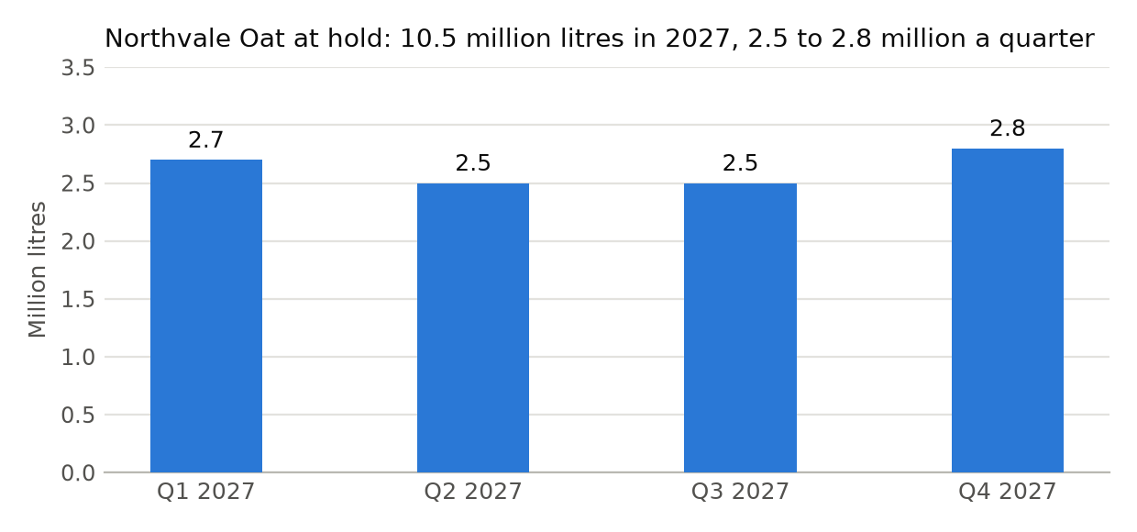
The year’s figure is the sum of the quarters before rounding.¹
¹ Households counted once however many times they buy. A household that buys the line only on promotion is counted in 2027 only if it buys at everyday price.

