Hollins Creek Electric Association, Distribution Planning
To: the board of directors From: Eileen Casey, manager of distribution planning Date: 12 November 2026
Make Quillpoint Sequence the EV Overnight default for 2027; the work plan replaces 13 transformers
Set the EV Overnight rate's charging default for 2027 to Quillpoint Sequence and carry 13 transformer replacements ($196,700) in the 2027 work plan. Under Board Policy EV-4 it is the cheapest of the three options at $249,200 for the year, against $397,100 for Quillpoint Stagger and $812,200 for leaving members on their own schedules.
Option | Transformers over their limit | Platform fee | Replacements | Total for 2027
Members' own schedules | 53 | $0 | $812,200 | $812,200
Quillpoint Stagger | 29.7 | $23,600 | $373,500 | $397,100
Quillpoint Sequence | 13 | $52,500 | $196,700 | $249,200
A summer like 2026: July and August 2026 as metered, the homes' hourly reads brought to the quarter-hour by DPS-7's peaking factors, with the 1,313 chargers enrolled on 1 November 2026 charging their 2026 sessions as each option would. Stagger starts sessions at random, so its expected cost counts each transformer at its chance of being over (EV-4 4.3). Fees at $18 and $40 per charger for the year; replacements at DPS-7's installed costs.
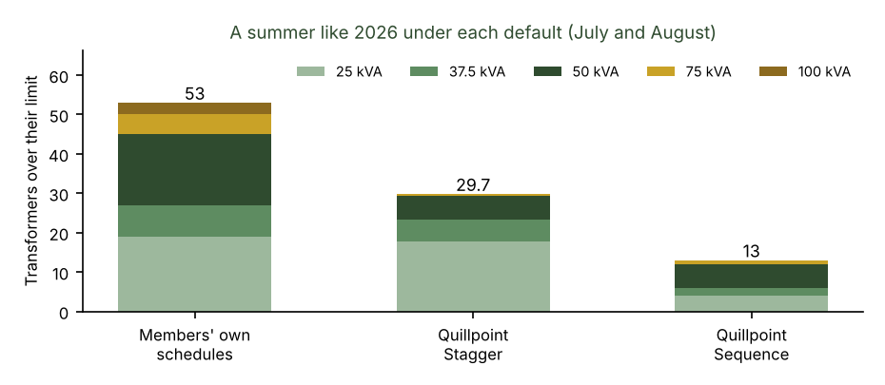
What the pilot showed, and what it did not
The pilot's managed quarter took 4.95 kW per enrolled charger off the 23:00 to 23:15 interval in July and August against the chargers on their owners' own schedules (0.34 kW against 5.29), because most own schedules start the car at 23:00 when the overnight price begins. Read as an average night, that looks as if a random start clears almost every transformer. It does not: a transformer's limit is its single highest quarter-hour of the summer, and the two to five chargers on a small transformer still land together on some night when each starts at random. Replayed night by night over the summer, Stagger still leaves 29.7 transformers over.
Sequence was not in the pilot. Run on each night's actual plug-ins, energy and unplug times, it keeps the chargers on a transformer apart most nights, but on nights when they need more charging than the hours to their departures allow, its rule starts a late charger alongside the others and the queue waits for it: 13 transformers stay over.
Members' own schedules are not what the meters saw in 2026, because a quarter of the chargers were under Stagger. With every charger back on its owner's own setting (its own-schedule sessions, or what the member told us at enrolment) 53 transformers would be over.
Sequence stays the cheapest unless its fee rises above about $153 per charger for the year. The CSV gives every transformer serving the rate's chargers, its limit, and its summer peak under each option.

