Rotalinha Platform Reliability
To: Engineering leadership group From: Teresa Nogueira, Platform Reliability Date: 14 January 2027
Ref: PR-SLO-3 annual review 2026, latency objectives, read over December 2026 in Lisbon time
Five services ran over their latency budget in 2026
Five services ran over their 2026 latency error budget and get a reliability engineer for January to June 2027, starting in this order, the service whose SLI counts the most requests over its threshold first: partner-gateway, places, fares, seat-map and notifications.
Start | Service | Share of over-threshold requests (%) | Latency SLI (%) | 90% interval (%) | Error budget (%)
1 | partner-gateway | 33 | 2.3 | 2.20 to 2.42 | 2.0
2 | places | 29 | 1.4 | 1.24 to 1.52 | 1.0
3 | fares | 17 | 1.3 | 1.19 to 1.40 | 1.0
4 | seat-map | 3 | 2.0 | 1.82 to 2.14 | 1.0
5 | notifications | 3 | 1.2 | 1.08 to 1.31 | 1.0
Source: trace_spans_2026-12.parquet weighted by the load balancer's hourly counts; budgets from PR-SLO-3 section 4. The interval is for the trace store's sample of December's requests.
Between them the five served 84% of the requests over their thresholds that all our services' SLIs count, about 200,000 more than their budgets allow.
Every service against its budget
Service | Threshold (ms) | Latency SLI (%) | Error budget (%) | Ran over
journey-search | 1,500 | 0.9 | 1.0 | no
fares | 300 | 1.3 | 1.0 | yes
places | 150 | 1.4 | 1.0 | yes
seat-map | 500 | 2.0 | 1.0 | yes
booking | 3,000 | 0.3 | 0.5 | no
payments | 2,000 | 0.2 | 0.5 | no
tickets | 1,500 | 0.7 | 1.0 | no
accounts | 600 | 1.3 | 2.0 | no
partner-gateway | 1,000 | 2.3 | 2.0 | yes
notifications | 600 | 1.2 | 1.0 | yes
Source: as above; thresholds from PR-SLO-3 section 4.
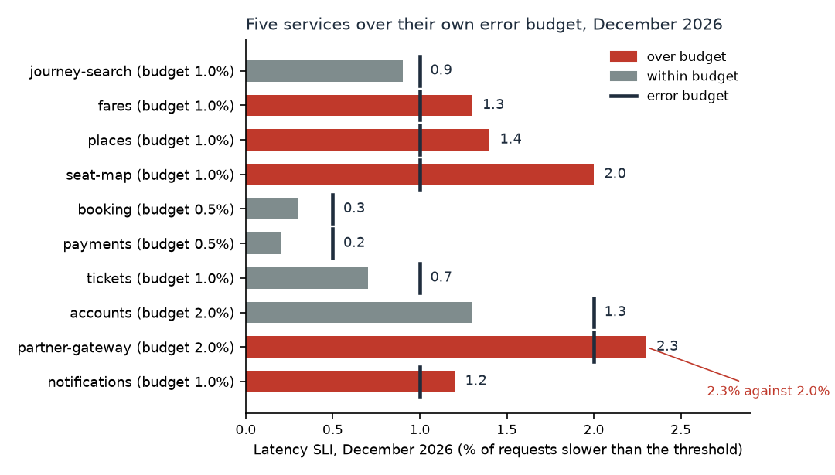
Each bar is the service's December SLI; the dark mark on it is the service's own error budget.
December's customer-facing incidents
PR-SLO-3 3.2 leaves a service's requests out of its SLI while a customer-facing incident named it, unless it owned the incident's root cause. December's post-incident reviews were still open, so the review dated, for each service an incident named, when its own handling of requests rose above what its load that hour would explain; the earliest rise owns the cause.
Incident | Declared (Lisbon) | Services named, in order | Root cause owned by
INC-1570 | 13 December 12:24 | partner-gateway, seat-map | seat-map
INC-1579 | 14 December 12:31 | seat-map, partner-gateway | partner-gateway
INC-1588 | 15 December 19:41 | journey-search, partner-gateway, fares | partner-gateway
INC-1594 | 17 December 20:49 | booking, payments, notifications | payments
INC-1611 | 21 December 19:46 | journey-search, fares, booking | fares
INC-1619 | 26 December 18:01 | accounts, notifications, payments | notifications
INC-1627 | 29 December 10:12 | places | places
Source: incidents_2026.csv, incident_timeline_2026.csv, status_page_history_2026.json and the span export.
INC-1611 and INC-1619 are the ones to read twice. In INC-1611, fares' own handling slowed from about 19:40, and journey-search's own handling only backed up behind it from about 20:25. In INC-1619, notifications' SMS verification slowed from about 17:00, and accounts' sign-in handling only backed up behind it from about 18:25. Charged to journey-search and accounts, they would leave fares and notifications at 0.7% and 0.8%.
How the SLI was read
The tracing store keeps a trace whole or not at all, and decides where the trace starts: each edge service keeps about the same number of traces every hour whatever its traffic. Each kept server span therefore counts for the requests its trace's edge service handled in the hour the trace started, over the traces it kept then, from the load balancer's hourly counts. For an internal service that weight belongs to the caller, not to the service: fares, partner-gateway and notifications are called from busy, thinly kept edge services for their slow operations and from quiet ones for their fast ones, so their own hourly counts, with the same incident time left out, would put them at 0.9%, 1.0% and 0.6%.
The trace export begins at 12 December 10:00: by the day it was pulled the store no longer held December's first 11 days, 33% of the month's edge requests, and those requests still count. Each service's requests in each of those hours, from the load balancer's counts, are counted at the share over threshold the service's held, incident-free hours show in the same band of hourly load. The first weeks were quieter than the holiday weeks the export holds, so read on the export's hours alone journey-search would be at 1.3% and over its budget; across December it is 0.9%.
The interval treats the kept traces as the sample they are: drawn within each edge service's hours, a whole trace at a time, so a service's spans in one trace move together and a thinly kept hour weighs more.
The same spans read other ways give other lists:
Reading of the December spans | Services over budget
Kept spans unweighted; each incident on the service named first; the export's hours alone | seat-map
Each service's spans on its own hourly count; causes dated by when own handling rose; the export's hours alone | journey-search, fares, places and seat-map
Each span at its trace root's keep share; causes dated; the export's hours alone | journey-search, fares, places, seat-map, partner-gateway and notifications
Each service's spans on its own hourly count; causes dated; the dropped hours counted at their load | places and seat-map
Each span at its trace root's keep share; causes dated; the dropped hours matched to the export's same weekday and hour | journey-search, fares, places, seat-map, partner-gateway and notifications
Each span at its trace root's keep share; each incident on the service furthest over its load curve; the dropped hours counted at their load | journey-search, places, seat-map and partner-gateway
Each span at its trace root's keep share; causes dated; the dropped hours counted at their load (this review) | fares, places, seat-map, partner-gateway and notifications
Source: trace_spans_2026-12.parquet and the load balancer's hourly counts, with the exclusions of PR-SLO-3 3.2 under each attribution.
Notes: SLIs are per cents to one decimal and are compared with the budget as rounded (PR-SLO-3 3.4); intervals are to two decimals. Shares and the requests beyond budget are worked from the unrounded figures. December in Lisbon time is UTC throughout, and the trace export's re-sent spans are counted once.

