To: Meredith Cooke, Head of Breeding
From: Jesse Gibson, Trials and Data
17 February 2026. HRBS nominations close on 27 February.
Nominate WI3554 and WI3559 for 2026: WI3571, high on our index, should lodge 48% in the series and return 100.8
WI3554 and WI3559 are the two Stage 3 lines we should expect most from in the series: relative yields of 113.4 and 109.5 over two seasons, against 103.4 for the next line, WI3528. Mount Rouse's standard is 107.0. The 80% ranges run from 108.4 to 118.3 and 104.7 to 114.3; they are ranges for what two seasons return, the seasons drawn as well as what we still do not know about the lines (WI3554 would run from 110.1 to 116.7 on the spread of its estimate alone).
The index points elsewhere. It would put up WI3554 and WI3571, at 119.7 and 112.8. WI3571 is weak-strawed: we expect 48% of its plots to lodge in the series, against 28% and 27% for WI3554 and WI3559, and a relative yield of 100.8.
Line | Index | Expected relative yield | 80% range | Expected lodging
WI3554 | 119.7 | 113.4 | 108.4 to 118.3 | 28%
WI3559 | 112.1 | 109.5 | 104.7 to 114.3 | 27%
WI3528 | 108.5 | 103.4 | 98.4 to 108.1 | 30%
WI3571 | 112.8 | 100.8 | 95.2 to 106.2 | 48%
Lines in the order above: the two to nominate, the first left out, the index's other choice. Source: workbook, sheet Stage 3 lines.
Why the past nominations fell short
The 24 nominations with both seasons in were quoted at 113.0 on average and returned 101.6, a gap of 11.4 points. Under the deed's four heads: 3.4 was the index itself, since lines picked for the highest index on the Stage 3 list are partly picked on their luck and at the same trials they should have been expected to give 109.7.¹ 5.5 was the move to the Series: before lodging the lines stand 0.54 t/ha over Byaduk at their index trials, where Byaduk yields 4.70 t/ha on 378 mm of season water, and 0.34 t/ha at their Series trials, where it yields 5.54 on 500 mm.² 2.1 was lodging, which costs 0.172 t/ha for each tenth of a plot lodged: the lines lodged 6.1 points more than Byaduk at their index trials and 13.6 points more in the Series. The remainder is 0.4.
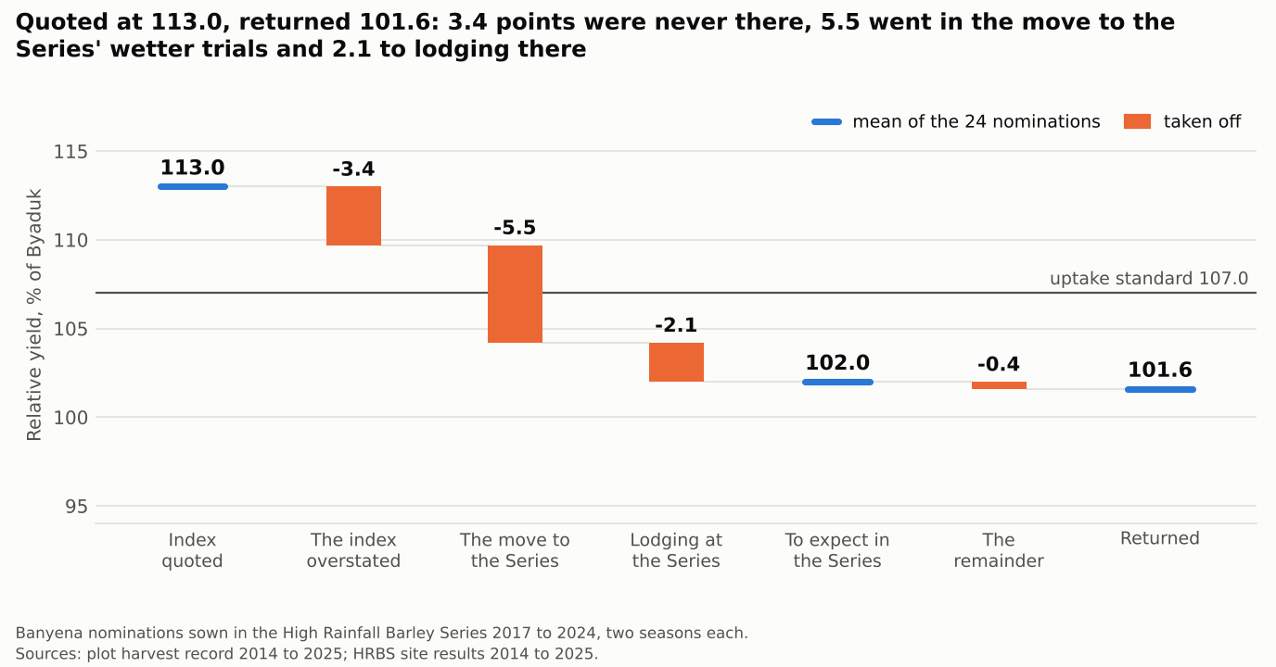
One year shows the second part most plainly: the 2017 nominations were quoted at 114.9 on index trials that had 336 mm of season water in 2016, against 384 mm over all seasons, and returned 93.6, with 11.9 points going in the move to the Series.
¹ Relative yield and the index as the series protocol (section 7) and our trial handbook (section 6) define them; the standard and the review's heads are clauses 2.1 and 4.2 of schedule 2 to the option deed.
² Season water is April to October rain, plus the water applied at Kerang. In the Series' trials Byaduk's gain over our nominated lines goes with season water (t 6.3); the trial's yield level, entered beside it, takes the opposite sign (t -2.7).

