To: Board of Directors, Kotuku Networks Limited
From: Tania Foley, General Manager Network
Prepared by: Hoani Marshall, Reliability Engineer
Date: 19 November 2026
Subject: The six feeders for the 2027 vegetation catch-up (for approval)

Recommendation: put PBY-10, HRK-03, HRK-05, WTK-02, PBY-11 and PBY-03 into the 2027 catch-up
On these six northern coastal feeders the catch-up avoids about 12,984 sustained customer interruptions caused by vegetation in 2027-28, the most it can avoid on any six of the network’s 48 feeders. That is 0.33 of network SAIFI on the 39,943 ICPs connected at 31 October 2026. The next-best feeder, TOT-02, would avoid 1,268. The saving is heaviest in the winter quarter: 2,752 in April to June 2027, 5,466 in July to September, 3,102 in October to December and 1,664 in January to March 2028. In nine years out of ten the six avoid between 10,000 and 19,000, depending on the year’s storms.
Why these six
Their corridors have gone longest since a cycle trim: each was last trimmed between October 2019 and May 2020, and through 2027-28 each will be seven and a half to eight years from its trim. Across the network a corridor’s vegetation interruptions, for the same wind, rise about 15.5 per cent for every year since its last trim, so these six carry the most growth that a trim takes away. Left as they stand they would have the six largest counts of vegetation interruptions in an ordinary year; after the catch-up most of that falls away.
Why not the feeders with the most interruptions now
The feeders with the most vegetation customer interruptions in the three years to October 2026 are TOT-02, TIT-04, MKR-01, KWH-01, TIT-01 and TIT-03, mostly the plantation feeders of the southern hills. Two things make that list the wrong one for this decision. First, those three years were unusual weather: Titi Saddle and Kowhai Ridge recorded about 312 and 260 hours a year with gusts of 60 km/h or more against their usual 133 and 122, while Paua Bay recorded 38 against its usual 106. The mean wind at every station moved by only a few per cent, so the difference sits in the damaging gusts, and the recent counts overstate the southern feeders and understate the northern ones. Second, the plantation corridors were cut in the second half of 2025 on their three-year cycle, and most of their interruptions come from the density of the corridor itself, which a catch-up does not change.
How the figures were made
Each feeder’s vegetation interruptions from April 2022 were read month by month against the gust load at its nearest weather station (each hour’s gust above 40 km/h, squared and added up), as a rate for the corridor straight after a cycle trim that grows with the years since the trim. Of the measures of wind we tried, the gust load fits the record best. 2027-28 is then taken at each station’s average year from 2006 to 2025, with the corridor left as it stands and with the catch-up finished on 31 March 2027, and counted in customer interruptions at the feeder’s own customers per vegetation interruption. Other measures of the wind (hours of gusts from 45 to 70 km/h, the gust excess over 35 or 45 km/h), other base years and other forms for the growth give the same six, with totals from 12,247 to 15,757. The range is the spread of the six’s saving across the weather of the regulatory years 2006-07 to 2024-25 in the station record, the 5th to the 95th percentile, with the corridors and their growth held as fitted.
Feeder | Weather station | Customer interruptions, left as is | After the catch-up | Avoided
PBY-10 | PBA | 4,161 | 1,419 | 2,741
HRK-03 | PBA | 3,628 | 1,291 | 2,337
HRK-05 | PBA | 3,553 | 1,274 | 2,279
WTK-02 | PBA | 2,949 | 1,032 | 1,916
PBY-11 | PBA | 2,891 | 1,001 | 1,890
PBY-03 | PBA | 2,894 | 1,073 | 1,821
The six |  | 20,076 | 7,091 | 12,984
Sustained unplanned interruptions coded to vegetation, counted under the Reliability Reporting Standard, excluding major event days. Figures are rounded after they are added.
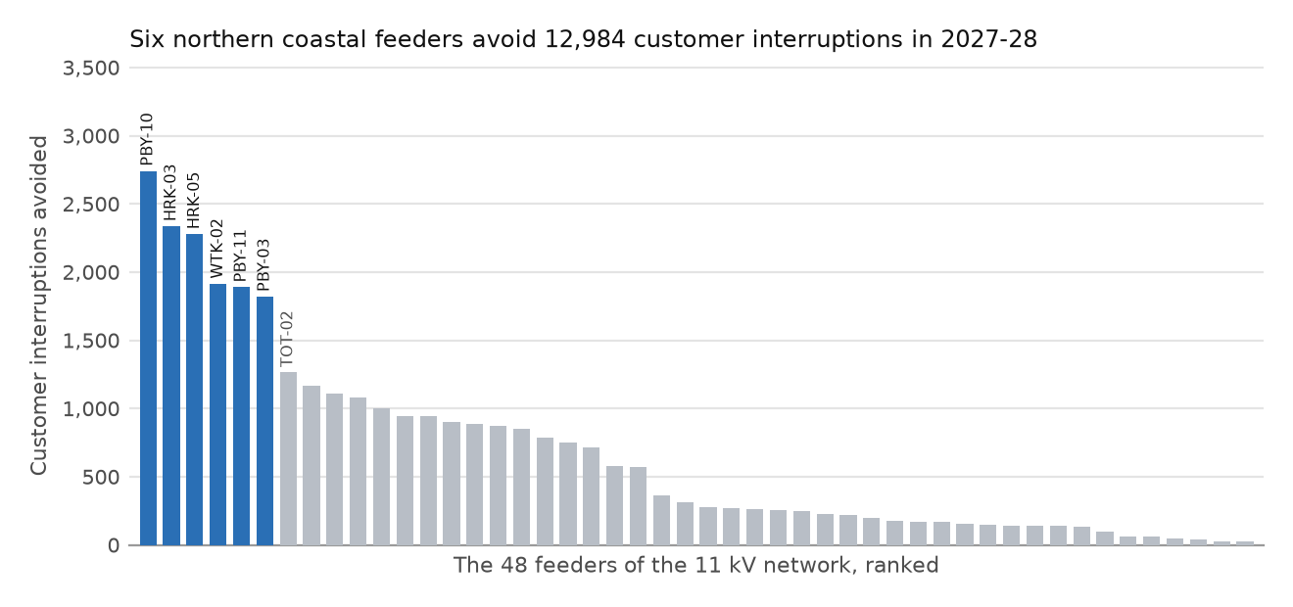
Every feeder’s figures are in vegetation_catchup_2027_feeders.csv.¹
¹ The major event days since April 2022 were the 5 snow days on the southern hills; no day of strong wind reached a boundary value.

