3-month ladder: no more than USD 114,400 a point; the USD 200,000 quoted for would have breached the collateral limit in November 2008
To: Stephanie Bowman, Director of Treasury
Cc: Edward Stewart, Chief Investment Officer
From: Treasury Analysis
Date: November 10, 2026
Re: Size of the new variance swap ladder and the Sleeve's line in the 2027 cash plan

Confirm the 3-month ladder to the panel at USD 114,400 a point per monthly sale. That is the largest size, in the USD 100 steps of Schedule D.2(a), at which the Sleeve stays inside both Schedule D.4 limits on the record. With the 12-month ladder at its USD 50,000 beside it, collateral would have peaked at USD 44,621,000 on November 20, 2008, against the limit of USD 44,628,000 (3.0% of the USD 1,487.6 million of net assets at June 30). The settlement limit is not the constraint: the worst calendar year is 2008, with USD 22,718,000 paid against USD 29,752,000. For the 2027 cash plan carry USD 5,728,000 from the Sleeve at that size, and plan for a year that lands anywhere from a net payment of USD 4,203,000 to receipts of USD 12,204,000 four times in five.
The USD 200,000 the dealers quoted for does not fit: on the same day the Sleeve would have posted USD 59,087,000, USD 14,459,000 over the limit. The size turns on 2008, and the 3-month index file begins on September 18, 2009. Schedule D.5(b) keeps every monthly sale date from January 2007 in the record whether or not the index was yet published, so the 32 strikes before that date have to be rebuilt. I rebuilt them from the two published maturities either side of three months (the 30-day index and the 6-month index, or the 1-year index before the 6-month index begins in January 2008), fitted on the 4,312 days all are published; the fit is off by 0.43 points on average and by 1.35 on the 102 days the 30-day index closed above 35, which are the days that decide this. The 30-day index alone looks like a good stand-in and is not: it explains 0.94 of the 3-month index's variation over the same days, but the 3-month index runs 12.5% above the 30-day index on average and 7.9% below it on those stressed days, so the stand-in is 2.3 points too high exactly where the limit is set. Strikes that are too high make 2008 look milder, and the size comes out at USD 124,500, at which the Sleeve would have posted USD 46,328,000 on November 20, 2008. Leaving the early sale dates out altogether gives USD 136,600.
A 6-month ladder instead could be no larger than USD 58,700 a point, bound by the same limit on the same day.
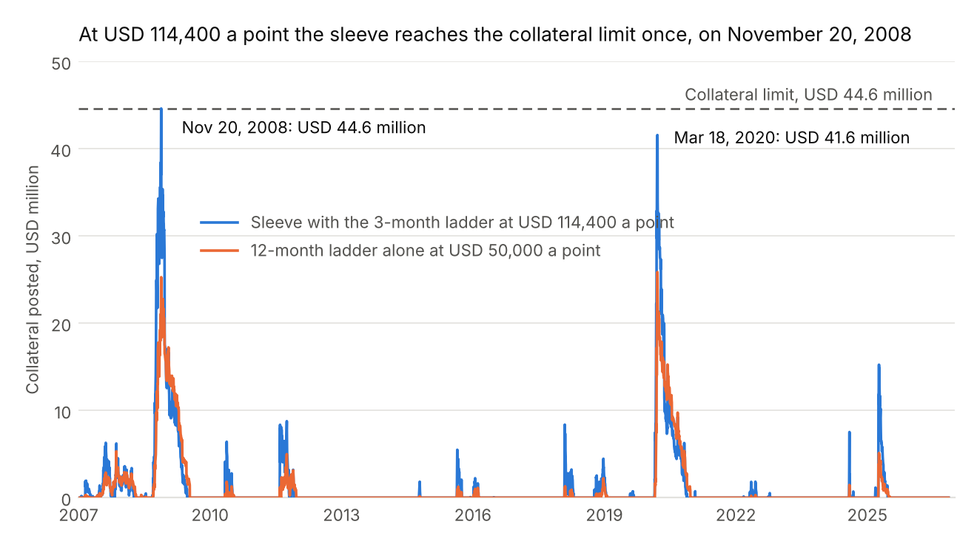
Collateral the Sleeve would have posted on each day of the record, January 2007 to November 9, 2026.
The 2027 plan is every settlement that falls in the year, 21 in all. The 12-month ladder brings USD 2,809,000: the 10 open sale months that expire in 2027, expected to settle at USD 2,494,000, and its November and December 2026 sales, which are not yet made and expire in November and December 2027, at the ladder's average of USD 158,000 a sale (Schedule D.7(b)). The 3-month ladder brings USD 2,919,000: its first sale is January 19, 2027, and only the 9 sales to September 20 expire inside the year, at the record's average of USD 284,000 a sale per USD 100,000 a point. The open swaps' figure is not their value. They are valued at USD 1,883,000 at the November 9 close, but a value is a price. Taking each of the record's 4,761 start dates since January 2007 and letting the S&P 500 run from there over each swap's remaining days, the same swaps would have gone on to pay more than that value from 80% of start dates, USD 2,494,000 on average (Schedule D.7(a) and (c)), and between USD 394,000 and USD 4,247,000 four times in five.
Cash plan 2027 (USD) | Expected | 80% range, low | 80% range, high
12-month ladder | 2,809,000
of which the open swaps that expire in 2027 | 2,494,000 | 394,000 | 4,247,000
3-month ladder at USD 114,400 a point | 2,919,000
Sleeve | 5,728,000 | -4,203,000 | 12,204,000
Source: blotter, dealer statements and custodian files; S&P 500 and Cboe volatility index closes through November 9, 2026. Workings in sleeve_ladder_2027.xlsx; daily collateral in sleeve_collateral_on_record.csv.
The year as a whole is much less certain than its parts suggest, because a bad stretch hits the open swaps and the new sales together. Replaying all 21 settlements from the same start dates (4,717 of them, the last on October 1, 2025), the plan lands between a net payment of USD 4,203,000 and receipts of USD 12,204,000 four times in five, and below zero from 11% of start dates; the worst start date, May 16, 2008, would have cost USD 28,122,000.
Nor does the record pin either ladder's average tightly. Sales a month apart share most of their days (the correlation between one sale's settlement and the next is 0.93 for the 12-month ladder and 0.64 for the 3-month), so 226 and 235 expired swaps are far fewer independent observations. Resampling the record in blocks of consecutive sales, the 12-month ladder's average of USD 315,000 per USD 100,000 a point lies between USD 63,000 and USD 552,000 four times in five, and the 3-month ladder's USD 284,000 between USD 143,000 and USD 413,000 (Schedule D.7(d)). Treated as unrelated, the same settlements would give USD 228,000 to USD 400,000 and USD 194,000 to USD 370,000, which is too narrow.
On the record the 3-month ladder's worst calendar year is 2008, a loss of USD 16,154,000 per USD 100,000 a point. The 12-month ladder at its USD 50,000 would have needed USD 25,876,000 of collateral at its peak (March 18, 2020, with November 20, 2008 at USD 25,287,000), which leaves the new ladder USD 19,341,000 of room on the binding day. At the November 9 close the open book, 24 confirmations in 12 sale months, is worth USD 2,619,000 to the Sleeve.
1. Open swaps are valued on the basis the dealers' statements show (variance realized to date and the variance implied for the remaining term, weighted by days, with the cap), read from the published term structure. No discounting (Schedule D.5(e)).
2. The blotter's August 2023 Altamere ticket booked at USD 250,000 was superseded the next morning at USD 25,000, and the March 2024 Wexcombe confirmation was novated to Brecon Sound in June 2024; both swaps have since expired and each is counted once.

