Platte Ridge Public Power District, System Planning
To: Joseph Harmon, manager of distribution engineering From: Mary Wilson, system planning Date: 20 November 2026
Voltage optimization in 2027: 13 feeders, $4,047,000
Put voltage optimization on ASH-113, ASH-116, ELC-113, ELC-116, FRV-113, FRV-219, FRV-222, GBR-113, GBR-219, GBR-222, HOL-116, HOL-219, HOL-222 in the 2027 capital program. Under VO-1 each of them saves more energy at its substation breaker over a year like 2026 than its equipment costs: together 12,336 MWh a year for $4,047,000 installed. The other 11 feeders do not clear their cost.
Feeder | Yearly saving at the substation | Installed cost | Value over cost
ASH-116 | 768 MWh | $176,800 | 1.96
FRV-113 | 917 MWh | $224,900 | 1.84
HOL-116 | 1,027 MWh | $287,200 | 1.61
FRV-222 | 835 MWh | $238,800 | 1.58
ELC-113 | 1,142 MWh | $334,100 | 1.54
HOL-222 | 723 MWh | $213,800 | 1.52
ELC-116 | 934 MWh | $287,700 | 1.46
FRV-219 | 1,156 MWh | $381,800 | 1.37
GBR-113 | 1,187 MWh | $429,900 | 1.25
GBR-219 | 1,224 MWh | $465,500 | 1.19
GBR-222 | 818 MWh | $332,400 | 1.11
HOL-219 | 573 MWh | $236,500 | 1.09
ASH-113 | 1,033 MWh | $437,600 | 1.06
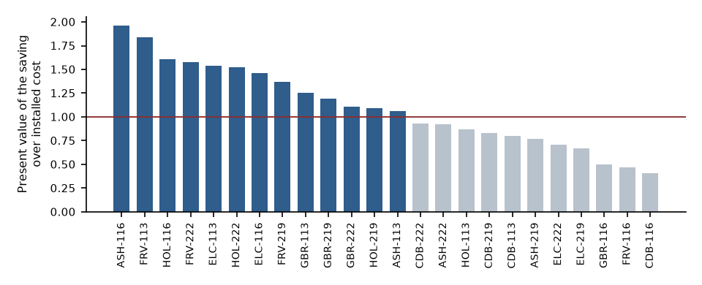
What the trial measured
On the eight trial feeders the energy drawn fell by 0.67 percent on average (0.64, 0.53, 0.61, 0.76, 0.67, 0.66, 0.67, 0.82, feeder by feeder) for each 1 percent the regulators actually took off the feeder-head voltage. The ON days did not all run: on some the pilot regulators stayed in local mode, and each ON day ramped down over its first hour, so a reading on the day's assignment alone understates the response.
Carrying it to every feeder and every hour
The trial ran in spring and autumn on eight feeders. Water heaters and resistive heat draw less at a lower voltage only until their thermostats keep them on longer, so over a day they give their energy back; every other load answers in proportion to its share. Each feeder's share of thermostatic load hour by hour comes from its own load against the weather and the 2025 appliance survey; scaled to what the trial measured, that gives each feeder's response through the whole year, lower in winter where resistive heat is common.
How far each feeder can go
VO-1 keeps every customer at or above 115 V in every hour. The far-end meters set what each feeder can give hour by hour: the trial's 4.8 V on the short, lightly loaded feeders, much less at the far end of the long rural lines and on the heaviest summer and winter hours.
Losses
Lowering the voltage raises the current the constant-power loads draw, so on most feeders the lines' own losses rise and give back part of the customers' saving; current squared, fitted on the feeders with substation revenue meters, puts the change between -126 and -4 MWh a year. The annual report's 6.1 percent loss rate, added in proportion, gets the sign wrong.
What a quicker reading would fund
Reading the trial on its assignment, carrying the trial feeders' average to the rest at the trial's 4.8 V all year and adding 6.1 percent for losses funds ASH-113, ASH-116, ASH-222, CDB-219, ELC-113, ELC-116, FRV-113, FRV-219, FRV-222, GBR-113, GBR-219, GBR-222, HOL-116, HOL-222 instead.

