Statistics Office | Section for Dwelling Statistics
Ministry of Local Government and Housing
Housing Policy Department
Attn. Eirik Haug
Our ref. 26/4470-3 Your ref. letter of 1 December 2026
12 January 2027
Certification under Section 7: vacant dwellings in the Hvitfjell pilot of the 2027 vacant dwelling activation grant
Five municipalities qualify for the grant: Tverrvika (7.3 per cent), Hesteby (6.4 per cent), Solmoen (6.5 per cent), Ørnevik (8.2 per cent) and Fjordeid (5.4 per cent). In each of them 5.0 per cent or more of the dwellings the regulation counts (Section 3) stood vacant in the reference fortnight of 9 to 22 November 2026 (Sections 4 and 6). The highest share below the threshold is Snøholt's 4.7 per cent. Across the county 396 of the 8,020 counted dwellings stood vacant.
Municipality | No. | Counted dwellings | Vacant dwellings | Vacancy share (%) | 90% interval (%) | Qualifies
Brekkevoll | 5801 | 1,640 | 66 | 4.0 | 3.3 to 4.9 | No
Tverrvika | 5802 | 520 | 38 | 7.3 | 5.5 to 9.5 | Yes
Hesteby | 5803 | 980 | 63 | 6.4 | 5.2 to 7.9 | Yes
Kvernhaug | 5804 | 860 | 33 | 3.8 | 2.8 to 5.1 | No
Solmoen | 5805 | 430 | 28 | 6.5 | 4.7 to 8.8 | Yes
Ravnsund | 5806 | 740 | 34 | 4.6 | 3.4 to 6.1 | No
Ørnevik | 5807 | 380 | 31 | 8.2 | 6.0 to 10.9 | Yes
Langgrav | 5808 | 1,120 | 36 | 3.2 | 2.4 to 4.2 | No
Fjordeid | 5809 | 560 | 30 | 5.4 | 3.9 to 7.2 | Yes
Snøholt | 5810 | 790 | 37 | 4.7 | 3.5 to 6.1 | No
County |  | 8,020 | 396

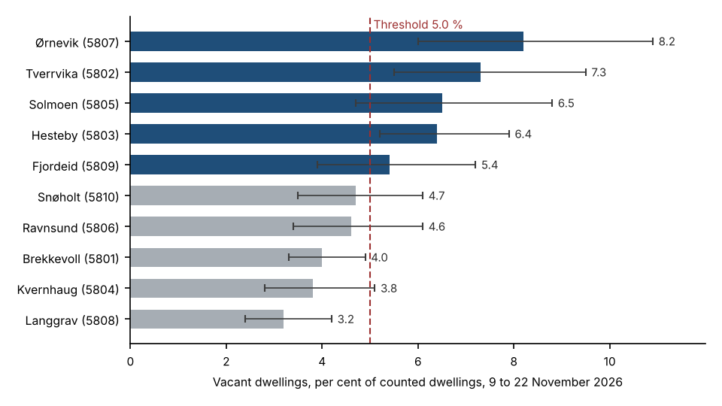
Figure 1. Vacancy share by municipality with its 90 per cent interval, against the Section 6 threshold. Qualifying municipalities in blue.
How vacancy was established. Each counted dwelling was joined to its household metering points in the hub's extract, by the cadastre's unit ID or, for a house without one, by its address, and its hourly values were put on Norwegian time, the measured value kept where an hour had been estimated first, a dwelling's two points added where its meter was changed in the fortnight. Each day was set against its own night hours and each dwelling against its own typical day, hour by hour: a dwelling was taken as lived in when some hour of some day ran more than 0.9 kWh above its typical day, the household doing something the building's own load does not repeat; it was vacant when its days repeated. In the dwellings read as vacant no hour ran more than 0.6 kWh above the typical day, and in the lived-in ones some hour ran at least 1.3 kWh above it. The level of use does not settle it in November: an empty dwelling here is left heated, and the vacant dwellings used a median 22.8 kWh a day against 20.4 for the lived-in ones. Nor does a morning or evening rise on its own: 70 vacant dwellings were heated on a timer, comfort hours over a night setback, and rose every morning and evening at the same hours, the same amount each day. Nor does the register: 118 of the vacant dwellings still had someone registered in them on 1 November, and 556 lived-in dwellings had nobody registered.
Each share is given with its 90 per cent interval, the municipality's counted dwellings taken as so many chances of a dwelling standing empty, as the ministry asked; the interval here is the exact binomial one. The intervals of Tverrvika, Hesteby and Ørnevik lie wholly above the 5.0 per cent threshold; the regulation designates on the share itself (Section 6), so the intervals do not change the certification, but they show how firmly each share sits against the line.
The dwelling-level list is in county_dwelling_occupancy_2026-11.xlsx.
Table A. The register held nobody in 834 counted dwellings on 1 November 2026, and 66.7 per cent of them were lived in
Municipality | No. | Overcoverage | Rate (%) | Undercoverage | Rate (%) | Net bias (%)
Brekkevoll | 5801 | 15 | 1.1 | 197 | 79.4 | 11.1
Tverrvika | 5802 | 13 | 2.7 | 7 | 21.9 | -1.2
Hesteby | 5803 | 8 | 0.9 | 28 | 33.7 | 2.0
Kvernhaug | 5804 | 7 | 1.0 | 146 | 84.9 | 16.2
Solmoen | 5805 | 12 | 3.0 | 11 | 40.7 | -0.2
Ravnsund | 5806 | 10 | 1.5 | 37 | 60.7 | 3.6
Ørnevik | 5807 | 19 | 5.3 | 8 | 40.0 | -2.9
Langgrav | 5808 | 10 | 1.0 | 55 | 67.9 | 4.0
Fjordeid | 5809 | 10 | 1.9 | 23 | 53.5 | 2.3
Snøholt | 5810 | 14 | 1.9 | 44 | 65.7 | 3.8
County |  | 118 | 1.6 | 556 | 66.7 | 5.5
Overcoverage: counted dwellings where the register held someone as resident on 1 November but that stood vacant, as a percentage of the counted dwellings where it held someone. Undercoverage: counted dwellings lived in where it held nobody, as a percentage of those where it held nobody. Net bias: the dwellings where it held nobody less the vacant dwellings, as a percentage of all counted dwellings. Registration is the register of 5 January 2027 with every event after 1 November undone; where the cadastre renumbered a block's flats in November the register shows each resident moving to the new unit number on the day, which is a change of number, not a move.
On these figures the register alone could not carry the count: in seven municipalities it holds nobody in more dwellings than stood vacant, and in Tverrvika, Solmoen and Ørnevik it still lists residents in enough empty dwellings to hold nobody in fewer.
Yours sincerely
Martine Strøm
Head of Section, Dwelling Statistics

