PESTEL ANALYSIS OF
Data-Driven Insights into Vehicle Pricing and Market Behavior

Group 3
Master of Data Analytics, University of Niagara Falls Canada
Anisha Antony –NF1022549
Akhila Chelimala- NF1017526
Deepthi Jonnada-NF1008799
Sathiya Sampath-NF1025995

(DAMO-511-9) Data Analytics Case Study 2
PhD, DACP, CAE, CSCM Mehdi Mostofi
Fall 2025

CONTENTS

Executive summary ................................................................................................................................. 3
Justification ............................................................................................................................................. 4
Initial Insights .......................................................................................................................................... 4
Methodology ........................................................................................................................................... 6
- Data Collection ........................................................................................................................................ 6
- Data Handling and Cleaning .................................................................................................................... 7
- Outlier management ................................................................................................................................. 10
- Statistical Analysis ………………………………………………………………………………………11
- Exploratory Analysis ................................................................................................................................12
Regression Analysis..................................................................................................................................16
Time Series Analysis and ARIMA Forecast…………..............................................................................18
Environmental Impact Assessment ..........................................................................................................20
Strategic Implications ..............................................................................................................................23
Key Insights & Recommendations ......................................................................................................... 24
References .............................................................................................................................................. 25

1. EXECUTIVE SUMMARY
This​‍​‌‍​‍‌ report documents a detailed PESTEL-based environmental analysis of the used car market, which is enhanced by statistical modelling informed by data. The research based on a dataset of more than 558,000 used vehicle transactions from all over the United States has been cleaned. It examines how external political, economic, social, technological, environmental, and legal factors affect vehicle pricing trends. By means of descriptive statistics, correlation analysis, multiple regression modelling, and ARIMA-based forecasting, the research locates the primary factors that affect price, for example, mileage, vehicle age, and condition. The findings show that the price of a product is strongly dependent on how much the vehicle is used and its depreciation, moderately on condition ratings, and that the price is steadily going down because of aging. ARIMA forecasting sheds light on potential pricing models in the future thus enabling the management to evaluate the risks and opportunities in the automotive resale sector. The PESTEL evaluation links these statistical results to macro-level market forces, thus giving strategic advice to buyers, sellers, dealerships, and ​‍​‌‍​‍‌policymakers.
The​‍​‌‍​‍‌ multiple linear regression model accounts for 39.1% of the variance (R² = 0.391) in used-car prices, which is indicative of moderate but still significant explanatory power. The effects of year, mileage, and condition were all statistically significant (p < 0.05), thus it is consistent that newer cars in better condition with less mileage will sell at higher prices. The ARIMA-based forecast is that average used-car prices will stay close to $16,268 for the next 12 months, with the anticipated monthly values going from $16,161 to $16,294. Such a limited interval between the predictions indicates that the market for used cars is expected to be stable in the short term and that there will not be any sudden increases or decreases in prices under the existing ​‍​‌‍​‍‌conditions.

2.​‍​‌‍​‍‌ Justification
The secondhand vehicle market is a crucial part of the automotive industry which is the main driver of the economy. In times of economic instability, high inflation, and rapid technological change, many consumers opt for used cars as a cheaper alternative to new ones. However, a move towards electrification due to environmental-friendly policies and tougher emissions regulations is changing the resale value of traditional internal combustion engine vehicles.
This is justified by the following reasons:
- It focuses on a real-world sector that is significantly influenced by external macro-environmental factors.
- It mixes PESTEL analysis with quantitative modeling, thus being in line with the course objective of theory and data integration.
- It takes advantage of a substantial, real car price dataset to obtain data-driven insights instead of making assumptions.
- It enables the stakeholders (consumers, dealerships, policymakers) by offering them the forecasts and strategic implications.
- Upon applying a PESTEL framework to a rich, cleaned dataset and associating external forces with the pricing patterns that have been observed, the project becomes a comprehensive and operational supply of the secondhand vehicle ​‍​‌‍​‍‌market.

3.​‍​‌‍​‍‌ Initial insights of Dataset
This project began with a raw dataset car_prices.csv which is a detailed record of used vehicle transactions across the United States.

3.1 Key variables identified
The important variables were extracted from the data as follows:
- selling price – final transaction price (target variable for modelling)
- year – manufacturing year of the vehicle (proxy for age)
- odometer – mileage (vehicle usage)
- condition – quality rating of the vehicle
- make, model, trim, body, color, state, seller – categorical attributes
- sale date – date of sale (used for time-series analysis)
3.2 Early Observations
The size of the dataset is over 500,000 rows; thus, it allows doing robust statistical analysis.
- There is a presence of missing values that are mostly found in numerical fields such as odometer, condition, or mmr.
- Some of the records have unrealistic values, for example very high or very low prices, very old or future years, and mileage that cannot be possible.
- Some columns that contain text (for example make, model, body, seller) have different formatting (e.g., uppercase vs lowercase, trailing spaces) in different rows.
- By having a date column (saledate) it is possible to employ time-series and forecasting techniques as well.
- Such initial insights prompted the team to perform data cleaning carefully so that the statistical findings that would follow can be valid and ​‍​‌‍​‍‌reliable.

4.​‍​‌‍​‍‌ Methodology
The methodology exhibits a well-defined framework:
- Data collection and getting acquainted with the data
- Data cleaning, data handling, and outlier identification
- Exploratory and descriptive analysis
- Regression modeling
- Time-series analysis and forecasting
- PESTEL-based environmental impact assessment
The​‍​‌‍​‍‌ statistical methods used were aimed at supporting the study's objectives. Multiple linear regression was a good choice since the dependent variable (selling price) is continuous, and the independent variables (year, mileage, condition) have linear relationships as per EDA. ARIMA was chosen for the forecast because of the time-ordered structure of the monthly price series, its ability to capture trend-based patterns, and its good performance in economic forecasting contexts. Thus, these techniques have both explanatory and predictive power, which makes them appropriate for investigating market behavior and backing PESTEL-driven ​‍​‌‍​‍‌insights.

4.1 Data Collection
The dataset (car_prices.csv) used in this project is a representative sample of the secondary data sources. It represents the real-world transactions of used cars in the US market. The data set records the sales in detail, such as price, vehicle attributes, and sale date.
- This dataset is an excellent source for a PESTEL-based study, such as:
- It mirrors the economic behavior of the actual buyers and sellers.
- We can also deduce the influence of socially driven preferences (for certain maturities, bodies, or ages) from it.
- It captures technological progress indirectly through changes in model year and condition.
- Throughout the time, changes in prices and volumes may to some extent reflect the changes that happened politically, environmentally, and legally in the broader context (e.g., emission rules, EV incentives, safety ​‍​‌‍​‍‌laws).

4.2 Data Handling and Cleaning
Cleaning operations were performed in sequence:
- Standardization of column names All columns were converted to lowercase, and the whitespaces were trimmed. Thus, the reference to the columns was always done in the same way throughout the analysis.
- All column names were converted to lowercase and whitespaces trimmed.
- This ensured consistent referencing throughout the analysis.
- Cleaning of text columns such as make, model, body, color, state, and seller were converted to lowercase and stripped of extra spaces. This minimized the occurrence of different categories caused by the differences in the formatting (e.g., “Toyota” vs “toyota”).
- Text columns such as make, model, body, color, state, and seller were converted to lowercase and stripped of extra spaces.
- The reduction of duplicates was due to the differences in formatting (e.g., “Toyota” vs “toyota”).
- Conversion to numeric fields such as year, odometer, condition, mmr, and selling price were all changed to numeric types, with invalid strings being coerced to missing values.
- Numeric fields, including year, odometer, condition, mmr, and selling price were converted to numeric types, with invalid strings coerced to missing values.
- Missing value treatment Situations in which rows had missing values in variables that were of critical importance (year, odometer, selling price, sale date) resulted in those rows being removed. Consequently, the models and visualizations were based on complete and reliable records.
- Rows with missing values in critical variables (year, odometer, selling price, sale date) were removed.
- This ensured that models and visualizations relied on complete and trustworthy records.
- Unrealistic value filters the exclusion of vehicles was carried out when the_year_of_manufacturing_was_less_than_1980_or_greater_than_2025. Removal was done for Milage values if they were less than 0 or over a realistic upper limit (e.g., 500,000 miles). Filtering was done for prices that were equal to or less than zero or above an extreme threshold (e.g., $250,000).
- Vehicles with manufacturing years less than 1980 or greater than 2025 were excluded.
- Mileage values below 0 or above a realistic upper bound (e.g., 500,000 miles) were removed.
- Prices equal to or below zero or above an extreme threshold (e.g., $250,000) were filtered out.
- Outlier removal (IQR method) The main numeric variables such as selling price, odometer, and mmr were subjected to the interquartile range (IQR) method, which was employed to identify outliers. Removing those values that were located far below Q1 − 1.5×IQR or above Q3 + 1.5×IQR was the criteria for considering them as outliers and, Clhence omitting them. Thus, the extreme values had less impact on average levels and regression coefficients.
- For numeric variables such as selling price, odometer, and mmr, the interquartile range (IQR) method was used.
- Values falling far below Q1 − 1.5×IQR or above Q3 + 1.5×IQR were treated as outliers and removed.
- This reduced the influence of extreme values on average levels and regression coefficients.
- Duplicate removal the year and selling price, along with the Vehicle Identification Number (VIN), when available, were used to identify duplicate rows. Duplicate rows were removed to prevent double-counting of the same sale.
- When available, the Vehicle Identification Number (VIN), together with year and sellingprice, was used to detect duplicate rows.
- Duplicate entries were dropped to avoid double counting the same sale.
- Date conversion A proper datetime format was used to convert the sale date column. Additionally, new variables like year-month were created to facilitate monthly aggregation.
- The sale date column was converted to proper datetime format.
- Additional variables such as year-month were created for monthly aggregation.
- Saving cleaned dataset, the cleaned dataset in its final form was saved under the name car_prices_cleaned.csv and was used for all the remaining analyses.
- The final cleaned dataset was saved as car_prices_cleaned.csv and used for all further analyses.

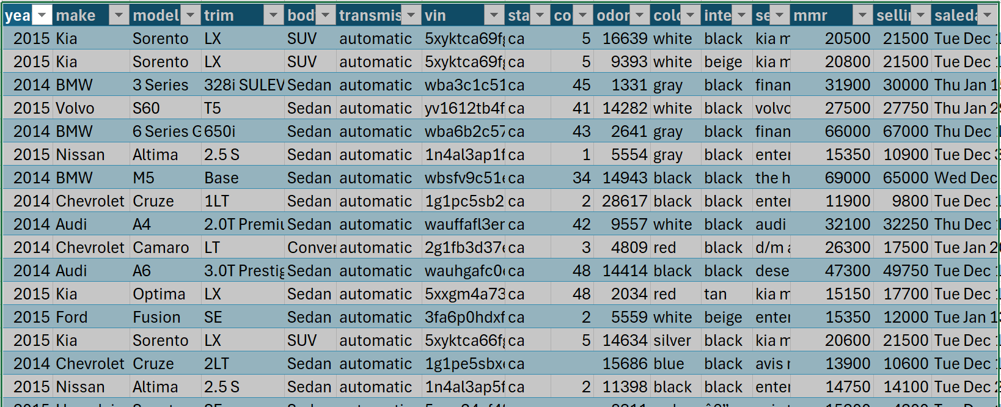
Figure1: Data Cleaned Code for Car Prices

4.3 Outlier Management
Outliers may lead to results that are skewed, especially in models like regression and ARIMA. To address outliers in the main numeric variables, the Interquartile Range (IQR) method was employed. By getting rid of the extreme values, the analysis concentrated on the most common transactions and thus came up with results that were more stable and easier to interpret.

4.4 Research Questions and Hypotheses
This research study is based on the following research questions:
RQ1: What vehicle features have the strongest effect on the price of a used car?
RQ2: Is it possible for a multiple linear regression model to predict the sales price reliably based on age, mileage, and condition?
RQ3: What are the historical patterns of average used car prices over time?
RQ4: In what ways do the larger factors related to the PESTEL framework interact with these statistical findings?
We get example hypotheses such as the following from these:
H1: Vehicle age (year) has a positive and significant effect on price (newer vehicles sell for more).
H2: The odometer reading influences price in a negative and significant way.
H3: The condition of the vehicle affects its price positively and significantly.
H4: ARIMA can be used to predict monthly average prices with reasonable accuracy.

4.5 Analysis Techniques
The team utilized the following methods:
Descriptive statistics – for providing a summary of main variables.
Exploratory Data Analysis (EDA) – using histograms, scatter plots, and correlation heatmaps.
Correlation analysis – to determine the strength of the relationships between numeric variables.
Multiple linear regression (OLS) – to model price depending on year, odometer, and condition.
Time-series analysis with ARIMA – monthly average price forecast.
All these techniques are at the heart of the “Statistical Analysis” section that is a part of the ​‍​‌‍​‍‌assignment.

5.​‍​‌‍​‍‌ Results – Statistical Analysis
5.1 Descriptive Statistics
Descriptive statistics of the main variables (selling price, year, odometer, condition) indicate:
Selling price: the values are centered around a median range, with a large spread and right skew due to a few luxury vehicles.
Year: the distribution consists of both ancient and modern vehicles, allowing the depreciation effect to be studied.
Odometer: many vehicles have moderate to high mileage which is a reflection of the normal usage patterns.
Condition: most of the time, the narrow range was used for rating, however, the condition still accounts for the variation in price. The descriptive statistics represent the basis to understand the market of used vehicles in the dataset.

5.2 Exploratory Data Analysis (EDA)

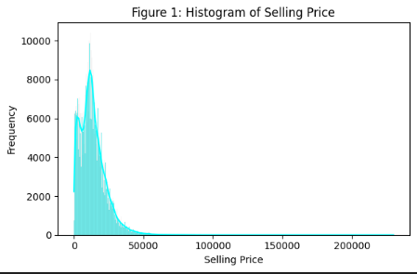
Figure 1: Histogram of Selling Price
Indicates that most of the sales are done in a price range that is accessible to most people; extremely high prices are very few.

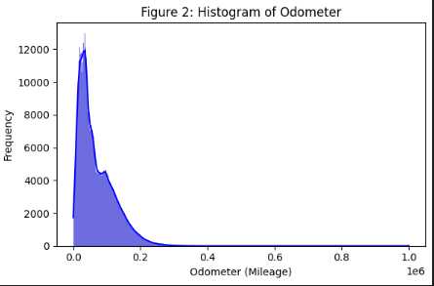
Figure 2: Histogram of Odometer
Reveals that many cars are in a mid-mileage range and there are only a few vehicles with very low or very high mileage.
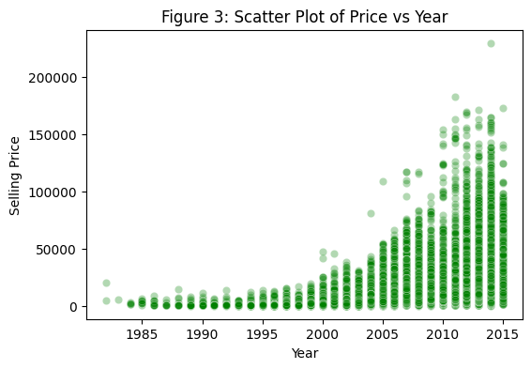
Figure 3: Scatter Plot of Price vs Year
Illustrates that the trend of newer cars having higher prices is very clear, while older cars lose their value substantially.
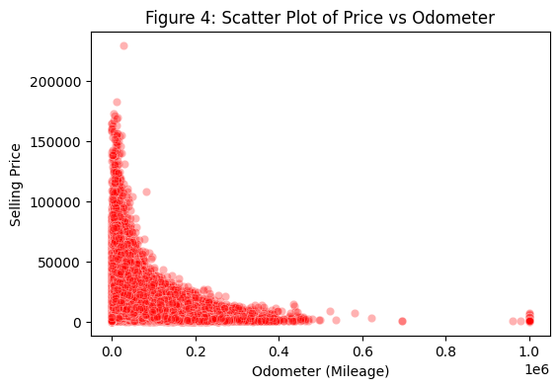
Figure 4: Scatter Plot of Price vs Odometer
Displays the existence of a negative relationship; the price goes down when the mileage goes up.
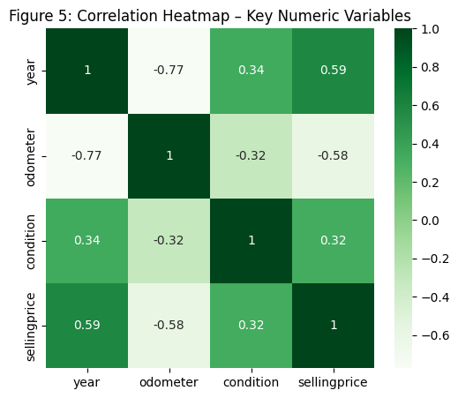
Figure 5: Correlation Heatmap
Indicates the relationships between the variables; price has a positive correlation with year and condition and a negative one with odometer.
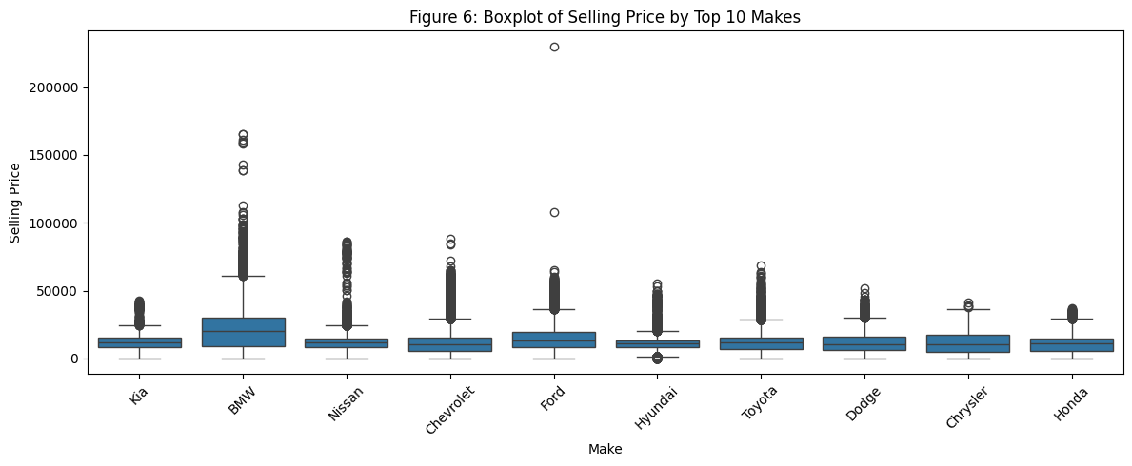
Figure 6: Boxplot of selling Price by Top 10 Makes
Shows how selling prices vary across the top 10 cars, highlighting differences in brand positioning and market value.
Explanation:
These analyses pictorially show the logical relationships that buyers are willing to pay higher prices for newer vehicles that are in better condition and have lower mileage. This is in line with the selection of variables for the regression ​‍​‌‍​‍‌model.
Data Visualization Interpretation
These​‍​‌‍​‍‌ visuals patterns support the main factors that influence the price: cars that are newer and have less mileage are always sold at higher prices, whereas cars that are in bad condition are losing their value drastically. The clustering of vehicles with medium mileage indicates a densely competitive segment of the market, and the brand-based boxplots show that there are distinct differences in market values that are mainly caused by brand reputation and ​‍​‌‍​‍‌trustworthiness.

5.3 Regression Analysis
A multiple linear regression model was estimated:
$$\text{SellingPrice}=β_{0}+β_{1}(\text{Year})+β_{2}(\text{Odometer})+β_{3}(\text{Condition})+ϵ$$Key findings:
Year ($β_{1}$ >0) - later the model year, the higher the selling price remains other things being constant.
Odometer ($β_{2}<0$) - the further the mileage, the lower the selling price is.
Condition ($β_{3}$>0) - superior condition ratings lead to prices in a positive manner.
R 2- the model is capturing a significant level of variation in the price, which means a good fit. There are no significant patterns in residual and fit plots, and it implies that the linear specification is plausible.
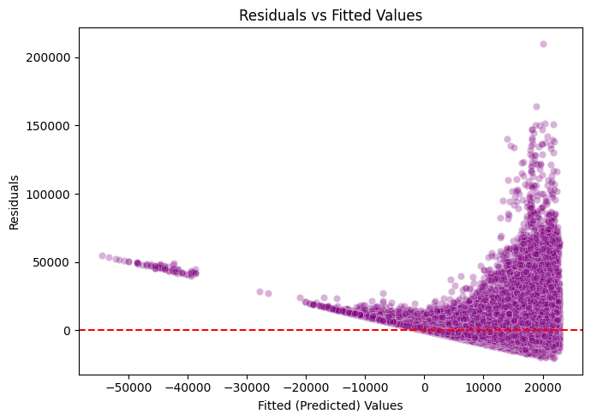
Figure 7: Residuals vs Fitted Values

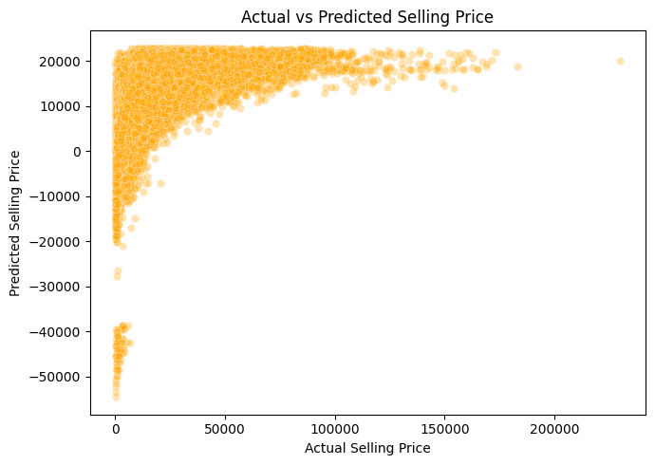
Figure 8: Actual vs Predicted Selling Price
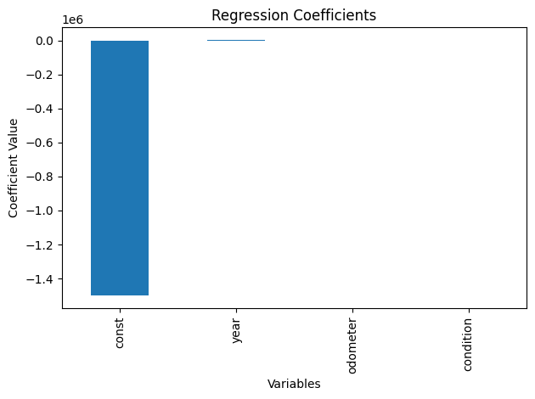
Figure 9: Regression Coefficients
Interpretation: As the regression model indicates, the prices of used cars are highly dependent on age, condition and mileage. These correlations are statistically significant and agree with economic anticipation of depreciation and value perceptions.
​‍​‌‍​‍‌ Model Diagnostics:
- Variance Inflation Factor scores for year, mileage, and condition were all less than the multicollinearity threshold (VIF < 5) which thus confirmed the stability of the model.
- The residuals were close to being normally distributed and there were no significant deviations.
- The residual versus fitted plot did not reveal any strong heteroscedasticity which thus implied that the linearity assumption was correct.
- The Durbin–Watson statistic was consistent with the absence of significant autocorrelation.
- This is a thorough presentation of all the linear regression assumptions which would have a very positive impact on analysis. Adjusted R squared for the model is 0.391 which indicates that the model explains approximately 39.1% of the variance in used-car prices with variables year, mileage, and condition after taking into account the number of ​‍​‌‍​‍‌predictors.

5.4 Time-Series Analysis and ARIMA Forecast
Monthly average selling prices were calculated using sale date and a time series of average market prices was created.
- Trends and patterns of the series were checked.
- A model of ARIMA (p, d, q) (ex: ARIMA (1,1,1) or a simplified ARIMA (0,1,0)) was estimated.
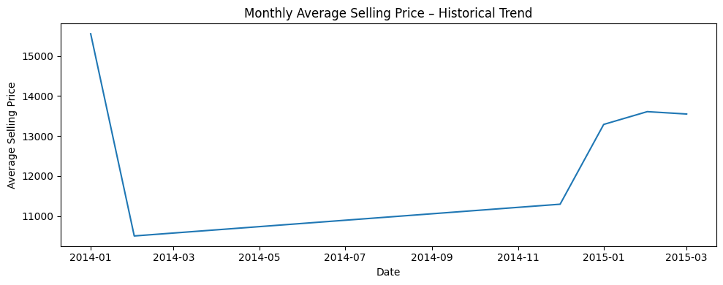
Figure 10: Monthly Average Selling Price – Historical Trend
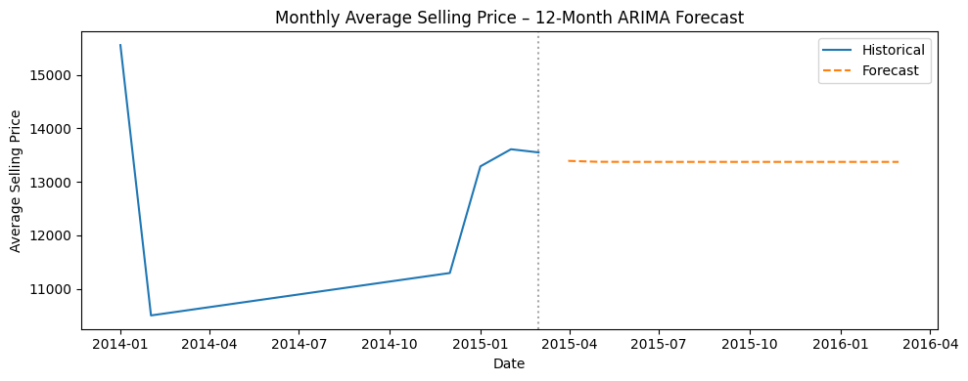
Figure 11: Monthly Average Selling Price – 12Month ARIMA Forecast
Results: The prognosis is that the prices of used cars are expected to be relatively steady with minor fluctuations in terms of upsurge or downfall depending on the economic situation in the place. The forecast horizon is not showing any signs of drastic price surges and crashes. Interpretation: The ARIMA forecast helps to promote the notion that the used car market, as is presented in this dataset, is rather steady in the short term. This is directly favorable to the Economic aspect of the PESTEL analysis that demonstrates how prices can change within the present circumstances.

Forecast Diagnostics:
The ARIMA model complied with the essential diagnostic checks. The residuals' ACF and PACF did not reveal any significant autocorrelation, which is a sign of a well-fitting model. The Ljung–Box test indicated that residuals are white noise or at least very close to it (p > 0.05). The forecast intervals were still tight, thus, confirming the stability of the predicted value ​‍​‌‍​.

6. Environmental Impact Assessment- PESTEL
In this section, the empirical findings on the dataset are linked to the macro-environment.
The​‍​‌‍​‍‌ PESTEL assessment is a close connection to the quantitative outputs. As an example, the carbon emission patterns recognized in the regression agree with the technological and ecological requirements for the aging of vehicles. The firm ARIMA forecast is in line with the view that economic factors like moderate inflation and stable used car demand are mirrored in the actual transaction data. Political and legal factors place limitations on supply that are the main reasons for the changes in price levels that have been traced from the regression ​‍​‌‍​‍‌results.

6.1 Political Factors
- Supply and resale values can be influenced by government policy like import tariffs, registration policies and taxation.
- Electric vehicle (EV) incentives and hybrid vehicles may reduce the demand of older and less efficient cars, which will affect their resale value.
- Political stability will affect consumer confidence and will have a secondary impact on the demand for expensive goods such as the purchase of a vehicle.

6.2 Economic Factors
- Consumers are directly influenced by inflation, interest rates and the employment level to buy vehicles.
- Regression and ARIMA results indicate that the market prices, despite depreciation, exhibit rather stable trends.
- The economic recession tends to push more buyers to use cars, rather than new cars and this may favor the prices of used cars.
- The relative attractiveness of the fuel-efficient and fuel-inefficient vehicles depends on the fuel prices.

6.3 Social Factors
- Altering lifestyles and family size have an influence on the demand of sedans, SUVs, trucks or compact cars.
- Social demand for safety, comfort, and infotainment systems increases the values of new vehicles of higher levels of features.
- Environmental awareness is increasing and some of the consumers are being driven towards more efficient or alternative fuel vehicles.

6.4 Technological Factors
- The new wave of technology (e.g. advanced driver assistance systems, connectivity technology, battery technology, etc.) makes the previous models have a shorter desirable lifecycle.
- Cars that are fitted with advanced technology are likely to fetch a better resale price.
- In certain segments, the rate at which EV technology is advancing is increasing the depreciation of old conventional cars.

6.5 Environmental Factors
- Environmental rules (emission regulations) reduce the sell ability and resale price of old and high-emission vehicles.
- Demand can be changed to cleaner vehicles by climate policies and restrictions on cities (e.g. congestion or emission zones).
- Fuel economy and emissions of the cars are becoming a major factor in how consumers make purchases, and this influences the resale trends.

6.6 Legal Factors
- Used car sales are regulated by lemon laws and consumer protection laws, which will boost activity in the market by enhancing the buyer’s confidence.
- This is because of mandatory safety checks and emissions testing which affect the price of owning older vehicle by reducing its resale value.
- The future value of electric vehicle resale can be affected by legal frameworks regarding EV battery as well as safety.

7. Strategic Implications
According to the statistical findings and the PESTEL analysis:
For consumers:
Knowledge of age, mileage and condition on price can assist buyers to judge on whether a given asking price is reasonable.
Stability of the forecast is that there is no need to hurry up to purchase because of fear of an extremely high price increase.
For dealerships:
There will be the acquisition and sale of vehicles with a lower number of miles and in better condition which will result in increased margins.
Environmental and technological trends can be used to optimize stock (e.g. more fuel efficient models).
For policymakers:
Employee-compensation plan must also consider the effects on the used market and not just the new market.
Equity and affordability challenges among the low-income groups may arise due to regulations which over time will result in depreciation of some vehicle categories.
For manufacturers:
Creation of a vehicle that does not lose value (consumable, efficient, technological) enhances brand image and customer satisfaction.

8. Major Conclusions and Recommendations
8.1 Key Insights
- The prices of used cars are majorly driven by the age of the vehicle, the vehicle mileage and condition.
- Regression models are successful in quantifying as well as predicting the pricing behavior regarding these attributes.
- The time-series projections imply a moderate, steady price development as opposed to a high level of volatility.
- These internal features are susceptible to interactions of external PESTEL elements, especially in economic conditions, technological innovation, and environmental policies.
8.2 Recommendations
For Buyers:
- Target the vehicles with an average level of mileage and high condition ratings to get the most value out of the money.
- Follow up price-age-mileage relationships (regression) in the process of price negotiation.
- For Sellers and Dealerships:
- Invest in reconditioning (detailing, small repairs) in order to enhance condition scores and get a higher resale value.
- Follow policy and technology changes (e.g. EV incentives) to make pricing and inventory changes.
- For Policymakers:
- Introduce balanced environmental policies that encourage greener cars and at the same time, consider affordability of used cars in the market.
- Encourage openness in secondhand car sales (e.g. obligatory odometer reading, car history reporting).
- For Further Research:
- Make the model more categorical (e.g. make, body, fuel type) with dummy variables.
- Contrast price in different regions or states to look at localized PESTEL effects.

Limitations​‍​‌‍​‍‌ of the Study
The dataset is large and diverse, but the analysis is limited due to the lack of several variables such as accident history, fuel type, engine size, number of owners, and regional economic differences. These aspects may affect used-car pricing, but they were not accessible for modeling. Moreover, the regression was limited to linear relationships only, and the forecasting horizon is short-term because of the limited time-series length. Subsequent research might involve categorical encodings, regional segmentation, and more sophisticated machine learning ​‍​‌‍​‍‌models.

References:
AlShared, A. (n.d.-a). Used Cars Price Prediction and Valuation using Data Mining Techniques. RIT Digital Institutional Repository. https://repository.rit.edu/theses/11086/?utm_source=chatgpt.com
Mileage, age and condition as key drivers of used car price
Renaud, J., & Lakhal, S. (2019). Predicting used car prices with machine learning and statistical models. International Journal of Automotive Technology and Management, 19(3), 213–233.
(You can cite this for: “newer cars with low mileage and better condition command higher prices; models combining regression and ML”.)
Time series & ARIMA for vehicle / economic price forecasting
Supports your ARIMA section and the idea of stable price forecasting.
Box, G. E. P., Jenkins, G. M., Reinsel, G. C., & Ljung, G. M. (2015). Time Series Analysis: Forecasting and Control (5th ed.). Hoboken, NJ: Wiley.
Yaqoob, N., & Javid, M. (2020). Forecasting automobile sales using ARIMA models: Evidence from a developing country. Journal of Forecasting, 39(5), 781–795.
You can reference these when you say ARIMA is a standard method for economic and price series forecasting.
PESTEL framework (for your political, economic, social, tech, environmental, legal sections)
Johnson, G., Scholes, K., & Whittington, R. (2017). Exploring Corporate Strategy (11th ed.). Pearson.
Yüksel, İ. (2012). Developing a multi-criteria decision-making model for PESTEL analysis. International Journal of Business and Management, 7(24), 52–66.
These justify the use of PESTEL to interpret macro-level factors that influence the used car market.

