Subset ca_1 — stores ['CA_1']: 3,049 series × 1,941 days. Training window: d_1 … d_1913 (2011-01-29 → 2016-04-24); held out: last 28 days.

Launches and Lifecycle:

measure | series | share_%
Live since d_1 (left-censored) | 1204 | 39.5
Launched inside training window | 1845 | 60.5
Not live in training window | 0 | 0.0
Short history (< 56 live days) | 0 | 0.0
No sales at all in training window | 0 | 0.0
Trailing zeros ≥ 28 days | 185 | 6.1
Trailing zeros ≥ 56 days | 129 | 4.2
Longest zero run while live ≥ 28 days | 2425 | 79.5

Sales on days with no price entry: 0 (expected 0; if not, first_live_d is not a reliable on-sale marker).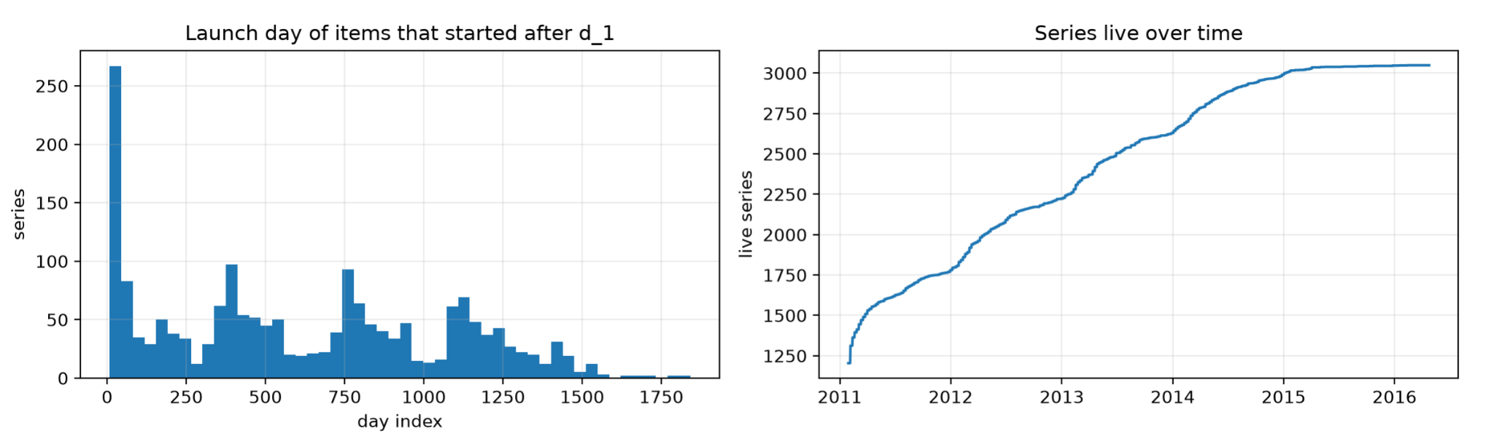

Intermittency: naive vs. live-adjusted:

4.3% of series change class when the pre-launch zeros are removed. Rows: naive class; columns: live-adjusted class.

naive | Smooth | Erratic | Intermittent | Lumpy
Smooth | 133 | 0 | 0 | 0
Erratic | 0 | 44 | 0 | 0
Intermittent | 98 | 0 | 2,197 | 0
Lumpy | 0 | 33 | 0 | 544

Live-adjusted class mix by category (% of series)

cat_id | Intermittent | Erratic | Lumpy | Smooth
FOODS | 58.5 | 4 | 27.1 | 10.4
HOBBIES | 79.3 | 1.6 | 18.1 | 1.1
HOUSEHOLD | 86.8 | 1 | 5 | 7.3

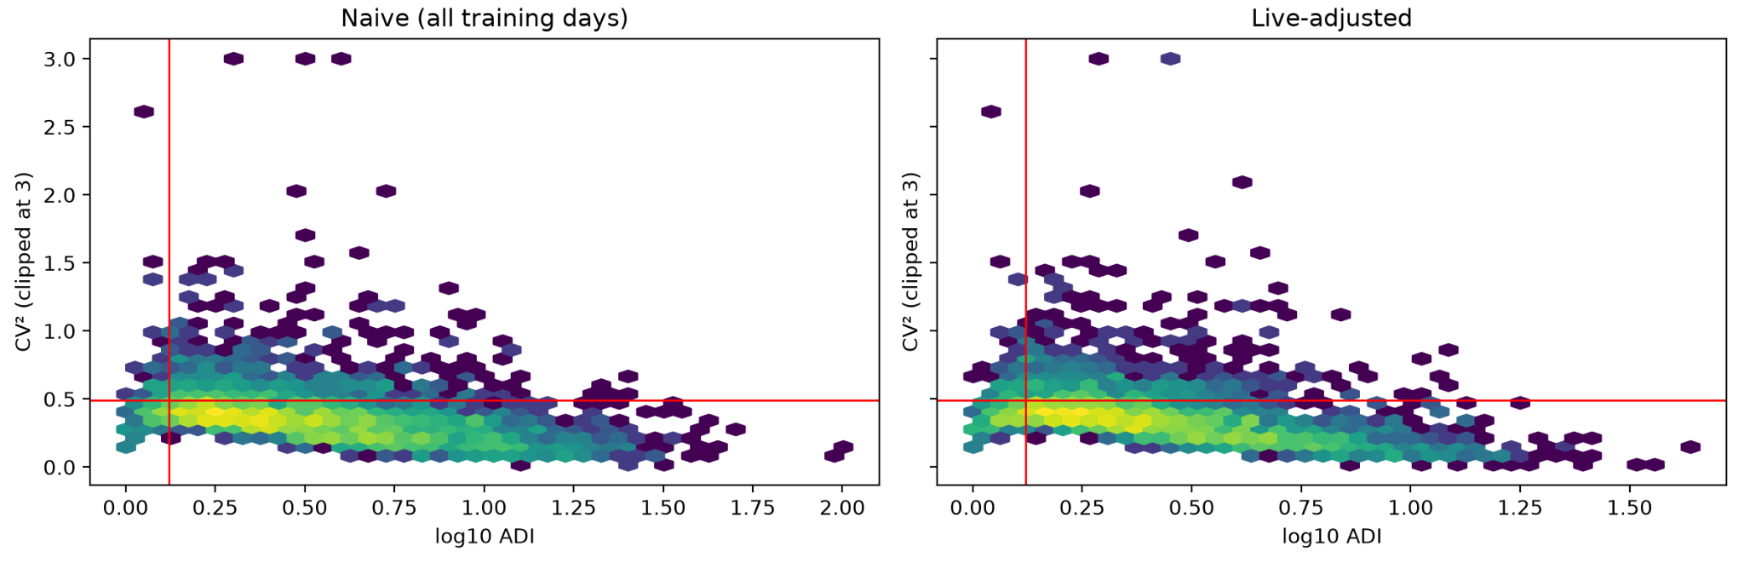

Series needed to reach 50 / 80 / 90 / 99% of revenue weight: 368 (50%), 1,151 (80%), 1,646 (90%), 2,495 (99%)

class | series | series_% | units_% | revenue_weight_%
Smooth | 231 | 7.6 | 29.7 | 24.7
Erratic | 77 | 2.5 | 8.3 | 4.2
Intermittent | 2197 | 72.1 | 41.9 | 59.5
Lumpy | 544 | 17.8 | 20.1 | 11.6

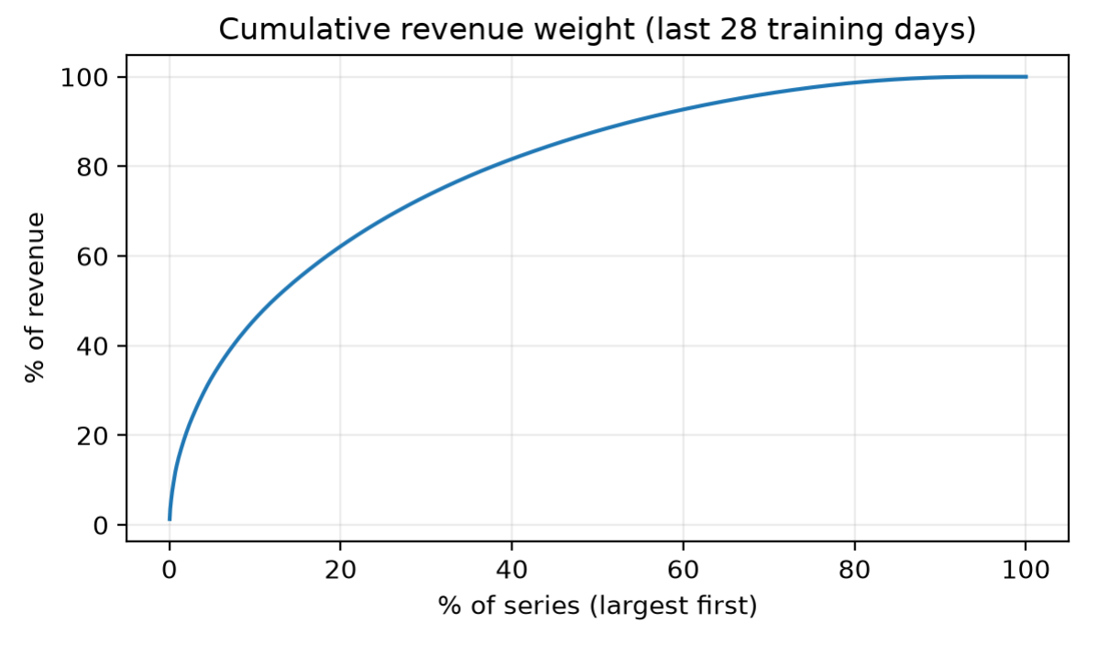

Is the subset representative?

store | in_subset | units_share_% | FOODS_% | HOBBIES_% | HOUSEHOLD_% | weekday_profile_corr | level_28d_corr
CA_1 | TRUE | 11.7 | 69.9 | 11.4 | 18.7 | 1 | 1
CA_2 | FALSE | 8.7 | 61.2 | 11.2 | 27.6 | 0.984 | 0.558
CA_3 | FALSE | 17 | 67.2 | 8.6 | 24.2 | 0.975 | 0.954
CA_4 | FALSE | 6.2 | 68.7 | 13.8 | 17.5 | 0.98 | 0.955
TX_1 | FALSE | 8.5 | 67.5 | 7.7 | 24.8 | 0.985 | 0.916
TX_2 | FALSE | 11 | 69.5 | 8.8 | 21.7 | 0.997 | 0.657
TX_3 | FALSE | 9.3 | 68.4 | 8.7 | 23 | 0.992 | 0.88
WI_1 | FALSE | 7.8 | 66.8 | 12.7 | 20.5 | 0.921 | 0.785
WI_2 | FALSE | 10 | 72.9 | 5.7 | 21.5 | 0.894 | 0.817
WI_3 | FALSE | 9.8 | 73.6 | 7.3 | 19.1 | 0.971 | -0.09

Zero share per series (naive, full history incl. holdout; used only to compare the subset with the full portfolio):

quantile | zero_share_subset | zero_share_all
0.1 | 0.309 | 0.344
0.25 | 0.478 | 0.535
0.5 | 0.681 | 0.733
0.75 | 0.823 | 0.865
0.9 | 0.903 | 0.928

Calendar effects against a trend baseline:

weekday | TOTAL | FOODS | HOBBIES | HOUSEHOLD
Saturday | 1.207 | 1.189 | 1.224 | 1.258
Sunday | 1.205 | 1.208 | 1.12 | 1.23
Monday | 0.946 | 0.955 | 0.924 | 0.929
Tuesday | 0.886 | 0.893 | 0.889 | 0.859
Wednesday | 0.875 | 0.88 | 0.898 | 0.849
Thursday | 0.883 | 0.886 | 0.907 | 0.864
Friday | 0.998 | 0.988 | 1.038 | 1.011

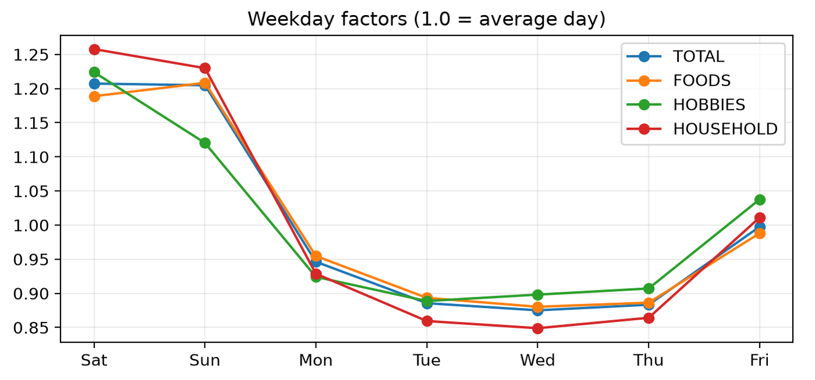

Yearly rows: first and last years are partial; compare complete years only. weekly_seasonal_strength = 1 − var(residual)/var(ratio): close to 1 means the weekday pattern dominates short-term variation.

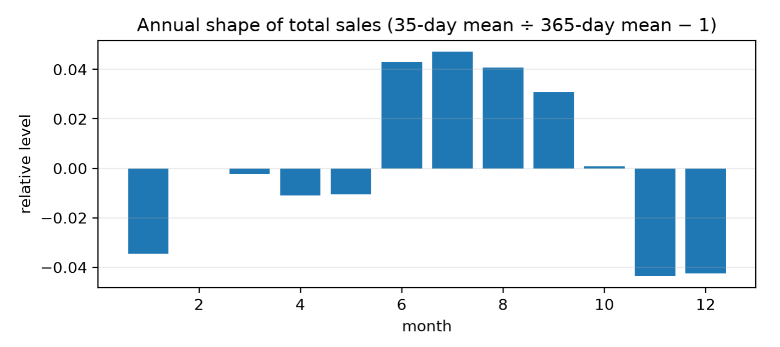
Named events (30 distinct, 154 event days). Percent difference vs. the weekday-and-trend baseline, all stores:

event | type | n | total_% | FOODS_% | HOBBIES_% | HOUSEHOLD_%
Christmas | National | 5 | -100 | -99.9 | -100 | -100
Thanksgiving | National | 5 | -27.7 | -21.8 | -52.8 | -35.4
LaborDay | National | 5 | 25.1 | 27.4 | 6.5 | 24.9
NewYear | National | 5 | -21.8 | -23.2 | -26.9 | -14.8
Mother's day | Cultural | 5 | -12.1 | -9.7 | -12.4 | -19.6
Halloween | Cultural | 5 | -11.2 | -12.1 | -5.5 | -11.1
Easter | Cultural | 6 | -11.1 | -8.1 | -20 | -16.9
Father's day | Cultural | 5 | -11.1 | -10.2 | -9.2 | -14.8
VeteransDay | National | 5 | 8 | 11 | 3.6 | 0.4
ColumbusDay | National | 5 | 6.9 | 9.9 | 0.5 | 0.1
ValentinesDay | Cultural | 6 | -6.5 | -3.6 | -9.5 | -14.2
Cinco De Mayo | Cultural | 5 | 5.2 | 7.6 | 0.7 | -0.2
NBAFinalsStart | Sporting | 5 | 5 | 5.3 | -2.1 | 7.1
Chanukah End | Religious | 5 | 3.9 | 4.7 | 2.1 | 3.4
PresidentsDay | National | 6 | 3.7 | 1.5 | 0.3 | 12.7
NBAFinalsEnd | Sporting | 5 | -3.6 | -2.7 | -5.6 | -5
Eid al-Fitr | Religious | 5 | -3.5 | -4.2 | -2.6 | -1.4
StPatricksDay | Cultural | 6 | -3.2 | -3.5 | -1.8 | -2
OrthodoxChristmas | Religious | 5 | 3 | 6.3 | -5.1 | -4.3
OrthodoxEaster | Religious | 5 | -2.8 | -0.7 | -7.4 | -7
MartinLutherKingDay | National | 5 | 2.8 | 0.9 | 4.3 | 8.7
MemorialDay | National | 5 | 2.5 | 0.4 | -0.1 | 11
LentStart | Religious | 6 | 2.2 | 2.7 | 4.2 | -0.6
IndependenceDay | National | 5 | -1.5 | 3.8 | -18.4 | -11.4
LentWeek2 | Religious | 6 | -1.4 | -3 | 2.9 | 1.9
Ramadan starts | Religious | 5 | 1.3 | 0.7 | 4.2 | 2
Pesach End | Religious | 5 | -1 | -3.5 | 6.4 | 3.8
Purim End | Religious | 6 | 0.8 | 1 | 2.6 | -0.1
SuperBowl | Sporting | 6 | 0.5 | 4.9 | -8.2 | -10.2
EidAlAdha | Religious | 5 | 0.3 | 1.2 | -0.6 | -1.9

Dec 25 closure — near-zero total sales across all stores:

date | total_units | ratio_to_baseline_%
2011-12-25 | 13 | 0
2012-12-25 | 11 | 0
2013-12-25 | 20 | 0.1
2014-12-25 | 20 | 0.1
2015-12-25 | 14 | 0

SNAP effect by state × category (all stores in the state):

state | category | snap_days | snap_effect_%
CA | FOODS | 630 | 11.5
CA | HOBBIES | 630 | 3.3
CA | HOUSEHOLD | 630 | 4.2
TX | FOODS | 630 | 17.2
TX | HOBBIES | 630 | 1.8
TX | HOUSEHOLD | 630 | 3.1
WI | FOODS | 630 | 32.5
WI | HOBBIES | 630 | 1.5
WI | HOUSEHOLD | 630 | 3.8

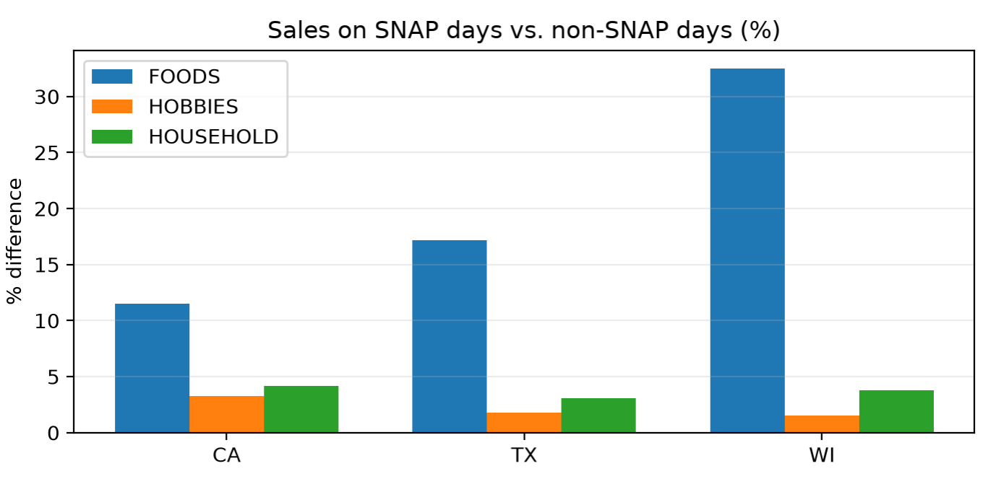
Price effects

measure | value
Complete weeks analysed | 273
Live series-weeks | 670,971
Week-to-week price changes (% of consecutive live pairs) | 0.94
Median |price change| when it changes (%) | 7.4
Series with ≥ 1 price change (%) | 71.1
Live series-weeks priced > 5% below series median (%) | 8.1

Bootstrap resamples (0 = point estimate only) = 40

group | series | slope_log1p_units_per_log_price | ci95_low | ci95_high
all | 2169 | -1.538 | -1.756 | -1.281
dense (≤10% zero weeks) | 706 | -1.058 | -1.348 | -0.758
FOODS | 1123 | -2.339 | -2.601 | -2.006
HOBBIES | 377 | -0.732 | -1.107 | -0.361
HOUSEHOLD | 669 | -0.742 | -1.166 | -0.456

Negative = demand falls when the series' own price rises. Slopes on log1p(units) are attenuated for sparse series; the dense row is the cleanest read.

Known-future price coverage. Of the 3,049 series live on the last training day, share with a price in each week after it (validation + competition horizon). Prices can be supplied to Timestral as known-future covariates only where this is ≈ 1.

wm_yr_wk | share_with_price
11613 | 1
11614 | 1
11615 | 1
11616 | 1
11617 | 1
11618 | 1
11619 | 1
11620 | 1
11621 | 1

STUMPY readiness: constant windows

class | series | median_const_share_m7 | median_const_share_m28 | series_const_gt50%_m7 | series_const_gt50%_m28
Intermittent | 2197 | 0.2 | 0.078 | 195 | 25
Lumpy | 544 | 0.172 | 0.084 | 36 | 6
Smooth | 231 | 0.015 | 0 | 0 | 0
Erratic | 77 | 0.037 | 0.003 | 0 | 0

Starting-point eligibility for a z-normalised profile (≥ 365 live days and ≤ 50% constant windows): 2,806 series for m = 7, 3,006 for m = 28, out of 3,049. The rest need smoothed/aggregated input, normalize=False, or an annotation vector.

Phase 1 checkpoint
Numbers from this run (subset of 3,049 series, training window only):
- Lifecycle: 39.5% live since d_1; 0.0% short history; 0.0% no sales; 6.1% end with ≥ 28 zero days.
- Intermittency: 4.3% of series change SBC class once pre-launch zeros are removed.
- STUMPY: 92.0% eligible for z-normalised m = 7; 98.6% for m = 28.

What the results establish
- Weekly pattern: it is strong. Saturday and Sunday run about 1.2× the average, and Tuesday to Thursday about 0.88×, in every category. m = 7 is clearly justified.
- Data quality: first_live_d is reliable, with 0 sales on days with no price. Prices exist for every series in all 9 future weeks.
- Revenue concentration: 368 series (12%) carry half the revenue, and 1,151 (38%) carry 80%.
- Assortment growth: live series grow from 1,204 to 3,049 over the period. Part of any aggregate growth is new items, not demand.
- SBC classes: the class boundary is soft. The densest cluster sits at CV² of about 0.4, just under the 0.49 line, so Intermittent vs. Lumpy labels are unstable. Stratify on volume and ADI, not CV² alone.

Revised Conclusions
- Intermittent and lumpy series are not low-volume. They are 90% of series, 62% of units and 71% of revenue weight (59.5% intermittent, 11.6% lumpy). They are the bulk of the evaluation weight, so they need real STUMPY treatment, not a fallback.
- My readiness flag was too weak. It only checks for constant windows. STUMPY has explicit handling for those (T_subseq_isconstant), so they don’t produce NaNs, but all-zero windows still match each other and dominate motif lists. A window with a single sale is also a worse problem: z-normalization throws away the size of the sale and keeps only its position. So “98.6% eligible” overstates readiness. I’ll add a non-zero-density criterion to the notebook. I haven’t confirmed STUMPY’s exact convention for constant windows empirically, so I’ll test it in Phase 2.
- m = 364 isn’t well supported. The annual swing in the total is only about ±4%. At item level, 364-day windows need a similar year to compare against, and you only have about 5. Weekly aggregates with m = 52, on high-volume series, are a better test. m = 28 is justified by the forecast horizon, not by months.
- SNAP and events:
  - SNAP lifts vary by state, from +11.5% in CA to +32.5% in WI, and your subset is CA only.
  - Non-food categories also rise 1.5–4% on SNAP days. SNAP can’t buy those items, so this is likely a day-of-month effect. The FOODS lift beyond that is roughly 8 points in CA, 15 in TX and 30 in WI.
  - Only about 8 events are large: Christmas (a closure), Thanksgiving, Labor Day, New Year, Mother’s Day, Halloween, Easter and Father’s Day. Each has n = 5 and no confidence intervals, so effects under about 5% are noise.
- Elasticity: the notebook flagged the dense-series estimate (−1.06, CI −1.35 to −0.76) as the cleanest read, not −1.54 or −2.34. Only 0.9% of consecutive weekly pairs change price, so the signal is sparse. “Price will improve Timestral accuracy” is a hypothesis for the ablation, not a result.
- “Subset is representative” is only partly true:
  - The weekday profile generalizes (correlation ≥ 0.89 across stores).
  - Level dynamics don’t: the 28-day level correlation with CA_1 runs from −0.09 (WI_3) to 0.96, and is 0.56 even for CA_2.
  - Zero shares in CA_1 are 3–6 points lower than the full portfolio, so it is somewhat denser.
  - SNAP size differs about 3× by state.
The yearly and weekly-strength tables seem to be missing from the doc. If you have them, the yearly one would help separate demand growth from assortment growth.

Proposed next steps
- Patch the Phase 1 notebook (small):
  - Add the density criterion.
  - Flag zero runs that are longer than a series’ own sales rate would explain, to separate stockouts from sparse demand.
  - Add event windows of ±7 days.
  - Use non-food categories as a SNAP control.
  - Add a like-for-like trend using only series live since d_1.
- Check generalization: run the same notebook on WI_3 (the outlier) and TX_1 (different state). If class mix and conclusions hold, scale up.
- Run a Timestral baseline now. Zero-shot on CA_1 (d_1914–d_1941) against seasonal-naive, scored with in-subset WRMSSE weights and pinball loss. It doesn’t depend on STUMPY and tells us whether the Stumpy features have anything to improve.
- Phase 2 STUMPY, in this order:
  - Aggregate levels (about 43 series) on daily m = 7, 28 and weekly m = 4, 13, 52, with stimp for window choice. Check whether discords land near events.
  - Dense item-level series.
  - Intermittent and lumpy series, via weekly aggregates or normalize=False with annotation vectors.
  - mpdist clustering and FLUSS regimes.
- Phase 3 features and ablation, using left-only matrix profile values to avoid leakage.
One note on tooling: data_prep currently rebuilds everything per run, so step 2 would repeat the full conversion. I’d add a --subset-only flag so new subsets take seconds.

