Now that your team has access to the Brix/MPL documentation. Please review so we can start working on defining the workflow process for new projects. Also, let us know if you have any questions.

In the meantime, here's something you and your team can help investigate, which will hopefully give you some background on the MPL SimpleCodeQuestion's driver code and how it works.

An instructor gave us some feedback on a question using the SimpleCodeQuestion...

The solution requires a semi-colon after enum declaration. Many students leave this off, which is correct, and are stumped.

I looked at the question in MPL and the driver is written in C++; which requires a semi-colon, while Java doesn't.

Here's a screenshot of the question the instructor is referring to...

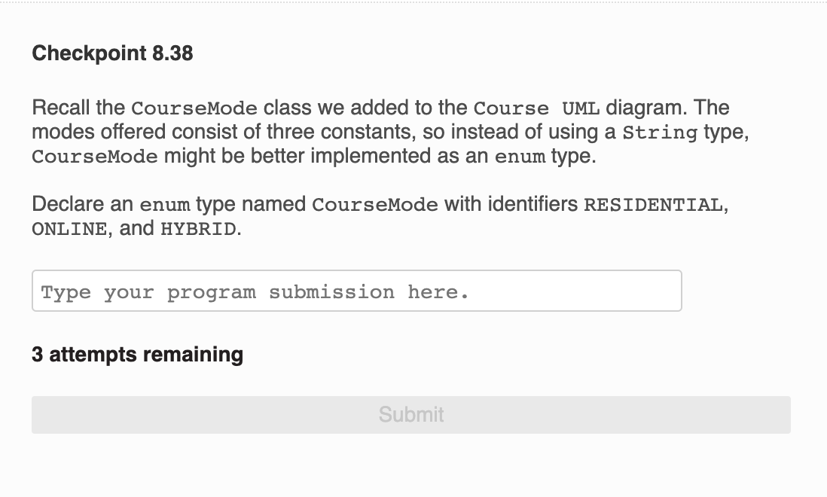

The correct answer is currently set to... enum CourseMode {RESIDENTIAL, ONLINE, HYBRID};

It should be... enum CourseMode {RESIDENTIAL, ONLINE, HYBRID}

I'm attaching in a ZIP file (Checkpoint 8.38.zip) the C++ code from the driver, which checks and validates the students input for the correct answer, as well as, a PDF of the driver code, just incase there are line break issues.

Can your team investigate if the current code, in C++, can be edited so the correct answer of "enum CourseMode {RESIDENTIAL, ONLINE, HYBRID}" with out the semi-colon will work?

If so, can your team correct the code in the file and annotate in the PDF what is wrong with the current code and sent it to me and I'll test in MPL.

Let me know if you have any questions.

Regards,

~Bob