

**Pearson Revel Project – Understanding Document**

**November 2019**

**Confidentiality Statement**

This document contains confidential and proprietary information of Integra Software Services Private Limited (“Integra”). Except for circulation to persons on a need- to-know basis for the purpose of assessing or evaluating the proposal submitted by Integra, the contents of this document cannot be copied, modified, reproduced or distributed in any media to any other third parties, without the explicit written permission of Integra.

**Copyright © Integra Software Services Private Limited 2019. All rights reserved.**

Table of Contents

Objective: 3

Understanding: 3

Assumptions: 3

Process flow: 4

Queries: 4

# Objective:

Revel is an interactive reading and learning environment that enables students to read, practice, and study in one continuous experience. In Revel Computer Science, MPL platform makes the learning process easy and efficient for the students by little quizzes for the better understanding of content. Our objective is to prepare answers for the questions provided by Pearson team for Gaddis C++ and Java books and further update it in Nemo platform.

# Understanding:

1. We will receive questions for C++ language and the programmer should provide answers/code snippets.
2. In Java language, we will get both questions and answers, where the answers for the given questions are not fully compiled. So, we must provide compiled answers.
3. We have to insert the questions and the answers/code snippets in Nemo environment.

# Assumptions:

1. Working with MPL (also known as Turing’s Craft code lab) is part of our scope. We assume that we will be predominantly working on Nemo environment.
2. The Revel Assessment MSS Examples documents, shared by Pearson team, are based on C++ 17. Please let us know that we have to use the same version or different versions of C++ for providing answers.
3. We have to create driver code for exercises for every possible student’s solutions.

# Process flow:

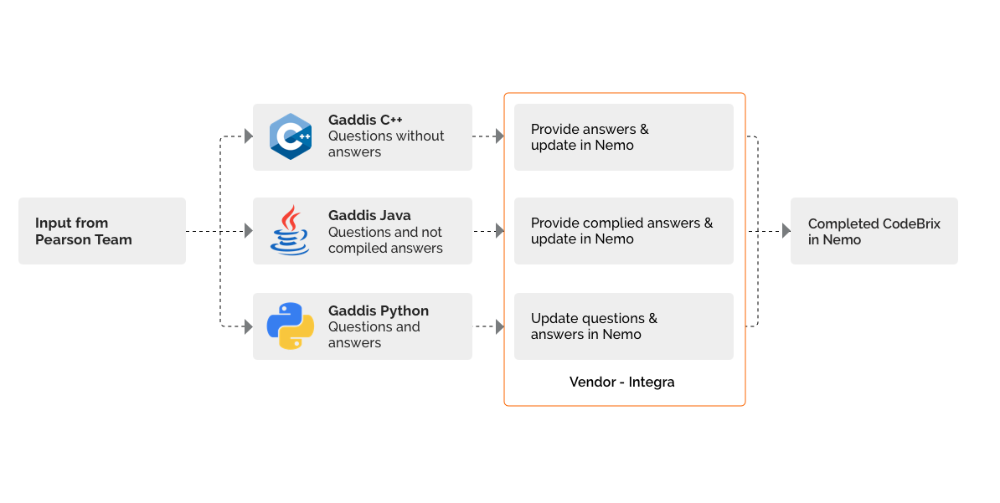

# Queries:

# Clarified:

1. In MPL user guide, what is meant by Model exercise in the term “Duplicate A Model Exercise”.
2. Let us know how to create hint part in MPL for a question.
3. In the term “MSS examples”, please clarify “MSS” for better understanding.
4. Please clarify regarding the comments noted by Author in the shared documents. What we have to do based on the comments? And please explain regarding the comment “Insert modern C++ icon” Will it be a part of our scope?
5. Please clarify regarding “Turing’s Craft code lab”.
6. In the Live example brix, what the term “column” is referring in Initial cursor position.
7. Let us know the C++ compiler behind MPL platform to compile the solution.
8. Please share the differences between Code question brix, Simple code question brix, and Live example brix.

# Need to be clarified:

1. How to view the Driver code and Test sets of other exercises which have not a lock icon in the Workbench box header?
2. While creating a new exercise, we have to provide type of the exercise. Please clarify regarding below three exercise types.
3. Standalone Function
4. Program Stdin-to-Stdout
5. Program Args-and-Files
6. For some questions, even the incorrect answers are recognized as correct answers in MPL. Please clarify about this ambiguity.

Example: exSSN: 462607-00008, exSSN: 462607-00010

1. Please share the sample terms to give as input in keyword section.
2. Are there any options in MPL platform to upload files for input and output? And please explain regarding “Options 🡪 File upload” part in MPL.
3. Which version of Java language we are supposed to use for providing answers.
4. We have searched for GUID of Code question brix, Simple code question brix, and Live example brix in Nemo. We assume that GUID is unique for each code brix. But for Live example brix, I am getting multiple results for one GUID. Please clarify the same.
5. Require further information on creating animation.
6. Please share the JavaScript files for creating an animation.
7. Please confirm, if we must provide variables, explanation, and output for line by line execution
8. Please confirm, if we need to check every animated program on Android TalkBack and iOS VoiceOver
9. Let us know, how to host an animated program in “media.pearsoncmg” domain.
10. As per Vidhu Nambiar’s mail, Vidhu Nambiar’s team have analysed and provided fixes for some MPL checkpoint issues. Please clarify whether we have to do this kind of analysis and share the fixes in future.
11. Please clarify regarding “TCI platform and changing the Driver code in TCI platform”.
12. Please clarify regarding “Assessment input of M/C”.
13. Please clarify regarding “Quad and Elm”.
14. Manuscript making is enriching the content supplied by the Author. Please clarify that we will be involving in “Manuscript making” process.
15. What are the expectations on project management in this project. For the programmer, who will be the point of contact to communicate.



**INDIA | JAPAN | UK | US | CANADA | GERMANY**

**Corporate Headquarters &**

**Principal Delivery Centre**

Integra Software Services Pvt. Ltd.

100 Feet Road (ECR), Pakkamudiyanpet

Pondicherry - 605 008, India