EX. NO : 1 Data Definition Commands, Data Manipulation Commands for Inserting, deleting, updating and retrieving Tables and Transaction Control statements

AIM
To create a database and to retrieve the information from the database using SQL queries.

DATA DEFINITION COMMANDS
Data Definition Language (DDL) is a standard for commands that define the different structures in a database

Create command
Create command is to create a new table in database.
SQL> create table stud (sname varchar2(30), sid varchar2(10), sage number(2), sarea varchar2(20));

Table created.

View command

SQL> desc stud;

Name Null? Type
----------------------------------------------------- -------- --------------------------------
SNAME VARCHAR2(30)
SID VARCHAR2(10)
SAGE NUMBER(2)
SAREA VARCHAR2(20)
Alter command

An existing database object can be modified using the alter command.
For adding a new column

SQL>alter table stud modify ( sage number(10));

Table altered.

For modifying a column

SQL> alter table stud add ( sdept varchar2(20));

Table altered.

SQL> desc stud;
Name Null? Type
----------------------------------------------------- -------- ---------------------------
SNAME VARCHAR2(30)
SID VARCHAR2(10)
SAGE NUMBER(10)
SAREA VARCHAR2(20)
SDEPT VARCHAR2(20)

For deleting a column

SQL> alter table stud drop (sdept varchar2(20));
Table altered.

Truncate Command

Truncate command, all the records in a database is deleted, but the database structure is maintained.

SQL> truncate table stud;
Table truncated.

Drop Command

Drop command, all the records, view, index in a database is deleted.

SQL> drop table stud;
Table dropped.

DATA MANIPULATION COMMANDS

1. INSERT - This command is used to insert values into the table.
SELECT - This command is used to display the contents of the table or particular column in a table

CREATION OF TABLE
SQL>create table stud (sname varchar2(30), sid varchar2(10), sage number(10), sarea varchar2(20), sdept varchar2(20));

Table created.

INSERTION OF VALUES INTO THE TABLE
SQL> insert into stud values ('ashwin',101,19,'anna nagar','aeronautical'); 1 row created.
SQL> insert into stud values ('bhavesh',102,18,'nungambakkam','marine'); 1 row created.
SQL> insert into stud values ('pruthvik',103,20,'anna nagar','aerospace'); 1 row created.
SQL> insert into stud values ('charith',104,20,'kilpauk','mechanical'); 1 row created.

SQL> select * from stud;
SNAME SID SAGE SAREA SDEPT
------------------------------ ---------- --------- -------------------- --------------------
ashwin | 101 | 19 anna nagar | aeronautical
bhavesh | 102 | 18 nungambakkam | marine
pruthvik | 103 | 20 anna nagar | aerospace
charith | 104 | 20 kilpauk | mechanical

2. RENAME - This command renames the name of the table.
ARITHMETIC OPERATIONS - Various operations such as addition, multiplication, subtraction and division can be performed using the numbers available in the table.
DISTINCT - This keyword is used along with select keyword to display unique values from the specified column. It avoids duplicates during display.
3. ORDER BY CLAUSE - The order by clause arranges the contents of the table in ascending order (by default) or in descending order (if specified explicitly) according to the specified column.
CONCATENATION OPERATOR - This combines information from two or more columns in a sentence according to the format specified.

RENAMING THE TABLE ‘STUD’
SQL> rename stud to studs; Table renamed.

ARITHMETIC OPERATION
SQL> select sname, sid+100 "stid" from studs;
SNAME stid
------------------------------ ---------
ashwin | 201
bhavesh | 202
pruthvik | 203
charith | 204

CONCATENATION OPERATOR
SQL> select sname || ' is a ' || sdept || ' engineer. ' AS "PROFESSION" from studs;
PROFESSION
-------------------------------------------------------------------
ashwin is a aeronautical engineer.
bhavesh is a marine engineer.
pruthvik is a aerospace engineer.
charith is a mechanical engineer

DISPLAY ONLY DISTINCT VALUES
SQL> select distinct sarea from studs;
SAREA
--------------------
anna nagar kilpauk nungambakkam

USING THE WHERE CLAUSE
SQL> select sname, sage from studs where sage<=19;
SNAME SAGE
------------------------------ ---------
ashwin 19
bhavesh 18

LOGICAL OPERATORS
AND : The oracle engine will process all rows in a table and displays the result only when all of the conditions specified using the AND operator are specified.
OR : The oracle engine will process all rows in a table and displays the result only when any of the conditions specified using the OR operators are satisfied.
NOT : The oracle engine will process all rows in a table and displays the result only when none of the conditions specified using the NOT operator are specified.
BETWEEN : In order to select data that is within a range of values, the between operator is used. (AND should be included)

LOGICAL AND OPERATOR
SQL> select sname ,sid from studs where sid>102 and sarea='anna nagar';
SNAME SID
------------------------------ ----------
pruthvik 103

LOGICAL OR OPERATOR
SQL> select sname ,sid from studs where sid>102 or sarea='anna nagar'; SNAME SID
------------------------------ ----------
Ashwin 101
pruthvik 103
charith 104

BETWEEN OPERATOR
SQL> select sname,sarea, sid from studs where sid between 102 and 104;
SNAME SAREA SID
------------------------------ -------------------- ----------
bhavesh | nungambakkam | 102
pruthvik | anna nagar | 103
charith | kilpauk | 104

PATTERN MATCH
LIKE PREDICATE : The use of like predicate is that it allows the comparison of one string value with another string value, which is not identical. This is achieved by using wildcard characters which are % and _. The purpose of % is that it matches any string and _ matches any single character.
IN AND NOT IN PREDICATE : The arithmetic operator = compares a single value to another single value. In case a value needs to be compared to a list of values then the in predicate is used. The not in predicate is the opposite of the in predicate. This will select all the rows whose values do not match all of the values in the list.
COMMAND

SQL> select sname, sarea from studs where sarea like
'%g%'; SAREA
SNAME
------------------------------ --------------------
ashwin anna nagar
bhavesh nungambakkam
pruthvik anna nagar

NOT IN PREDICATE
SQL> select sname, sid from studs where sid not in(102,104); SNAME SID
------------------------------ ----------
ashwin 101
pruthvik 103

IN PREDICATE
SQL> select sname,sarea , sid from studs where sid in(102,104); SNAME SAREA SID
------------------------------ -------------------- ----------
bhavesh nungambakkam 102
charith kilpauk 104

NUMERIC FUNCTIONS
THE ORACLE TABLE – DUAL - Dual is a small oracle table which consists of only one row and one column and contains the value X in that column.
ABS: It returns the absolute value of ‘n’.
POWER: It returns m raised to nth power. n must be an integer else an error is returned.
ROUND: It returns n rounded to m places right of the decimal point. If m is omitted, n is rounded to zero places. m must be an integer.
SQRT: It returns square root of n. n should be greater than zero.

NUMERIC FUNCTIONS
SQL> select abs(-20) result from dual;

RESULT
--------- 20
SQL> select power (2,10) result from dual;

RESULT
--------- 1024
SQL> select round(15.359,2) result from dual;

RESULT
--------- 15.36
SQL> select sqrt (36) result from dual;

RESULT
--------- 6

STRING FUNCTIONS
LOWER: It returns char with letters in lower case.
INITCAP: It returns char with the first letter in upper case. UPPER: It returns char with all letters forced to upper case.
SUBSTR: It returns a portion of char beginning at character m, exceeding up to n characters. If n is omitted result is written up to the end character. The 1stposition of char is one.
LENGTH: It returns the length of char
LTRIM: It removes characters from the left of char with initial characters removed up to the 1st character not in set.
RTRIM: It returns char with final characters removed after the last character not in the set. Set is optional. It defaults to spaces.
LPAD: It returns char1, left padded to length n with the sequence of characters in char2. char2 defaults to blanks.
RPAD: It returns char1, right padded to length n with the characters in char2, replicated as many times as necessary. If char2 is omitted, it is padded with blanks.

STRING FUNCTIONS
SQL> select lower('ORACLE') result from dual;

RESULT
------
oracle
SQL> select upper('oracle') result from dual;

RESULT
------ ORACLE
SQL> select initcap('Oracle') result from dual;

RESULT
------
Oracle
SQL> select substr('oracle' ,2 ,5) result from dual;
RESULT
-----
racle
SQL> select lpad('oracle',10,'#') result from dual;

RESULT
SQL> select to_char( 17145, '099,999') result from dual;

RESULT
------- 017,145
SQL> select to_char(sysdate,'dd-mon-yyyy') result from dual;

RESULT
-----------
16-jul-2008

AGGREGATE FUNCTIONS
AVG (N): It returns average value of n ignoring null values. MIN (EXPR): It returns minimum value of the expression.
COUNT (EXPR): It returns the number of rows where expression is not null.
COUNT (*): It returns the number of rows in the table including the duplicates and those with null values.
MAX (EXPR): It returns maximum value of the expression. SUM(N): It returns sum of values of n

AGGREGATE FUNCTIONS
SQL> select avg( spocket ) result from studs;

RESULT
--------- 400
SQL> select min(spocket) result from studs;

RESULT
2
SQL> select max(spocket) result from studs;

RESULT
-------------------- 750
SQL> select sum(spocket) result from studs;

RESULT
--------- 1600

DATE FUNCTIONS
SYSDATE : The sysdate is a pseudo column that contains the current date and time. It requires no arguments when selected from the table dual and returns the current date.
ADD_MONTHS(D,N): It returns date after adding the number of months specified with the function.
LAST_DAY(D): It returns the last date of the month specified with the function MONTHS_BETWEEN(D1,D2): It returns number of months between D1 and D2. NEXT_DAY(DATE, CHAR): It returns the date of the first week day named by char . char must be a day of the week.

DATE FUNCTIONS
SQL> select sysdate from dual;
SYSDATE
---------
- JUL-08

SQL> select sysdate,add_months(sysdate,4) result from dual;
SYSDATE RESULT
--------- --------- 16-JUL-08 16-NOV-08

SQL> select sysdate, last_day(sysdate) result from dual;
SYSDATE RESULT
--------- --------- 16-JUL-08 31-JUL-08
SQL> select sysdate, next_day(sysdate,'sunday') result from dual;

SYSDATE RESULT
--------- --------- 16-JUL-08 20-JUL-08
SQL> select months_between('09-aug-91','11-mar-90') result from dual;

RESULT
--------- 16.935484

GROUP BY CLAUSE
The group by clause is another section of the select statement. This optional class tells oracle to group rows based on distinct values that exists for specified columns.

GROUP BY CLAUSE
SQL> select sarea, sum(spocket) result from studs group by sarea; SAREA RESULT
-------------------- ------------
anna nagar 1000
nungambakkam 500
kilpauk 100

HAVING CLAUSE
The having clause can be used in conjunction with the group by clause. Having imposes a condition on the group by clause, which further filters the groups created by the group by clause.

HAVING CLAUSE
SQL> select sarea, sum(spocket) result from studs group by sarea having spocket<600;

NAME
--------------------
Nungambakkam
kilpauk

SNAME SID SAGE SAREA SDEPT SPOCKET
------------------------------ ---------- --------- -------------------- -------------------- -------------------
Bhavesh 102 18 nungambakkam marine 500
pruthvik | 103 | 20 | anna nagar | aerospace 250
charith | 104 | 20 | kilpauk | mechanical 100

SET OPERATIONS
UNION CLAUSE: Multiple queries can be put together and their output combined using the union clause. The union clause merges the output of two or more queries into a single set of rows and columns.
INTERSECT CLAUSE: Multiple queries can be put together and their output can be combined using the intersect clause. The intersect clause outputs only rows produced by both the queries intersected. The output in an intersect clause will include only those rows that are retrieved by both the queries.

TO CREATE SSTUD2 TABLE
SQL> create table sstud2 ( sname varchar2(20), dept varchar2(10), marks number(10)); Table created.

SQL> insert into sstud2 values ('prajan','cse',700); 1 row created.
SQL> insert into sstud2 values ('anand','it',650); 1 row created.
SQL> insert into sstud2 values ('vasu','cse',680); 1 row created.
SQL> insert into sstud2 values ('ravi','it',600);
1 row created.

SQL> select * from sstud2;
SNAME DEPT MARKS
-------------------- ---------- ---------
prajan cse 700
anand it 650
vasu cse 680
ravi it 600
SQL> select * from sstud1; SNAME PLACE
-------------------- --------------------
prajan chennai
anand chennai
kumar chennai
ravi Chennai

NESTED QUERIES
SQL> select sname from sstud1 where sstud1.sname in ( select sstud2.sname from sstud2 );
SNAME
--------------------
anand prajan ravi

SQL> select sname from sstud1 where sstud1.sname not in ( select sstud2.sname from sstud2 );

SNAME
--------------------
Kumar

SQL> select sname from sstud1 where exists ( select sstud2.sname from sstud2 where sstud1.sname=sstud2.sname );
SNAME
--------------------
prajan anand ravi

SQL> select dept from sstud1 union select place from sstud2 ;

SNAME PLACE
--------------------------------------------
cse chennai
it chennai
cse chennai
it Chennai

SQL> select sname from sstud1 intersect select sname from sstud2 ;

SNAME
-----------
anand prajan ravi

RESULT:
The DDL, DML commands were executed and the output was verified.

EX. NO : 2 Database Querying – Simple queries, Nested queries, Sub queries and Joins

Aim
To create a database and to retrieve the information from the database using SQL queries.

DOMAIN INTEGRITY CONSTRAINTS NOT NULL CONSTRAINT
SQL> create table empl (ename varchar2(30) not null, eid varchar2(20) not null);
Table created.

SQL> insert into empl values ('abcde',11);
1 row created.
SQL> insert into empl values ('fghij',12);
1 row created.
SQL> insert into empl values ('klmno',null);

insert into empl values ('klmno',null)
*ERROR at line 1:

ORA-01400: cannot insert NULL into ("ITA"."EMPL"."EID")

CHECK AS A COLUMN CONSTRAINT
SQL> create table depts ( dname varchar2(30) not null, did number(20) not null check (did<10000)); Table created.

SQL> insert into depts values ('sales ',9876); 1 row created.

SQL> insert into depts values ('marketing',5432); 1 row created.

SQL> insert into depts values ('accounts',789645); insert into depts values ('accounts',789645)

*ERROR at line 1:
ORA-02290: check constraint (ITA.SYS_C003179) violated

SQL> select * from depts;
DNAME DID
------------------------------ ---------
sales 9876
marketing 5432

CHECK AS A TABLE CONSTRAINT
SQL> create table airports (aname varchar2(30) not null , aid number(20) not null, acity varchar2(30) check( acity in ('chennai','hyderabad','bangalore')));
Table created.

SQL> insert into airports values( 'abcde', 100,'chennai'); 1 row created.

SQL> insert into airports values( 'fghij',101,'hyderabad');
1 row created.
SQL> insert into airports values( 'klmno', 102,'bangalore');
1 row created.

ENTITY INTEGRITY CONSTRAINTS
UNIQUE AS A COLUMN CONSTRAINT

SQL> create table book (bname varchar2(30) not null, bid number(20) not null unique);
Table created.
SQL> insert into book values ('fairy tales',1000);
1 row created.
SQL> insert into book values ('bedtime stories',1001);
1 row created.
SQL> insert into book values ('comics',1001);
insert into book values ('comics',1001)
*ERROR at line 1:
ORA-00001: unique constraint (ITA.SYS_C003130) violated SQL> select * from book;
BNAM BID
---------------------- ---------
fairy tal 1000
edtime stories 1001

UNIQUE AS A TABLE CONSTRAINT
SQL> create table orders( oname varchar2(30) not null , oid number(20) not null , unique(oname,oid)); Table created.
SQL> insert into orders values ('chair', 2005); 1 row created.
SQL> insert into orders values ('table',2006); 1 row created.
SQL> insert into orders values ('chair',2007);
1 row created.
SQL> insert into orders values ('chair', 2005);
insert into orders values ('chair', 2005)
*ERROR at line 1:
ORA-00001: unique constraint (ITA.SYS_C003152) violated
SQL> select * from orders;
ONAME OID
------------------------------ ---------
chair | 2005
table | 2006
chair | 2007

PRIMARY KEY AS A COLUMN CONSTRAINT
SQL> create table custo ( cname varchar2(30) not null , cid number(20) not null primary key); Table created.
SQL> insert into custo values ( 'jones', 506); 1 row created.
SQL> insert into custo values ('hayden',508); 1 row created.

SQL> select * from orders;
ONAME OID
------------------------------ ---------
chair | 2005
table | 2006
chair | 2007

PRIMARY KEY AS A TABLE CONSTRAINT

SQL> create table branches( bname varchar2(30) not null , bid number(20) not null , primary key(bnam e,bid));
Table created.
SQL> insert into branches values ('anna nagar', 1005);
1 row created.
SQL> insert into branches values ('adyar',1006);
1 row created.
SQL> insert into branches values ('anna nagar',1007);
1 row created.
SQL> insert into branches values ('anna nagar', 1005);
insert into branches values ('anna nagar', 1005)
*ERROR at line 1:
ORA-00001: unique constraint (ITA.SYS_C003173) violated SQL> select * from branches;
BNAME BID
anna nagar 1005
adyar 1006
anna nagar 1007

REFERENTIAL INTEGRITY CONSTRAINTS
TO CREATE ‘DEPTS’ TABLE
SQL> create table depts(city varchar2(20), dno number(5) primary key);
Table created.
SQL> insert into depts values('chennai', 11);
1 row created.
SQL> insert into depts values('hyderabad', 22);
1 row created

TO CREATE ‘SEMP’ TABLE
SQL> create table semp(ename varchar2(20), dno number(5) references depts(dno)); Table created.
SQL> insert into semp values('x', 11); 1 row created.
SQL> insert into semp values('y', 22); 1 row created.
SQL> select * from semp;
ENAME DNO
-------------------- ---------
x 11
y 22
JOIN OPERATIONS
- INNER JOIN/ NATURAL JOIN/ JOIN: It is a binary operation that allows us to combine certain selections and a Cartesian product into one operation.
- OUTER JOIN: It is an extension of join operation to deal with missing information.
    - Left Outer Join: It takes tuples in the left relation that did not match with any tuple in the right relation, pads the tuples with null values for all other attributes from the right relation and adds them to the result of the natural join

    - Right Outer Join: It takes tuples in the right relation that did not match with any tuple in the left relation, pads the tuples with null values for all other attributes from the left relation and adds them to the result of the natural join.
    - Full Outer Join: It combines tuples from both the left and the right relation and pads the tuples with null values for the missing attributes and hem to the result of the natural join.

CREATING TABLES FOR DOING JOIN AND NESTED QUERY OPERATIONS CREATING DEPT TABLE:
SQL> create table dept(dno number(10),dname varchar(10),loc varchar(10));
Table created.
SQL> insert into dept values(10,'inventory','hyd'); 1 row created.
SQL> insert into dept values(20,'finance','bglr'); 1 row created.
SQL> insert into dept values(30,'HR','mumbai'); 1 row created.

SQL> select * from dept;
DNO DNAME LOC
---------- ---------- ----------
10 inventory hyd
20 finance bglr
30 HR mumbai
Creating emp2 table:
SQL> create table emp2(eno number(10),ename varchar(10),job varchar(10),M er(10),dno number(10));
Table created.
SQL> insert into emp2 values(111,'saketh','analyst',444,10); 1 row created.
SQL> insert into emp2 values(222,'sandeep','clerk',333,20); 1 row created.
SQL> insert into emp2 values(333,'jagan','manager',111,10);
1 row created.
SQL> insert into emp2 values(444,'madhu','engineer',222,40);
1 row created.
SQL> select * from emp2;
ENO ENAME JOB MGR DNO
111 saketh analyst | 444 10
222 sandeep clerk | 333 20
333 jagan manager | 11 10
444 madhu engineer | 222 40
1. EQUIJOIN:

A join which contains an equal to ‘=’ operator in this joins condition

SQL> select eno,ename,job,dname,loc from emp2 e,dept d where e.dno=d.dno;

ENO ENAME JOB DNAME LOC
---------- ---------- ---------- ---------- ----------
111 saketh analyst inventory hyd
222 sandeep clerk finance bglr
333 jagan manager inventory hyd

USING CLAUSE:

SQL> select eno,ename,job,dname,loc from emp2 e join dept d using(dno); ENO ENAME JOB DNAME LOC
---------- ---------- ---------- ---------- ----------
111 saketh analyst inventory hyd 222 sandeep clerk finance bglr 333 jagan manager inventory hyd

ON CLAUSE:
SQL> select eno,ename,job,dname,loc from emp2 e join dept d on(e.dno=d.dno);

ENO ENAME JOB DNAME LOC
---------- ---------- ---------- ---------- ----------
111 saketh analyst inventory hyd 222 sandeep clerk finance bglr 333 jagan manager inventory hyd

NON-EQUIJOIN:
A join which contains an operator other than equal to ‘=’ in the join condition. SQL> select eno,ename,job,dname,loc from emp2 e,dept d where e.dno>d.dno;

ENO ENAME JOB DNAME LOC
---------- ---------- ---------- ---------- ----------
222 sandeep clerk inventory hyd 444 madhu engineer inventory hyd 444 madhu engineer finance bglr 444 madhu engineer HR Mumbai

SELF JOIN:
Joining the table itself is called self join.

SQL> select e1.eno,e2.ename,e1.job,e2.dno from emp2 e1,emp2 e2 where e1.eno=e2gr;
ENO ENAME JOB DNO
---------- ---------- ---------- ----------
444 saketh engineer 10
333 sandeep manager 20
111 jagan analyst 10
222 madhu clerk 40

NATURAL JOIN:
It compares all the common columns.

SQL> select eno,ename,job,dname,loc from emp2 natural join dept; ENO ENAME JOB DNAME LOC
---------- ---------- ---------- ---------- ----------
111 saketh analyst inventory hyd 222 sandeep clerk finance bglr 333 jagan manager inventory hyd

CROSS JOIN:
This will give the cross product.
SQL> select eno,ename,job,dname,loc from emp2 cross join dept;

ENO ENAME JOB DNAME LOC
---------- ---------- ---------- ---------- ----------
111 saketh analyst inventory hyd 222 sandeep clerk inventory hyd 333 jagan manager inventory hyd 444 madhu engineer inventory hyd 111 saketh analyst finance bglr 222 sandeep clerk finance bglr
333 jagan manager finance bglr 444 madhu engineer finance bglr 111 saketh analyst HR mumbai 222 sandeep clerk HR mumbai 333 jagan manager HR mumbai

OUTER JOIN:
It gives the non matching records along with matching records.

LEFT OUTER JOIN:
This will display the all matching records and the records which are in left hand side table those that are in right hand side table.
SQL> select eno,ename,job,dname,loc from emp2 e left outer join dept d on(e.dno= d.dno);
(OR)
SQL> select eno,ename,job,dname,loc from emp2 e,dept d where e.dno=d.dno(+);

ENO ENAME JOB DNAME LOC
---------- ---------- ---------- ---------- ----------
333 jagan manager inventory hyd 111 saketh analyst inventory hyd 222 sandeep clerk finance bglr 444 madhu engineer

RIGHT OUTER JOIN:
This will display the all matching records and the records which are in right hand side table those that are not in left hand side table.

SQL> select eno,ename,job,dname,loc from emp2 e right outer join dept d on(e.dno=d.dno);
(OR)
SQL> select eno,ename,job,dname,loc from emp2 e,dept d where e.dno(+)=d.dno;

ENO ENAME JOB DNAME LOC
---------- ---------- ---------- ---------- ----------
111 saketh analyst inventory hyd 222 sandeep clerk finance bglr 333 jagan manager inventory hyd
HR mumbai

FULL OUTER JOIN:
This will display the all matching records and the non matching records from both tables. SQL> select eno,ename,job,dname,loc from emp2 e full outer join dept d on(e.dno= d.dno);
ENO ENAME JOB DNAME LOC
---------- ---------- ---------- ---------- ----------
333 jagan manager inventory hyd 111 saketh analyst inventory hyd 222 sandeep clerk finance bglr 444 madhu engineer HR Mumbai

Result

Thus the database was created and nested Queries has been implemented using join operation
Ex. No 3: VIEWS, SYNONYMS, SEQUENCE
AIM:
To create views, synonyms, sequences using DDL, DML and DCL statements
DESCRIPTION:
VIEWS
A database view is a logical or virtual table based on a query. It is useful to think of a view as a stored query. Views are queried just like tables. A DBA or view owner can drop a view with the DROP VIEW command.

TYPES OF VIEWS
  - Updatable views – Allow data manipulation
  - Read only views – Do not allow data manipulation

TO CREATE THE TABLE ‘FVIEWS’

SQL> create table fviews( name varchar2(20),no number(5), sal number(5), dno number(5)); Table created.

SQL> insert into fviews values('xxx',1,19000,11); 1 row created.
SQL> insert into fviews values('aaa',2,19000,12); 1 row created.
SQL> insert into fviews values('yyy',3,40000,13); 1 row created.

SQL> select * from fviews;
NAME NO SAL DNO
-------------------- --------- --------- ---------
xxx 1 19000 11
aaa 2 19000 12
yyy 3 40000 13

TO CREATE THE TABLE ‘DVIEWS’
SQL> create table dviews( dno number(5), dname varchar2(20));
Table created.

SQL> insert into dviews values(11,'x'); 1 row created.
SQL> insert into dviews values(12,'y'); 1 row created.

SQL> select * from dviews;
DNO DNAME
--------- --------------------
- x
- y

CREATING THE VIEW ‘SVIEW’ ON ‘FVIEWS’ TABLE
SQL> create view sview as select name,no,sal,dno from fviews where dno=11;
View created

SQL> select * from sview;
NAME NO SAL DNO
----------------- --------------------------------------
xxx 1 19000 11

Updates made on the view are reflected only on the table when the structure of the table and the view are not similar – proof

SQL> insert into sview values ('zzz',4,20000,14);
1 row created.

SQL> select * from sview;
NAME NO SAL DNO
-------------------- --------- --------- ---------
xxx 1 19000 11

SQL> select * from fviews;
NAME NO SAL DNO
--------- --------- ---------
xxx | 1 | 19000 11
aaa | 2 | 19000 12
yyy | 3 40000 | 13
zzz | 4 20000 | 14

Updates made on the view are reflected on both the view and the table when the structure of the table and the view are similar – proof

CREATING A VIEW ‘IVIEW’ FOR THE TABLE ‘FVIEWS’
SQL> create view iview as select * from fviews;
View created.

SQL> select * from iview;

NAME NO SAL DNO
-------------------- --------- --------- ---------
xxx 1 19000 11
aaa 2 19000 12
yyy | 3 40000 13
zzz | 4 20000 14

PERFORMING UPDATE OPERATION
SQL> insert into iview values ('bbb',5,30000,15);
1 row created.

SQL> select * from iview;
NAME NO SAL DNO
-------------------- --------- --------- -------------
Xxx 15 19000 11
Bbb 12 30000 15

SQL> select * from fviews;
NAME NO SAL DNO
-------------------- --------- --------- ---------
xxx | 1 19000 11
aaa | 2 19000 12
yyy | 3 40000 13
zzz | 4 20000 14
bbb | 5 30000 15

SYNONYMS
- A synonym is an alias, that is, a form of shorthand used to simplify the task of referencing a database object.
- There are two categories of synonyms, public and private. A public synonym can be accessed by any system user.
- The individual creating a public synonym does not own the synonym – rather, it will belong to the PUBLIC user group that exists within Oracle.
- Private synonyms, on the other hand, belong to the system user that creates them and reside in that user's schema.
- A system user can grant the privilege to use private synonyms that they own to other system users.
- In order to create synonyms, we will need to have the CREATE SYNONYM privilege. This privilege will be granted to us by the DBA.
- We must have the CREATE PUBLIC SYNONYM privilege in order to create public synonyms.
- If we own a synonym, we have the right to drop (delete) the synonym. The DROP SYNONYM command is quite simple.
- DROP SYNONYM synonym_name;

Examples:
SQL> select * from class;

NAME ID
---------- ----------
anu 1
brindha 2
chinthiya 3
divya 4
ezhil 5
fairoz 7
hema 9
- rows selected.

CREATE SYNONYM:
SQL> create synonym c1 for class;
Synonym created.
SQL> insert into c1 values('kalai',20);
1 row created.

SQL> select * from class;
NAME ID
---------- ----------

anu 1

brindha 2

chinthiya 3

divya 4

ezhil 5

fairoz 7

hema 9

kalai 20
8 rows selected.

SQL> select * from c1;
NAME ID
---------- --------------

anu | 1
brindha | 2
chinthiya | 3
divya | 4
ezhil | 5
fairoz | 7
hema | 9
kalai | 20
8 rows selected.

SQL> insert into class values('Manu',21);
1 row created.
SQL> select * from c1;

DROP SYNONYM:
SQL> drop synonym c1;
Synonym dropped.

SQL> select * from c1
ERROR at line 1:
ORA-00942: table or view does not exist

SEQUENCES
- Oracle provides the capability to generate sequences of unique numbers, and they are called sequences.
- Just like tables, views, indexes, and synonyms, a sequence is a type of database object.
- Sequences are used to generate unique, sequential integer values that are used as primary key values in database tables.
- The sequence of numbers can be generated in either ascending or descending order.

Creation of table:
SQL> create table class(name varchar(10),id number(10));
Table created.
Insert values into table:
SQL> insert into class values('anu',01);
1 row created
SQL> insert into class values('birundha',02);
1 row created
SQL> insert into class values('chinthiya',03);
1 row created

SQL> select * from class;
NAME ID
---------- ----------
Anu 1
brindha 2
chinthiya 3
Create Sequence:
SQL> create sequence s_1
2 start with 4
3 increment by 1
4 maxvalue 100
5 nocycle
6 cache 10;
Sequence created.

SQL> insert into class values('divya',s_1.nextval);
1 row created.

SQL> select * from class;
NAME ID
---------- ----------
anu 1
brindha 2
chinthiya 3
divya 4

Alter Sequence:
SQL> alter sequence s_1
2 increment by 2;
Sequence altered.

SQL> insert into class values('fairoz',s_1.nextval);
1 row created.
SQL> select * from class;

NAME ID
---------- ----------
anu 1
brindha 2
chinthiya 3
divya 4
fairoz 6

RESULT:

Thus the Views, Synonyms, and Sequences has been executed using DDL, DML statements.

Ex. No: 5 PROCEDURES AND FUNCTIONS

AIM
To study and implement the concepts of procedures and functions

DEFINITION
A procedure or function is a logically grouped set of SQL and PL/SQL statements that perform a specific task. They are essentially sub-programs. Procedures and functions are made up of,
- Declarative part

- Executable part
- Optional exception handling part
These procedures and functions do not show the errors.

KEYWORDS AND THEIR PURPOSES
REPLACE: It recreates the procedure if it already exists.
PROCEDURE: It is the name of the procedure to be created.
ARGUMENT: It is the name of the argument to the procedure. Paranthesis can be omitted if no arguments are present.
IN: Specifies that a value for the argument must be specified when calling the procedure ie. used to pass values to a sub-program. This is the default parameter.
OUT: Specifies that the procedure passes a value for this argument back to it’s calling environment after execution ie. used to return values to a caller of the sub-program.
INOUT: Specifies that a value for the argument must be specified when calling the procedure and that procedure passes a value for this argument back to it’s calling environment after execution.
RETURN: It is the datatype of the function’s return value because every function must return a value, this clause is required.

PROCEDURES – SYNTAX
create or replace procedure <procedure name> (argument {in,out,inout} datatype )
{is,as} variable declaration; constant declaration;
begin PL/SQL subprogram body; exception
exception PL/SQL block;
end;

CREATING THE TABLE ‘ITITEMS’ AND DISPLAYING THE CONTENTS
SQL> create table ititems(itemid number(3), actualprice number(5), ordid number(4), prodid number(4)); Table created.
SQL> insert into ititems values(101, 2000, 500, 201); 1 row created.
SQL> insert into ititems values(102, 3000, 1600, 202); 1 row created.
SQL> insert into ititems values(103, 4000, 600, 202);
1 row created.
SQL> select * from ititems;

ORDID PRODID ITEMID ACTUALPRICE

-----------
-------- ---------

2000
3000
4000
500
1600
600
201
202
202
101
102
103

PROGRAM FOR GENERAL PROCEDURE – SELECTED RECORD’S PRICE IS INCREMENTED BY 500 , EXECUTING THE PROCEDURE CREATED AND DISPLAYING THE UPDATED TABLE

SQL> create procedure itsum(identity number, total number) is price number;
2 null_price exception;
- begin
- select actualprice into price from ititems where itemid=identity; 5 if price is null then
- raise null_price;
- else
- update ititems set actualprice=actualprice+total where itemid=identity; 9 end if;
- exception
- when null_price then
- dbms_output.put_line('price is null'); 13 end;
14 /
Procedure created.

SQL> exec itsum(101, 500);
PL/SQL procedure successfully completed.

PROCEDURE FOR ‘IN’ PARAMETER – CREATION, EXECUTION
SQL> set serveroutput on;
SQL> create procedure yyy (a IN number) is price number; 2 begin
3 select actualprice into price from ititems where itemid=a; 4 dbms_output.put_line('Actual price is ' || price);
- if price is null then
- dbms_output.put_line('price is null'); 7 end if;
8 end;
9 /
Procedure created.
SQL> exec yyy(103);
Actual price is 4000

PROCEDURE FOR ‘OUT’ PARAMETER – CREATION, EXECUTION
SQL> set serveroutput on;
SQL> create procedure zzz (a in number, b out number) is identity number; 2 begin
3 select ordid into identity from ititems where itemid=a; 4 if identity<1000 then
5 b:=100;
- end if;
- end;
8 /
Procedure created.
SQL> declare
- a number;
- b number;
- begin
5 zzz(101,b);
6 dbms_output.put_line('The value of b is '|| b); 7 end;
8 /
The value of b is 100
PL/SQL procedure successfully completed.

PROCEDURE FOR ‘INOUT’ PARAMETER – CREATION, EXECUTION
SQL> create procedure itit ( a in out number) is 2 begin
3 a:=a+1;
4 end;
5 /
Procedure created.
SQL> declare
- a number:=7;
- begin
- itit(a);
- dbms_output.put_line(‘The updated value is ‘||a); 6 end;
7 /
The updated value is 8
PL/SQL procedure successfully completed.

FUNCTIONS – SYNTAX
create or replace function <function name> (argument in datatype,……) return datatype
{is,as} variable declaration; constant
declaration; begin PL/SQL subprogram body; exception exception PL/SQL block; end;

CREATE THE TABLE ‘ITTRAIN’ TO BE USED FOR FUNCTIONS
SQL>create table ittrain ( tno number(10), tfare number(10)); Table created.
SQL>insert into ittrain values (1001, 550);
1 row created.
SQL>insert into ittrain values (1002, 600);
1 row created.
SQL> create table itempls (ename varchar2(10), eid number(5), salary number(10)); Table created.
SQL> insert into itempls values('xxx',11,10000); 1 row created.
SQL> insert into itempls values('yyy',12,10500); 1 row created.

TO CREATE THE TABLE ‘ITEMPLS’
SQL> insert into itempls values('zzz',13,15500); 1 row created.
SQL> insert into itempls values('zkz',13,15500); 1 row created.
SQL> select * from itempls;

PROGRAM FOR FUNCTION AND IT’S EXECUTION
SQL> create function aaa (trainnumber number) return number is 2 trainfunction ittrain.tfare % type;
- begin
- select tfare into trainfunction from ittrain where tno=trainnumber; 5 return(trainfunction);
6 end;
7 /
Function created.
SQL> set serveroutput on;
SQL> declare
- total number;
- begin
4 total:=aaa (1001);
5 dbms_output.put_line('Train fare is Rs. '||total); 6 end;
7 /
Train fare is Rs.550
PL/SQL procedure successfully completed.

FACTORIAL OF A NUMBER USING FUNCTION — PROGRAM AND EXECUTION
SQL> create function itfact (a number) return number is 2 fact number:=1;
- b number;
- begin
5 b:=a;
- while b>0
- loop
- fact:=fact*b;
9 b:=b-1;
- end loop;
- return(fact);
- end;
13 /
Function created. SQL> set serveroutput on; SQL> declare
- a number:=7;
- f number(10);
- begin
- f:=itfact(a);
- dbms_output.put_line(‘The factorial of the given number is’||f); 7 end;
8 / The factorial of the given number is 5040 PL/SQL procedure successfully completed.

Result
Thus the study and implement of Triggers and functions is completed successfully

Ex. No: 6 TRIGGERS

AIM
To study and implement the concepts of Triggers

DEFINITION
A trigger is a statement that is executed automatically by the system as a side effect of a modification to the database. The parts of a trigger are,
Trigger statement: Specifies the DML statements and fires the trigger body. It also specifies the table to which the trigger is associated.
Trigger body or trigger action: It is a PL/SQL block that is executed when the triggering statement is used.
Trigger restriction: Restrictions on the trigger can be achieved The different uses of triggers are as follows,
- To generate data automatically
- To enforce complex integrity constraints
- To customize complex securing authorizations
- To maintain the replicate table
- To audit data modifications

TYPES OF TRIGGERS
- The various types of triggers are as follows,
- Before: It fires the trigger before executing the trigger statement.
- After: It fires the trigger after executing the trigger statement. For each row: It specifies that the trigger fires once per row.
- For each statement: This is the default trigger that is invoked. It specifies that the trigger fires once per statement

VARIABLES USED IN TRIGGERS
- :new
- :old

These two variables retain the new and old values of the column updated in the database. The values in these variables can be used in the database triggers for data manipulation

TRIGGERS - SYNTAX
create or replace trigger triggername [before/after] {DML statements} on [tablename] [for each row/statement]
begin
-------------------
exception end;

USER DEFINED ERROR MESSAGE

The package “raise_application_error” is used to issue the user defined error messages Syntax: raise_application_error(error number,‘error message‘);
The error number can lie between -20000 and -20999.
The error message should be a character string.

TO CREATE A SIMPLE TRIGGER THAT DOES NOT ALLOW INSERT UPDATE AND DELETE OPERATIONS ON THE TABLE
SQL> create trigger ittrigg before insert or update or delete on itempls for each row 2 begin
3 raise_application_error(-20010,'You cannot do manipulation'); 4 end;
5
6 /
Trigger created.
SQL> insert into itempls values('aaa',14,34000); insert into itempls values('aaa',14,34000)
*
ERROR at line 1:
ORA-20010: You cannot do manipulation ORA-06512: at "STUDENT.ITTRIGG", line 2
ORA-04088: error during execution of trigger 'STUDENT.ITTRIGG' SQL> delete from itempls where ename='xxx';
delete from itempls where ename='xxx'
*
ERROR at line 1:
ORA-20010: You cannot do manipulation ORA-06512: at "STUDENT.ITTRIGG", line 2
ORA-04088: error during execution of trigger 'STUDENT.ITTRIGG' SQL> update itempls set eid=15 where ename='yyy';
update itempls set eid=15 where ename='yyy'
*
ERROR at line 1:
ORA-20010: You cannot do manipulation ORA-06512: at "STUDENT.ITTRIGG", line 2
ORA-04088: error during execution of trigger 'STUDENT.ITTRIGG'

TO DROP THE CREATED TRIGGER
SQL> drop trigger ittrigg; Trigger dropped.

TO CREATE A TRIGGER THAT RAISES AN USER DEFINED ERROR MESSAGE AND DOES NOT ALLOW UPDATION AND INSERTION
SQL> create trigger ittriggs before insert or update of salary on itempls for each row 2 declare
- triggsal itempls.salary%type;
- begin
- select salary into triggsal from itempls where eid=12; 6 if(:new.salary>triggsal or :new.salary<triggsal) then
7 raise_application_error(-20100,'Salary has not been changed'); 8 end if;
9 end;
10 /
Trigger created.
SQL> insert into itempls values ('bbb',16,45000); insert into itempls values ('bbb',16,45000)
*ERROR at line 1:
ORA-04098: trigger 'STUDENT.ITTRIGGS' is invalid and failed re-validation SQL> update itempls set eid=18 where ename='zzz';
update itempls set eid=18 where ename='zzz' ERROR at line 1:
ORA-04298: trigger 'STUDENT.ITTRIGGS' is invalid and failed re-validation

RESULT:
The triggers were created, executed and their respective outputs were verified.

Ex. No: 7 Exception Handling

AIM:

To write a PL/SQL program with exception handling mechanisms.
DESCRIPTION:

PL/SQL provides a feature to handle the Exceptions which occur in a PL/SQL Block known as exception Handling. Using Exception Handling we can test the code and avoid it from exiting abruptly.

When an exception occurs amessages which explains its cause is recieved. PL/SQL Exception message consists of three parts.
- Type of Exception
- An Error Code
- A message
General Syntax for coding the exception section DECLARE
Declaration section BEGIN
Exception section EXCEPTION
WHEN ex_name1 THEN - Error handling statements
WHEN ex_name2 THEN - Error handling statements
WHEN Others THEN
-Error handling statements END;

SQL> DECLARE
- N INTEGER:=&N;
- A EXCEPTION;
- B EXCEPTION;
- BEGIN
- IF MOD(N,2)=0 THEN
- RAISE A;
- ELSE
- RAISE B;
- END IF;
- EXCEPTION
- WHEN A THEN
- DBMS_OUTPUT.PUT_LINE('THE INPUT IS EVEN. ')
- WHEN B THEN
- DBMS_OUTPUT.PUT_LINE('THE INPUT IS ODD ');
- END;
- 17 /

Enter value for n: 20
old 2: N INTEGER:=&N;
new 2: N INTEGER:=20;
THE INPUT IS EVEN.....
PL/SQL procedure successfully completed.

SQL> Enter value for n: 21
old 2: N INTEGER:=&N;
new 2: N INTEGER:=21;
THE INPUT IS ODD.....

PL/SQL procedure successfully completed.

PROGRAM WITH SYSTEM DEFINED EXCEPTION: DIVIDE BY ZERO EXCEPTION:
SQL> DECLARE
  - L_NUM1 NUMBER;
  - L_NUM2 NUMBER;
4
5 BEGIN
6 L_NUM1 := 10;
7 L_NUM2 := 0;
8 DBMS_OUTPUT.PUT_LINE('RESULT:'||L_NUM1/L_NUM2);
- EXCEPTION
- WHEN ZERO_DIVIDE THEN
- DBMS_OUTPUT.PUT_LINE(SQLCODE);
- DBMS_OUTPUT.PUT_LINE(SQLERRM);
15 END;
16 /

ORA-01476: divisor is equal to zero PL/SQL procedure successfully completed.
1 row created.
SQL> insert into gender ( id, code, description ) values ( 2, 'M', 'Male' ); 1 row created.
SQL> insert into gender ( id, code, description ) values ( 3, 'U', 'Unknown' ); 1 row created.

SQL> declare
- d_birth_date employee1.birth_date%TYPE;
- n_gender_id employee1.gender_id%TYPE;
- n_selected number := -1;
- n_id empoyee1.id%TYPE;
- v_first_name employee1.first_name%TYPE;
- v_last_name employee1.last_name%TYPE;
- v_middle_name employee1.middle_name%TYPE;
- v_name employee1.name%TYPE; 11
- begin
- v_first_name := 'JOHN';
- v_middle_name := 'J.';
- v_last_nae := 'DOUGH';
- v_name := rtrim(v_last_name||', '||v_first_name||' '||v_middle_name); d_birth_date := to_date('19800101', 'YYYYMMDD');
begin
select id into n_gender_id from gender where code = 'M'; exception
when OTHERS then
raise_application_error(-20001, SQLERRM||' on select gender'); end;

RESULT:

Thus the PL/SQL program that handles exception has been implemented and output was verified.

Ex.No:11 MINI PROJECT (APPLICATION DEVELOPMENT USING ORACLE/ MYSQL)

AIM:
The aim of the mini Project is to design a new application for real-time systems.

ALGORITHM:

Step1: Start the process
Step2: Create a new database in oracle
Step3: Connect the database to the front end tool Visual Basic Step4: If database is connected check for test connection report
Step5: Write a query to access the record in the table which is already created Step6: End the Visual Basic Execution

CODING:

Private Sub Command1_Click()
If Val(Text1.Text) = "pass" And Val(Text2.Text) Then MsgBox 'Welcome'
Else
MsgBox 'check ur user name and password' Form1.Hide
Form2.Show End Sub
Private Sub Form_Load() Form1.Show
End Sub
Private Sub Command1_Click()
If Adodc1.Recordset.AddNew Then MsgBox 'new record added'
End If End Sub

47

Private Sub Command2_Click()
If Adodc1.Recordset.Update Then MsgBox 'new record updated' End If
End Sub
Private Sub Command3_Click() If Adodc1.Recordset.Delete Then MsgBox 'one record deleted' End If
End Sub
Private Sub Command4_Click() End
End Sub

INVENTORY CONTROL SYSTEM
-- 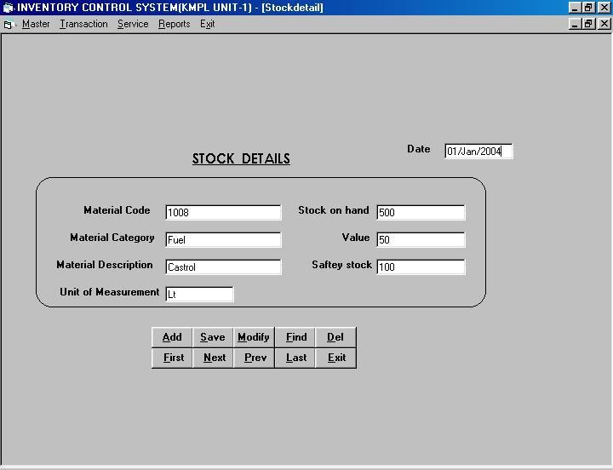

48

MATERIAL REQUIREMENT PROCESSING
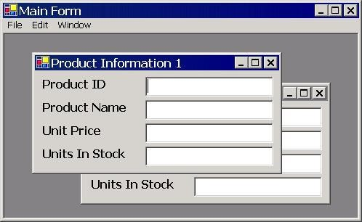

- HOSPITAL MANAGEMENT SYSTEM.
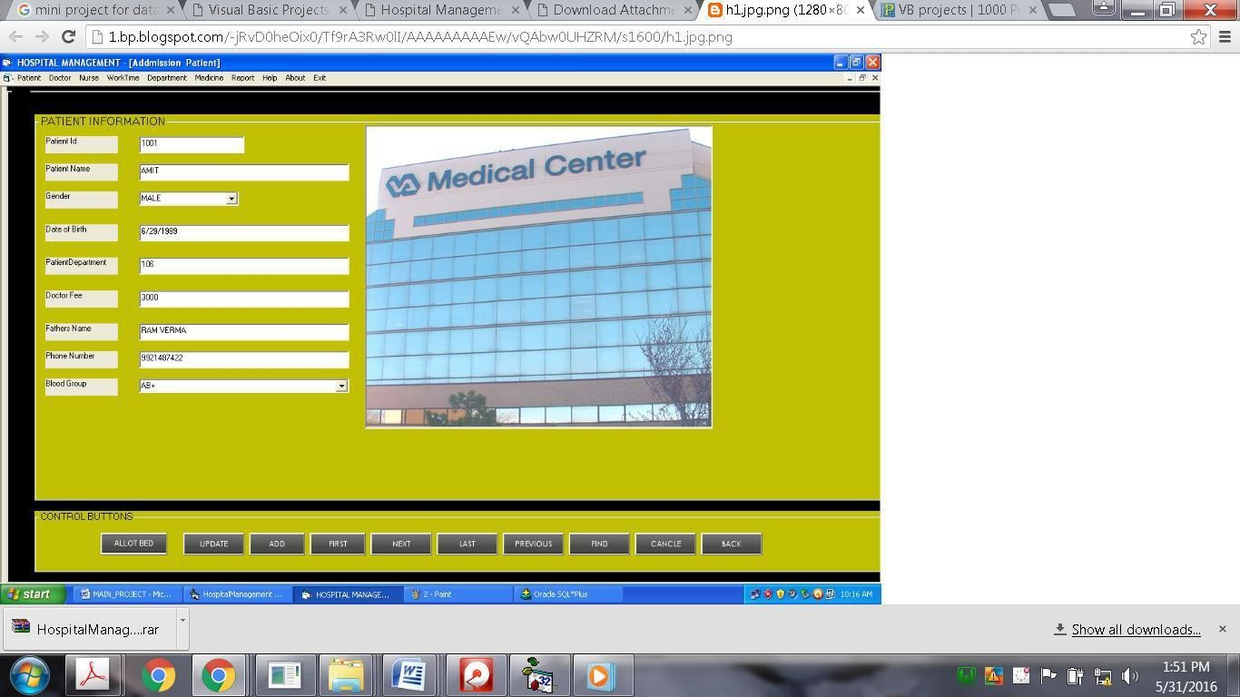

49

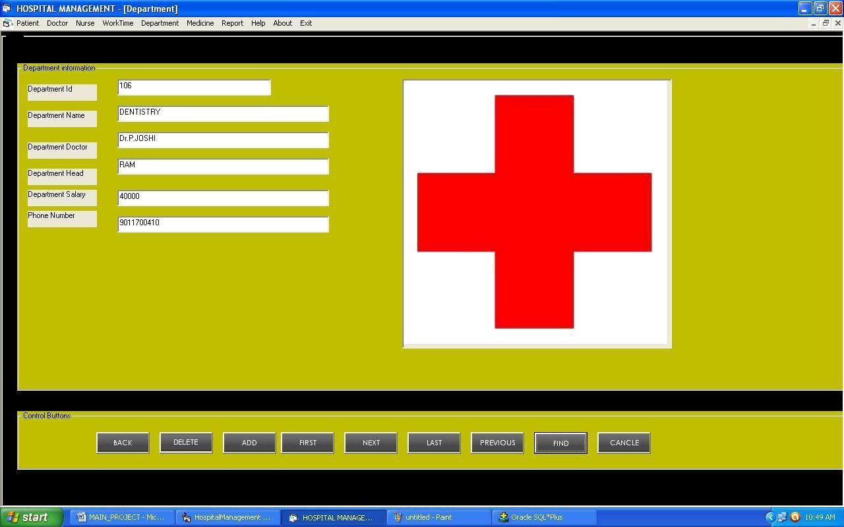

- RAILWAY RESERVATION SYSTEM.
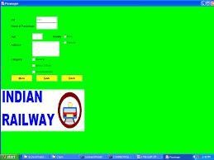
Rev No / Date: 01 / 03-06-2016

PERSONAL INFORMATION SYSTEM.
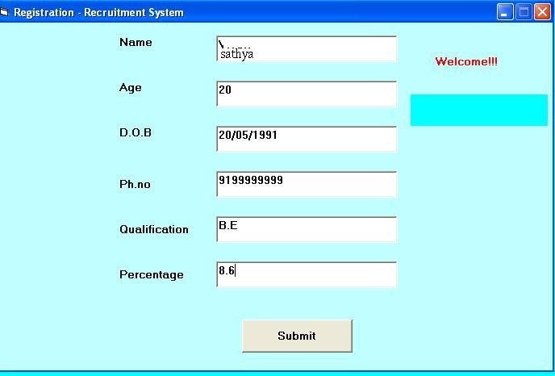

- WEB BASED USER IDENTIFICATION SYSTEM.
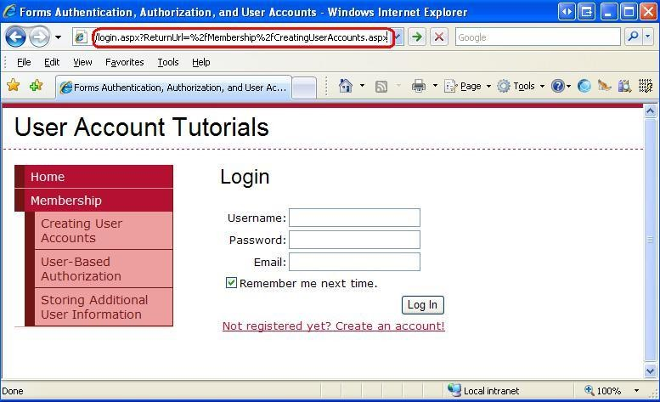
- TIMETABLE MANAGEMENT SYSTEM.
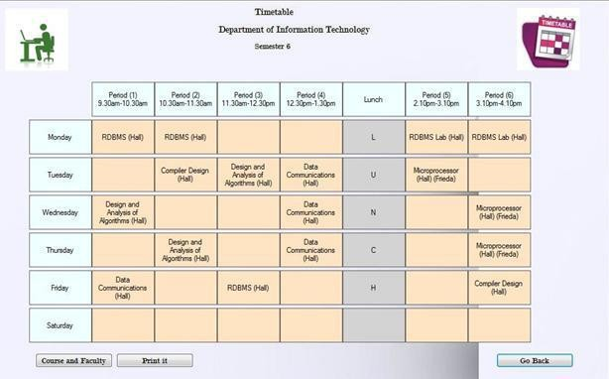

HOTEL MANAGEMENT SYSTEM
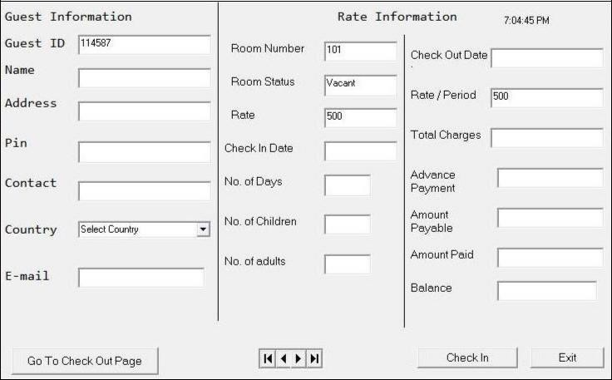

Ex. No: 12 FRONT END TOOLS

AIM
To implement a simple calculator by using Visual Basic front end tools.

PROCEDURE:
Step1: create a new project in visual basic using the option file---> new project.
Step2: In the form use the front end tools in the toolbox like textbox, label,command button and create a front end Design for the simple calculator.
Step3: Open the properties window for the tool sand select properties. Now the properties window is
opened.
Step4: Set properties for each tool in the form like caption, name, etc. Step5: Double click each and every tool to open the project code window. Step6: write the code for the events of the tools.
Step7: write the code for the simple operations in the calculator like Addition, subtraction, multiplication and division.
Step7: The code is Automatically compiled at the end of each line while pressing the Enter key.
Step7: now execute the code by click the F5 button in the keyboard or select Run--->start.
Step8: after successfully executing the project create the executable file by Select the option file---> make file.exe.

CODING:
Dim a, b, c, d As Integer
Private Sub button0_Click() display.Text = display.Text + button0.Caption End Sub
Private Sub button1_Click() display.Text = display.Text + button1.Caption End Sub
Private Sub button2_Click() display.Text = display.Text + button2.Caption End Sub
Private Sub button3_Click() display.Text = display.Text + button3.Caption End Sub
Private Sub button4_Click() display.Text = display.Text + button4.Caption End Sub
Private Sub button5_Click() display.Text = display.Text + button5.Caption End Sub
Private Sub button6_Click() display.Text = display.Text + button6.Caption End Sub
Private Sub button7_Click() display.Text = display.Text + button7.Caption End Sub
Private Sub button8_Click() display.Text = display.Text + button8.Caption End Sub
Private Sub button9_Click() display.Text = display.Text + button9.Caption End Sub
Private Sub add_Click()a = Val(display.Text) display.Text = "" d=1End Sub
Private Sub sub_Click() a = Val(display.Text) display.Text = ""d=2 End Sub
Private Sub mul_Click() a = Val(display.Text) display.Text = ""d=3 End Sub
Private Sub div_Click() a = Val(display.Text) display.Text = ""d=4 End Sub
Private Sub equalto_Click() b = Val(display.Text)
If d = 1 Then
c=a+b display.Text= c
ElseIf d = 2 Then
c=a-b display.Text = c
ElseIf d = 3 Then
c=a*b display.Text = c
ElseIf d = 4 Then
c=a/b display.Text = c
End If
End Sub
Private Sub clear_Click()
a=0
b=0
c=0

display.Text= ""
End Sub
Private Sub off_Click()
MSG = MsgBox("THANKS FOR USING FX990ES FROM NASA COPY RIGHTS RESERVED", vbOKOnly, "BYE")
End
End Sub
Private Sub decimalpoint_Click()
display.Text = display.Text + decimalpoint.Caption
End Sub

RESULT:
Thus the simple calculator created by using the front end tools was executed successfully.

55

