NCD_Diabetes

Capstone_Hyderabad

Wednesday, July 05, 2017

### Load required libraries

library(caret)

## Warning: package 'caret' was built under R version 3.3.3

## Loading required package: lattice

## Loading required package: ggplot2

## Warning: package 'ggplot2' was built under R version 3.3.3

library(rpart)

## Warning: package 'rpart' was built under R version 3.3.3

library(ROCR)

## Warning: package 'ROCR' was built under R version 3.3.3

## Loading required package: gplots

## Warning: package 'gplots' was built under R version 3.3.2

##   
## Attaching package: 'gplots'

## The following object is masked from 'package:stats':  
##   
## lowess

library(ineq)

## Warning: package 'ineq' was built under R version 3.3.2

library(plyr)

## Warning: package 'plyr' was built under R version 3.3.2

library(dplyr)

## Warning: package 'dplyr' was built under R version 3.3.3

##   
## Attaching package: 'dplyr'

## The following objects are masked from 'package:plyr':  
##   
## arrange, count, desc, failwith, id, mutate, rename, summarise,  
## summarize

## The following objects are masked from 'package:stats':  
##   
## filter, lag

## The following objects are masked from 'package:base':  
##   
## intersect, setdiff, setequal, union

library(ggplot2)  
library(scales)

## Warning: package 'scales' was built under R version 3.3.2

library(stringr)

## Warning: package 'stringr' was built under R version 3.3.3

library(rattle)

## Warning: package 'rattle' was built under R version 3.3.2

## Rattle: A free graphical interface for data mining with R.  
## Version 4.1.0 Copyright (c) 2006-2015 Togaware Pty Ltd.  
## Type 'rattle()' to shake, rattle, and roll your data.

library(RColorBrewer)

## Warning: package 'RColorBrewer' was built under R version 3.3.2

library(lmtest)

## Warning: package 'lmtest' was built under R version 3.3.3

## Loading required package: zoo

## Warning: package 'zoo' was built under R version 3.3.3

##   
## Attaching package: 'zoo'

## The following objects are masked from 'package:base':  
##   
## as.Date, as.Date.numeric

library(pscl)

## Warning: package 'pscl' was built under R version 3.3.3

## Loading required package: MASS

## Warning: package 'MASS' was built under R version 3.3.3

##   
## Attaching package: 'MASS'

## The following object is masked from 'package:dplyr':  
##   
## select

## Classes and Methods for R developed in the

## Political Science Computational Laboratory

## Department of Political Science

## Stanford University

## Simon Jackman

## hurdle and zeroinfl functions by Achim Zeileis

require(caret)  
library(mlbench)

## Warning: package 'mlbench' was built under R version 3.3.3

### Load dataset

setwd("C:\\Material\\CAPStone\\Scripts")  
data <- read.csv("ncd_latest_062817.csv")  
  
source("required_user_functions.R")  
  
d_data <- subset(data, Diabetes %in% c('No','Yes') & ALIVE...DEAD == 'ALIVE')  
  
data_d <- subset(d_data, select = c("FINANCIAL.GROUP","FAMILY.HISTORY","STAPLE.FOOD",  
 "ALCOHOL","Known.H.o.Smoking","Cholestrol.High","PhysicalActivity","Obese","Diabetes"))  
str(data_d)

## 'data.frame': 9328 obs. of 9 variables:  
## $ FINANCIAL.GROUP : Factor w/ 3 levels "Higher Class",..: 1 1 1 1 1 1 1 1 1 1 ...  
## $ FAMILY.HISTORY : Factor w/ 2 levels "No","Yes": 2 2 2 2 2 2 2 2 2 2 ...  
## $ STAPLE.FOOD : Factor w/ 3 levels "Pizza","Rice",..: 3 3 3 1 3 3 3 3 3 3 ...  
## $ ALCOHOL : Factor w/ 2 levels "No","Yes": 1 1 2 2 1 2 1 1 1 1 ...  
## $ Known.H.o.Smoking: Factor w/ 2 levels "No","Yes": 2 2 2 2 2 2 2 2 2 2 ...  
## $ Cholestrol.High : Factor w/ 2 levels "No","Yes": 1 1 1 1 1 1 1 1 1 1 ...  
## $ PhysicalActivity : Factor w/ 2 levels "No","Yes": 1 1 1 1 1 1 1 1 1 1 ...  
## $ Obese : num 20.7 24.1 22.6 19 24.4 ...  
## $ Diabetes : Factor w/ 2 levels "No","Yes": 2 2 2 2 2 2 2 2 2 2 ...

colnames(data_d)[1] <- "Fin_Group"   
colnames(data_d)[2] <- "Family_history"   
colnames(data_d)[3] <- "Staple_Food"   
colnames(data_d)[4] <- "Alcohol"   
colnames(data_d)[5] <- "Smoke"   
colnames(data_d)[6] <- "High_Cholestrol"   
colnames(data_d)[7] <- "Phy_Activity"   
colnames(data_d)[8] <- "Obese"   
colnames(data_d)[9] <- "Diabetes"   
  
  
diabetes_vector <- c("Fin_Group","Family_history","Staple_Food","Alcohol","Smoke","High_Cholestrol","Phy_Activity","Obese")  
  
  
  
data_d$Obese <- ifelse(data_d$Obese > 30,'Y','N')  
data_d$Obese <- as.factor(data_d$Obese)  
str(data_d)

## 'data.frame': 9328 obs. of 9 variables:  
## $ Fin_Group : Factor w/ 3 levels "Higher Class",..: 1 1 1 1 1 1 1 1 1 1 ...  
## $ Family_history : Factor w/ 2 levels "No","Yes": 2 2 2 2 2 2 2 2 2 2 ...  
## $ Staple_Food : Factor w/ 3 levels "Pizza","Rice",..: 3 3 3 1 3 3 3 3 3 3 ...  
## $ Alcohol : Factor w/ 2 levels "No","Yes": 1 1 2 2 1 2 1 1 1 1 ...  
## $ Smoke : Factor w/ 2 levels "No","Yes": 2 2 2 2 2 2 2 2 2 2 ...  
## $ High_Cholestrol: Factor w/ 2 levels "No","Yes": 1 1 1 1 1 1 1 1 1 1 ...  
## $ Phy_Activity : Factor w/ 2 levels "No","Yes": 1 1 1 1 1 1 1 1 1 1 ...  
## $ Obese : Factor w/ 2 levels "N","Y": 1 1 1 1 1 1 1 1 1 1 ...  
## $ Diabetes : Factor w/ 2 levels "No","Yes": 2 2 2 2 2 2 2 2 2 2 ...

names(data_d)

## [1] "Fin_Group" "Family_history" "Staple_Food" "Alcohol"   
## [5] "Smoke" "High_Cholestrol" "Phy_Activity" "Obese"   
## [9] "Diabetes"

nrow(data_d)

## [1] 9328

count(data_d, vars=c("Diabetes"))

## Warning: package 'bindrcpp' was built under R version 3.3.3

## # A tibble: 1 x 2  
## vars n  
## <chr> <int>  
## 1 Diabetes 9328

### Split the data into two sets each containing 1500 records of Diabetes and Not Diabetes

d_d <- subset(data_d,Diabetes == 'Yes')  
d_n <- subset(data_d,Diabetes == 'No')  
#  
NCD <- "Diabetes"  
displaySplitCount(d_d$Diabetes,"1",NCD)

##   
## Dataset file 1 Diabetes Count :

## dd  
## No Yes   
## 0 1551

displaySplitCount(d_n$Diabetes,"2",NCD)

##   
## Dataset file 2 Diabetes Count :

## dd  
## No Yes   
## 7777 0

set.seed(123)  
  
smp_size1 = min(1000,nrow(d_d))  
samp_ind1 <- sample(seq_len(nrow(d_d)), size = smp_size1)  
d1 <- d_d[samp_ind1,]  
  
smp_size2 = min(1000,nrow(d_n))  
samp_ind2 <- sample(seq_len(nrow(d_n)), size = smp_size2)  
d2 <- d_n[samp_ind2,]  
  
print(head(d1))

## Fin_Group Family_history Staple_Food Alcohol Smoke  
## 2090 Lower Middle Class Yes Pizza No No  
## 8081 Middle Class Yes Roti Yes Yes  
## 3001 Higher Class No Roti Yes Yes  
## 9403 Middle Class No Pizza No Yes  
## 10072 Lower Middle Class Yes Roti Yes Yes  
## 323 Middle Class Yes Roti Yes No  
## High_Cholestrol Phy_Activity Obese Diabetes  
## 2090 No Yes N Yes  
## 8081 Yes No N Yes  
## 3001 Yes No N Yes  
## 9403 Yes No N Yes  
## 10072 Yes No N Yes  
## 323 No Yes N Yes

print(nrow(d1))

## [1] 1000

print(head(d2))

## Fin_Group Family_history Staple_Food Alcohol Smoke  
## 3112 Lower Middle Class No Roti Yes Yes  
## 6509 Higher Class Yes Roti Yes No  
## 1747 Middle Class Yes Roti Yes No  
## 9277 Lower Middle Class No Roti Yes No  
## 9209 Lower Middle Class Yes Roti Yes Yes  
## 5246 Higher Class No Roti No No  
## High_Cholestrol Phy_Activity Obese Diabetes  
## 3112 Yes Yes N No  
## 6509 No Yes N No  
## 1747 No Yes N No  
## 9277 Yes Yes N No  
## 9209 Yes Yes N No  
## 5246 Yes Yes N No

print(nrow(d2))

## [1] 1000

displaySplitCount(d1$Diabetes,"1",NCD)

##   
## Dataset file 1 Diabetes Count :

## dd  
## No Yes   
## 0 1000

displaySplitCount(d2$Diabetes,"2",NCD)

##   
## Dataset file 2 Diabetes Count :

## dd  
## No Yes   
## 1000 0

### Split dataset d1 into training dataset and testing dataset in the ratio 70 % : 30 %

set.seed(123)  
rnd <- sort(sample(nrow(d1),nrow(d1)*.7))  
d1_train <- d1[rnd,]  
d1_test <- d1[-rnd,]  
  
print(nrow(d1_train))

## [1] 700

print(nrow(d1_test))

## [1] 300

### Split dataset d2 into training dataset and testing dataset

d2_train <- d2[rnd,]  
d2_test <- d2[-rnd,]  
  
print(nrow(d2_train))

## [1] 700

print(nrow(d2_test))

## [1] 300

### Merge d1_train (Diabetes dataset) and d2_train (Non-Diabetes dataset) to form training dataset

d_train <- bind_rows(d1_train,d2_train)  
d_test <- bind_rows(d1_test,d2_test)  
  
print(nrow(d_train))

## [1] 1400

print(nrow(d_test))

## [1] 600

### Check the dataset the proportion of Diabetes and Non-Diabetes

Yes1_train <- length(which(str_trim(d1_train$Diabetes) == 'Yes'))  
No1_train <- length(which(str_trim(d1_train$Diabetes) == 'No'))  
  
cat("\n Diabetes Count Yes: ",Yes1_train," No: ",No1_train)

##   
## Diabetes Count Yes: 700 No: 0

Yes2_train <- length(which(str_trim(d2_train$Diabetes) == 'Yes'))  
No2_train <- length(which(str_trim(d2_train$Diabetes) == 'No'))  
  
cat("\n Diabetes Count Yes: ",Yes2_train," No: ",No2_train)

##   
## Diabetes Count Yes: 0 No: 700

Yes1_test <- length(which(str_trim(d1_test$Diabetes) == 'Yes'))  
No1_test <- length(which(str_trim(d1_test$Diabetes) == 'No'))  
  
cat("\n Diabetes Count Yes: ",Yes1_test," No: ",No1_test)

##   
## Diabetes Count Yes: 300 No: 0

Yes2_test <- length(which(str_trim(d2_test$Diabetes) == 'Yes'))  
No2_test <- length(which(str_trim(d2_test$Diabetes) == 'No'))  
  
###  
  
cat("\n Train dataset file Diabetes Count : ",nrow(d_train))

##   
## Train dataset file Diabetes Count : 1400

table(d_train$Diabetes)

##   
## No Yes   
## 700 700

cat("\n Test dataset file Diabetes Count : ",nrow(d_test))

##   
## Test dataset file Diabetes Count : 600

table(d_test$Diabetes)

##   
## No Yes   
## 300 300

### Remove unwanted variables

#### The following columns are not required for Diabetes - NCD:

1. "S.NO."
2. "Year"
3. "ALIVE...DEAD"
4. "RELIGION"
5. "Random.Blood.Sugar"
6. "HBA1C"
7. "Specialty.of.Treatment"
8. "Height"
9. "Weight"

for (e in 1:length(diabetes_vector)){  
eda_functions("Diabetes",d_train,d_train[,"Diabetes"],d_train[,e],diabetes_vector[e])  
 }

##   
##   
## Performing mlbenchxtab   
##   
## Diabetes Vs Fin_Group   
##   
## column Higher Class Lower Middle Class Middle Class  
## target   
## No 210 388 102  
## Yes 218 343 139  
##   
##   
## Within each level of predictor variable values, % of Diabetes patients   
##   
## column  
## target Higher Class Lower Middle Class Middle Class  
## No 0.3000000 0.5542857 0.1457143  
## Yes 0.3114286 0.4900000 0.1985714  
##   
##   
## Diabetes Vs predictor variable values   
##   
## column  
## target Higher Class Lower Middle Class Middle Class  
## No 0.4906542 0.5307798 0.4232365  
## Yes 0.5093458 0.4692202 0.5767635  
##   
##   
## Performing Chi Square Test for Diabetes and Fin_Group  
##   
## Step 1: State the hypothesis   
##   
##   
## Null hypothesis : The relative proportions of Diabetes are independent of Fin_Group  
##   
##   
## Alternative hypothesis : The relative proportions of Diabetes are dependent of Fin_Group  
##   
## Step 2: Formulate Analysis Plan   
##   
##   
## The analysis plan describes how to use sample data to accept or reject the null hypothesis.  
## Plan should have these elements:  
## Significance level: We can use the standard 0.05 or 5% level  
## Test method: Use Chi Square test of independence  
## Significance level: We can use the standard 0.05 or 5% level  
## Test method: Chi Square test of independence  
## In our contingency table, we assume the expected frequency count for each cell of the table is at least 5.  
##   
## Step 3: Analyze Sample data   
##   
## column  
## target Higher Class Lower Middle Class Middle Class  
## No 210 388 102  
## Yes 218 343 139  
## Call: xtabs(formula = ~(target + column), data = data1)  
## Number of cases in table: 1400   
## Number of factors: 2   
## Test for independence of all factors:  
## Chisq = 8.6, df = 2, p-value = 0.01357  
##   
##   
## If the counts are not large enough to use a Chi-square distribution,   
## we shall use the p-value based on simulation instead, including the argument simulate.p.value = TRUE.  
## In our contingency table, if we do not have the expected frequency count for each cell of the table is at least 5,  
## we shall use the p-value based on simulation instead, including the argument simulate.p.value = TRUE  
## Minimum value 210   
##   
## <------ Chi square without simulation for p value --------->   
## Pearson's Chi-squared test  
##   
## data: tab1  
## X-squared = 8.6002, df = 2, p-value = 0.01357  
##   
##   
##   
## Step 4: Interpret the results   
##   
##   
##   
## ### ---------------------------------------------------------  
## P value obtained without simulation for p-value : 0.01356714   
##   
##   
## <-- Decision: -->  
## The relative proportions of Diabetes are dependent of Fin_Group at 5% level of significance   
##   
##   
## This p-value is the probability of observing a sample statistic as extreme as the test statistic.   
##   
## We compare the p-value to the significance level and reject the null hypothesis when the p-value is less than the significance level else accept.  
##   
##   
## Performing mlbenchxtab   
##   
## Diabetes Vs Family_history   
##   
## column No Yes  
## target   
## No 363 337  
## Yes 263 437  
##   
##   
## Within each level of predictor variable values, % of Diabetes patients   
##   
## column  
## target No Yes  
## No 0.5185714 0.4814286  
## Yes 0.3757143 0.6242857  
##   
##   
## Diabetes Vs predictor variable values   
##   
## column  
## target No Yes  
## No 0.5798722 0.4354005  
## Yes 0.4201278 0.5645995  
##   
##   
## Performing Chi Square Test for Diabetes and Family_history  
##   
## Step 1: State the hypothesis   
##   
##   
## Null hypothesis : The relative proportions of Diabetes are independent of Family_history  
##   
##   
## Alternative hypothesis : The relative proportions of Diabetes are dependent of Family_history  
##   
## Step 2: Formulate Analysis Plan   
##   
##   
## The analysis plan describes how to use sample data to accept or reject the null hypothesis.  
## Plan should have these elements:  
## Significance level: We can use the standard 0.05 or 5% level  
## Test method: Use Chi Square test of independence  
## Significance level: We can use the standard 0.05 or 5% level  
## Test method: Chi Square test of independence  
## In our contingency table, we assume the expected frequency count for each cell of the table is at least 5.  
##   
## Step 3: Analyze Sample data   
##   
## column  
## target No Yes  
## No 363 337  
## Yes 263 437  
## Call: xtabs(formula = ~(target + column), data = data1)  
## Number of cases in table: 1400   
## Number of factors: 2   
## Test for independence of all factors:  
## Chisq = 28.894, df = 1, p-value = 7.644e-08  
##   
##   
## If the counts are not large enough to use a Chi-square distribution,   
## we shall use the p-value based on simulation instead, including the argument simulate.p.value = TRUE.  
## In our contingency table, if we do not have the expected frequency count for each cell of the table is at least 5,  
## we shall use the p-value based on simulation instead, including the argument simulate.p.value = TRUE  
## Minimum value 263   
##   
## <------ Chi square without simulation for p value --------->   
## Pearson's Chi-squared test with Yates' continuity correction  
##   
## data: tab1  
## X-squared = 28.319, df = 1, p-value = 1.029e-07  
##   
##   
##   
## Step 4: Interpret the results   
##   
##   
##   
## ### ---------------------------------------------------------  
## P value obtained without simulation for p-value : 1.028631e-07   
##   
##   
## <-- Decision: -->  
## The relative proportions of Diabetes are dependent of Family_history at 5% level of significance   
##   
##   
## This p-value is the probability of observing a sample statistic as extreme as the test statistic.   
##   
## We compare the p-value to the significance level and reject the null hypothesis when the p-value is less than the significance level else accept.  
##   
##   
## Performing mlbenchxtab   
##   
## Diabetes Vs Staple_Food   
##   
## column Pizza Rice Roti  
## target   
## No 9 4 687  
## Yes 11 7 682  
##   
##   
## Within each level of predictor variable values, % of Diabetes patients   
##   
## column  
## target Pizza Rice Roti  
## No 0.012857143 0.005714286 0.981428571  
## Yes 0.015714286 0.010000000 0.974285714  
##   
##   
## Diabetes Vs predictor variable values   
##   
## column  
## target Pizza Rice Roti  
## No 0.4500000 0.3636364 0.5018262  
## Yes 0.5500000 0.6363636 0.4981738  
##   
##   
## Performing Chi Square Test for Diabetes and Staple_Food  
##   
## Step 1: State the hypothesis   
##   
##   
## Null hypothesis : The relative proportions of Diabetes are independent of Staple_Food  
##   
##   
## Alternative hypothesis : The relative proportions of Diabetes are dependent of Staple_Food  
##   
## Step 2: Formulate Analysis Plan   
##   
##   
## The analysis plan describes how to use sample data to accept or reject the null hypothesis.  
## Plan should have these elements:  
## Significance level: We can use the standard 0.05 or 5% level  
## Test method: Use Chi Square test of independence  
## Significance level: We can use the standard 0.05 or 5% level  
## Test method: Chi Square test of independence  
## In our contingency table, we assume the expected frequency count for each cell of the table is at least 5.  
##   
## Step 3: Analyze Sample data   
##   
## column  
## target Pizza Rice Roti  
## No 9 4 687  
## Yes 11 7 682  
## Call: xtabs(formula = ~(target + column), data = data1)  
## Number of cases in table: 1400   
## Number of factors: 2   
## Test for independence of all factors:  
## Chisq = 1.0364, df = 2, p-value = 0.5956  
##   
##   
## If the counts are not large enough to use a Chi-square distribution,   
## we shall use the p-value based on simulation instead, including the argument simulate.p.value = TRUE.  
## In our contingency table, if we do not have the expected frequency count for each cell of the table is at least 5,  
## we shall use the p-value based on simulation instead, including the argument simulate.p.value = TRUE  
## Minimum value 4   
##   
## <------ Chi square with simulation for p value --------->   
## Pearson's Chi-squared test with simulated p-value (based on 2000  
## replicates)  
##   
## data: tab1  
## X-squared = 1.0364, df = NA, p-value = 0.5562  
##   
##   
##   
## Step 4: Interpret the results   
##   
##   
##   
## ### ---------------------------------------------------------  
## P value obtained with simulation for p-value : 0.5562219   
##   
##   
## <-- Decision: -->  
## The relative proportions of Diabetes are independent of Staple_Food at 5% level of significance   
##   
##   
## This p-value is the probability of observing a sample statistic as extreme as the test statistic.   
##   
## We compare the p-value to the significance level and reject the null hypothesis when the p-value is less than the significance level else accept.  
##   
##   
## Performing mlbenchxtab   
##   
## Diabetes Vs Alcohol   
##   
## column No Yes  
## target   
## No 292 408  
## Yes 320 380  
##   
##   
## Within each level of predictor variable values, % of Diabetes patients   
##   
## column  
## target No Yes  
## No 0.4171429 0.5828571  
## Yes 0.4571429 0.5428571  
##   
##   
## Diabetes Vs predictor variable values   
##   
## column  
## target No Yes  
## No 0.4771242 0.5177665  
## Yes 0.5228758 0.4822335  
##   
##   
## Performing Chi Square Test for Diabetes and Alcohol  
##   
## Step 1: State the hypothesis   
##   
##   
## Null hypothesis : The relative proportions of Diabetes are independent of Alcohol  
##   
##   
## Alternative hypothesis : The relative proportions of Diabetes are dependent of Alcohol  
##   
## Step 2: Formulate Analysis Plan   
##   
##   
## The analysis plan describes how to use sample data to accept or reject the null hypothesis.  
## Plan should have these elements:  
## Significance level: We can use the standard 0.05 or 5% level  
## Test method: Use Chi Square test of independence  
## Significance level: We can use the standard 0.05 or 5% level  
## Test method: Chi Square test of independence  
## In our contingency table, we assume the expected frequency count for each cell of the table is at least 5.  
##   
## Step 3: Analyze Sample data   
##   
## column  
## target No Yes  
## No 292 408  
## Yes 320 380  
## Call: xtabs(formula = ~(target + column), data = data1)  
## Number of cases in table: 1400   
## Number of factors: 2   
## Test for independence of all factors:  
## Chisq = 2.276, df = 1, p-value = 0.1314  
##   
##   
## If the counts are not large enough to use a Chi-square distribution,   
## we shall use the p-value based on simulation instead, including the argument simulate.p.value = TRUE.  
## In our contingency table, if we do not have the expected frequency count for each cell of the table is at least 5,  
## we shall use the p-value based on simulation instead, including the argument simulate.p.value = TRUE  
## Minimum value 292   
##   
## <------ Chi square without simulation for p value --------->   
## Pearson's Chi-squared test with Yates' continuity correction  
##   
## data: tab1  
## X-squared = 2.1163, df = 1, p-value = 0.1457  
##   
##   
##   
## Step 4: Interpret the results   
##   
##   
##   
## ### ---------------------------------------------------------  
## P value obtained without simulation for p-value : 0.1457379   
##   
##   
## <-- Decision: -->  
## The relative proportions of Diabetes are independent of Alcohol at 5% level of significance   
##   
##   
## This p-value is the probability of observing a sample statistic as extreme as the test statistic.   
##   
## We compare the p-value to the significance level and reject the null hypothesis when the p-value is less than the significance level else accept.  
##   
##   
## Performing mlbenchxtab   
##   
## Diabetes Vs Smoke   
##   
## column No Yes  
## target   
## No 418 282  
## Yes 256 444  
##   
##   
## Within each level of predictor variable values, % of Diabetes patients   
##   
## column  
## target No Yes  
## No 0.5971429 0.4028571  
## Yes 0.3657143 0.6342857  
##   
##   
## Diabetes Vs predictor variable values   
##   
## column  
## target No Yes  
## No 0.6201780 0.3884298  
## Yes 0.3798220 0.6115702  
##   
##   
## Performing Chi Square Test for Diabetes and Smoke  
##   
## Step 1: State the hypothesis   
##   
##   
## Null hypothesis : The relative proportions of Diabetes are independent of Smoke  
##   
##   
## Alternative hypothesis : The relative proportions of Diabetes are dependent of Smoke  
##   
## Step 2: Formulate Analysis Plan   
##   
##   
## The analysis plan describes how to use sample data to accept or reject the null hypothesis.  
## Plan should have these elements:  
## Significance level: We can use the standard 0.05 or 5% level  
## Test method: Use Chi Square test of independence  
## Significance level: We can use the standard 0.05 or 5% level  
## Test method: Chi Square test of independence  
## In our contingency table, we assume the expected frequency count for each cell of the table is at least 5.  
##   
## Step 3: Analyze Sample data   
##   
## column  
## target No Yes  
## No 418 282  
## Yes 256 444  
## Call: xtabs(formula = ~(target + column), data = data1)  
## Number of cases in table: 1400   
## Number of factors: 2   
## Test for independence of all factors:  
## Chisq = 75.09, df = 1, p-value = 4.505e-18  
##   
##   
## If the counts are not large enough to use a Chi-square distribution,   
## we shall use the p-value based on simulation instead, including the argument simulate.p.value = TRUE.  
## In our contingency table, if we do not have the expected frequency count for each cell of the table is at least 5,  
## we shall use the p-value based on simulation instead, including the argument simulate.p.value = TRUE  
## Minimum value 256   
##   
## <------ Chi square without simulation for p value --------->   
## Pearson's Chi-squared test with Yates' continuity correction  
##   
## data: tab1  
## X-squared = 74.162, df = 1, p-value < 2.2e-16  
##   
##   
##   
## Step 4: Interpret the results   
##   
##   
##   
## ### ---------------------------------------------------------  
## P value obtained without simulation for p-value : 7.195087e-18   
##   
##   
## <-- Decision: -->  
## The relative proportions of Diabetes are dependent of Smoke at 5% level of significance   
##   
##   
## This p-value is the probability of observing a sample statistic as extreme as the test statistic.   
##   
## We compare the p-value to the significance level and reject the null hypothesis when the p-value is less than the significance level else accept.  
##   
##   
## Performing mlbenchxtab   
##   
## Diabetes Vs High_Cholestrol   
##   
## column No Yes  
## target   
## No 517 183  
## Yes 268 432  
##   
##   
## Within each level of predictor variable values, % of Diabetes patients   
##   
## column  
## target No Yes  
## No 0.7385714 0.2614286  
## Yes 0.3828571 0.6171429  
##   
##   
## Diabetes Vs predictor variable values   
##   
## column  
## target No Yes  
## No 0.6585987 0.2975610  
## Yes 0.3414013 0.7024390  
##   
##   
## Performing Chi Square Test for Diabetes and High_Cholestrol  
##   
## Step 1: State the hypothesis   
##   
##   
## Null hypothesis : The relative proportions of Diabetes are independent of High_Cholestrol  
##   
##   
## Alternative hypothesis : The relative proportions of Diabetes are dependent of High_Cholestrol  
##   
## Step 2: Formulate Analysis Plan   
##   
##   
## The analysis plan describes how to use sample data to accept or reject the null hypothesis.  
## Plan should have these elements:  
## Significance level: We can use the standard 0.05 or 5% level  
## Test method: Use Chi Square test of independence  
## Significance level: We can use the standard 0.05 or 5% level  
## Test method: Chi Square test of independence  
## In our contingency table, we assume the expected frequency count for each cell of the table is at least 5.  
##   
## Step 3: Analyze Sample data   
##   
## column  
## target No Yes  
## No 517 183  
## Yes 268 432  
## Call: xtabs(formula = ~(target + column), data = data1)  
## Number of cases in table: 1400   
## Number of factors: 2   
## Test for independence of all factors:  
## Chisq = 179.8, df = 1, p-value = 5.368e-41  
##   
##   
## If the counts are not large enough to use a Chi-square distribution,   
## we shall use the p-value based on simulation instead, including the argument simulate.p.value = TRUE.  
## In our contingency table, if we do not have the expected frequency count for each cell of the table is at least 5,  
## we shall use the p-value based on simulation instead, including the argument simulate.p.value = TRUE  
## Minimum value 183   
##   
## <------ Chi square without simulation for p value --------->   
## Pearson's Chi-squared test with Yates' continuity correction  
##   
## data: tab1  
## X-squared = 178.36, df = 1, p-value < 2.2e-16  
##   
##   
##   
## Step 4: Interpret the results   
##   
##   
##   
## ### ---------------------------------------------------------  
## P value obtained without simulation for p-value : 1.107847e-40   
##   
##   
## <-- Decision: -->  
## The relative proportions of Diabetes are dependent of High_Cholestrol at 5% level of significance   
##   
##   
## This p-value is the probability of observing a sample statistic as extreme as the test statistic.   
##   
## We compare the p-value to the significance level and reject the null hypothesis when the p-value is less than the significance level else accept.  
##   
##   
## Performing mlbenchxtab   
##   
## Diabetes Vs Phy_Activity   
##   
## column No Yes  
## target   
## No 275 425  
## Yes 452 248  
##   
##   
## Within each level of predictor variable values, % of Diabetes patients   
##   
## column  
## target No Yes  
## No 0.3928571 0.6071429  
## Yes 0.6457143 0.3542857  
##   
##   
## Diabetes Vs predictor variable values   
##   
## column  
## target No Yes  
## No 0.3782669 0.6315007  
## Yes 0.6217331 0.3684993  
##   
##   
## Performing Chi Square Test for Diabetes and Phy_Activity  
##   
## Step 1: State the hypothesis   
##   
##   
## Null hypothesis : The relative proportions of Diabetes are independent of Phy_Activity  
##   
##   
## Alternative hypothesis : The relative proportions of Diabetes are dependent of Phy_Activity  
##   
## Step 2: Formulate Analysis Plan   
##   
##   
## The analysis plan describes how to use sample data to accept or reject the null hypothesis.  
## Plan should have these elements:  
## Significance level: We can use the standard 0.05 or 5% level  
## Test method: Use Chi Square test of independence  
## Significance level: We can use the standard 0.05 or 5% level  
## Test method: Chi Square test of independence  
## In our contingency table, we assume the expected frequency count for each cell of the table is at least 5.  
##   
## Step 3: Analyze Sample data   
##   
## column  
## target No Yes  
## No 275 425  
## Yes 452 248  
## Call: xtabs(formula = ~(target + column), data = data1)  
## Number of cases in table: 1400   
## Number of factors: 2   
## Test for independence of all factors:  
## Chisq = 89.64, df = 1, p-value = 2.85e-21  
##   
##   
## If the counts are not large enough to use a Chi-square distribution,   
## we shall use the p-value based on simulation instead, including the argument simulate.p.value = TRUE.  
## In our contingency table, if we do not have the expected frequency count for each cell of the table is at least 5,  
## we shall use the p-value based on simulation instead, including the argument simulate.p.value = TRUE  
## Minimum value 248   
##   
## <------ Chi square without simulation for p value --------->   
## Pearson's Chi-squared test with Yates' continuity correction  
##   
## data: tab1  
## X-squared = 88.635, df = 1, p-value < 2.2e-16  
##   
##   
##   
## Step 4: Interpret the results   
##   
##   
##   
## ### ---------------------------------------------------------  
## P value obtained without simulation for p-value : 4.748797e-21   
##   
##   
## <-- Decision: -->  
## The relative proportions of Diabetes are dependent of Phy_Activity at 5% level of significance   
##   
##   
## This p-value is the probability of observing a sample statistic as extreme as the test statistic.   
##   
## We compare the p-value to the significance level and reject the null hypothesis when the p-value is less than the significance level else accept.  
##   
##   
## Performing mlbenchxtab   
##   
## Diabetes Vs Obese   
##   
## column N Y  
## target   
## No 608 92  
## Yes 590 110  
##   
##   
## Within each level of predictor variable values, % of Diabetes patients   
##   
## column  
## target N Y  
## No 0.8685714 0.1314286  
## Yes 0.8428571 0.1571429  
##   
##   
## Diabetes Vs predictor variable values   
##   
## column  
## target N Y  
## No 0.5075125 0.4554455  
## Yes 0.4924875 0.5445545  
##   
##   
## Performing Chi Square Test for Diabetes and Obese  
##   
## Step 1: State the hypothesis   
##   
##   
## Null hypothesis : The relative proportions of Diabetes are independent of Obese  
##   
##   
## Alternative hypothesis : The relative proportions of Diabetes are dependent of Obese  
##   
## Step 2: Formulate Analysis Plan   
##   
##   
## The analysis plan describes how to use sample data to accept or reject the null hypothesis.  
## Plan should have these elements:  
## Significance level: We can use the standard 0.05 or 5% level  
## Test method: Use Chi Square test of independence  
## Significance level: We can use the standard 0.05 or 5% level  
## Test method: Chi Square test of independence  
## In our contingency table, we assume the expected frequency count for each cell of the table is at least 5.  
##   
## Step 3: Analyze Sample data   
##   
## column  
## target N Y  
## No 608 92  
## Yes 590 110  
## Call: xtabs(formula = ~(target + column), data = data1)  
## Number of cases in table: 1400   
## Number of factors: 2   
## Test for independence of all factors:  
## Chisq = 1.8744, df = 1, p-value = 0.171  
##   
##   
## If the counts are not large enough to use a Chi-square distribution,   
## we shall use the p-value based on simulation instead, including the argument simulate.p.value = TRUE.  
## In our contingency table, if we do not have the expected frequency count for each cell of the table is at least 5,  
## we shall use the p-value based on simulation instead, including the argument simulate.p.value = TRUE  
## Minimum value 92   
##   
## <------ Chi square without simulation for p value --------->   
## Pearson's Chi-squared test with Yates' continuity correction  
##   
## data: tab1  
## X-squared = 1.6719, df = 1, p-value = 0.196  
##   
##   
##   
## Step 4: Interpret the results   
##   
##   
##   
## ### ---------------------------------------------------------  
## P value obtained without simulation for p-value : 0.1960004   
##   
##   
## <-- Decision: -->  
## The relative proportions of Diabetes are independent of Obese at 5% level of significance   
##   
##   
## This p-value is the probability of observing a sample statistic as extreme as the test statistic.   
##   
## We compare the p-value to the significance level and reject the null hypothesis when the p-value is less than the significance level else accept.

printggPlot2(d_train,d_train$Fin_Group,d_train$Diabetes,colnames(data_d)[1],colnames(data_d)[9])

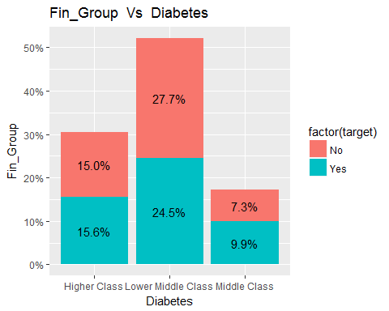

### Interpretation

#### Lower Middle class people are more prone to diabetes (24.5%)

printggPlot2(d_train,d_train$Family_history,d_train$Diabetes,colnames(data_d)[2],colnames(data_d)[9])

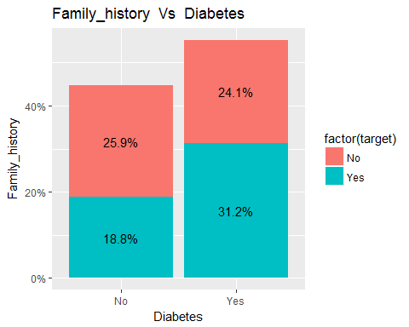

### Interpretation

#### People having family history of diabetes are more prone to diabetes(31.9%)

printggPlot2(d_train,d_train$Staple_Food,d_train$Diabetes,colnames(data_d)[3],colnames(data_d)[9])

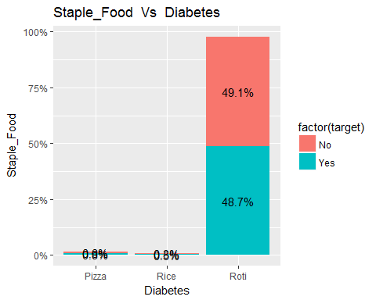

### Interpretation

#### People having Staple Food are more prone to diabetes(48.7%)

printggPlot2(d_train,d_train$Alcohol,d_train$Diabetes,colnames(data_d)[4],colnames(data_d)[9])

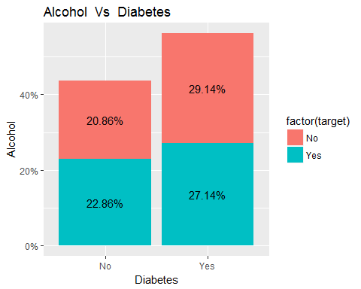

### Interpretation

#### People having Alcohol habit are more prone to diabetes(27.14%)

printggPlot2(d_train,d_train$Smoke,d_train$Diabetes,colnames(data_d)[5],colnames(data_d)[9])

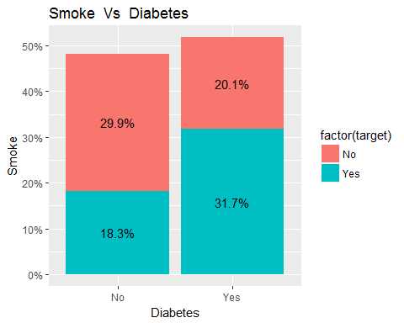

### Interpretation

#### People having Smoking habit are more prone to diabetes(31.7%)

printggPlot2(d_train,d_train$High_Cholestrol,d_train$Diabetes,colnames(data_d)[6],colnames(data_d)[9])

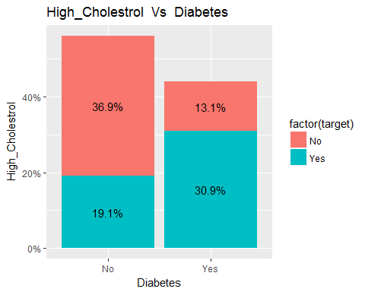

### Interpretation

#### People having High_Cholestrol are more prone to diabetes(30.9%)

printggPlot2(d_train,d_train$Phy_Activity,d_train$Diabetes,colnames(data_d)[7],colnames(data_d)[9])

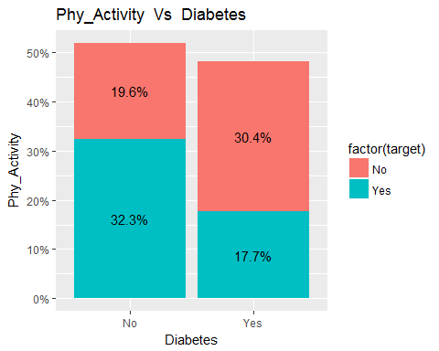

### Interpretation

#### People not having Phy_Activity are more prone to diabetes(32.3%)

printggPlot2(d_train,d_train$Obese,d_train$Diabetes,colnames(data_d)[8],colnames(data_d)[9])

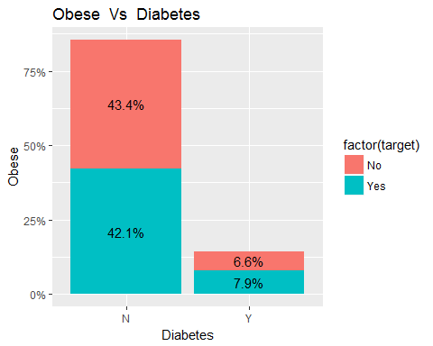

### Interpretation

#### People having obese are more prone to diabetes(42.1%)

## CART

formula <- Diabetes ~ Fin_Group + Family_history + Staple_Food + Alcohol + Smoke + High_Cholestrol + Phy_Activity + Obese  
title <- "Classification Tree for Diabetes"  
df <- d_train  
fit<-NULL  
pfit <- cart_fn(df, formula, title)

##   
## Classification tree:  
## rpart(formula = formula, data = d_train, method = "class")  
##   
## Variables actually used in tree construction:  
## [1] Family_history High_Cholestrol Phy_Activity Smoke   
##   
## Root node error: 700/1400 = 0.5  
##   
## n= 1400   
##   
## CP nsplit rel error xerror xstd  
## 1 0.355714 0 1.00000 1.06857 0.026663  
## 2 0.161429 1 0.64429 0.64429 0.024978  
## 3 0.085714 2 0.48286 0.49857 0.023123  
## 4 0.051429 3 0.39714 0.41714 0.021717  
## 5 0.040000 5 0.29429 0.36571 0.020662  
## 6 0.010000 6 0.25429 0.25429 0.017807

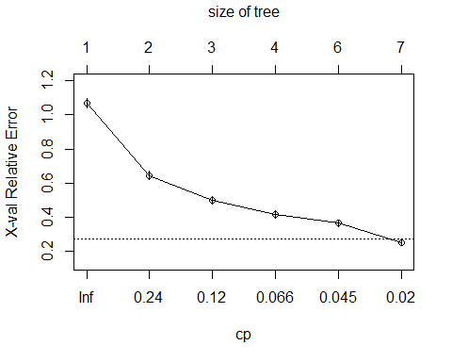

## Call:  
## rpart(formula = formula, data = d_train, method = "class")  
## n= 1400   
##   
## CP nsplit rel error xerror xstd  
## 1 0.35571429 0 1.0000000 1.0685714 0.02666322  
## 2 0.16142857 1 0.6442857 0.6442857 0.02497810  
## 3 0.08571429 2 0.4828571 0.4985714 0.02312342  
## 4 0.05142857 3 0.3971429 0.4171429 0.02171697  
## 5 0.04000000 5 0.2942857 0.3657143 0.02066193  
## 6 0.01000000 6 0.2542857 0.2542857 0.01780670  
##   
## Variable importance  
## Smoke Phy_Activity High_Cholestrol Family_history   
## 38 31 17 14   
##   
## Node number 1: 1400 observations, complexity param=0.3557143  
## predicted class=No expected loss=0.5 P(node) =1  
## class counts: 700 700  
## probabilities: 0.500 0.500   
## left son=2 (785 obs) right son=3 (615 obs)  
## Primary splits:  
## High_Cholestrol splits as LR, improve=89.898400, (0 missing)  
## Phy_Activity splits as RL, improve=44.822400, (0 missing)  
## Smoke splits as LR, improve=37.543220, (0 missing)  
## Family_history splits as LR, improve=14.447170, (0 missing)  
## Fin_Group splits as LLR, improve= 3.430844, (0 missing)  
## Surrogate splits:  
## Phy_Activity splits as RL, agree=0.743, adj=0.415, (0 split)  
## Smoke splits as LR, agree=0.734, adj=0.393, (0 split)  
## Family_history splits as RL, agree=0.612, adj=0.117, (0 split)  
## Staple_Food splits as LRL, agree=0.561, adj=0.002, (0 split)  
##   
## Node number 2: 785 observations, complexity param=0.05142857  
## predicted class=No expected loss=0.3414013 P(node) =0.5607143  
## class counts: 517 268  
## probabilities: 0.659 0.341   
## left son=4 (277 obs) right son=5 (508 obs)  
## Primary splits:  
## Family_history splits as LR, improve=63.7138400, (0 missing)  
## Smoke splits as RL, improve=45.3644100, (0 missing)  
## Phy_Activity splits as LR, improve=36.0856400, (0 missing)  
## Fin_Group splits as LLR, improve=18.5328700, (0 missing)  
## Alcohol splits as RL, improve= 0.6359643, (0 missing)  
## Surrogate splits:  
## Phy_Activity splits as LR, agree=0.652, adj=0.014, (0 split)  
##   
## Node number 3: 615 observations, complexity param=0.1614286  
## predicted class=Yes expected loss=0.297561 P(node) =0.4392857  
## class counts: 183 432  
## probabilities: 0.298 0.702   
## left son=6 (131 obs) right son=7 (484 obs)  
## Primary splits:  
## Smoke splits as LR, improve=133.7054000, (0 missing)  
## Phy_Activity splits as RL, improve=132.8831000, (0 missing)  
## Alcohol splits as RL, improve= 0.9061767, (0 missing)  
## Obese splits as LR, improve= 0.7898675, (0 missing)  
## Fin_Group splits as RLL, improve= 0.5847998, (0 missing)  
## Surrogate splits:  
## Phy_Activity splits as RL, agree=0.793, adj=0.031, (0 split)  
##   
## Node number 4: 277 observations  
## predicted class=No expected loss=0.06859206 P(node) =0.1978571  
## class counts: 258 19  
## probabilities: 0.931 0.069   
##   
## Node number 5: 508 observations, complexity param=0.05142857  
## predicted class=No expected loss=0.4901575 P(node) =0.3628571  
## class counts: 259 249  
## probabilities: 0.510 0.490   
## left son=10 (124 obs) right son=11 (384 obs)  
## Primary splits:  
## Smoke splits as RL, improve=33.76448000, (0 missing)  
## Phy_Activity splits as LR, improve=22.67744000, (0 missing)  
## Fin_Group splits as LLR, improve= 7.51036700, (0 missing)  
## Alcohol splits as RL, improve= 3.21276800, (0 missing)  
## Staple_Food splits as RRL, improve= 0.00197641, (0 missing)  
## Surrogate splits:  
## Phy_Activity splits as LR, agree=0.795, adj=0.161, (0 split)  
##   
## Node number 6: 131 observations  
## predicted class=No expected loss=0.06870229 P(node) =0.09357143  
## class counts: 122 9  
## probabilities: 0.931 0.069   
##   
## Node number 7: 484 observations, complexity param=0.08571429  
## predicted class=Yes expected loss=0.1260331 P(node) =0.3457143  
## class counts: 61 423  
## probabilities: 0.126 0.874   
## left son=14 (60 obs) right son=15 (424 obs)  
## Primary splits:  
## Phy_Activity splits as RL, improve=104.62870000, (0 missing)  
## Fin_Group splits as RLR, improve= 0.54669420, (0 missing)  
## Obese splits as LR, improve= 0.07778531, (0 missing)  
## Staple_Food splits as RRL, improve= 0.06443730, (0 missing)  
## Alcohol splits as RL, improve= 0.01197519, (0 missing)  
##   
## Node number 10: 124 observations  
## predicted class=No expected loss=0.1693548 P(node) =0.08857143  
## class counts: 103 21  
## probabilities: 0.831 0.169   
##   
## Node number 11: 384 observations, complexity param=0.04  
## predicted class=Yes expected loss=0.40625 P(node) =0.2742857  
## class counts: 156 228  
## probabilities: 0.406 0.594   
## left son=22 (48 obs) right son=23 (336 obs)  
## Primary splits:  
## Phy_Activity splits as LR, improve=16.2976200, (0 missing)  
## Fin_Group splits as LLR, improve= 3.9409090, (0 missing)  
## Alcohol splits as RL, improve= 2.0561390, (0 missing)  
## Obese splits as LR, improve= 0.2228395, (0 missing)  
##   
## Node number 14: 60 observations  
## predicted class=No expected loss=0 P(node) =0.04285714  
## class counts: 60 0  
## probabilities: 1.000 0.000   
##   
## Node number 15: 424 observations  
## predicted class=Yes expected loss=0.002358491 P(node) =0.3028571  
## class counts: 1 423  
## probabilities: 0.002 0.998   
##   
## Node number 22: 48 observations  
## predicted class=No expected loss=0.2083333 P(node) =0.03428571  
## class counts: 38 10  
## probabilities: 0.792 0.208   
##   
## Node number 23: 336 observations  
## predicted class=Yes expected loss=0.3511905 P(node) =0.24  
## class counts: 118 218  
## probabilities: 0.351 0.649

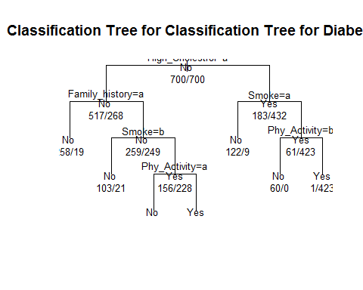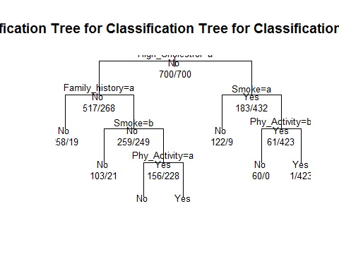

fancyRpartPlot(pfit)

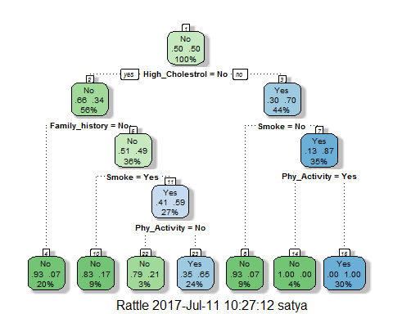

varImp(object=fit)

## rpart variable importance  
##   
## Overall  
## Phy_ActivityYes 100.00000  
## SmokeYes 73.40354  
## High_CholestrolYes 26.35565  
## Family_historyYes 22.91458  
## Fin_GroupMiddle Class 8.64096  
## Fin_GroupLower Middle Class 3.13072  
## AlcoholYes 1.20756  
## ObeseY 0.25437  
## Staple_FoodRoti 0.13557  
## Staple_FoodRice 0.03757  
## `Fin_GroupMiddle Class` 0.00000  
## `Fin_GroupLower Middle Class` 0.00000

plot(varImp(fit))

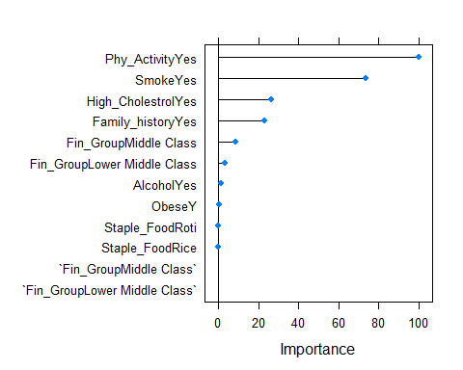

#### Interpretation of Variable Importance for diabetes

###### Above graph shows the top 10 important variables.Physical activity,smoking,high cholestrol and family history are the top influencing predictors.

###### Financial group and Alcohol comsumption also have significant importance.

### Performance measures using training data

target <- d_train[,'Diabetes']  
title <- 'Training dataset'  
perf_measures1 <- perf_measures_cart(d_train,pfit,target,title)

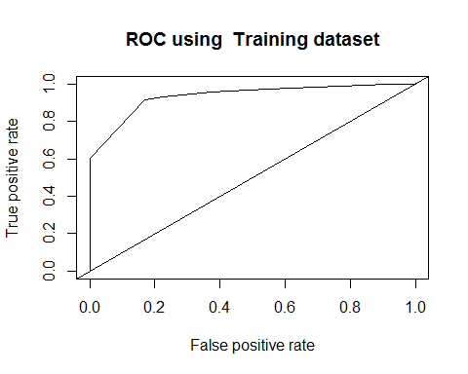

print(perf_measures1)

## Dataset KS auc gini OA  
## 1 Training dataset 0.7457143 0.9354122 0.4354122 0.8728571

cat("\n OA is overall accuracy \n")

##   
## OA is overall accuracy

### Performance measures using test data

target <- d_test[,'Diabetes']  
title <- 'Test dataset'  
perf_measures2 <- perf_measures_cart(d_test,pfit,target,title)

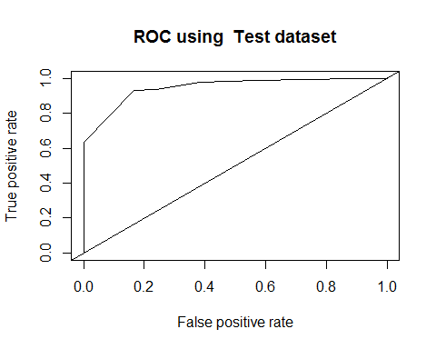

print(perf_measures2)

## Dataset KS auc gini OA  
## 1 Test dataset 0.7666667 0.9479611 0.4306094 0.8833333

cat("\n OA is overall accuracy \n")

##   
## OA is overall accuracy

### Logistic Regression

strTarget<-"Diabetes"  
formula <- Diabetes ~ Fin_Group + Family_history +   
 Staple_Food + Alcohol + Smoke + High_Cholestrol + Phy_Activity + Obese  
logit=logistic(formula,d_train)  
summary(logit)

##   
## Call:  
## glm(formula = formula, family = "binomial", data = d_train)  
##   
## Deviance Residuals:   
## Min 1Q Median 3Q Max   
## -2.22864 -0.95941 -0.06611 1.00334 2.17366   
##   
## Coefficients:  
## Estimate Std. Error z value Pr(>|z|)   
## (Intercept) -1.318497 0.544110 -2.423 0.01538 *   
## Fin_GroupLower Middle Class -0.048254 0.140424 -0.344 0.73112   
## Fin_GroupMiddle Class 0.837182 0.189552 4.417 1.00e-05 ***  
## Family_historyYes 1.302732 0.138803 9.386 < 2e-16 ***  
## Staple_FoodRice 0.702330 0.847708 0.829 0.40738   
## Staple_FoodRoti 0.006088 0.507671 0.012 0.99043   
## AlcoholYes -0.255713 0.122956 -2.080 0.03755 *   
## SmokeYes 0.423638 0.147235 2.877 0.00401 **   
## High_CholestrolYes 1.568759 0.149698 10.479 < 2e-16 ***  
## Phy_ActivityYes -0.647083 0.150154 -4.309 1.64e-05 ***  
## ObeseY 0.174333 0.172493 1.011 0.31218   
## ---  
## Signif. codes: 0 '***' 0.001 '**' 0.01 '*' 0.05 '.' 0.1 ' ' 1  
##   
## (Dispersion parameter for binomial family taken to be 1)  
##   
## Null deviance: 1940.8 on 1399 degrees of freedom  
## Residual deviance: 1604.7 on 1389 degrees of freedom  
## AIC: 1626.7  
##   
## Number of Fisher Scoring iterations: 4

#### Interpretation of Variable Importance for diabetes based on Coefficients table shown above

###### Physical activity,high cholestrol,family history and financial group are the top influencing predictors.

###### Smoking and Alcohol comsumption also have significant importance.significance level considered is 95%

perf <- pR2(logit)  
print(perf)

## llh llhNull G2 McFadden r2ML   
## -802.3273547 -970.4060528 336.1573962 0.1732045 0.2134606   
## r2CU   
## 0.2846141

### Logistic Regression Performance measures using training data

target <- d_train[,'Diabetes']  
title <- 'Training dataset'  
  
perf_measures1 <- perf_measures_logistic(d_train,logit,target,title)

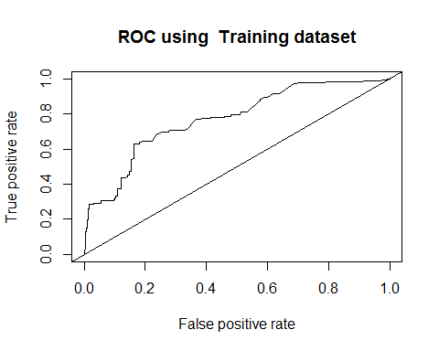

print(perf_measures1)

## Dataset auc McFadden OA  
## 1 Training dataset 0.7719918 0.1732045 0.483871

cat("\n OA is overall accuracy \n")

##   
## OA is overall accuracy

### Logistic Regression Performance measures using test data

target <- d_test[,'Diabetes']  
title <- 'Test dataset'  
perf_measures2 <- perf_measures_logistic(d_test,logit,target,title)

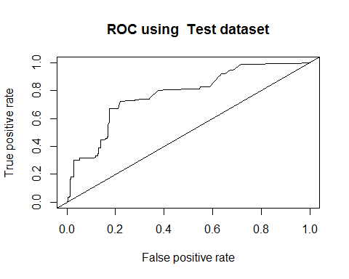

print(perf_measures2)

## Dataset auc McFadden OA  
## 1 Test dataset 0.7741556 0.1732045 0.25

cat("\n OA is overall accuracy \n")

##   
## OA is overall accuracy

varImp(logit, scale = FALSE)

## Overall  
## Fin_GroupLower Middle Class 0.34363038  
## Fin_GroupMiddle Class 4.41662832  
## Family_historyYes 9.38551044  
## Staple_FoodRice 0.82850474  
## Staple_FoodRoti 0.01199143  
## AlcoholYes 2.07970128  
## SmokeYes 2.87729635  
## High_CholestrolYes 10.47949576  
## Phy_ActivityYes 4.30945466  
## ObeseY 1.01066723

### End of R script

```