
SRI CHANDRASEKHARENDRA SARASWATHI VISWA MAHAVIDYALAYA
(UNIVERSITY ESTABLISHED under section 3 of UGC Act 1956) ENATHUR, KANCHIPURAM – 631 561

OBJECT ORIENTED PROGRAMMING IN JAVA
LABORATORY RECORD

Name :
Reg. No :
Class : B.Sc. (CS with Cyber Security)

Subject : BSCY233P80 – Object Oriented Programming
in Java Lab

SRI CHANDRASEKHARENDRA SARASWATHI VISWA MAHAVIDYALAYA
(University Established under section 3 of UGC Act 1956)

BONAFIDE CERTIFICATE

This is to certify that this is the bonafide record of work done by Mr./Ms. with Reg.No. of Second Year B.Sc. [Computer Science with Cyber Security] in the Object Oriented Programming in Java Laboratory during the year 2026.

Staff-in-charge Head of the Department

Submitted for the Practical Examination held on .

Internal Examiner External Exam

Index

S.No | Date | Title | Page No | Signature
1. |  | Java Programming Fundamentals
2. |  | Arrays and Strings
3. |  | Classes and Objects
4. |  | Inheritance and Polymorphism
5. |  | Packages and Interfaces
6. |  | Exception Handling
7. |  | Multithreading
8. |  | Introduction to Swing
9. |  | Swing Controls
10. |  | Event Handling

Date:

Object Oriented Java Programming Lab Exercises
Exercise 1: Java Program Fundamentals

AIM:
To write a Java Program using variables, data types, operators, input/output statements, and control structures.

ALGORITHM:
- Start the program.
- Create a Scanner object to read input from the user.
- Declare variables of different data types (int, double, char, boolean).
- Read two integer values from the user.
- Perform arithmetic operations:
  - Addition
  - Subtraction
  - Multiplication
  - Division (If the second number is not Zero).
  - Modulus
- Calculate the average of the two numbers.
- Compare the two numbers using a relational operator.
- Determine the grade using the if-else control structure based on the average.
- Display the results of all operations.
- Use a for loop to display numbers from 1 to 10.
- Close the Scanner object.
- Stop the program.

SOURCE CODE:

Import java.util.Scanner;
public class Program1 {
public static void main(String[] args) {
//Scanner Object
Scanner sc = new Scanner(System.in);

//Variable Declaration int num1, num2; double average;
char grade; boolean isGreater;

//Inputs
System.out.print("Enter first number: "); num1 = sc.nextInt(); System.out.print("Enter second number: "); num2 = sc.nextInt();
//Operations
int sum = num1 + num2;
int difference = num1 - num2; int product = num1 * num2;

double quotient;

if (num2 != 0) {
quotient = (double) num1 / num2;
} else {
System.out.println("Division by zero is not

allowed.");

}

quotient = 0; // Assigning a default value

average = (num1 + num2) / 2.0;

//Relational Operation
isGreater = num1 > num2;

//Grade Calculation - IF ELSE
if (average >= 90) { grade = 'A';
} else if (average >= 80) { grade = 'B';
} else if (average >= 70) { grade = 'C';
} else if (average >= 60) { grade = 'D';
} else {
grade = 'F';

zero)");
}

//Outputs
System.out.println("Sum: " + sum); System.out.println("Difference: " + difference); System.out.println("Product: " + product);
if (num2 != 0) {
System.out.println("Quotient: " + quotient);
} else {
System.out.println("Quotient: Undefined (division by

}
System.out.println("Average: " + average); System.out.println("Is first number greater than second? "
+ isGreater);
System.out.println("Grade: " + grade);

//Loop - For Loop System.out.println("Numbers from 1 to 10:"); for (int i = 1; i <= 10; i++) {
System.out.print(i + " ");

numbers

}
}
System.out.println(); // Print a new line after the

//Closing Scanner
sc.close();

}

COMPILATION PROCESS:
- Type the java Program in a programming environment and save it with the file name Program1.java.
- Open the Command Prompt or Terminal.
- Navigate to the folder where the program is saved using the cd command.
- Compile the program using the command: javac Program1.java
- If no error occurred, then Run the program using the command: java Program1

OUTPUT:

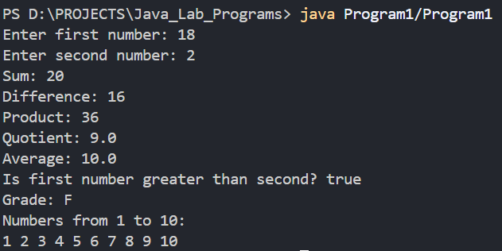

RESULT:
The Java Program was compiled and executed successfully. The Expected output has been generated and verified.

Date:

Exercise 2: Arrays and Strings

AIM:
To develop a Java Program using one-dimensional array, two-dimensional array, String, and StringBuffer classes.

ALGORITHM:
- Start the program.
- Create a Scanner object to read input from the user.
- Declare a one-dimensional array of size 5.
- Read five integer elements into the array.
- Calculate the sum of the array elements.
- Display the elements and their sum.
- Declare a two-dimensional (2x2) array.
- Read the elements of the 2x2 matrix from the user.
- Display the matrix.
- Read a string from the user.
- Perform string operations:
  - Find the length of the string.
  - Convert it to uppercase.
  - Convert it to lowercase.
  - Reverse the string.
- Create a StringBuffer object and Perform the following operations:
  - Append a string.
  - Insert a string.
  - Replace characters.

  - Delete characters.
  - Reverse the string.
- Display the results of all operations.
- Close the Scanner object.
- Stop the program.

SOURCE CODE:

import java.util.Scanner; public class Program2 {
public static void main(String[] args) {
//Scanner Object
Scanner sc = new Scanner(System.in);

//----- 1D Array -----int[] arr = new int[5]; int sum = 0;
System.out.println("Enter 5 numbers for the array:"); for (int i = 0; i < arr.length; i++) {
arr[i] = sc.nextInt(); sum += arr[i];
}

System.out.println("\nElements in the array:"); for (int i = 0; i < arr.length; i++) {
System.out.print(arr[i] + " ");
}

System.out.println("\nSum of array elements: " + sum);
//----- 2D Array -----
int[][] matrix = new int[2][2]; System.out.println("\nEnter elements for a 2x2 matrix:"); for (int i = 0; i < matrix.length; i++) {
for (int j = 0; j < matrix[i].length; j++) { matrix[i][j] = sc.nextInt();
}
}

System.out.println("\nElements in the 2x2 matrix:"); for (int i = 0; i < matrix.length; i++) {
for (int j = 0; j < matrix[i].length; j++) { System.out.print(matrix[i][j] + " ");
}
System.out.println();

//----- String Operations -----System.out.print("\nEnter a string: "); String inputString = sc.next();
System.out.println("You entered: " + inputString); System.out.println("Length of the string: " +
inputString.length());
System.out.println("Uppercase: " + inputString.toUpperCase());
System.out.println("Lowercase: " + inputString.toLowerCase());
System.out.println("Reversed string: " + new StringBuilder(inputString).reverse());

//----- StringBuffer Operations -----StringBuffer sb = new StringBuffer(inputString); sb.append(" Java");
System.out.println("\nStringBuffer after appending: " +

sb);

}
}

sb.insert(0, "Hello ");
System.out.println("StringBuffer after inserting: " + sb);
sb.delete(0, 6);
System.out.println("StringBuffer after deleting: " + sb);

sb.replace(0, 4, "Hi");
System.out.println("StringBuffer after replacing: " + sb);

sb.reverse();
System.out.println("StringBuffer after reversing: " + sb); sc.close();

COMPILATION PROCESS:
- Type the java Program in a programming environment and save it with the file name Program2.java.
- Open the Command Prompt or Terminal.
- Navigate to the folder where the program is saved using the cd command.
- Compile the program using the command: javac Program2.java
- If no error occurred, then Run the program using the command: java Program2

OUTPUT:
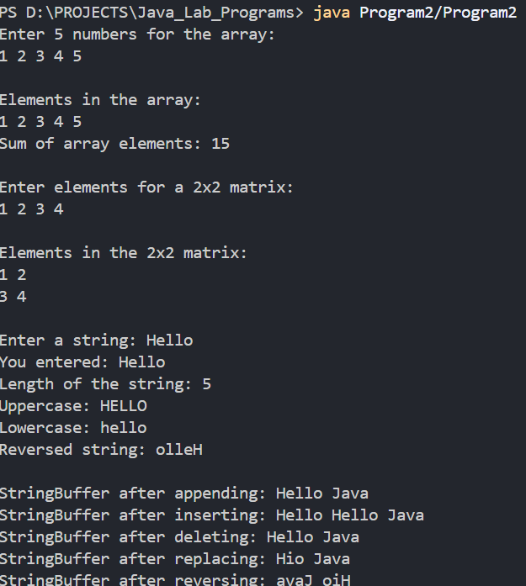

RESULT:
The Java Program was compiled and executed successfully. The Expected output has been generated and verified.

Date:

Exercise 3: Classes and Object

AIM:
To develop a Java Program demonstrating Classes, Objects, Methods, and Constructors

ALGORITHM:
- Start the program.
- Import the Scanner class for the user input.
- Define a Student class with data members:
  - Roll Number
  - Name
  - Marks array
  - Total and Average
  - Grade
- Create a parameterized constructor to initialize the student’s roll number and name.
- Create the getMarks() method to
  - Read marks for 5 subjects.
  - Store them in an array.
  - Calculate the total marks.
  - Calculate the average marks.
- Create the calculateGrade() method to determine the grade based on the average.
- Create the displayDetails() method to display the student’s roll number, name, subject marks, total, average, and grade.
- In the main() method:

  - Read the student’s roll number and name.
  - Create a student object using the constructor.
  - Call the getMarks() method.
  - Call the calculateGrade() method.
  - Call the displayDetails() method.
- Close the Scanner object.
- Stop the program.

SOURCE CODE:

import java.util.Scanner;

class Student { int rollNo; String name;
int[] marks = new int[5]; int total;
double average; char grade;
Student(int rollNo, String name){ this.rollNo = rollNo; this.name = name;
}

//methods to get marks void getMarks(Scanner sc){
total = 0;
System.out.println("\nEnter marks for 5 subjects: "); for(int i=0; i<5; i++){
System.out.println("Subject " + (i+1) + ": "); marks[i] = sc.nextInt();
total += marks[i];
}
average = (double)total / marks.length;
}

//calculate grade
void calculateGrade(){ if(average >= 90){
grade = 'A';
} else if(average >= 80){ grade = 'B';

} else if(average >= 70){ grade = 'C';
} else if(average >= 60){ grade = 'D';
} else {
grade = 'F';
}
}

//display student details
void displayDetails(){ System.out.println("\nStudent Details:"); System.out.println("Roll No: " + rollNo); System.out.println("Name: " + name); System.out.println("Marks: ");
for(int i=0; i<marks.length; i++){ System.out.println("Subject " + (i+1) + ": " +
marks[i]);
}
System.out.println("Total Marks: " + total); System.out.println("Average Marks: " + average); System.out.println("Grade: " + grade);
}
}

public class Program3 {
public static void main(String[] args) { Scanner sc = new Scanner(System.in); System.out.print("Enter roll number: "); int rollNo = sc.nextInt();
sc.nextLine(); // consume the newline character System.out.print("Enter name: ");
String name = sc.nextLine();
Student student = new Student(rollNo, name); student.getMarks(sc); student.calculateGrade(); student.displayDetails();
sc.close();
}
}

COMPILATION STEPS:
- Type the java Program in a programming environment and save it with the file name Program3.java.
- Open the Command Prompt or Terminal.
- Navigate to the folder where the program is saved using the cd command.
- Compile the program using the command: javac Program3.java
- If no error occurred, then Run the program using the command: java Program3

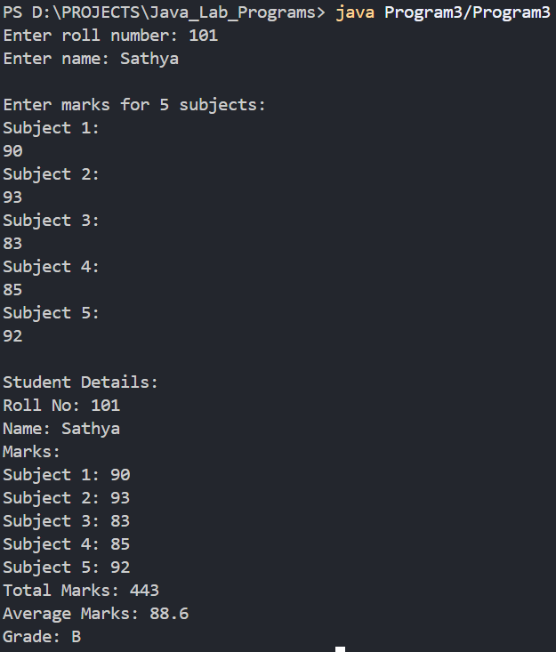
OUTPUT:

RESULT:
The Java Program was compiled and executed successfully. The Expected output as been generated and verified.

Date:

Exercise 4: Inheritance and Polymorphism
AIM:
To develop a Java Program demonstrating the concepts of Single Inheritance, Multilevel Inheritance, Hierarchical Inheritance, Method Overloading, and Method Overriding.

ALGORITHM:
- Start the program.
- Create a superclass named Person with a data member name and a method display().
- Create a subclass Student that inherits from Person.
- Override the display() method in the Student class.
- Create two overloaded showDetails() methods in the Student class.
- Create another subclass SportsStudent that inherits from Student to demonstrates Multilevel Inheritance.
- Override the display() method in the SportsStudent class.
- Create another subclass Teacher that inherits from Person to demonstrate Hierarchical Inheritance.
- Override the display() method in the Teacher class.
- In the main() method, create objects of the Student, SportsStudent, and Teacher classes.
- Call the appropriate methods to demonstrate Inheritance, Method Overloading, and Method Overriding.
- Display the output.
- Stop the Program.

SOURCE CODE:
class Person{
String name;

Person(String name) { this.name = name;
}

void display() { System.out.println("Name: " + name);
}
}

//Single Inheritance
class Student extends Person { int rollNo;

Student(String name, int rollNo) { super(name);
this.rollNo = rollNo;
}
//Method Overriding
@Override
void display() { super.display();
System.out.println("Roll No: " + rollNo);
}

//Method Overloading
void showDetails(){
System.out.println("Student details displayed successfully.");
}
void showDetails(String dept){ System.out.println("Department: " + dept);
}
}

//Multilevel Inheritance
class SportsStudent extends Student {

String sport;

SportsStudent(String name, int rollNo, String sport) { super(name, rollNo);
this.sport = sport;
}

@Override
void display() { super.display();
System.out.println("Sport: " + sport);
}
}

//Hierarchical Inheritance
class Teacher extends Person { String subject;
Teacher(String name, String subject) { super(name);
this.subject = subject;
}

@Override
void display() { super.display();
System.out.println("Subject: " + subject);
}
}

public class Program4 {
public static void main(String[] args) { System.out.println("===== Student ======"); Student student = new Student("John Doe", 101); student.display();
student.showDetails(); student.showDetails("Computer Science");

System.out.println("\n===== Sports Student ======"); SportsStudent sportsStudent = new SportsStudent("Jane
Smith", 102, "Basketball"); sportsStudent.display();

System.out.println("\n===== Teacher ======"); Teacher teacher = new Teacher("Mr. Johnson",
"Mathematics");
teacher.display();
}
}

COMPILATION STEPS:
- Type the java Program in a programming environment and save it with the file name Program4.java.
- Open the Command Prompt or Terminal.
- Navigate to the folder where the program is saved using the cd command.
- Compile the program using the command: javac Program4.java
- If no error occurred, then Run the program using the command: java Program4

OUTPUT:
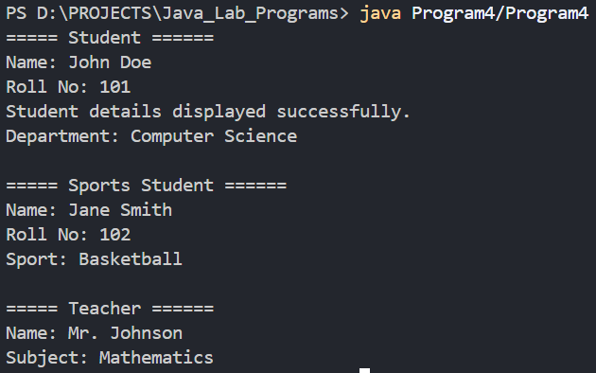

RESULT:
The Java Program was compiled and executed successfully. The Expected output has been generated and verified.

Date:

Exercise 5: Packages and Interfaces

AIM:
To develop a Java Program using an Interface and a User-defined Package to perform simple Arithmetic operations.

ALGORITHM:
- Start the program.
- Create an interface Calculator inside a package named mypackage.
- Declare methods in the interface:
  - add()
  - subtract()
  - product()
  - divide()
  - modulus()
- Import the Calculator interface into the main program.
- Create a class MyCalculator that implements the Calculator interface.
- Override the methods inside the class MyCalculator.
- In the main method:
  - Declare a Scanner object and read two integer values from user.
  - Create an object of the class MyCalculator
  - Call the Overridden methods using the class object to perform the operations.
- Display the results.
- Stop the program.

STRUCTURE:
Program_Folder/
|
|- Exercise4.java
|- MyPackage/
|
|- Calculator.java

SOURCE CODE:
Program_Folder/MyPackage/Calculator.java:
package MyPackage;

public interface Calculator { public int add(int a, int b);
public int subtract(int a, int b); public int multiply(int a, int b); public double divide(int a, int b); public int modulus(int a, int b);
}

Program_Folder/Program5.java:

import MyPackage.Calculator; import java.util.Scanner;
class MyCalculator implements Calculator { @Override
public int add(int a, int b) { return a + b;
}

@Override
public int subtract(int a, int b) { return a - b;
}

@Override
public int multiply(int a, int b) { return a * b;
}

@Override
public double divide(int a, int b) { if (b == 0) {
System.out.println("Error: Division by zero is not
allowed.");

}
return (double) a / b;
}

@Override
public int modulus(int a, int b) { if (b == 0) {
System.out.println("Error: Modulus by zero is not
allowed.");
return 0; // Return 0 or handle the error as needed
} else {
return a % b;
}
}
}

public class Program5 {
public static void main(String[] args) { Scanner sc = new Scanner(System.in);

System.out.print("Enter first number: "); int num1 = sc.nextInt(); System.out.print("Enter second number: "); int num2 = sc.nextInt();
MyCalculator calculator = new MyCalculator(); System.out.println("Addition: " + calculator.add(num1,
num2));
System.out.println("Subtraction: " +
calculator.subtract(num1, num2)); System.out.println("Multiplication: " +
calculator.multiply(num1, num2)); if(num2 != 0) {
System.out.println("Division: " + calculator.divide(num1, num2));
} else {
System.out.println("Division: Error: Division by zero is not allowed.");
}
if(num2 != 0) { System.out.println("Modulus: " +
calculator.modulus(num1, num2));
} else {
System.out.println("Modulus: Error: Modulus by zero is not allowed.");
}

sc.close();
}
}

COMPILATION STEPS:
- Type the java Program in a programming environment and save it with the file name
Program5.java.
- Open the Command Prompt or Terminal.
- First change the directory to the Package MyPackage using the cd, and compile the Calculator.java by using the command: javac Calculator.java.
- Then Change back to the parent directory, and compile the file Program5.java using the command: javac Program5.java
- Execute the code Exercise5.java using the command: java Program5.

OUTPUT:
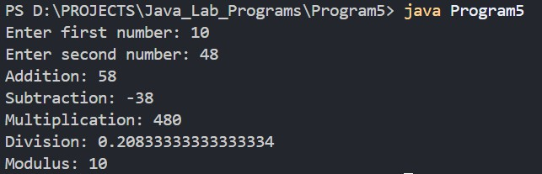

RESULT:
The Java Program was compiled and executed successfully. The Expected output has been generated and verified.

Date:

Program-6: Exception Handling

Aim:
To write a Java Program demonstrating exception handling using try, catch, finally,
throw, throws, and a user-defined exception.

Algorithm:
- Start the Program.
- Create a user-defined exception class named AgeException by extending the
Exception class
- Create a method checkage() that uses the throws keyword to declare
AgeException.
- Inside checkage(), check whether the given age is less that 18.
- If the age is less than 18, use throw to generate an AgeException.
- Otherwise, display that the person is eligible.
- In the main() method, use a try block to call checkage().
- Use a catch block to handle the user-defined exception.
- Add another try-catch block to demonstrate handling of an arithmetic exception.
- Use a finally block to display message that the block is always executed.
- Stop the Program.

Source Code:
import java.util.Scanner;
// User-defined exception
class AgeException extends Exception { AgeException(String message) {
super(message);
}
}
public class Program6 {

// Method using throws
static void checkAge(int age) throws AgeException { if (age < 18) {

// Using throw
throw new AgeException("Age must be 18 or above.");
} else {
System.out.println("Eligible to vote.");
}
}
public static void main(String[] args) { Scanner sc = new Scanner(System.in);
// try-catch-finally with user-defined exception try {
System.out.print("Enter your age: "); int age = sc.nextInt();

checkAge(age);
}
catch (AgeException e) {
System.out.println("Exception: " + e.getMessage());
}
finally {
System.out.println("Age verification completed.");
}
// try-catch for built-in exception try {
System.out.print("Enter a number: "); int num = sc.nextInt();

int result = 100 / num; System.out.println("Result = " + result);
}
catch (ArithmeticException e) {
System.out.println("Exception: Cannot divide by zero.");
}
finally {
System.out.println("Arithmetic operation completed.");
}
sc.close();
}
}

Compilation Steps:
- Type the java Program in a programming environment and save it with the file name Program6.java.
- Open the Command Prompt or Terminal
- Navigate to the folder where the program is saved using the cd command.
- Compile the program using the command: javac Program6.java
- If no error occurred, then Run the program using the command: java Program6.

Output:
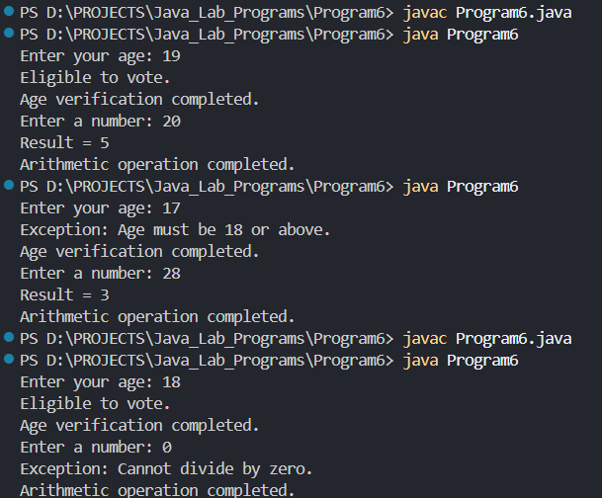

Result:
Thus, the Java Program was successfully executed to demonstrate try, catch, finally, throw and throws, and user-defined exception handling.

Date:

Program-7: Multithreading

Aim:
To write a Java Program to create and execute multiple threads using the Thread class and Runnable interface.

Algorithm:
- Start the program.
- Create a class MyThread by extending the Thread class.
- Override the run() method in MyThread.
- Create another class MyRunnable that implements the Runnable interface.
- Override the run() method in MyRunnable.
- Create objects of both classes.
- Create a Thread object using the MyRunnable object.
- Start both threads using the start() method.
- The run() methods execute concurrently.
- Display the thread name and its iteration number.
- Use join() to wait for both threads to complete.
- Display a message indicating that all threads have completed.
- Stop the Program.

Source Code:
// Program to demonstrate Multithreading

// Thread class
class MyThread extends Thread {
public void run() {
for (int i = 1; i <= 5; i++) { System.out.println("Thread Class: " + i);
try {
Thread.sleep(500);
} catch (InterruptedException e) { System.out.println("Thread interrupted.");
}
}

}
}
// Runnable interface
class MyRunnable implements Runnable {
public void run() {
for (int i = 1; i <= 5; i++) {
System.out.println("Runnable Interface: " + i);

try {
Thread.sleep(500);
} catch (InterruptedException e) { System.out.println("Thread interrupted.");
}
}
}
}
public class Program7 {

public static void main(String[] args) {

// Creating thread using Thread class MyThread t1 = new MyThread();

// Creating thread using Runnable interface MyRunnable r = new MyRunnable(); Thread t2 = new Thread(r);
// Starting both threads t1.start();
t2.start();

try {
// Wait for both threads to finish t1.join();
t2.join();
} catch (InterruptedException e) { System.out.println("Main thread interrupted.");
}
System.out.println("All threads completed.");
}

Compilation Steps:

- Type the java Program in a programming environment and save it with the file name Program7.java.
- Open the Command Prompt or Terminal
- Navigate to the folder where the program is saved using the cd command.
- Compile the program using the command: javac Program7.java
- If no error occurred, then Run the program using the command: java Program7.

Output:
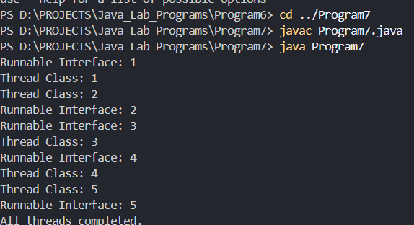

Result:
Thus, the Java Program was successfully executed to demonstrate multithreading using the Thread class and Runnable interface.

Date:

Program-8: Introduction to Swing

Aim:
To write a Java Swing program to create a basic GUI application using JFrame, JPanel, JLabel, JButton, JTextField, JTextArea.

Algorithm:
- Start the Program.
- Create a class named SwingDemo that extends JFrame.
- Create a JPanel to hold the GUI Components.
- Create a JLabel components to display labels.
- Create a JTextField to accept a name from the user.
- Create a JTextArea to display the entered information.
- Create a JButton named Submit.
- Add an ActionListener to the button.
- When the button is clicked, read the name form the text field.
- Display the entered name in the text area.
- Add all components to the panel.
- Add the panel to the frame.
- Set the frame size and make it visible.
- Stop the program.

Source Code:
import javax.swing.*; import java.awt.*; import java.awt.event.*;
public class Program8 extends JFrame {
JLabel nameLabel;
JTextField nameField; JButton submitButton; JTextArea outputArea; JPanel panel;

Program8() {

// Create panel
panel = new JPanel();
panel.setLayout(new FlowLayout());
// Create label
nameLabel = new JLabel("Enter Your Name:");

// Create text field
nameField = new JTextField(15);

// Create button
submitButton = new JButton("Submit");
// Create text area
outputArea = new JTextArea(5, 25); outputArea.setEditable(false);
// Add action to button
submitButton.addActionListener(new ActionListener() { public void actionPerformed(ActionEvent e) {

String name = nameField.getText();
outputArea.setText("Hello, " + name + "!\n" + "Welcome to Java Swing.");
}
});
// Add components to panel panel.add(nameLabel); panel.add(nameField);
panel.add(submitButton); panel.add(outputArea);

// Add panel to frame add(panel);
// Frame settings
setTitle("Java Swing Demo"); setSize(400, 250);
setDefaultCloseOperation(JFrame.EXIT_ON_CLOSE); setVisible(true);
}
public static void main(String[] args) { new Program8();
}
}

Compilation Steps:
- Type the java Program in a programming environment and save it with the file name Program8.java.
- Open the Command Prompt or Terminal
- Navigate to the folder where the program is saved using the cd command.
- Compile the program using the command: javac Program8.java
- If no error occurred, then Run the program using the command: java Program8.

Output:
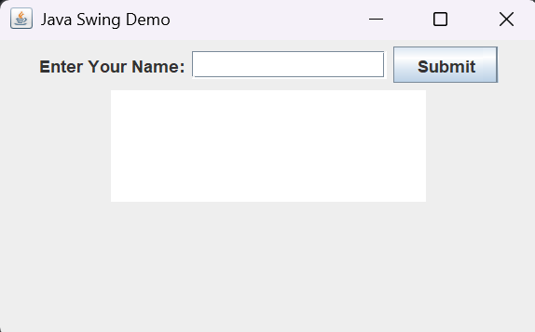

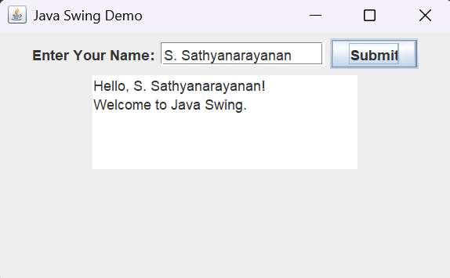

Result:
Thus, the Java Swing program was successfully executed to create a basic GUI application using JFrame, JPanel, JLabel, JButton, JTextField, and JTextArea.

  - Date:

Program-9: Swing Controls

Aim:
To write a Java Swing program to demonstrate various Swing controls such as
JCheckBox, JRadioButton, JComboBox, JList, JTable, JScrollPane, and JOptionPane.

Algorithm:
- Start the program.
- Create a JFrame to display the GUI.
- Create a JCheckBox for selecting a programming language.
- Create JRadioButton components for selecting gender.
- Group the radio buttons using ButtonGroup.
- Create a JComboBox for selecting a course.
- Create a JList for selecting skills.
- Create a JTable to display student details.
- Add the JTbale inside a JScrollPane so the table can be scrolled.
- Create a JButton named Submit.
- When the Submit button is clicked, retrieve the selected values.
- Display the selectd information using JOptionPane.
- Set the frame size and make it visible.
- Stop the program.

Source Code:

import javax.swing.*; import java.awt.*; import java.awt.event.*;
public class Program9 extends JFrame { JCheckBox javaCheckBox;
JRadioButton maleRadio;
JRadioButton femaleRadio; JComboBox<String> courseComboBox; JList<String> skillsList;
JTable studentTable;
JButton submitButton;
Program9() {

setTitle("Swing Controls Demo"); setSize(600, 600);
setDefaultCloseOperation(JFrame.EXIT_ON_CLOSE);
JPanel panel = new JPanel();
panel.setLayout(new FlowLayout());

// JCheckBox
javaCheckBox = new JCheckBox("Java");
// JRadioButton
maleRadio = new JRadioButton("Male"); femaleRadio = new JRadioButton("Female");

ButtonGroup genderGroup = new ButtonGroup(); genderGroup.add(maleRadio);
genderGroup.add(femaleRadio);

// JComboBox
String[] courses = {
"B.Sc Cybersecurity", "BCA",
"B.Sc Computer Science", "B.Tech IT"
};

courseComboBox = new JComboBox<>(courses);
// JList
String[] skills = { "Java",
"Python",
"HTML",
"CSS",
"JavaScript"
};

skillsList = new JList<>(skills); skillsList.setVisibleRowCount(3);
JScrollPane listScrollPane = new JScrollPane(skillsList);

// JTable
String[] columns = {"ID", "Name", "Course"}; String[][] data = {

{"101", "Arun", "Cybersecurity"},
{"102", "Bala", "BCA"},
{"103", "Kiran", "Computer Science"}
};
studentTable = new JTable(data, columns);

JScrollPane tableScrollPane = new JScrollPane(studentTable);

// Submit button
submitButton = new JButton("Submit");
submitButton.addActionListener(new ActionListener() { public void actionPerformed(ActionEvent e) {

String gender = "";

if (maleRadio.isSelected()) { gender = "Male";
} else if (femaleRadio.isSelected()) { gender = "Female";
} else {
gender = "Not Selected";
}
String course =
courseComboBox.getSelectedItem().toString(); String language;
if (javaCheckBox.isSelected()) { language = "Java";
} else {
language = "Not Selected";
}
String skillsSelected =
skillsList.getSelectedValue();

if (skillsSelected == null) {
skillsSelected = "Not Selected";
}

String message =
"Gender: " + gender + "\nCourse: " + course + "\nLanguage: " + language +

"\nSkill: " + skillsSelected;
JOptionPane.showMessageDialog( Program9.this,
message,
"Selected Information", JOptionPane.INFORMATION_MESSAGE
);
}
});
// Add components
panel.add(new JLabel("Select Language:")); panel.add(javaCheckBox);

panel.add(new JLabel("Gender:")); panel.add(maleRadio);
panel.add(femaleRadio);

panel.add(new JLabel("Course:")); panel.add(courseComboBox);

panel.add(new JLabel("Select Skill:")); panel.add(listScrollPane);
panel.add(tableScrollPane); panel.add(submitButton); add(panel);
setVisible(true);
}

public static void main(String[] args) { new Program9();
}
}

Compilation Steps:
- Type the java Program in a programming environment and save it with the file name Program9.java.
- Open the Command Prompt or Terminal
- Navigate to the folder where the program is saved using the cd command.
- Compile the program using the command: javac Program9.java
- If no error occurred, then Run the program using the command: java Program9.

Output:
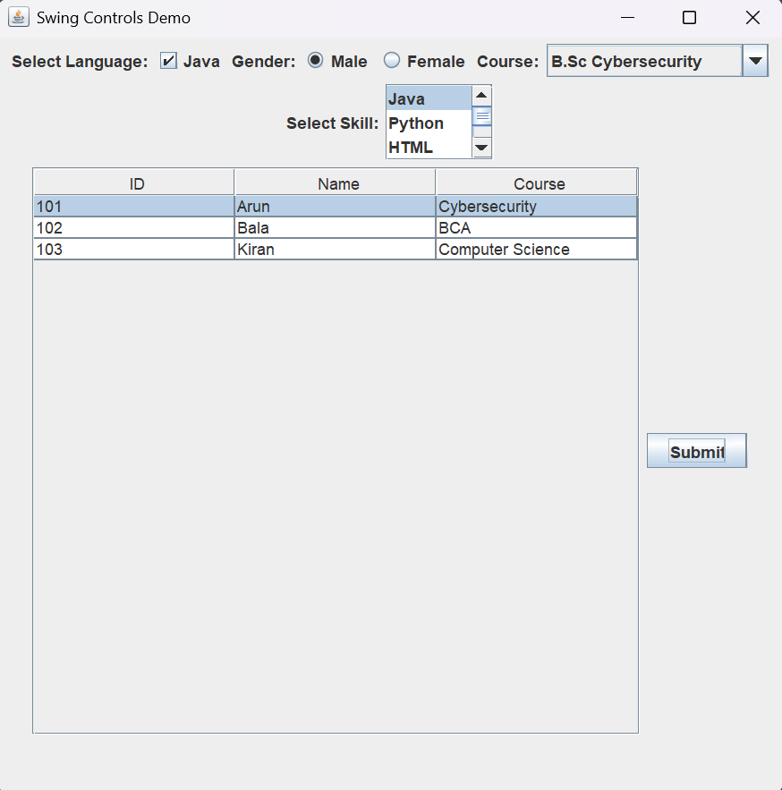
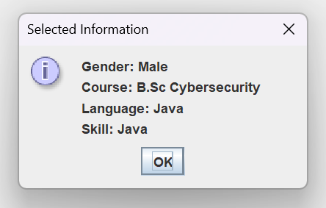

Result:
Thus, the Java Swing program was successfully executed to demonstrate JCheckBox, JRadioButton, JComboBox, JList, JTable, JScrollPane, and JOptionPane.

Date:

Program-10: Event Handling

Aim:
To write a Java Swing program to demonstrate event handling using ActionListener, ItemListener, MouseListener, MouseMotionListener, KeyListener, and WindowListener.

Algorithm:

- Start the Program.
- Create a JFrame with required Swing components.
- Create a JButton and register an ActionListener to handle button clicks.
- Create a JCheckBox and register an ItemListener to detect selection changes.
- Register a MouseListener with the frame to detect mouse clicks and other mouse events.
- Register a MouseMotionListener to detect mouse movement.
- Create a JTextField and register a KeyListener to detect keyboard events.
- Register a WindowListener with the frame to handle window events.
- Display the event information in a JTextArea.
- Perform different actions such as clicking the button, selecting the checkbox, moving the mouse, pressing keys, and closing the window.
- Display the corresponding event messages.
- Stop the program.

Source Code:

import javax.swing.*; import java.awt.*; import java.awt.event.*;
public class Program10 extends JFrame implements ActionListener, ItemListener, MouseListener, MouseMotionListener, KeyListener, WindowListener {
JButton button;
JCheckBox checkBox; JTextField textField; JTextArea textArea;

Program10() {
setTitle("Java Event Handling"); setSize(600, 500);
setLayout(new FlowLayout());

// Create components
button = new JButton("Click Me");
checkBox = new JCheckBox("Select Me"); textField = new JTextField(20);
textArea = new JTextArea(15, 45); textArea.setEditable(false);
// Register listeners button.addActionListener(this); checkBox.addItemListener(this); addMouseListener(this); addMouseMotionListener(this); textField.addKeyListener(this); addWindowListener(this);

// Add components add(button);
add(checkBox);

add(new JLabel("Type something:")); add(textField);
add(new JScrollPane(textArea));

setDefaultCloseOperation(JFrame.DO_NOTHING_ON_CLOSE); setVisible(true);
}

// ActionListener
public void actionPerformed(ActionEvent e) {
textArea.append("ActionListener: Button clicked\n");
}
// ItemListener
public void itemStateChanged(ItemEvent e) {

if (checkBox.isSelected()) {
textArea.append("ItemListener: Checkbox selected\n");
} else {

textArea.append("ItemListener: Checkbox deselected\n");
}
// MouseListener
public void mouseClicked(MouseEvent e) {
textArea.append("MouseListener: Mouse clicked\n");
}
public void mousePressed(MouseEvent e) {
textArea.append("MouseListener: Mouse pressed\n");
}
public void mouseReleased(MouseEvent e) {
textArea.append("MouseListener: Mouse released\n");
}

public void mouseEntered(MouseEvent e) {
textArea.append("MouseListener: Mouse entered window\n");
}

public void mouseExited(MouseEvent e) {
textArea.append("MouseListener: Mouse exited window\n");
}
// MouseMotionListener
public void mouseMoved(MouseEvent e) {
textArea.append("MouseMotionListener: Mouse moved\n");
}

public void mouseDragged(MouseEvent e) {
textArea.append("MouseMotionListener: Mouse dragged\n");
}

// KeyListener
public void keyTyped(KeyEvent e) {
textArea.append("KeyListener: Key typed = " + e.getKeyChar() + "\n");
}

public void keyPressed(KeyEvent e) {
textArea.append("KeyListener: Key pressed\n");
}
public void keyReleased(KeyEvent e) {
textArea.append("KeyListener: Key released\n");
}
// WindowListener

public void windowOpened(WindowEvent e) {
textArea.append("WindowListener: Window opened\n");
}

public void windowClosing(WindowEvent e) {
textArea.append("WindowListener: Window closing\n"); JOptionPane.showMessageDialog(
this,
"Window is closing."
);
dispose();
}
public void windowClosed(WindowEvent e) { System.out.println("WindowListener: Window closed");
}

public void windowIconified(WindowEvent e) {
textArea.append("WindowListener: Window minimized\n");
}
public void windowDeiconified(WindowEvent e) {
textArea.append("WindowListener: Window restored\n");
}
public void windowActivated(WindowEvent e) {
textArea.append("WindowListener: Window activated\n");
}
public void windowDeactivated(WindowEvent e) {
textArea.append("WindowListener: Window deactivated\n");
}

public static void main(String[] args) { new Program10();
}
}

Compilation Steps:
- Type the java Program in a programming environment and save it with the file name Program10.java.
- Open the Command Prompt or Terminal
- Navigate to the folder where the program is saved using the cd command.
- Compile the program using the command: javac Program10.java
- If no error occurred, then Run the program using the command: java Program10.

Output:
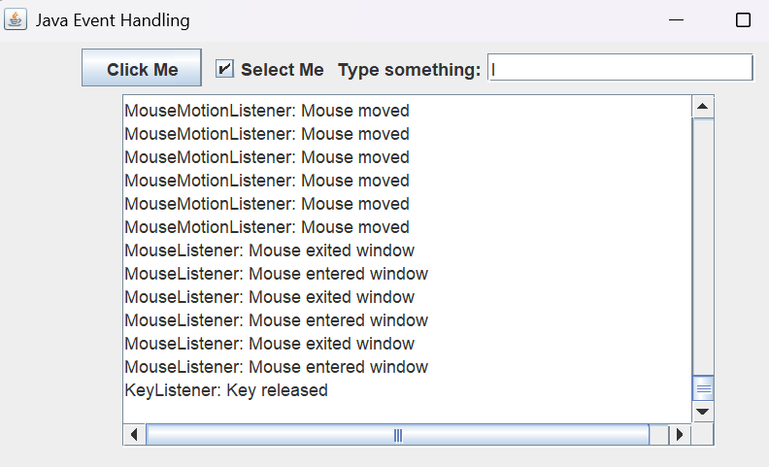

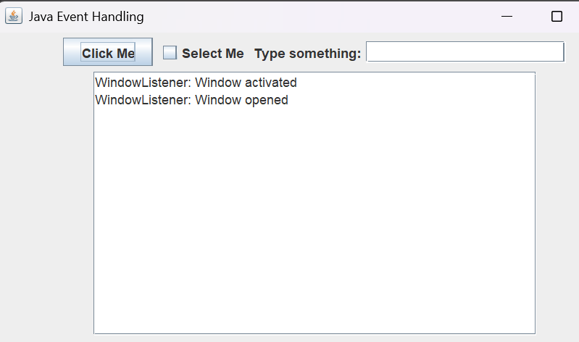

Result:
Thus, the Java Swing program was successfully executed to demonstrate event handling using ActionListener, ItemListener, MouseListener, MouseMotionListener, KeyListener, and WindowListener.

