4. SYSTEMS OF FORCES AND MOMENTS

4.1 TWO-DIMENSIONAL DESCRIPTION OF THE MOMENT

Magnitude of the moment
P
d
F

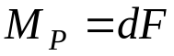 M_{P} - moment of the force F about the point P
d - perpendicular distance from P to the line of action of the force F
F - magnitude of the force

- if the line of action of the force passes through P → d = 0 → M_{P} = 0

Sense of the moment - positive (if the force tends to cause counterclockwise rotation), negative (if the force tends to cause clockwise rotation)

Dimensions of the moment - (distance) × (force) - newton-meters (SI units)
- foot-pound (U.S. Customary units)

Sum of the moments of a system of coplanar forces about a point in the same plane

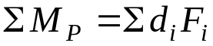 - the sense of the moment should be considered here
(add the positive and subtract the negative moments)

4.2 THE MOMENT VECTOR
F
r
θ
The moment of a force F about a point P is a vector
P
θ

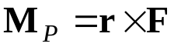 M_{P} - moment vector
d
r - position vector from P to any point on the line of action of F
F - magnitude of the force

Magnitude of the moment

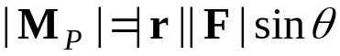 θ - angle between r and F, when they are placed tail to tail

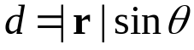 d - perpendicular distance from P to the line of action of the force F

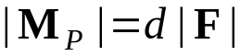 (if the line of action of the force F passes through P → M_{P} = 0)

Sense of the moment

M_{P} (moment vector) is perpendicular to both r and F (from the cross product definition).
It is usually denoted by a circular arrow around the vector.
The direction of M_{P} indicates the sense of the moment through a right-hand rule.
Relation to the two-dimensional description

If our view is perpendicular to the plane containing the point P and the force F, M_{P} is
perpendicular to the page, and the right-hand rule indicates whether it points out of
or into the page.

Varignon’s theorem - the moment of a concurrent system of forces about a point P is

F₁, F₂, … , F_{N} - concurrent system of forces
Q - intersection point (lines of action of all forces intersect at Q)
r_{PQ} - vector from P to Q

This theorem follows from the distributive property of the cross product.

Moment of a force about P is equal to the sum of the moments of its components about P

4.3 MOMENT OF A FORCE ABOUT A LINE

The measure of the tendency of a force to cause rotation about a line/axis is called the moment of the force about the line.

Definition

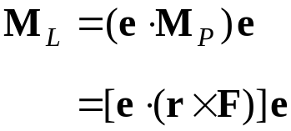
M_{L} - moment of the force F about the line L (parallel to L)
M_{P} - moment of F about an arbitrary point P on L
e - unit vector along L

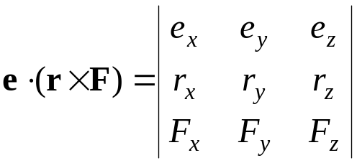

The scalar 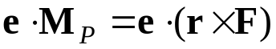 determines both the magnitude and direction of M_{L}
(if it is positive, M_{L} points in the direction of e; if negative, their directions are opposite)

How to determine the M_{L}?

- Determine a vector r – choose any point P on L, and determine the components of a vector r from P to any point on the line of action of F.
- Determine a vector e – determine the components of a unit vector along L (doesn’t matter in which direction along L it points).
- Evaluate M_{L} – calculate 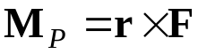 and determine M_{L} using definition.

Some useful results

- When the line of action of F is perpendicular to a plane containing L, the magnitude of M_{L} is 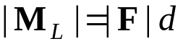.
- When the line of action of F is parallel to L, the moment M_{L} is zero (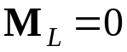).
- When the line of action of F intersects L, the moment M_{L} is zero.

4.4 COUPLES

Couple - two forces that have equal magnitudes, opposite directions, and
different lines of action
- tends to cause rotation of an object even though the vector sum of the forces
is zero

Moment of a couple - is simply the sum of the moments of the forces about point P

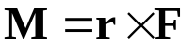 - the moment it exerts is the same about any point P
(r does not depend on the position of P)
- the cross product 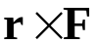 is perpendicular to r and F →
M is perpendicular to the plane containing F and -F

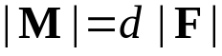 d - perpendicular distance between the lines of action of the two forces

4.5 EQUIVALENT SYSTEMS

System of forces and moments - particular set of forces and moments of couples

Conditions for equivalence

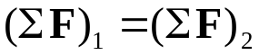 - the sums of forces are equal

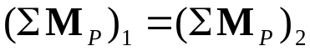 - the sums of moments about a point P are equal

Demonstration of equivalence

System 1 - two forces F_{A} and F_{B} and a couple M_{C}
System 2 - a force F_{D} and two couples M_{E} and M_{F}

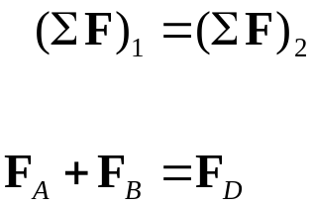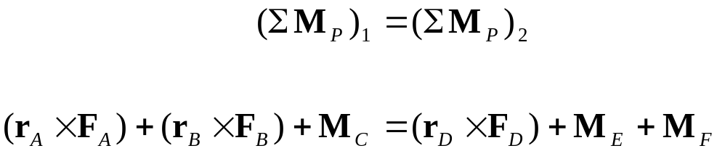

If the sums of the forces are equal for two systems of forces and moments, and
the sums of the moments about one point P are equal, then the sums of the moments
about any point are equal:

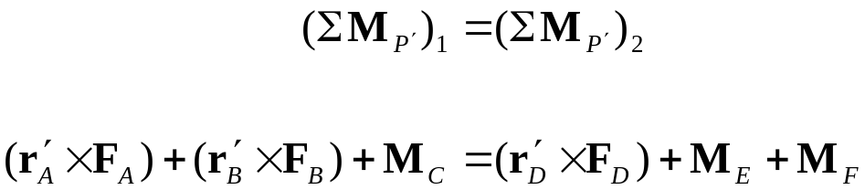

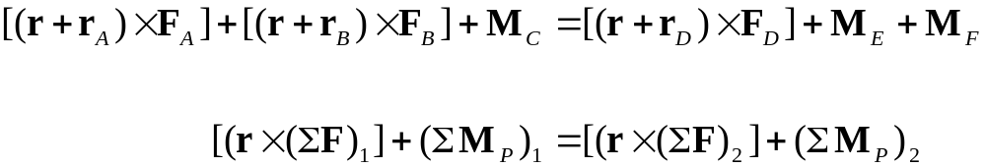

4.6 REPRESENTING SYSTEMS BY EQUIVALENT SYSTEMS

Instead of showing the actual forces and couples acting on an object, we can show a
different system that exerts the same total force and moment (we can replace a given
system by a less complicated one to simplify the analysis of the forces and moments).

Representing a system by a force and a couple

No matter how complicated a system of forces and moments may be,
we can represent it by a single force acting at a given point and a single couple.

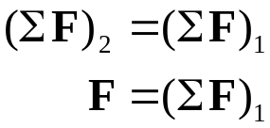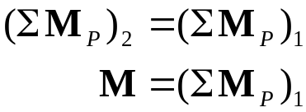

Three particular cases occur frequently in practice:

1) Representing a force by a force and a couple

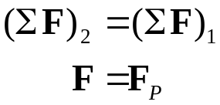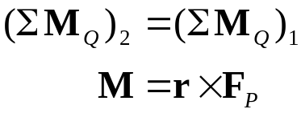
System 1 - force F_{P} acting at P

System 2 - force F acting at Q
and a couple M

The systems are equivalent if the force F equals the force F_{P}, and
the couple M equals the moment of F_{P} about Q.

2) Concurrent forces represented by a force

A system of concurrent forces whose lines of action intersect at point P, can be
represented by a single force F whose line of action intersects P.

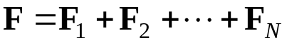

The systems are equivalent if the force F equals the sum of the forces in system 1
(the sum of moments about P equals zero for each system).

3) Parallel forces represented by a force

A system of parallel forces whose sum is not zero, can be represented by a single
force F. Its line of action will be parallel to forces from a given system, and it has
to exert the same moment about any point, as the original system of forces does
(this will define the position of the force F).

Representing a system by a wrench

Wrench - the simplest system that can be equivalent to an arbitrary system of forces
and moments

- consists of a single force, or a single couple, or a force F and a couple M
that is parallel to F

Representing a system by a wrench requires two steps:

- Determine the components of M parallel (M_{p}) and normal (M_{n}) to F

- The wrench consists of the force F acting at point Q, and the parallel component
M_{p} of M. To achieve the equivalence, the point Q must be chosen so that the moment of F about P equals the normal component M_{n} of M, so that 

