ANNEXURE : SYSCALL
HERE ARE MORE SYSTEM CALLS THAT GET ADDED AS WE GO ON ADDING MORE FUNCTIONALITY INTO OUR KERNEL. LET IS MAKE THIS A SEPARATE ANNEXURE CALLED “syscall'.
HOW CONTROL REACHES THE IMPLEMENTED SYSTEM CALL: DETAILED BLOCK DIAGRAM OF EXCEPTION HANDELLING MECHANISM IS AS FOLLOWSs.
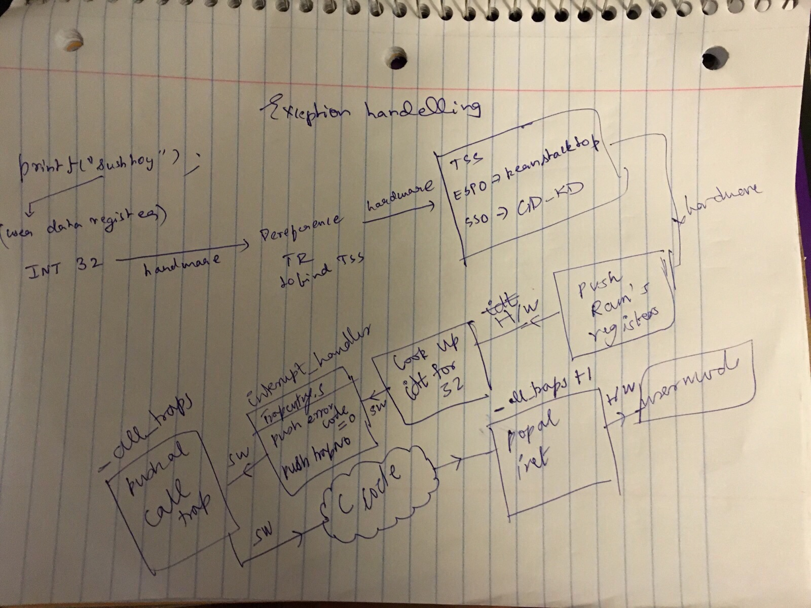
SETPS TO BE UNDER-TAKEN TO IMPLEMENT A SYSTEM CALL IN JOS.
Reserve a number in the enum struct for our syscall.
Go to the “syscall” function, This function can be called the syscall_dispatch function.
Add a switch case to the syscall_dispatch and call the syscall function.
ANNEXURE INDEX:
syscall //syscall_dispatch
sys_page_unmap
sys_page_map
sys_page_alloc
sys_exofork
sys_env_set_status
sys_yield
sys_cputs
sys_cgetc
sys_getenvid
sys_env_destroy
SYSTEM CALLS SOURCE CODE AND EXPLANTION:
We have written these system calls as APIs to get done some work we plan to do, such as memory allocation and so on. As JOS is an exokernel by design we use these system calls to shift most of the kernel functionalities to the user space one such example that follows is the page fault handler. It executes as a user space function. A detailed discussion on design philosophies of various kernel designs will be a part of this document.
Function name: syscall() //syscall_dispatch
Parameters: uint32_t syscallno, uint32_t a1, uint32_t a2, uint32_t a3, uint32_t a4, uint32_t a5
// syscallno is given as a parameter and is used to select the appropriate system call.
eax ==> contains the syscall number.
edx, ecx, ebx, edi,esi ==> registers
Return value: eax
//Dispatches to the correct kernel function, passing the arguments.
{
// Call the function corresponding to the 'syscallno' parameter.
// Return any appropriate return value.
// LAB 3: Your code here.
int retval;
switch (syscallno) {
case SYS_page_unmap:
return sys_page_unmap(a1, (void *)a2);
case SYS_page_map:
return sys_page_map(a1,(void *) a2, a3, (void *)a4, a5);
case SYS_page_alloc:
return sys_page_alloc(a1,(void *) a2, a3);
case SYS_exofork:
return sys_exofork(); //returns env_id of child --> may be a positive value!
case SYS_env_set_status:
return sys_env_set_status(a1, a2);
case SYS_yield:
sys_yield();
break;
case SYS_cputs:
sys_cputs((char *)a1, (size_t)a2);
break;
case SYS_cgetc:
return sys_cgetc();
case SYS_getenvid:
return (int32_t)sys_getenvid();
case SYS_env_destroy:
return sys_env_destroy(sys_getenvid());
default:
return -E_NO_SYS;
}
return 0;
}
System call name: sys_cputs
Parameters : const char *s, size_t len
{ // checks for privilege as the user should not be printing out something he or she does not have //access to
// Check that the user has permission to read memory [s, s+len).
// Destroy the environment if not.
// LAB 3: Your code here.
user_mem_assert(curenv, (void *)s, len, PTE_U); //check if user may read the address passed
// Print the string supplied by the user.
cprintf("%.*s", len, s);
}
AT THIS POINT IN THE NOTES, WE HAVE TO GO OVER THE FILES “CONSOLE.C” AND “MONITOR.C” FOR AN INCREASED CLARITY OF HOW BASIC I/O IS MANAGED. WE SHALL MAKE IT AN ANNEXURE. SO PIECES OF CODE FROM HERE ON WILL BE REFERED TO THE SOON TO BE MADE ANNEXURE.
System call name: sys_cgetc
Parameters: void
Wrapper for cons_getc(). Lets see what cons_getc does.
sub_function : cons_getc ==> very important. Is a part of the kernels I/O. Grabs the next character from the input buffer. Ideally should be inside a while loop to keep polling.
int c;
// poll for any pending input characters,
// so that this function works even when interrupts are disabled
// (e.g., when called from the kernel monitor).
serial_intr(); // REFER ANNEXURE “kern_io”
kbd_intr(); // REFER ANNEXURE “kern_io”
// grab the next character from the input buffer.
if (cons.rpos != cons.wpos) {
c = cons.buf[cons.rpos++];
if (cons.rpos == CONSBUFSIZE)
cons.rpos = 0;
return c;
}
System call name: sys_getenvid(void)
Parameters: void
returns curenv->env_id;
System call name : sys_env_destroy
Parameters : envid_t envid
Is a wrapper around env_destory. Checks if the envid is greater than 0 and environment's status is RUNNABLE. It prints the environment id and exits honorably by calling env_destory.
System call name: sys_yield
Parameters : void
// Deschedule current environment and pick a different one to run. Calls shed_yield.
sched_yield(); // will be discussed in the scheduler section.
System call name: sys_env_set_status
Parameters : envid_t envid, int status
Checks if the given environment id is a valid environment id. Checks if the current status is a valid status for this environment(if the status is either ENV_RUNNABLE or ENV_NOT_RUNNABLE).
ret_val = envid2env(envid, &envir, true); //returns 0 on success.
Envid2env==> very important function that takes in envid and envstruct's address as parameters. It finds the environment struct for a given envid.
envir->env_status = status; //sets the status and returns 0 in success.

System call name :sys_page_alloc
parameters : envid_t envid, void *va, int perm
It's a wrapper around page_alloc. It gets the env struct using envid2env(envid). It checks the permissions and status of the this env. If all these checks go through, we call page_alloc and page_insert to insert mappings of this allocated page into the environment's page_tables. If page_insert fails we free the allocated page and return -1.
ret_val = envid2env(envid, &envir, true);
new_page = page_alloc(ALLOC_ZERO);
ret_val = page_insert(envir->env_pgdir, new_page, va, perm);
if(0 != ret_val)
{
page_free(new_page);
return ret_val;
}
return 0;
System call name: sys_page_map()
Parameters : envid_t srcenvid, void *srcva, envid_t dstenvid, void *dstva, int perm
//It is a wrapper around page_lookup.
// Map the page of memory at 'srcva' in srcenvid's address space
// at 'dstva' in dstenvid's address space with permission 'perm'.
// Perm has the same restrictions as in sys_page_alloc, except
// that it also must not grant write access to a read-only
// page.
//
// Return 0 on success, < 0 on error. Errors are:
// -E_BAD_ENV if srcenvid and/or dstenvid doesn't currently exist,
// or the caller doesn't have permission to change one of them.
// -E_INVAL if srcva >= UTOP or srcva is not page-aligned,
// or dstva >= UTOP or dstva is not page-aligned.
// -E_INVAL is srcva is not mapped in srcenvid's address space.
// -E_INVAL if perm is inappropriate (see sys_page_alloc).
// -E_INVAL if (perm & PTE_W), but srcva is read-only in srcenvid's
// address space.
// -E_NO_MEM if there's no memory to allocate any necessary page tables.
Does sanity checks for the environement who's id is given as input. Finds the envstruct for the given envid using “envid2env” function and calls page_lookup following page_insert. If the page_insert fails, we call page_free.
System call name: sys_page_unmap()
Parameter: envid_t envid, void *va
with envid find env struct using envid2env. Then call page_remove(envir->env_pgdir, va);

SYTEM CALLS FOR ENVIRONMENT GENERATION:
We have implemented a series of system calls, with their help we will go on to implement a system call similar to “fork()” in linux.
System call name: sys_exofork()
Parameters : void
Allocate a new environment. Returns envid of new environment.
struct Env *child; // child environments pointer.
int ret_val;
ret_val = env_alloc(&child, curenv->env_id); //calls env_alloc
if( 0 != ret_val) {
return ret_val; //returns if alloc fails
}
// Environment for child created
child->env_status = ENV_NOT_RUNNABLE;
child->env_tf = curenv->env_tf;
// Set return value for child process to 0
child->env_tf.tf_regs.reg_eax = 0;
return child->env_id; //returns the child's env_id
system call name: sys_env_set_status()
Parameters: envid_t envid, int status
Set envid's env_status to status, which must be ENV_RUNNABLE or ENV_NOT_RUNNABLE. Returns 0 on success, < 0 on error. Sets the created environment's status.
struct Env *envir;
int ret_val;
if((ENV_RUNNABLE != status) && (ENV_NOT_RUNNABLE != status))
{
return -E_INVAL;
}
ret_val = envid2env(envid, &envir, true); // looks for the environment's env struct given its env id.
if(0 != ret_val)
{
return ret_val;
}
envir->env_status = status; // sets the given status
return 0;
Copy-on-write Fork:
Fork() routine in linux spawns a new process, originally it used to copy all the data out of the parent process to child process. But generally after a fork call we call exec. Exec copies a specified data into the child process's address space. Most of the data copied out of the parent process is rendered useless.
Hence the optimization of copy on write. Copy-on-write finds its main use in virtual memory operating systems; when a process creates a copy of itself, the pages in memory that might be modified by either the process or its copy are marked copy-on-write. When one process modifies the memory, the operating system's kernel intercepts the operation and copies the memory; thus a change in the memory of one process is not visible in another's.
Another use involves the calloc function. This can be implemented by means of having a page of physical memory filled with zeros. When the memory is allocated, all the pages returned refer to the page of zeros and are all marked copy-on-write. This way, the amount of physical memory allocated for the process does not increase until data is written. This is typically done only for larger allocations.
Copy-on-write can be implemented by notifying the MMU that certain pages in the process's address space are read-only. When data is written to these pages, the MMU raises an exception which is handled by the kernel, which allocates new space in physical memory and makes the page being written correspond to that new location in physical memory.
One major advantage of COW is the ability to use memory sparsely. Because the usage of physical memory only increases as data is stored in it, very efficient hash tables can be implemented which only use little more physical memory than is necessary to store the objects they contain. However, such programs run the risk of running out of virtual address space — virtual pages unused by the hash table cannot be used by other parts of the program[citation needed]. The main problem with COW at the kernel level is the complexity it adds, but the concerns are similar to those raised by more basic virtual-memory concerns such as swapping pages to disk; when the kernel writes to pages, it must copy any such pages marked copy-on-write.
To implement this copy of write, we have to first implement a page fault handler. Being an exo-kernel design we implement this page fault handler in the user space. More about exokernels in the main document.
In while employing demand paging, we copy the mappings alone from the parent process to the child process. This is a state when some part of the memory remains shared among the two processes. While in the shared state we remove the write permissions from both these processes. While write permission is removed if either of these processes tries to write into the shared memory location. It raises a hardware level fault. This fault is handled by the page fault handler. So it is paramount to implement a page fault handler to implement copy-on-write support to our fork routine.
JOS page fault handler:
System call name : sys_env_set_pgfault_upcall
Arguments : envid_t envid, void *func
As a part of this lab we have added a new field to the env struct called env_pgefault_upcall.
It comes through the exception handling infrastructure when this system call is executed, it saves the user defined page fault handler in the env struct's env_pgfault_upcall field.
struct Env *envir;
int ret_val;
ret_val = envid2env(envid, &envir, true); // looks up env struct from the envid
if(0 != ret_val)
{
return ret_val;
}
envir->env_pgfault_upcall = (void*) func; //stores the func pointer.
Return 0;

