AI WeatherWise API

Project Design Phase


1. Problem Statement Definition
1.1 Background

Alex is a travel enthusiast who frequently visits different cities and needs a streamlined way to track local weather conditions and receive AI-driven activity suggestions based on current forecasts.
1.2 Problem Statement

- Difficulty tracking and managing multiple favorite weather locations efficiently.
- Lack of personalized recommendations for outdoor activities or clothing based on weather.
- Need for natural-language weather summaries rather than raw numeric metrics.
- Absence of a secure system to store and sync location preferences across devices.

2. Proposed Solution

AI WeatherWise is a RESTful backend platform, built with Node.js, Express.js and MongoDB (Mongoose ODM), that centralizes weather data retrieval and AI orchestration. It manages a secure User and Location database, fetches live weather metrics, and integrates Google Gemini AI to turn raw weather data into personalized, natural-language insights and recommendations. Secure JWT authentication and bcrypt password hashing protect user data, and a resilient fallback mode keeps core weather features working even when an external AI key is unavailable.

2.1 Usage / Actors

- Registered User: Manages favorite cities (CRUD), fetches real-time weather, and requests AI insights for recommendations and summaries.
- Admin: Monitors API health, manages user registrations, and verifies weather/AI service integrations.
- Weather App User (Guest): Interfaces with public weather endpoints to view current metrics without an account.


2.2 Expected Outcome

By centralizing data management and layering AI on top of raw weather metrics, users spend less time interpreting numbers and more time acting on clear, context-aware advice. Mongoose schemas enforce data integrity across the User and Location collections.
3. Solution Architecture
The system follows a client-server model in which the Express Server Gateway routes incoming requests to a Controller layer. Controllers coordinate two responsibilities: retrieving live metrics from OpenWeatherMap, and passing weather context to Google Gemini AI for summary generation. All persistent data — user accounts and saved locations — is stored through the Mongoose Model layer into MongoDB.

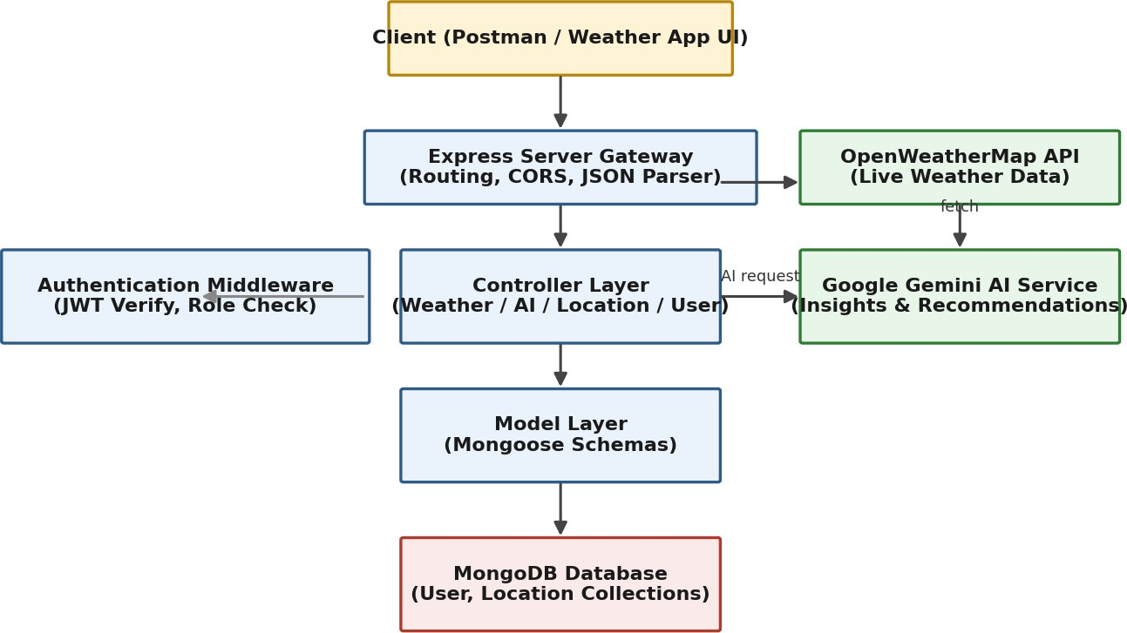

Fig 3.1: Solution Architecture of AI WeatherWise API

3.1 Components Definition

- Interface: API tools such as Postman query distinct route paths to exchange JSON payloads.
- Express Server Gateway: Monitors network ports, maps HTTP methods (GET, POST, PUT, DELETE), parses JSON payloads, and handles CORS headers.
- Authentication Middleware: Extracts JWT tokens from headers, validates user identity, and checks role-based authorization for guarded routes.
- Controller Layer: Enforces business logic for authentication, location management, weather retrieval, and AI-orchestration workflows.
- Database Interface Layer: Mongoose translates application logic into MongoDB queries and enforces schema validation.
- AI Service Integration: Uses @google/generative-ai to generate weather summaries and personalized recommendations from live conditions.
4. Technical Architecture

AI WeatherWise follows the MVC (Model-View-Controller) pattern to decouple business logic from data management, adapted for a headless REST API.
4.1 Model Layer (Data Blueprint)

Defines structure blueprints via Mongoose schemas, mapping fields into MongoDB collections, and enforcing default values, indexing and validation before persistence.
4.2 Controller Layer (Execution Matrix)

Captures incoming requests, validates structural constraints, delegates processing to models and external services (OpenWeatherMap, Gemini AI), and packages the result into a standard JSON response.
4.3 View Layer (Routing Network Interface)

As a headless backend, there is no template-rendering view. Instead, this layer exists as the API Routing Layer, mapping each network path to its corresponding controller handler.

4.4 Entity-Relationship Overview

The data architecture manages User profiles and their associated favorite Locations through a one-to-many relationship: a registered user can save multiple favorite locations.

Field | Type | Description
_id | ObjectId | Primary key
name | String | Required
email | String | Required, unique
password | String | Hashed, required
role | String | Default: "reader"

Field | Type | Description
_id | ObjectId | Primary key
user | ObjectId | Foreign key referencing User collection
city | String | Required
country | String | Required
createdAt | Date | Default: now


5. Data Flow Diagrams
5.1 Level 0 DFD (Context Diagram)

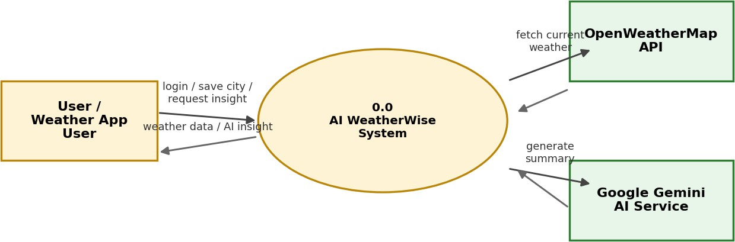

The context diagram treats AI WeatherWise as a single process exchanging data with the user and two external services.

Fig 5.1: Level 0 Data Flow Diagram


5.2 Level 1 DFD

The Level 1 diagram decomposes the system into its four core processes and the data stores / external systems each one touches.

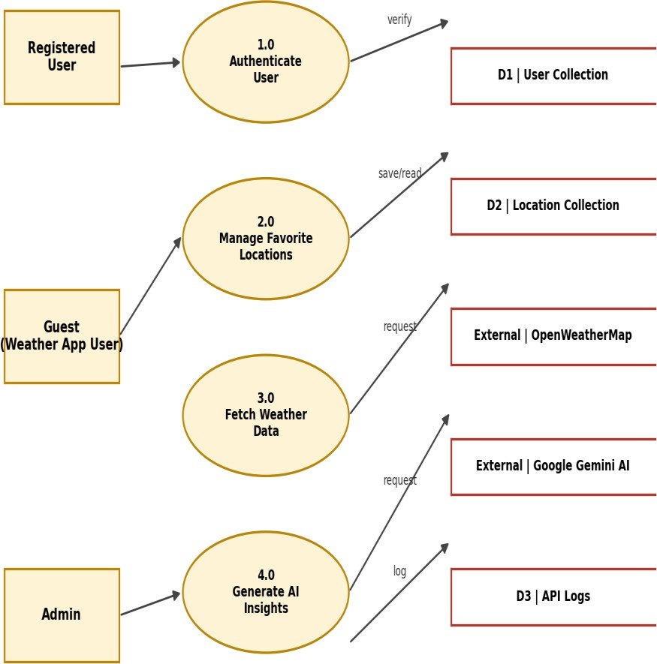

Fig 5.2: Level 1 Data Flow Diagram
6. User Flow

- 1. User logs in or registers.
- 2. User saves a favorite city via the API.
- 3. User fetches current weather metrics for that city.
- 4. User requests AI-driven insights (summaries / recommendations) based on the weather data.
- 5. System validates the JWT and returns the requested information.


7. User Stories

User Type | Functional  Requirement (Epic) | User  Story No. | User Story / Task | Acceptance Criteria | Priority
Registered User | Authentication | USN-1 | As a user, I can register with my name, email and password so that I can  create an account. | Account is created and a JWT token is issued on success. | High
Registered User | Authentication | USN-2 | As a user, I can log in with my email and password so that I can access my saved  locations. | Valid credentials return a JWT; invalid credentials are rejected. | High
Registered User | Location Management | USN-3 | As a user, I can add a city  to my favorites so that I can track its weather regularly. | City is saved against my  user ID in the Location collection. | High
Registered User | Location Management | USN-4 | As a user, I can view and delete my saved favorite  locations. | List/delete operations reflect immediately in  the database. | Medium
Registered User | Weather Data | USN-5 | As a user, I can fetch real-time weather metrics for any saved location. | Live temperature, humidity and condition data is returned from  OpenWeatherMap. | High
Registered User | AI Insights | USN-6 | As a user, I can request an AI-generated summary and activity  recommendation for a location's weather. | Gemini AI returns a natural-language summary and suggestion; a fallback message appears if the  AI key is unavailable. | High
Weather App User (Guest) | Public Access | USN-7 | As a guest, I can view current weather metrics for a city without creating an  account. | Public weather endpoint responds without requiring a JWT. | Medium

User Type | Functional Requirement  (Epic) | User Story  No. | User Story / Task | Acceptance Criteria | Priority
Admin | User Management | USN-8 | As an admin, I can create,  suspend or delete user accounts. | Role-guarded endpoints reject non-admin tokens. | Medium
Admin | Monitoring | USN-9 | As an admin, I can check API health and review system logs. | Health-check endpoint returns service status for DB, Weather API and  Gemini AI. | Low

