FULLSTACK WEB DEVELOPMENT
IN
KANI VILAS TECHNOLOGY SERVICES

A SUMMER INTERNSHIP REPORT
Submitted by

HEMAVATHI J.S
913123104048

in partial fulfillment for the award of the degree of
in

COMPUTER SCIENCE AND ENGINEERING
VELAMMAL COLLEGE OF ENGINEERING AND TECHNOLOGY, MADURAI – 09
(Autonomous Institution Affiliated to Anna University)

JULY 2025

VELAMMAL COLLEGE OF ENGINEERING AND TECHNOLOGY, MADURAI – 09
(Autonomous Institution Affiliated to Anna University)

BONAFIDE CERTIFICATE
Certified that this internship report “Fullstack Web Development” is the bonafide work of HEMAVATHI J.S (913123104048) who carried out the internship report work under my supervision during the Academic Year 2024 - 2025. I certify that to the best of my knowledge, the work reported here in does not form part of any other work conferred on an earlier occasion or any other candidate.

SIGNATURE SIGNATURE
Dr.G.VINOTH CHAKKARAVARTHY,M.E.,Ph.D. Mrs.K.SANTHASHEELA,B.E.,M.E.
HEAD OF THE DEPARTMENT FACULTY MENTOR
Computer Science and Engineering, Computer Science and Engineering,
Velammal College of Engineering and Velammal College of Engineering and Technology. Technology
MADURAI – 625 009 MADURAI – 625 009

Submitted for the summer internship at Velammal College of Engineering and Technology
on ………………………..
EXAMINER-1 EXAMINER-2

GPS PHOTO PROOF OF YOUR PRESENCE IN THE COMPANY

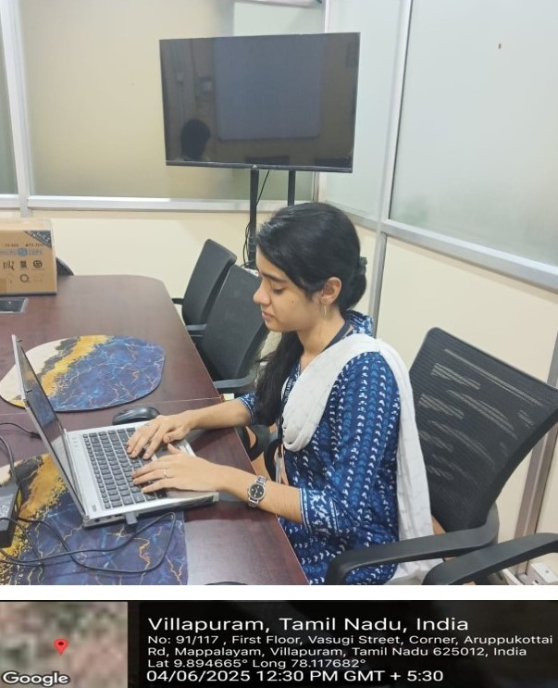

ACKNOWLEDGEMENT

We wish to express our deep sense of gratitude to Dr. P.Alli, Principal of Velammal College of Engineering and Technology, for providing me with the incredible opportunity to participate in an internship. This experience has been invaluable in shaping my knowledge, skills, and professional growth.
We wish to express our sincere thanks to Dr. G. Vinoth Chakkaravarthy, Head of the Department of Computer Science and Engineering for his support and ardent guidance.
We owe our special thanks and gratitude to our faculty mentor Mrs.K.Shanthasheela, Assistant Professor of Computer Science and Engineering for her guidance and support throughout our internship.
I extend my sincere thanks Mr. M. Muthukumar, Reporting Director, 1st Floor, 3, Kaveri 2nd Street, Parasakthi Nagar, Madurai - 625012 for providing me the industry experience.
We are also indebted to all the teaching and non-teaching staff members of our department for helping us directly and indirectly by all means throughout the course of our study and project work.
We extremely thank our parents, family members and friends for their moral support and encouragement for our internship

ABSTRACT

I completed my Full Stack Web Development internship at Kani Vilas Technology Services, where I worked on building dynamic web applications using ASP.NET Framework, C#, and SQL Server. This internship provided me with practical exposure to both front-end and back-end development.
On the front-end, I designed responsive and user-friendly interfaces using HTML, CSS and JavaScript, ensuring cross-browser compatibility and mobile responsiveness.
On the back-end, I developed and optimized server-side logic using C# and ASP.NET MVC, handling data validation, session management, and secure API integration. I also implemented role-based authentication and authorization, improving application security.
For database management, I used SQL Server Management Studio (SSMS) to design relational schemas, write stored procedures, optimize queries, and perform CRUD operations efficiently.
In addition to technical development, I actively participated in Agile practices, including daily stand-ups, sprint planning, and code reviews, which helped me improve teamwork, problem-solving, and code quality following industry best practices.
This internship strengthened my expertise in ASP.NET full-stack development, MVC architecture, and database handling, while giving me the confidence to deliver scalable, real-world web applications.

TABLE OF CONTENTS
CHAPTER | TITLE |  | PAGE NO
 | LIST OF TABLES |  | 8
 | LIST OF FIGURE |  | 9
 | LIST OF SYMBOLS, ABBREVIATION
1 | Introduction
 | 1.1 | Duties & Responsibilities | 10
 | 1.2 | Details about the whole internship | 11
 | 1.3 | Objective | 11
2 | About the Company
 | 2.1 | About the company | 12
 | 2.2 | Company’s vision and mission | 12
 | 2.3 | Profiles of all departments/units | 12
3 | Internship Overview
 | 3.1 | Weekly Activity Report | 14
 | 3.2 | Contribution of the intern to the organization/ Outcome | 16
4 | Conclusion and Outcome
 | 4.1 | Knowledge gained from internship | 17
 | 4.2 | Work Sample | 17
 | 4.3 | Conclusion | 26
 | REFERENCES
 | PLAGARISM REPORT

LIST OF TABLES

TABLE NO. | TITLE | PAGENO.
3.1.1 | Internship status report | 14-15

LIST OF FIGURES

FIGURE NO. | TITLE | PAGENO.
4.2.1 | Home page | 18
4.2.2 | About page | 18
4.2.3 | Products page | 19
4.2.4 | Review page | 20
4.2.5 | Contact page | 20
4.2.6 | Home page | 22
4.2.7 | Citizen signup page | 22
4.2.8 | Citizen login page | 23
4.2.9 | Citizen news upload page | 23
4.2.10 | Citizen logout page | 24
4.2.11 | Media signup page | 24
4.2.12 | Media login page | 25
4.2.13 | Media news verification page | 25
4.2.14 | Media news upload page | 26

CHAPTER-I
INTRODUCTION

CHAPTER-I: INTRODUCTION

During my 30-day internship in the Full Stack Development domain at Reccsar Private Limited, I was introduced to the fundamental concepts and practical applications of web development technologies. I worked under the Software Development Department, where I was guided by my reporting manager, S.K. Sanjay Raj, who played a significant role in mentoring and assigning relevant tasks throughout the internship period.
1.1.Duties & Responsibilities Assigned to the Intern:
- Learn and implement front-end technologies such as HTML, CSS, JavaScript, and React.
- Develop a responsive static website (Flower Shop) to understand UI layout and styling.
- Build a full-stack News Portal Website with features including user registration, login,
news submission, media upload, and verification system.
- Work with MongoDB for database management and perform CRUD operations
using Node.js and Express.
- Participate in code review sessions and fix bugs based on feedback.
- Learn basic version control using Git.
(a)Duration
- The internship lasted for 30 days, from 02.06.2025 to 28.06.2025.
(b) Department Allotted & Reporting Manager:
- Department: Web Application Team
- Reporting Manager: S.K.SanjayRaj, Full Stack Developer
(c) Brief Detailing About the Internship:
The internship started with training on basic web technologies, followed by individual tasks to reinforce learning. I initially worked on a responsive Flower Shop website using HTML and CSS, which helped me understand structure and design. Later, I developed a more advanced News Portal Website that involved frontend development using React and backend integration using Node.js and MongoDB. The platform supported user roles, media uploads, and real-time content handling, giving me complete exposure to full stack development. Regular feedback sessions and task tracking ensured continuous improvement throughout the internship.

1.2 Details About the Whole Internship

The internship was conducted at [Company Name] from June 2, 2025, to June 28, 2025, and provided an intensive learning experience in the domain of Full Stack Web Development.
Under the guidance of experienced developers and mentors, I worked on three real-time projects that collectively demonstrated the practical applications of front-end frameworks, backend services, and database operations.
- The News Portal Website was a dynamic and fully functional MERN stack application, featuring user authentication, dashboard views, news submission, and administrative verification workflows.
- The Responsive Flower Shop and Ice Cream Store websites were static projects designed to focus on layout design, responsiveness, and frontend component structuring using HTML, CSS, and JavaScript.
Our daily tasks were goal-oriented and tied to project modules. I was encouraged to independently research best practices, troubleshoot issues, and participate in demo sessions. Tools and technologies used during the internship included React, Node.js, Express, MongoDB, Git, and VS Code.
This internship provided strong exposure to industry-relevant technologies, software development workflows, and the foundational skills required for full stack web application development.

1.3 Objective
- To gain hands-on experience in developing complete web applications using frontend and backend technologies.
- To understand the practical workflow involved in building, testing, and deploying full stack applications.
- To strengthen my foundation in modern web technologies such as React, Node.js, and MongoDB.
- To develop responsive and user-friendly interfaces for real-world use cases.

CHAPTER-II
ABOUT THE COMPANY

CHAPTER-II: ABOUT THE COMPANY

2.1. About the Company
Reccsar Private Limited is a forward-thinking technology company committed to building smart, scalable, and user-centric solutions in the fields of Artificial Intelligence, Software Engineering, and Educational Technology. Located in Madurai, the company focuses on delivering cutting-edge tools that address modern challenges in learning, career development, and automation. Reccsar is known for integrating intelligent systems into everyday applications, especially in education, e-governance, and decision-support solutions. The company emphasizes real-world project-based learning and fosters a culture of innovation and technical excellence.

2.2. Vision and Mission
Vision:
To be a leader in delivering innovative, AI-driven solutions that empower individuals and institutions through technology.
Mission:
- To provide impactful software solutions that combine artificial intelligence and practical utility.
- To mentor and train budding professionals through internship programs and live projects.
- To build tools that promote skill development, career growth, and accessible learning for all.

2.3. Profile of All Departments/Units
- Artificial Intelligence and Machine Learning Department:
This department is the backbone of AI innovation at Reccsar. It focuses on developing intelligent systems for predictive analysis, career counseling, skill recommendation, and automation. The team works extensively with supervised and unsupervised learning models, natural language processing, and deep learning frameworks to build scalable AI solutions tailored to various industries.
- Software Development Department:
Reccsar’s software development unit specializes in building end-to-end digital platforms such as Learning Management Systems (LMS), AI-integrated web applications, and enterprise tools. The department handles frontend and backend development, API integration, UI/UX design, and system architecture using the latest technologies like Python, Flask, HTML/CSS, JavaScript, and cloud deployment tools.
- Research and Development (R&D) Department:
This department is dedicated to exploring emerging technologies and transforming innovative ideas into real-world applications. Areas of focus include artificial intelligence, IoT, automation, edge computing, and data-driven solutions. The R&D team at Reccsar drives continuous improvement by integrating research into ongoing projects, ensuring technological relevance and future-readiness.
❖ Training and Development Unit:
Committed to skill-building and professional readiness, the Training and Development Unit offers internships, workshops, and certification programs for students and graduates. These training sessions cover topics such as AI, machine learning, IoT, software engineering, and project management, preparing participants for industry demands.
❖ Consulting and Project Implementation Services:
This unit provides technical consulting to clients seeking digital transformation. Reccsar offers strategic guidance on AI adoption, software solutions, system upgrades, and data management. The consulting team also assists educational institutions and industries in implementing customized tech solutions.
❖ Emerging Technology Programs:
Reccsar conducts short-term and long-term programs focused on high-demand domains such as:
- Artificial Intelligence & Machine Learning
- Internet of Things (IoT)
- Data Science
- Cloud Computing
- Web Development
These programs are designed to equip participants with industry-relevant skills, promoting innovation and career advancement.

CHAPTER-III
INTERNSHIP OVERVIEW

CHAPTER-III: INTERNSHIP OVERVIEW

During my internship, I worked as a Full Stack Development Intern where I was introduced to core technologies such as HTML, CSS, JavaScript, React, Node.js, and MongoDB. I developed and practiced building responsive websites and single-page applications. My work involved creating standalone frontend projects (like a Flower Shop and Ice Cream website) as well as a major full-stack News Portal Website.

3.1. Weekly Activity Report
Title of Summer Internship: -FullStack Develpoment
Date From: 02.06.2025
Date To: 28.06.2025

Day & Date | Time | Tasks assigned | Tasks completed | Observations
Week 1 | 10.00AM to 1.00PM | Introduction to HTML & CSS, basic webpage structure | Create Ice Cream Store UI with HTML & CSS Completed basic Ice Cream Website Improved creativity with layout design | Improved creativity with layout design
Week 2 | 10.00AM to 1.00PM | JavaScript fundamentals & DOM handling Added interactivity to websites(buttons | Created Flower Shop website layout Understood HTML tags, CSS styles, and form usage Responsive design using | Learned responsive breakpoints and flexbox
Day & Date | Time | Tasks Assigned | Tasks Completed | Observations
 |  | events)Understood how JS brings user engagement | media queries made flower shop responsive across devices
Week 3 | 10.00AM to 1.00PM | Learn React – Components, Props,useState | Built frontend for News Portal Website | Learned state management and component-based architecture
Week 4 | 10.00AM to1.00PM | Setup backend with Node.js, Express, MongoDB  Integrate frontend with backend, test full flow | Created backend APIs and data models  Completed full News Portal Website with login & dashboard | Understood CRUD operations and REST API structure  Full-stack integration experience achieved

Remarks of Industry Guide:
The student showed strong commitment and quick understanding of full stack development concepts. They effectively applied HTML, CSS, React, Node.js, and MongoDB across all tasks.
Projects like the News Portal Website, Flower Shop, and Ice Cream Store were completed with good functionality and user experience. The student demonstrated solid problem-solving skills and consistent progress throughout.Overall, they performed well and showed strong potential for future roles in web development. Gained practical experience in frontend design, backend integration, and full stack application development.
3.2 Contribution of the Intern to the Organization/ Outcome

Initiatives & Responsibilities Taken by the Intern:
- Took initiative to build sample websites (Flower Shop and Ice Cream Store) to understand responsive design and layout.
- Contributed actively to the planning and design of the News Portal Website.
Task Accomplishments Made:
- Developed a full-featured News Portal Web App using React, Node.js, and MongoDB.
- Built a responsive Ice Cream Store website using only HTML and CSS.
- Practiced DOM scripting and basic interactivity with JavaScript.
New Ideas & Concepts:
- Suggested including post status labels (Verified, Rejected) in the user dashboard of the news portal.
- Proposed adding animations to improve user interface in the ice cream site.
Involvement in Major Assignments:
- Led the frontend implementation of the News Portal Website.
- Created sample UI websites from scratch to apply concepts learned during training.

CHAPTER IV
CONCLUSIONS & OUTCOME

CHAPTER IV: CONCLUSIONS & OUTCOME

4.1. Knowledge gained from Internship
During this 30-day internship in Full Stack Web Development, I gained hands-on experience in building web applications from scratch using technologies like HTML, CSS, JavaScript, React, Node.js, and MongoDB. I learned to design responsive user interfaces, manage application state, connect frontend to backend services, and perform database operations efficiently.

Analysis of Achievements Vs Objectives

OBJECTIVE | ACHIEVEMENT
Learn front-end development | Successfully built 2 UI websites (Flower Shop & Ice Cream Store) using HTML, CSS
Understand React JS | Developed user dashboard and dynamic UI for News Portal
Learn backend and database operation | Implemented APIs using Node.js & Express, connected with MongoDB
Build a complete full stack website | Built and tested a News Portal Website with user login, submission, and admin review

Major areas where the concept can be practically used.
- E-commerce platforms – Shopping cart, login systems, and product listings.
- Content management systems (CMS) – Like blogs, news portals, and admin dashboards.

4.2 Work Sample
Work Sample 1: Flower Shop Website
Description: A responsive website for a fictional flower shop built using HTML, CSS, and JavaScript. The website featured a product listing, basic layout, contact form, and media queries for responsiveness.
My Role: I created the full layout design from scratch, implemented responsive behavior for various screen sizes, and styled the components with CSS.

4.2.1. Home page

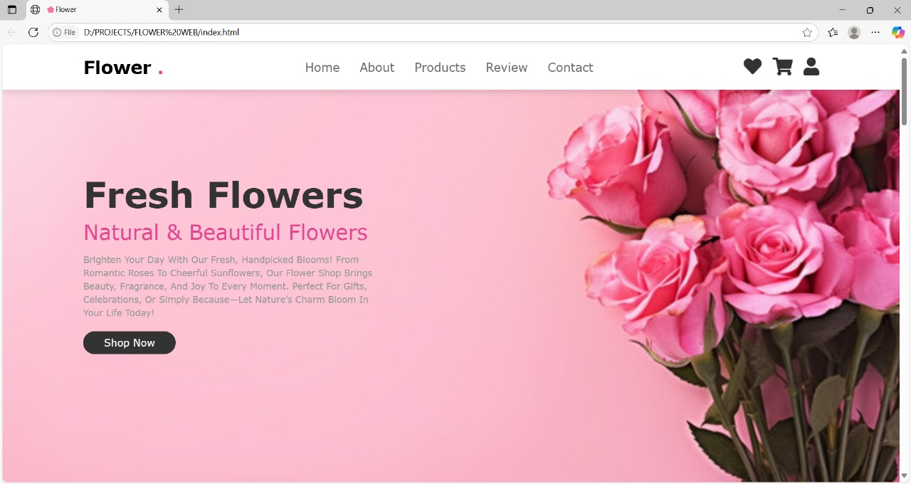

4.2.2. About page
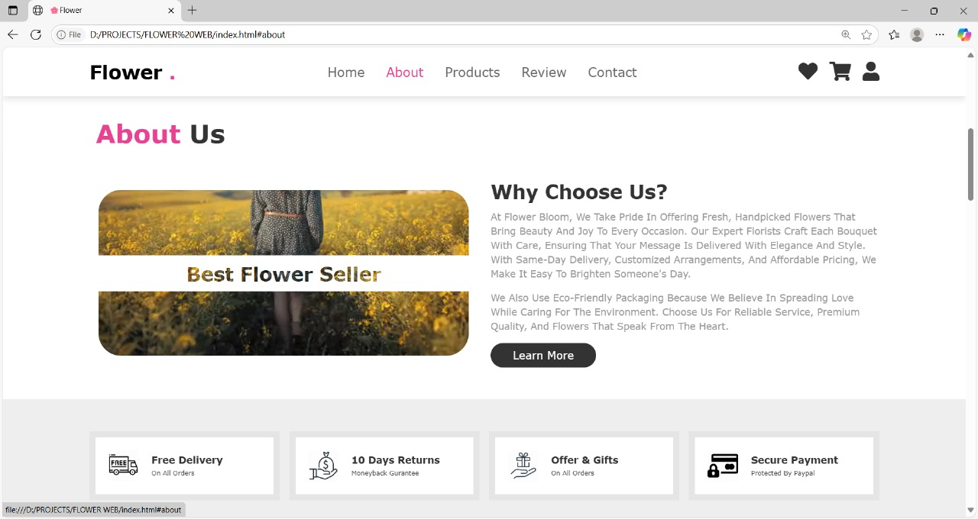

4.2.3. Products page

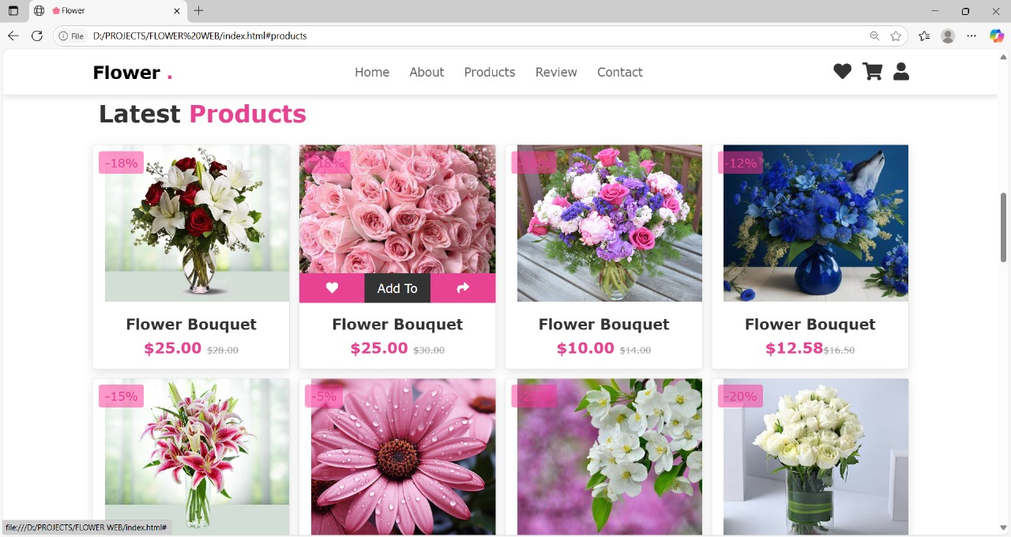

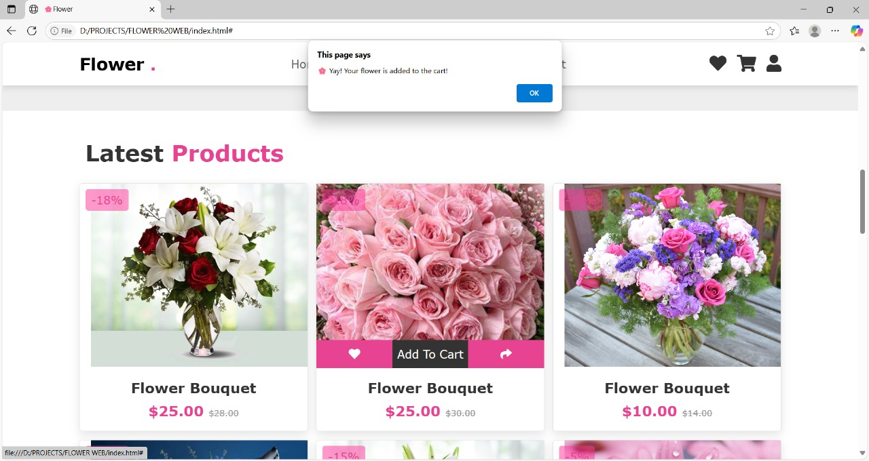

4.2.4. Review page

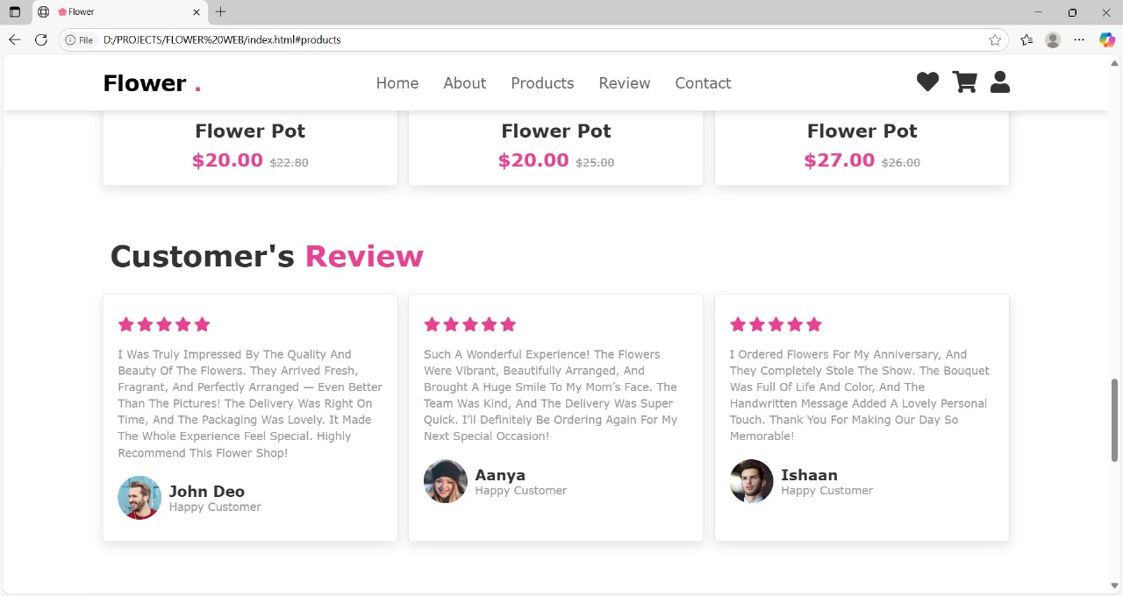

4.2.5. Contact page

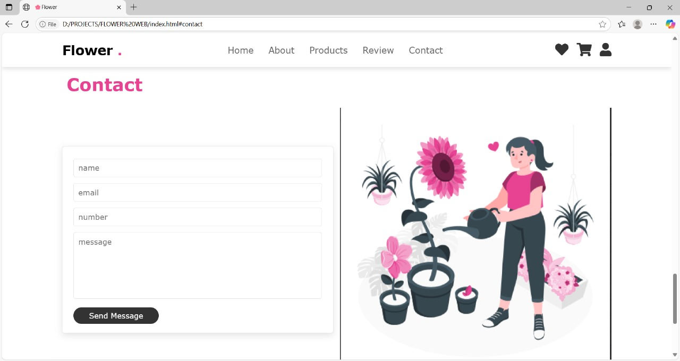

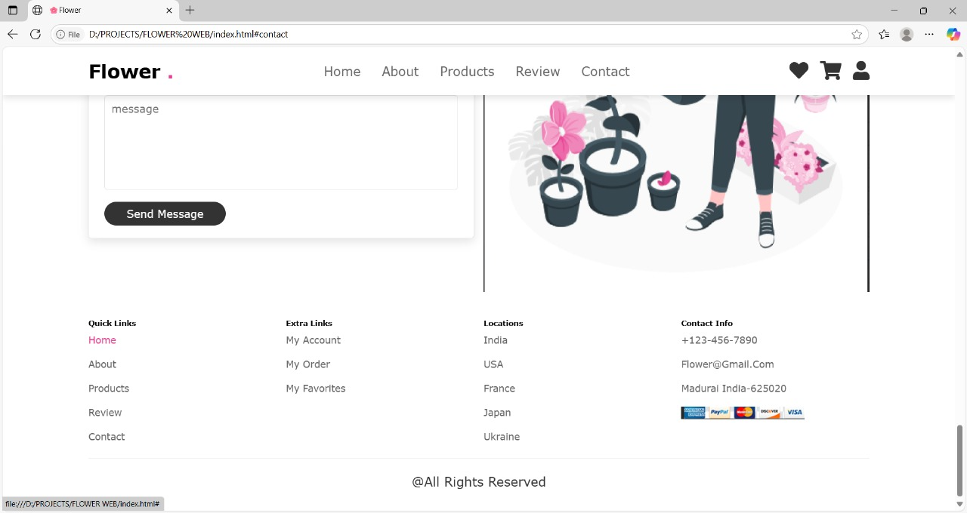

Work Sample 2: News Portal Website
Description: A full-stack web application that allows users to register, submit news stories, and view verified content. It included role-based dashboards for citizens and media professionals, and featured media upload and admin verification functionality.
My Role: I designed the React frontend, developed the backend using Express and MongoDB, and handled integration between the two. I also contributed ideas for dashboard UI and implemented user notifications.

4.2.6. Home page

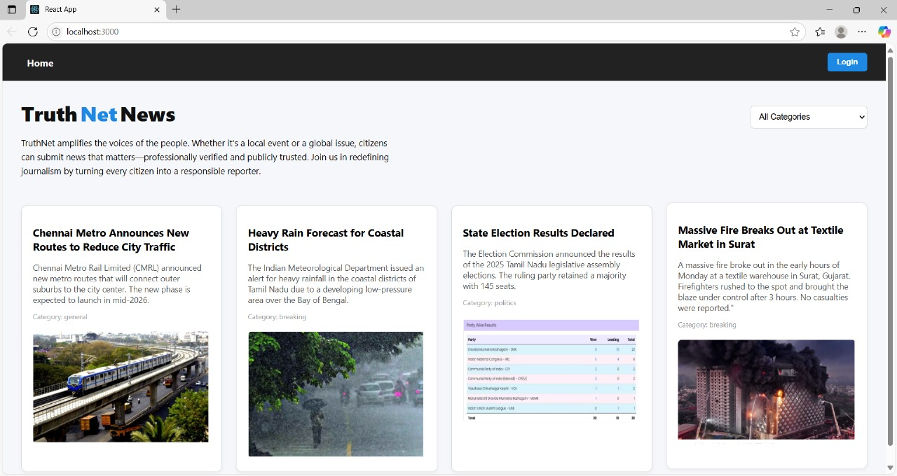

4.2.7. Citizen signup page

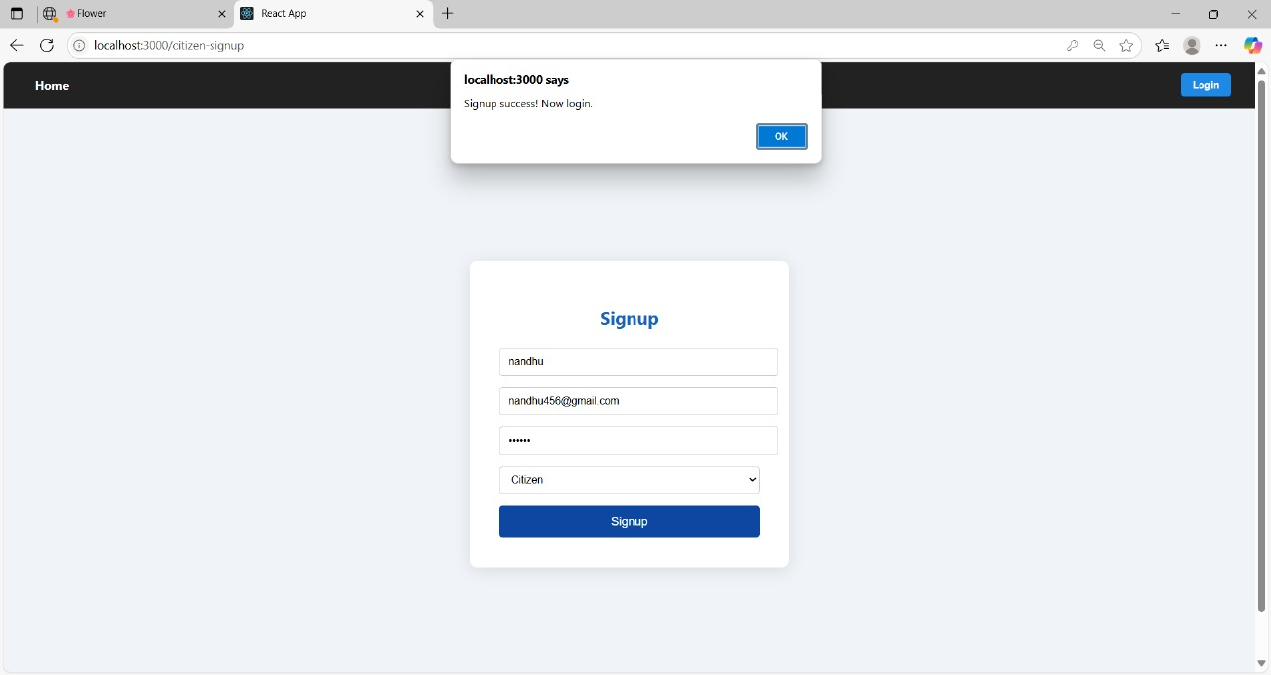

4.2.8. Citizen login page

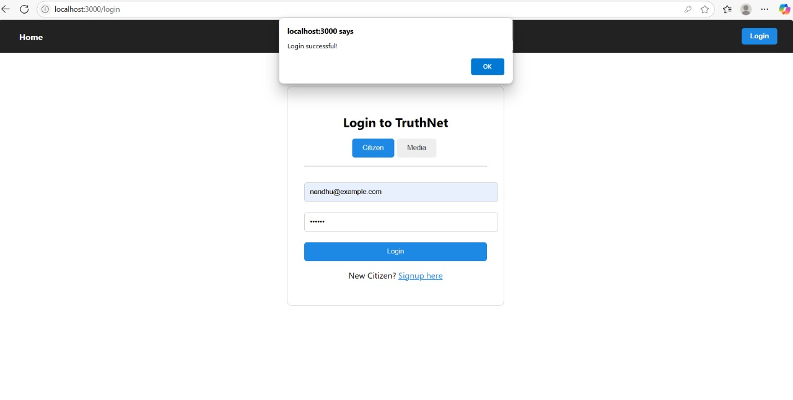

4.2.9. Citizen news upload page

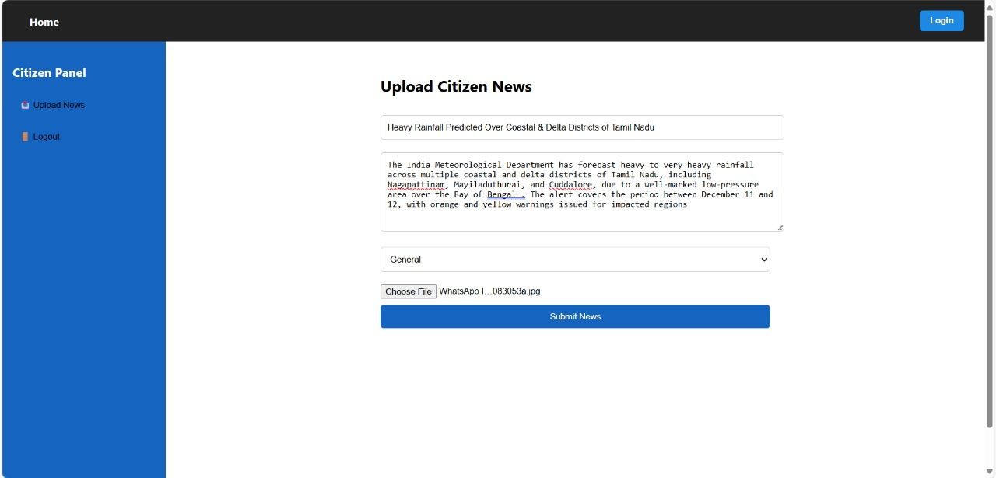

4.2.10. Citizen logout page

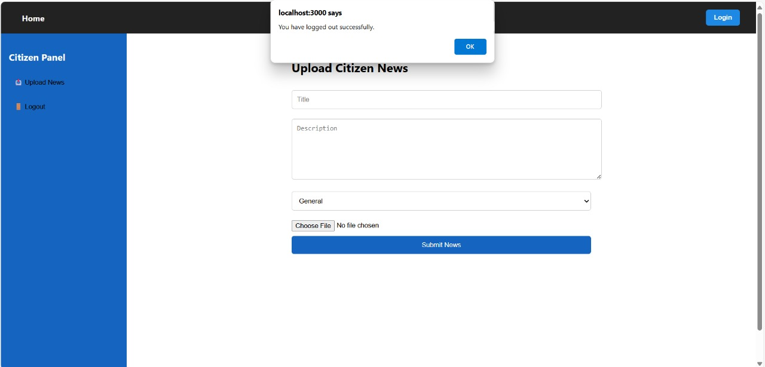

4.2.11. Media signup page

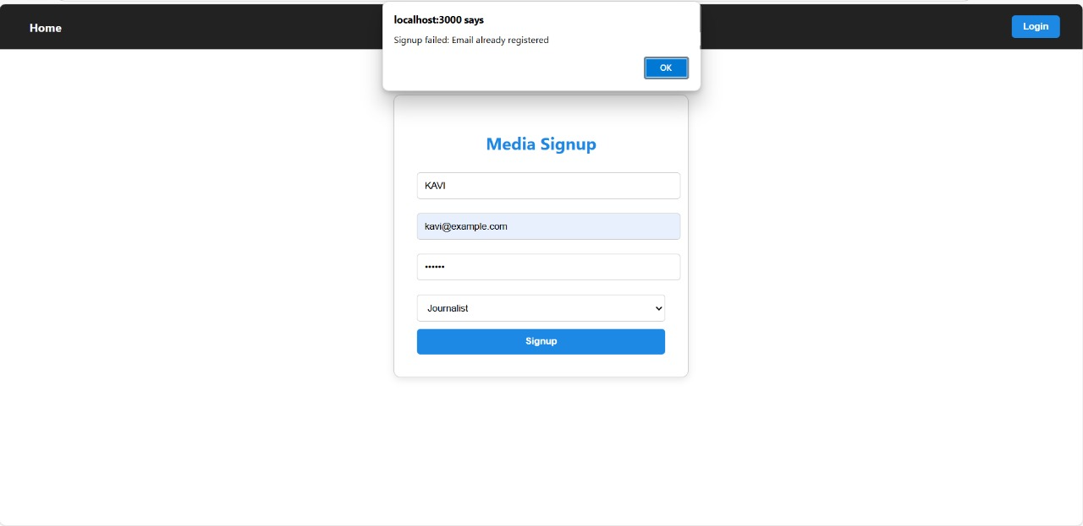

4.2.12. Media login page

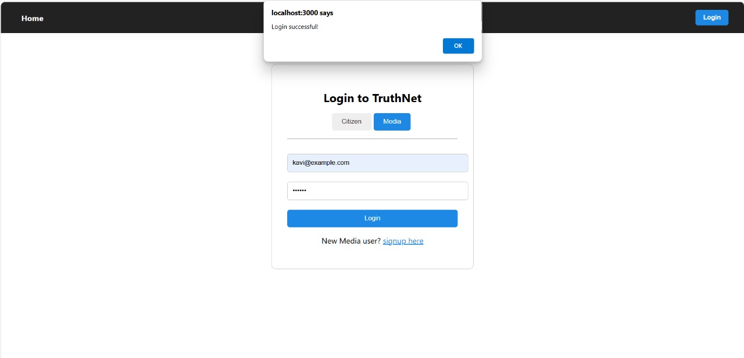

4.2.13. Media news verification page

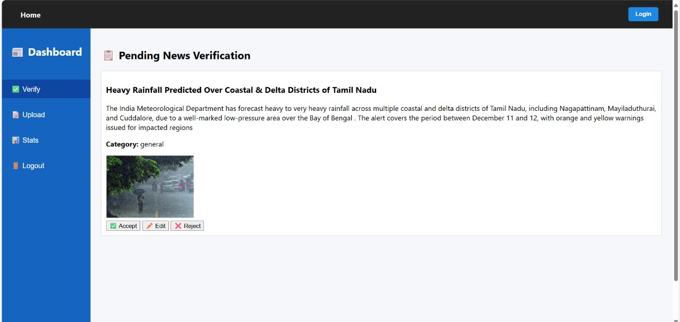

4.2.14. Media news upload page
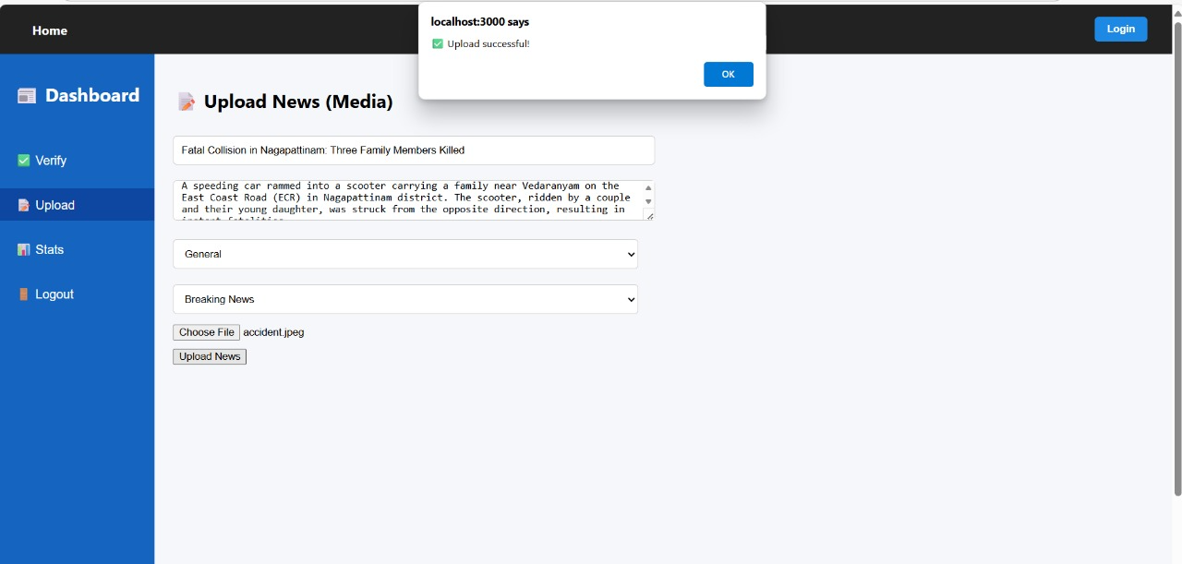
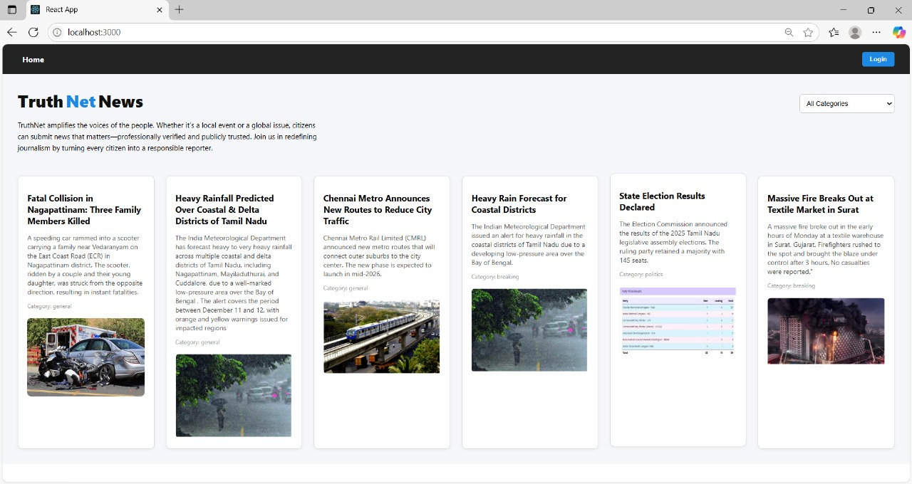
4.3.Conclusion

The internship offered practical exposure to full stack web development using HTML, CSS, JavaScript, React, Node.js, and MongoDB. Through projects like the News Portal Website, Flower Shop, and Ice Cream Store, I gained experience in building responsive frontends,developing APIs, and integrating backend systems.This hands-on experience improved my technical skills, problem-solving ability, and understanding of real-world web application workflows. Overall, the internship enhanced my confidence and prepared me for future roles in the web development field.

