**Multi-regression using r**

Interpreting the output of a linear regression model in R involves looking at several key components: coefficients, residuals, model fit statistics, and significance levels. Here's a breakdown of the output you provided:

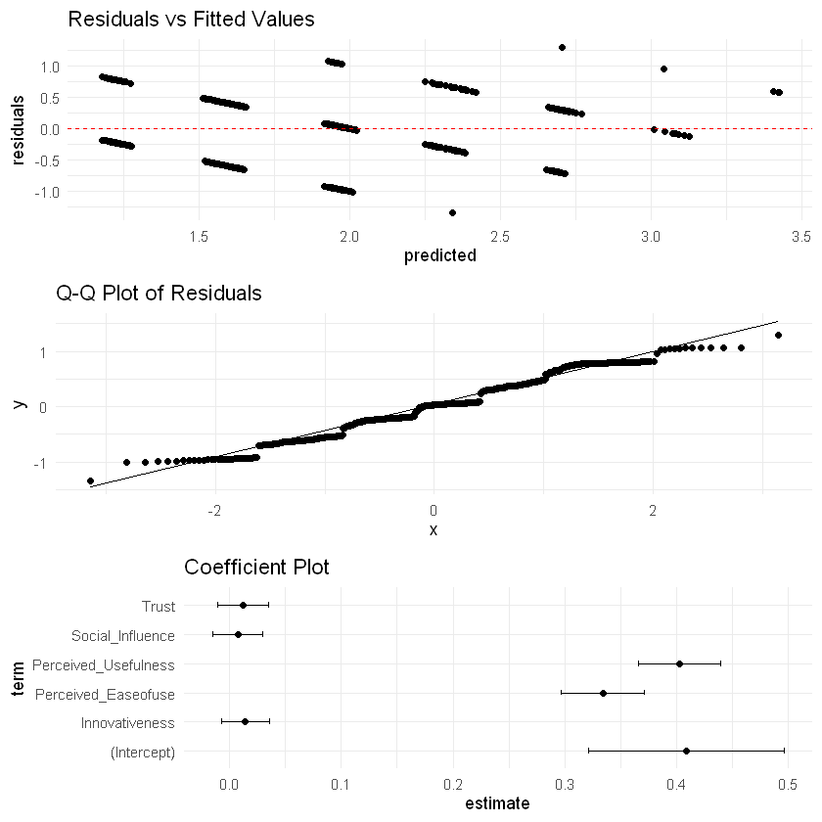

**1. Residuals**

**Min 1Q Median 3Q Max**

-1.34026 -0.27632 0.03044 0.36534 1.29477

* **Min, 1Q, Median, 3Q, Max**:
  + These statistics describe the distribution of the residuals (the differences between the observed and predicted values).
  + **Min (-1.34026)**: The smallest residual indicates that there are predictions that are significantly lower than the observed values.
  + **1Q (-0.27632)**: The first quartile shows that 25% of the residuals are below this value.
  + **Median (0.03044)**: The median residual is close to zero, suggesting that the predictions are balanced around the actual values.
  + **3Q (0.36534)**: The third quartile indicates that 75% of the residuals are below this value.
  + **Max (1.29477)**: The largest residual indicates there are predictions that are significantly higher than the observed values.

**Coefficients:**

**Estimate Std. Error t value Pr(>|t|)**

(Intercept) 0.408938 0.087478 4.675 3.64e-06 ***

Perceived_Usefulness 0.402769 0.036699 10.975 < 2e-16 ***

Perceived_Easeofuse 0.333901 0.037339 8.942 < 2e-16 ***

Trust 0.011849 0.022804 0.520 0.604

Social_Influence 0.007376 0.022537 0.327 0.744

Innovativeness 0.014304 0.021422 0.668 0.505

---

Signif. codes: 0 '***' 0.001 '**' 0.01 '*' 0.05 '.' 0.1 ' ' 1

**2. Coefficients**

* Each row corresponds to a predictor variable in the model, along with the **Intercept**:
  + **Estimate**: This is the estimated coefficient for each variable, representing the average change in the response variable (Customer Satisfaction) for a one-unit change in the predictor variable, holding all other variables constant.
    - **Intercept (0.408938)**: This is the expected value of Customer Satisfaction when all predictors are zero.
    - **Perceived_Usefulness (0.402769)**: A one-unit increase in Perceived Usefulness is associated with a 0.402769 increase in Customer Satisfaction, significant at p < 0.001.
    - **Perceived_Easeofuse (0.333901)**: A one-unit increase in Perceived Ease of Use is associated with a 0.333901 increase in Customer Satisfaction, significant at p < 0.001.
    - **Trust (0.011849)**: Not significant (p = 0.604); it does not have a meaningful impact on Customer Satisfaction in this model.
    - **Social_Influence (0.007376)**: Also not significant (p = 0.744).
    - **Innovativeness (0.014304)**: Also not significant (p = 0.505).

**3. Significance Codes**

* The p value indicates thresholds for determining whether the coefficients are statistically significant. In this case:
  + **Perceived_Usefulness** and **Perceived_Easeofuse** are significant predictors, while **Trust**, **Social_Influence**, and **Innovativeness** are not significant.

Residual standard error: 0.4942 on 594 degrees of freedom

Multiple R-squared: 0.5107, Adjusted R-squared: 0.5066

F-statistic: 124 on 5 and 594 DF, p-value: < 2.2e-16

**4. Residual Standard Error**

* **Residual standard error (0.4942)**: This is the average amount that the response variable (Customer Satisfaction) deviates from the fitted line. A smaller value indicates a better fit.

**5. Model Fit Statistics**

* **Multiple R-squared (0.5107)**: This indicates that approximately 51.07% of the variance in Customer Satisfaction can be explained by the predictors in the model. This is a moderate level of explained variance.
* **Adjusted R-squared (0.5066)**: This adjusts the R-squared value for the number of predictors in the model, providing a more accurate measure of model fit. It's very close to the Multiple R-squared, indicating that the added predictors contribute to the model.
* **F-statistic (124 on 5 and 594 DF, p-value: < 2.2e-16)**: The F-statistic tests whether at least one predictor variable has a non-zero coefficient. A very small p-value indicates that the model is statistically significant overall.

**Summary**

In summary, your model suggests that **Perceived Usefulness** and **Perceived Ease of Use** are significant predictors of **Customer Satisfaction**, while **Trust**, **Social Influence**, and **Innovativeness** do not significantly affect Customer Satisfaction in this dataset. The model explains about 51% of the variability in Customer Satisfaction, which indicates a moderate level of fit. The results imply that focusing on improving perceived usefulness and ease of use could lead to higher customer satisfaction levels.

**Key Findings**

1. **Customer Satisfaction**: This is the main thing you’re measuring. You want to see what makes customers happy.
2. **Factors Studied**:
   * **Perceived Usefulness**: How much customers think a product or service helps them.
   * **Perceived Ease of Use**: How easy customers find the product or service to use.
   * **Trust**: How much customers trust the brand.
   * **Social Influence**: How much others (friends, family) affect their opinions.
   * **Innovativeness**: How much customers think the product is new or cutting-edge.

**What the Results Mean**

* **Significant Factors**:
  + **Perceived Usefulness**: If customers think a product is useful, their satisfaction increases. This factor is very important.
  + **Perceived Ease of Use**: If customers find it easy to use the product, they are also more satisfied. This factor is also very important.
* **Less Important Factors**:
  + **Trust**, **Social Influence**, and **Innovativeness** did not show a meaningful effect on customer satisfaction in this study. This means that these factors don’t significantly impact how satisfied customers feel about the product or service in your dataset.

**Overall Model Performance**

* The model explains about **51%** of what makes customers satisfied. This is a decent amount, meaning your study captures a good portion of the factors that contribute to customer happiness, but there's still some room for other influences that weren't measured.
* The **F-statistic** tells you that your overall model is statistically significant. This means that at least one of your factors really does affect customer satisfaction.

**Takeaway**

To make customers happier, focus on making your product more useful and easier to use. Trust and social influences don’t seem to matter as much based on this study.