**1 INTRODUCTION**

* 1. Overview

A social media post is a short-form type of content or message that gets published on social media platforms such as Facebook, Instagram, Twitter, LinkedIn, and other similar channels. It takes several different forms that result from mixing text, images, videos, links, and audio files.

1.2 Purpose

Social media posts are an important part of any social media marketing strategy. They allow businesses to build a community around their brand and establish a meaningful presence in the online space.

**2 problem definition & Design Thinking**

2.1 Empathy map

* 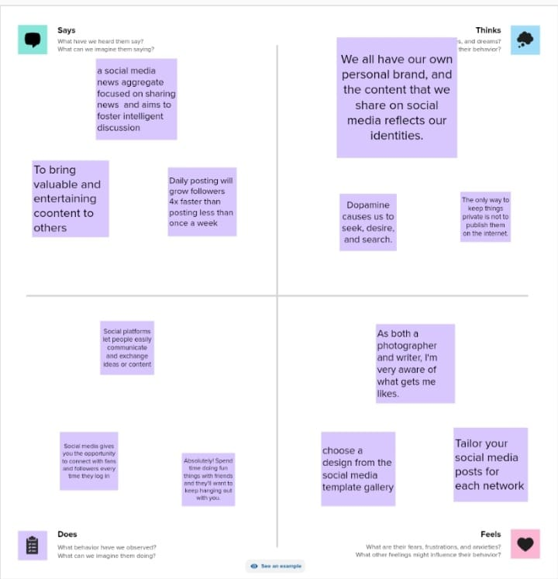

**2.2 Ideation & Brainstorming map**

* 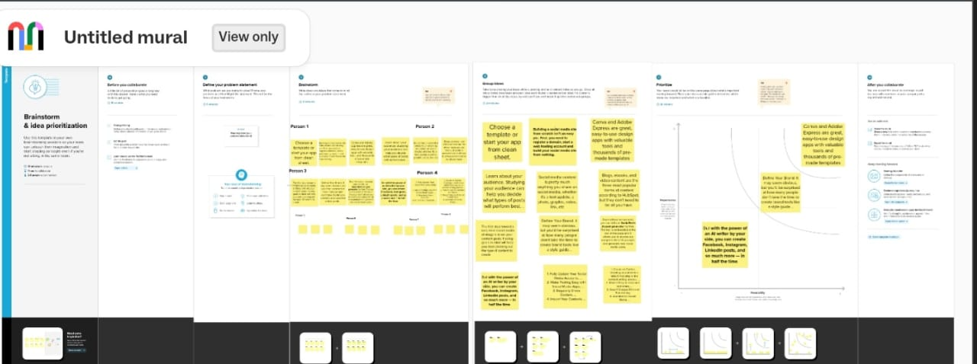

1. **RESULT**