1. **INTRODUTION**

1.1 Overview

While creativity is vital, don't forget to include essential details in the invitation. Make sure to mention the date, time, and location of the party, along with an RSVP contact. If there's a dress code or specific theme, be sure to convey that information clearly to your guests. Example: “Save the Date.

1.2 purpose

Select a template that works for you and edit the text, colors, layout, and graphics to make it unique to your child. You can even upload a photo of them for an extra touch. Whichever way you choose to design the invitation card is up to you and easy to deposes

1. **Problem Definition & Design Thinking**

2.1 Empathy Map

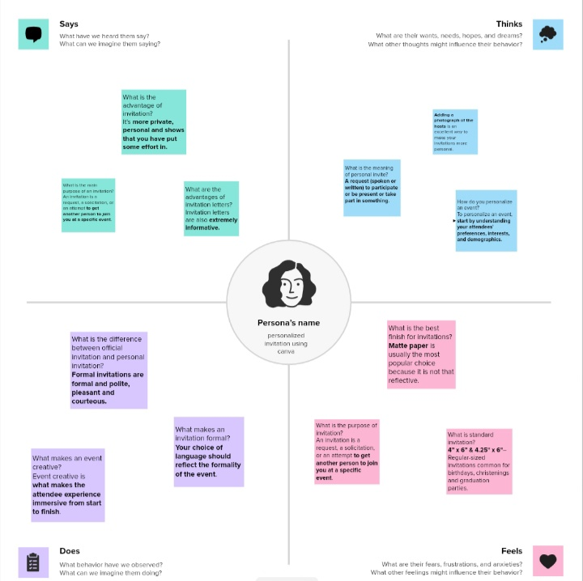

2.2 Ideation & Brainstorming Map 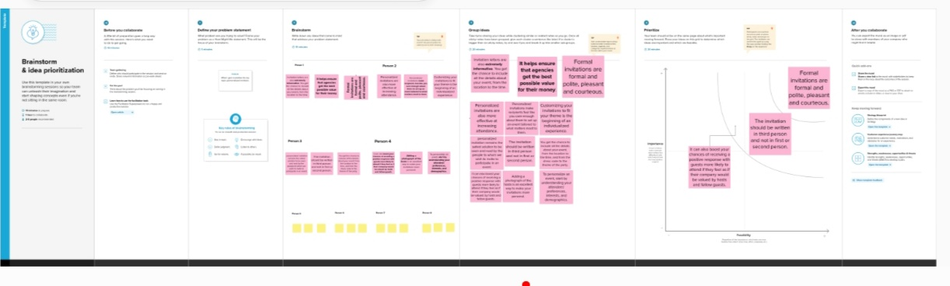

**3 RESULT**

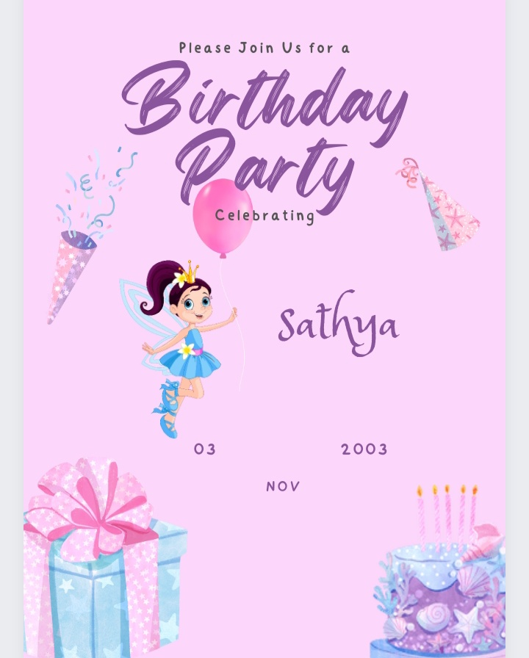

ADVANTAGES & DISADVANTAGE

ADVANTADE

Sending a customized paper invitation shows that you put in the effort and even spent money to make sure you included them in your event. It also shows how much planning you have put **into your event.**

DISADVANTAGE

While celebrating birthdays is generally seen as a positive and enjoyable occasion, there can be certain disadvantages associated with it. These can include: 1. Financial burden: Birthday celebrations often involve expenses such as gifts, decorations, parties, and outings

**5 APPLICATION**

I have used use mural and canva.

**6 conclution**

We have created birthday invition with the help of canva.

**7 FUTURE SCOPE**

We were planning to join the graphic designing course.