NETFLIX MOVIES ANALYSIS

- Project Overview
This project analyse Netflix movies dataset collected from Kaggle.com. The goal is to derive insights into thew trends and patterns in Netflix’s catalogue to guide strategic business decisions.
- Dataset Summary
Rows: 16000
Columns: 13
Key Features:
- Netflix Columns( Show_id, Type, Title, Director, Country, Date_added, Rating, Genres, Language, Popularity, Vote_Count, Vote_Average, Revenue.
- Missing Data: 705 values in Review Director, Country, Genres column.

- Exploratory Data Analysis using Python
We began with data preparation and cleaning in Python:
● Data Loading:
Imported the dataset using pandas.
● Initial Exploration:
Used df.info() to check structure and df.describe() for summary statistics.
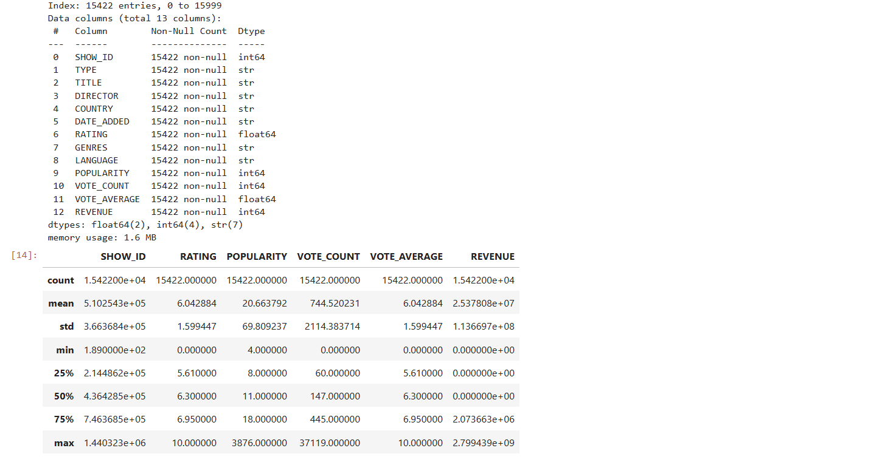
● Missing Data Handling:
Checked for null values and imputed missing values in the Review Director, Country, Genres column using df.dropna(inplace=True)
● Column Standardization:
Renamed columns to snake case for better readability and documentation.
● Data Consistency Check:
Verified if
- df[['TITLE','DIRECTOR']].head(10)
- df[['COUNTRY','RATING']].head(10)

● Database Integration:
Connected Python script to PostgreSQL and loaded the cleaned DataFrame into the database for SQL analysis.

4. Data Analysis using SQL (Business Transactions)
We performed structured analysis in PostgreSQL to answer key business questions:

- Top 5 Titles by Revenue – Found titles with the highest average revenue.

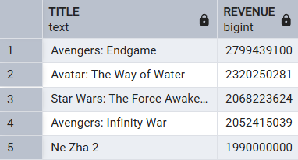

- Top 3 Country-Found most use movie count of countries.

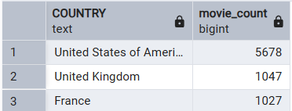

3.Action vs Drama Movies-Compared average revenue across movies status.

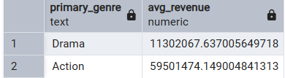

4.Highest Movies User Engagement-Found titles on the high vote_count.

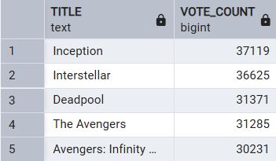

5.High use of Language-Identify to language with the highest popularity to use them.

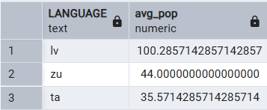

6.Top 5 Directors by Ratings- Found directors with the highest average review ratings.

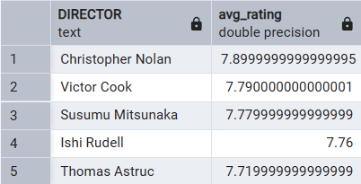

7.2019 vs 2020 Movies Revenue-Identified movies in 2019 and 2020 total revenue with the date_added.

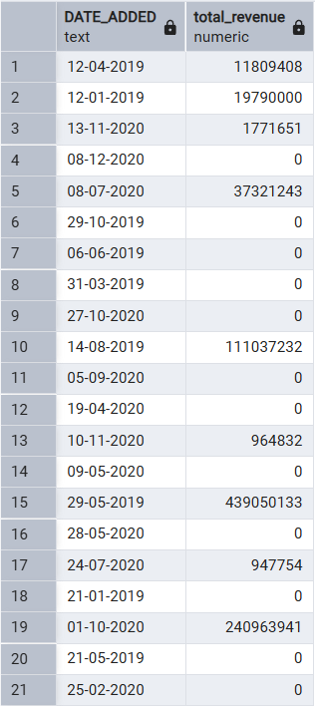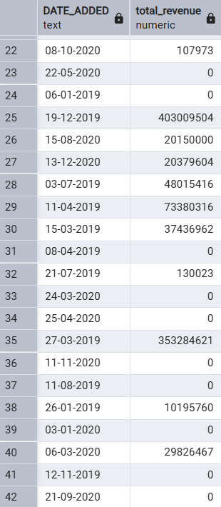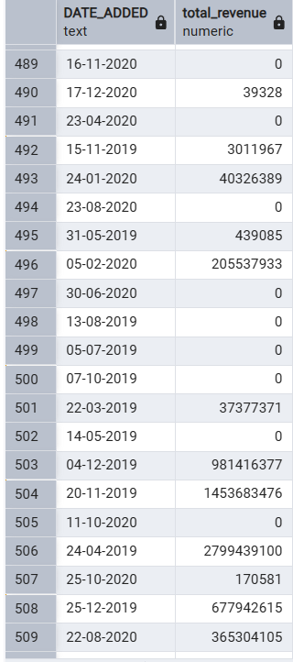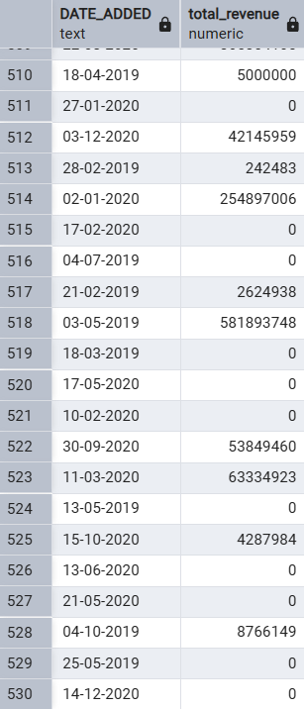

8. Ratings by Country-identified the country is at least 50 movies ratings.

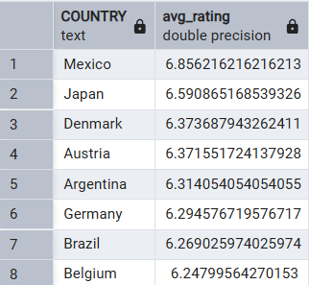

5. Dashboard in Excel
Finally, we built an interactive dashboard in Excel to present insights visually.
- Connect the data in SQL from Excel Sheet.

