**USING RAPTOR – CHECK GIVEN NUMBER PALINDROME OR NOT**

**FLOWCHART**

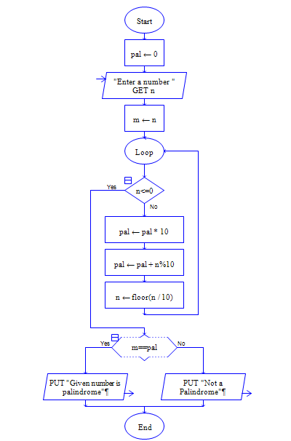

**OUTPUT**

INPUT IS 1234321

