**USING RAPTOR – CHECK GIVEN NUMBER PRIME OR NOT**

**FLOWCHART**

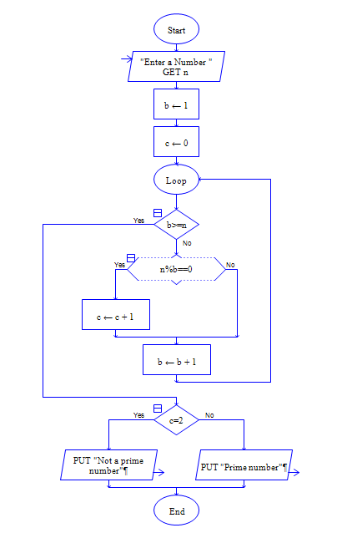

**OUTPUT**

INPUT IS 5

