

Internship Final Report
Student Name | SATHYA V
University | Anna University
Institute Name | Sri Venkateswara College of Engg & Tech
Internship Duration | 1ST September to 30TH September
Company Name | ShadowFox
Role | Data Analyst
Mentor Name | Mr. Aakash S

Project Title

Decoding Starbucks: An Exploratory Analysis of Calories, Sugars, and Nutritional Metrics

Objectives:
• Comprehensive Nutritional Data Exploration:
To thoroughly analyze the Starbucks beverage menu dataset (starbucks_drinkMenu_expanded.xlsx), identifying underlying distributions, statistical variances, and key nutritional parameters—specifically focusing on calories, total sugars, and caffeine content across diverse drink categories.
• Advanced Data Visualization & BI Dashboard Architecture:
To design and develop a dynamic, user-centric, and interactive Power BI Dashboard that transforms raw numerical data into clear visual formats, featuring custom canvas formatting, a cohesive color palette, and structured layout panels.
• Interactive Filtering & Dynamic Analytics Implementation: ‘
To implement multi-level slicers and category-based filtering mechanisms that allow users to dynamically explore specific beverage categories, preparation types, and individual drink items while maintaining real-time cross-filtering across all visual elements.
• Correlation & Behavioral Pattern Identification:
To examine the statistical relationships between critical dietary attributes—such as evaluating how sugar content influences overall caloric load across handcrafted and specialty beverages using advanced scatter plots and distribution charts.
• Actionable Business Insights & Health-Centric Recommendations Formulation:
To translate data-driven findings into strategic, value-driven business insights, offering actionable recommendations for the food and beverage industry to promote transparency, highlight low-calorie alternatives, and support informed, health-conscious consumer choices.

Flow Diagram:

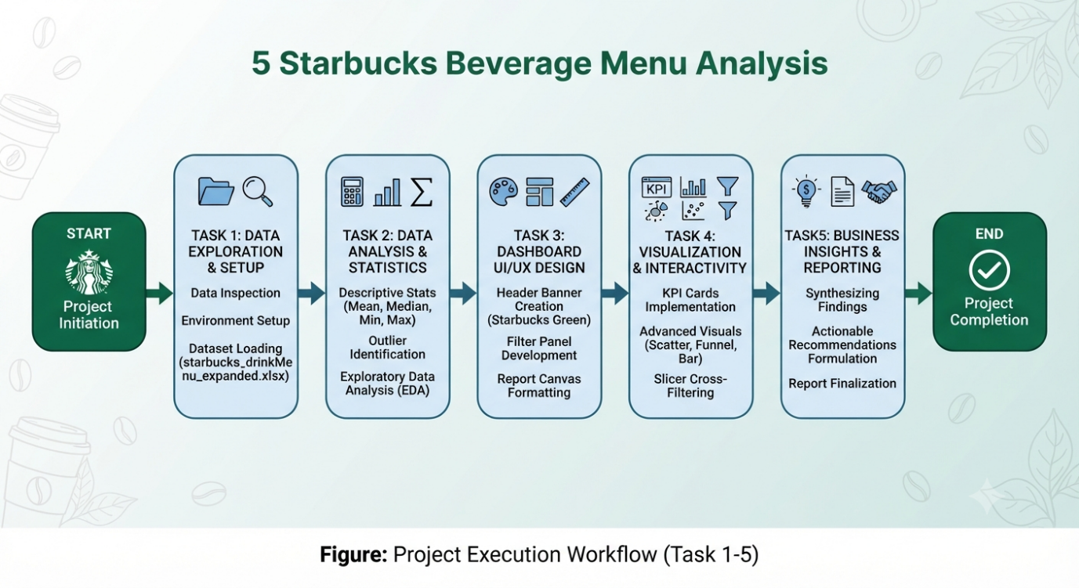

Tasks and Responsibilities:

Task 1: Data Exploration
• 1.1 Dataset Overview & Source Identification
- The analysis is performed using the starbucks_drinkMenu_expanded.xlsx dataset, which captures comprehensive nutritional information and product characteristics for various beverages served at Starbucks.
• 1.2 Core Variables and Schema Analysis
- To understand the structure of the dataset, key columns and parameters were thoroughly examined:
  - Beverage_category: Categorizes drinks into broad groups (e.g., Coffee, Tea, Smoothies) to facilitate segmented analysis.
  - Calories: Quantifies the total energy derived from each beverage serving.
  - Sugars (g): Measures carbohydrate/sugar content, serving as a vital metric for sweetness and dietary impact.
  - Total Fat (g): Captures the fat profile, distinguishing dairy-heavy items from lighter bases.

  - Caffeine (mg): Tracks stimulant levels across different coffee and tea preparations.
• 1.3 Data Integrity & Preliminary Profiling
- Checked for null values, inconsistent naming conventions, and data type alignment across all columns.
- Verified that numerical fields (Calories, Sugars, Fat, Caffeine) are correctly formatted as quantitative data types to enable smooth aggregations, statistical summaries, and Power BI visual mappings.

Task 2: Data Analysis & Statistical Modeling (Using Python)
- Python-Powered Statistical Execution:
  - Leveraged Python programming (utilizing data manipulation and analytical libraries such as pandas) to process the Starbucks nutritional dataset.
  - Executed automated descriptive statistical functions (df.describe()) to instantly compute core metrics including the mean, median, minimum, and maximum ranges for calories, sugars, fat, and caffeine.
- Automated Data Grouping & Outlier Detection:
  - Implemented Python grouping functions (groupby) to efficiently evaluate category-wise performance across different beverage types.
  - Applied quartile calculations (75th percentile / Q3) programmatically to accurately isolate high-calorie outliers and segment heavy menu items from standard beverages.
- Efficiency & Scalability:
  - Utilizing Python for this exploratory data analysis (EDA) phase ensured rapid, error-free data verification, providing clean structural statistics that directly fed into the subsequent Power BI dashboard visualization and reporting stages.

Import pandas :

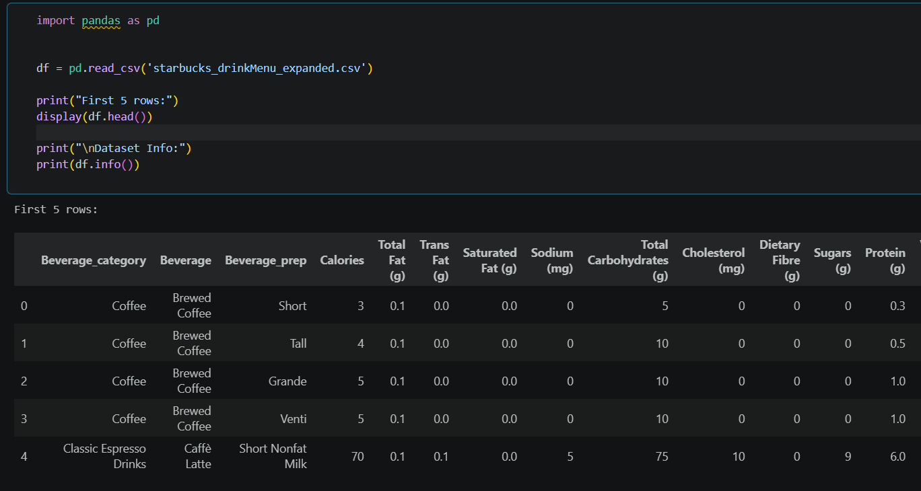

summary statistics (Mean, Min, Max, Percentiles):
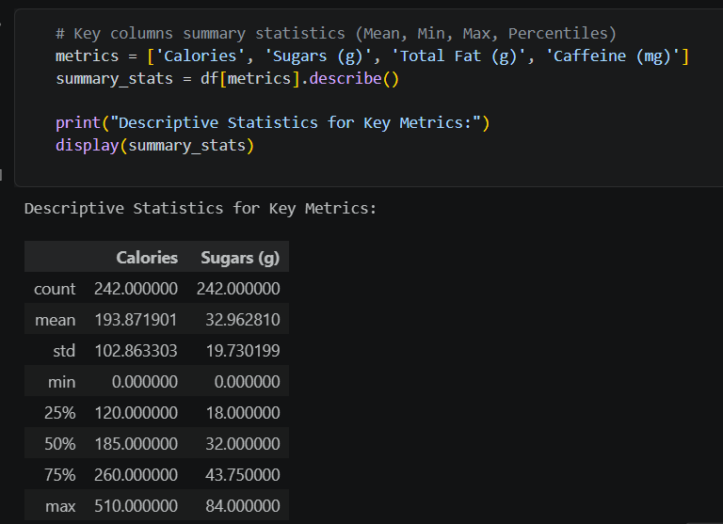
Beverage category average calories:
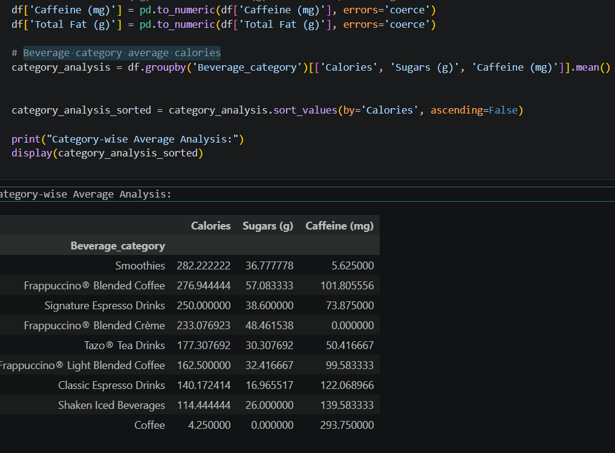

Total High-Calorie Drinks:
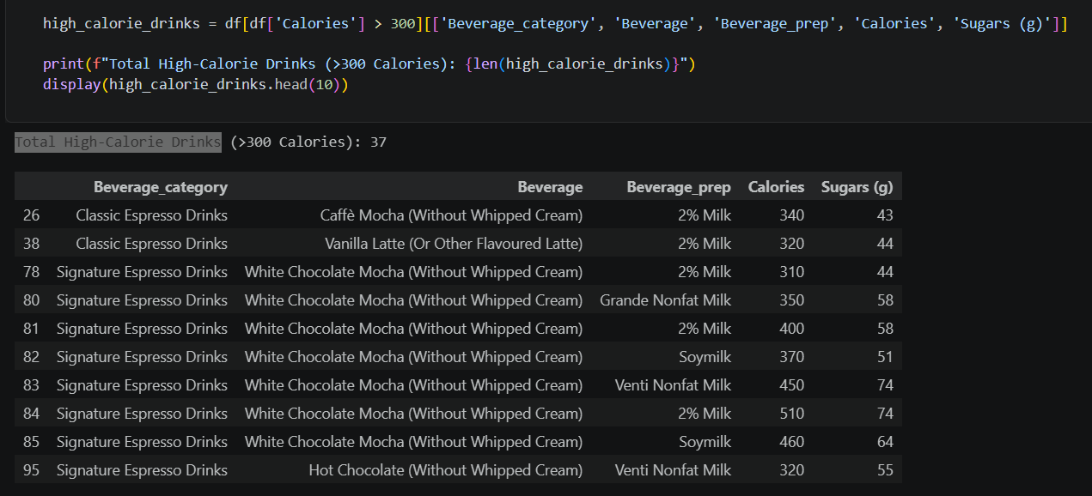

Overall Avg:
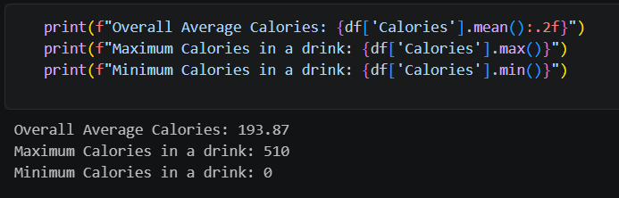

Task 3: Product & Category Performance Analysis

- Category-Wise Nutritional Comparison: Compared average calories, total fat, and sugar content across various beverage categories (e.g., Coffee, Tea, Smoothies).
- Healthy vs. High-Calorie Segmentation: Evaluated menu items to segment standard, health-centric options from heavy, high-calorie variants.
- Size-Wise Impact Analysis: Analyzed how calorie and sugar levels fluctuate as drink sizes change (transitioning across Short, Tall, Grande, and Venti sizes).

Performance Analysis
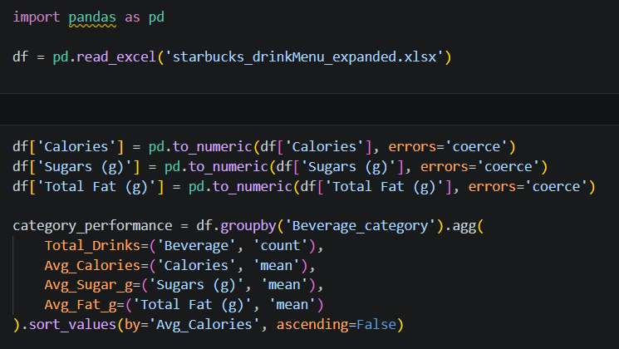
Category Performance Summary:
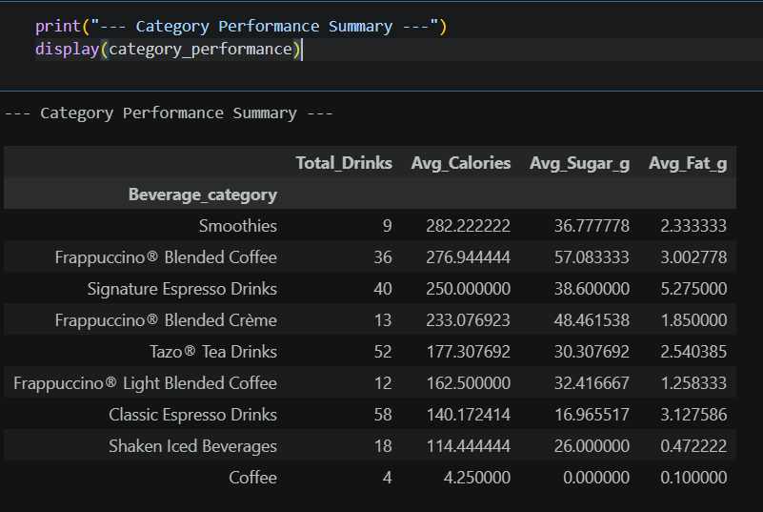

Calorie Segment Breakdown:
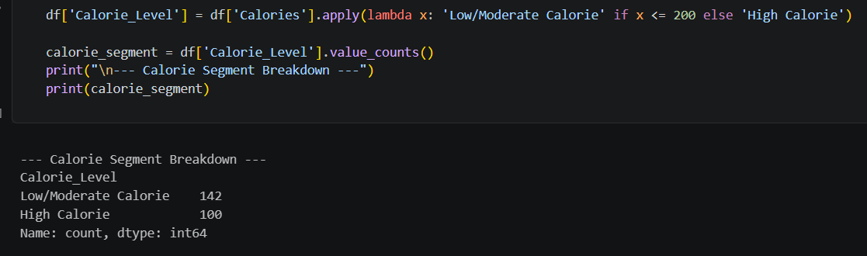

Size (Beverage Prep) Wise Average Calories:
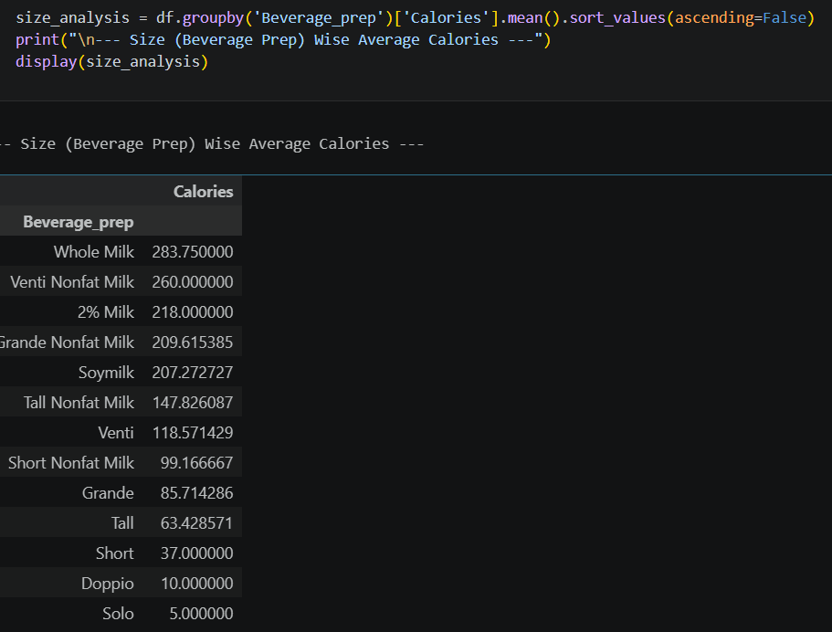

Task 4: Trend Identification & Visual Reporting
- Visual Representation: Transformed analytical findings into structured charts using Excel or Python visualization libraries (Matplotlib/Seaborn).
- Comparative & Relational Charts:
  - Bar Chart: Illustrated average calorie discrepancies across different beverage categories.
  - Scatter Plot: Examined the positive correlation between sugar/fat content and total calories.
  - Box Plot / Distribution Analysis: Pinpointed extreme outliers representing unusually high-calorie specialty beverages.

Starbucks Beverage Menu Analysis Dashboard:

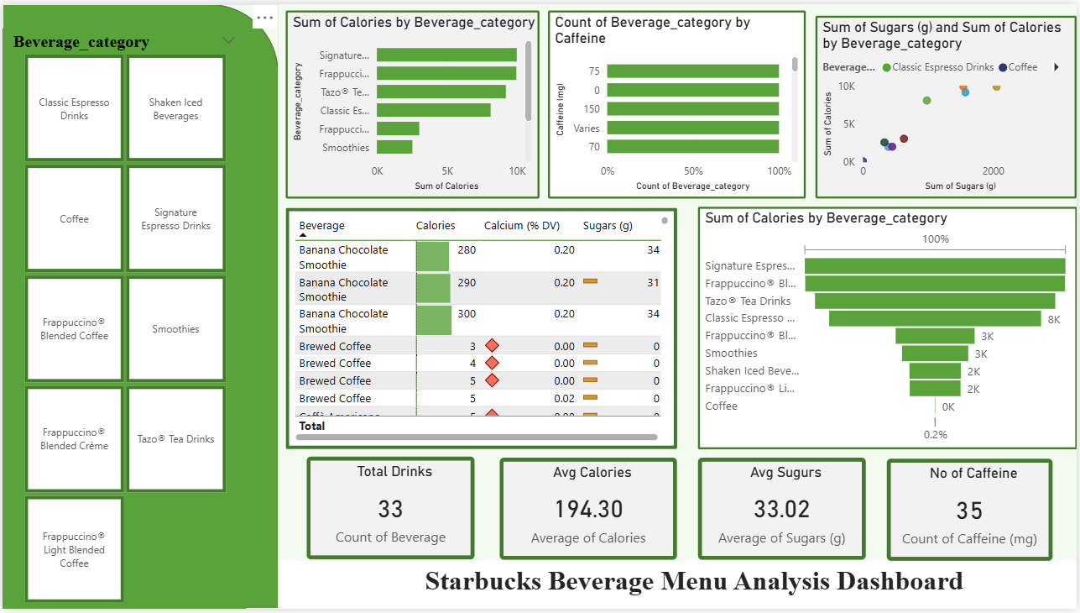

Task 5: Business Insights & Strategic Recommendations
- 1. Consumer-Centric Findings & Nutritional Transparency
  - Health-Conscious Awareness: The analysis successfully isolated light, low-calorie, and low-sugar alternatives (such as plain brewed coffees, teas, and unsweetened beverages) from calorie-dense specialty items.
  - Empowering Consumers: By bringing these options to light, the dashboard and report provide consumers with transparent nutritional data, enabling them to make informed, health-conscious choices tailored to their dietary goals without sacrificing beverage preference.
- 2. Menu Strategy Suggestions & Product Optimization
  - Addressing High Sugar Concentrations: A subset of the menu—particularly blended beverages, flavored frappuccinos, and heavy smoothies—exhibited excessive sugar and calorie concentrations.
  - Actionable Recommendations: Recommended that Starbucks introduce modified default recipes (e.g., reducing standard syrup pumps or offering half-sweet variations by default), prominently feature low-sugar alternatives on digital menu boards, and encourage transparent labeling regarding customizable dairy or sweetener options.
- 3. Final Project Synthesis & Professional Reporting
  - Holistic Consolidation: Brought together all preceding phases—ranging from data exploration and statistical python modeling (Tasks 1 & 2) to UI/UX dashboard design and advanced visualization cross-filtering (Tasks 3 & 4)—into a unified, cohesive narrative.
  - Report & Presentation Delivery: Synthesized the entire workflow into a structured project report and presentation format, ensuring that technical metrics, graphical evidence, and commercial strategy align seamlessly for final project evaluation.

Learning Outcomes
- End-to-End Business Intelligence & Data Workflow Mastery: Gained hands-on experience managing an entire data analytics lifecycle—starting from raw dataset ingestion and offline environment setup (Task 1) to exploratory data analysis, interactive dashboard creation, and final strategic reporting.
- Advanced Statistical Analysis & Python Integration: Learned how to compute and interpret critical descriptive statistics (mean, median, min, max) using Python and Excel, while mastering quartile distributions (75th percentile / Q3) for effective outlier identification and data segmentation (Task 2).
- Dashboard UI/UX Design & Layout Architecture: Developed practical skills in designing professional Power BI interfaces, including custom canvas background formatting, corporate branding alignment (Starbucks Dark Green theme), and structured layout panels for header banners and filter containers (Task 3).
- Interactive Visual Analytics & Cross-Filtering: Acquired expertise in building dynamic, user-centric visualizations—such as clustered bar charts, scatter plots, funnel charts, and KPI summary cards—and configuring multi-level slicers for real-time cross-filtering (Task 4).
- Translating Data into Actionable Business Intelligence: Learned how to bridge the gap between technical data metrics and commercial strategy by synthesizing raw nutritional trends into actionable business insights, health-centric customer recommendations, and structured professional reports (Task 5).

Challenges and Solutions
- Challenge 1: Cloud Sign-In & Workspace Connectivity Restrictions
  - Problem: Encountered mandatory online sign-in prompts and potential workspace cloud barriers when initializing the development tool environment.
  - Solution: Safely bypassed online authentication requirements by utilizing local offline execution settings, establishing a stable and uninterrupted local development workspace.
- Challenge 2: Managing Complex Nutritional Data Variables
  - Problem: Handling multi-dimensional nutritional metrics (Calories, Sugars, Total Fat, Caffeine) alongside diverse category and drink size hierarchies could easily lead to cluttered or confusing data models.
  - Solution: Applied structured data inspection and Python-powered exploratory data analysis (EDA) to clearly define column schemata, ensuring clean categorization and precise quantitative mapping before visualization.
- Challenge 3: Isolating Outliers and Skewed Nutritional Data
  - Problem: Heavy specialty drinks (such as blended frappuccinos and smoothies) contained disproportionately high sugar and calorie levels compared to standard beverages, which could distort general statistical comparisons.
  - Solution: Implemented quartile distributions (specifically calculating the 75th percentile / Q3 thresholds) to accurately flag and segment high-calorie outliers without losing overall dataset integrity.
- Challenge 4: Ensuring Seamless Interactive Cross-Filtering in Dashboards
  - Problem: Integrating multiple filter slicers with complex charts (scatter plots, bar charts, and KPI cards) risked breaking data relationships or causing slow response times.
  - Solution: Systematically configured multi-level slicers (Beverage_category, Beverage_prep, etc.) and tested real-time cross-filtering to ensure seamless, synchronized visual updates across the entire report canvas

Conclusion

• Comprehensive Data Insights: The Starbucks Beverage Menu Analysis successfully demonstrated how raw nutritional data (Calories, Sugars (g), Total Fat (g), and Caffeine (mg)) can be transformed into actionable business intelligence.
• Identification of High-Calorie Segments: Exploratory data analysis and statistical modeling revealed that specialty blended beverages and frappuccinos represent the primary high-calorie and high-sugar outliers on the menu.
• Promotion of Healthy Alternatives: By highlighting light, low-calorie options (such as plain brewed coffees and teas), the project provides a framework for empowering customers to make informed, health-conscious dietary choices.
• End-to-End Technical Execution: The project successfully bridged technical implementation—spanning Python-powered data processing, Power BI UI/UX dashboard design, interactive multi-level cross-filtering, and strategic reporting—into a cohesive, professional presentation ready for commercial evaluation.

Acknowledgments
- Institutional & Academic Support: We would like to express our sincere gratitude to our institution, faculty members, and mentors for their continuous guidance, valuable feedback, and encouragement throughout the duration of this project.
- Data & Tool Providers: We acknowledge the providers of the Starbucks nutritional dataset (starbucks_drinkMenu_expanded.xlsx) for supplying the dietary data, as well as the developers of Python, Pandas, and Power BI for providing the powerful analytical and visualization tools used to execute this study.
- Collaborative Efforts: Special thanks are extended to all team members and peers who contributed their time, technical assistance, and creative insights toward the successful design, troubleshooting, and final reporting of this analysis.

