Euclidean distance is:

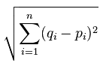

n= number of dimensions

i is dimension (goes from 1 to n)

q is one point, p is another point

q = (1,3)

p= (2,5)

square root of: (1-2)^2 + (3-5)^2