|  |  |
| --- | --- |
| **Practicum Case** |  |
| COMP6799 | COMP6799001 | COMP6799016 | COMP6799049  Database Technology |
| **Computer Science** | **E231-COMP6799-HG01-03** |
| ***Valid on*** *Even Semester Year 2022/2023* | **Revision 00** |

## Learning Outcomes

* LO2 – explain the concepts of relational algebra, DDL, DML, transaction management on database and concurrency control

## Topic

* Session 03 – Data Manipulation Language (DML)

## Subtopics

* Alter Table
* Update Query
* Delete Query
* Transaction

**Tabel Relasional**

*Relational Table*

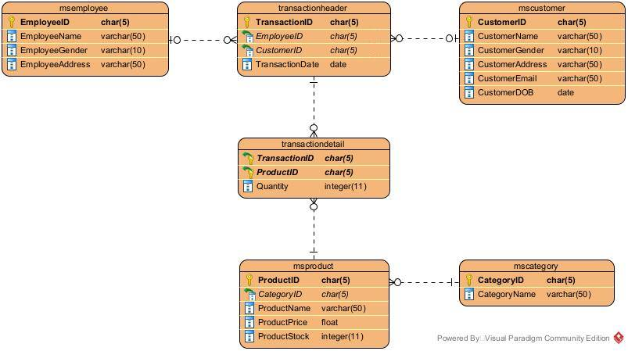

## Soal

*Case*

1. **Insert** these data into **TransactionDetail** **table**:

|  |  |  |
| --- | --- | --- |
| **TransactionID** | **ProductID** | **Quantity** |
| TR001 | PR014 | 27 |
| TR001 | PR010 | 2 |
| TR005 | PR005 | 26 |
| TR005 | PR002 | 21 |

1. **Insert** this data into **MsProduct** **table**:

(**RAND**, **ROUND**)

|  |  |  |  |  |
| --- | --- | --- | --- | --- |
| **ProductID** | **CategoryID** | **ProductName** | **ProductPrice** | **ProductStock** |
| PR047 | CT004 | Wagyu Saikoro | 12.99 | Random decimal number between 10 and 50 and round the result to 2 decimal places. |

1. **Add** this **column** to **MsCustomer** **table**:

|  |  |  |  |
| --- | --- | --- | --- |
| **Field Name** | **Data Type** | **Length** | **Description** |
| CustomerPhone | VARCHAR | 50 | Cannot be empty. |

1. **Add** a **constraint** named “**check_phonenumber**” to check the **CustomerPhone** must be **numeric**.

(**REGEXP**)

1. **Delete** data on **TransactionHeader** **table** for every **transaction** which **TransactionID is** ‘**TR001**’, ‘**TR003**’, or ‘**TR005**’.

(**IN**)

**Before**:

**After**:

1. **Update** data on **MsProduct** **table** by **subtracting** **ProductPrice** **by 2** for every **product** which **price is** **above** **10**.

**Before**:

**After**:

1. **Update** data on **MsCustomer table** by **adding** ‘**Mrs.**’ to customer name and **adding** ‘**lady**’ to customer email before the ‘**@**’ character for every **female** customer which **age** is **over 20**.

(**CONCAT**, **INSERT**, **LOCATE**, **TIMESTAMPDIFF**, **CURDATE**)

**Before**:

**After**:

1. Display **ProductID**, **ProductName**, **ProductPrice** (obtained by **adding** ‘**$**’ in front of the **ProductPrice**), and **CategoryName** for every **product** which **category is** “**Dairy**” **or** “**Meat**”.

(**CONCAT**, **JOIN**)

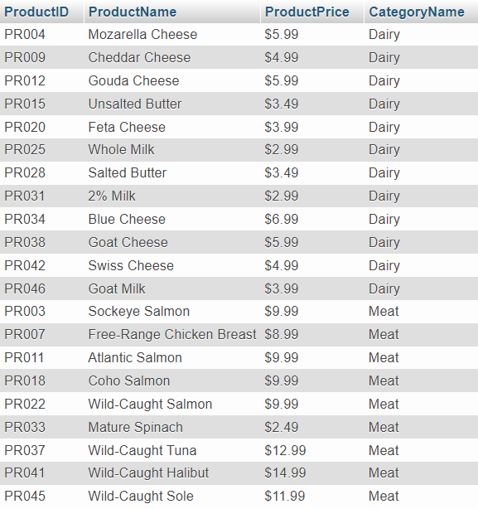

1. Display **EmployeeName** and **EmployeeAddress** for every **employee** who ever handled a transaction with a **female** **customer** in **December.**

(**DISTINCT**, **MONTH**)

