BASIS
BigBasket Assortment & Strategy Intelligence System
10-Chart Product Assortment, Pricing, Brand and Category Analysis

Dataset records analysed: 27,553
Categories: 11 | Subcategories: 90 | Brands: 2,313
Dataset scope note: This BigBasket dataset is a product catalogue snapshot. It does not contain customer IDs, orders, transaction dates, quantities sold, or actual revenue. Therefore, this report focuses on assortment, listed pricing, discount structure, ratings, brands and category positioning rather than claiming actual sales, revenue, demand or price elasticity.

1. Product Distribution Across Categories
Chart type: Horizontal bar chart
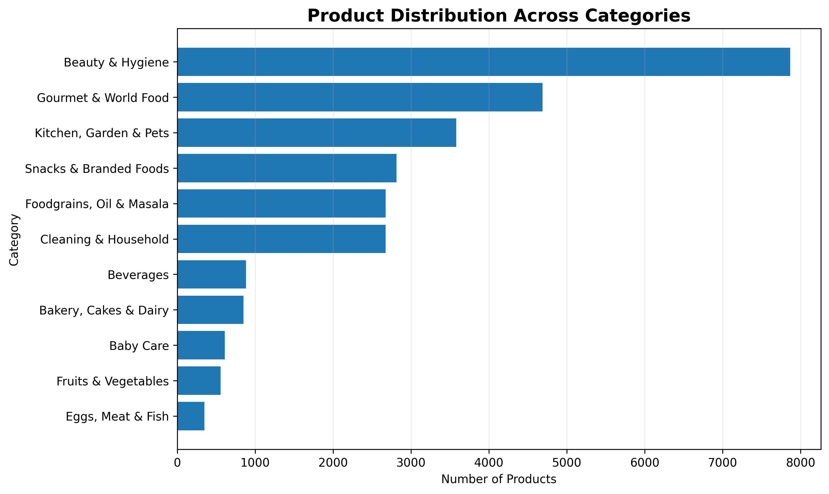
Purpose: Shows how the catalogue is distributed across major product categories.
What to look for: Categories with very large or very small assortment sizes and the relative breadth of the catalogue.
Business relevance: Useful for assortment planning and identifying categories with comparatively high or low catalogue coverage.

2. Top 15 Subcategories by Product Count
Chart type: Horizontal bar chart
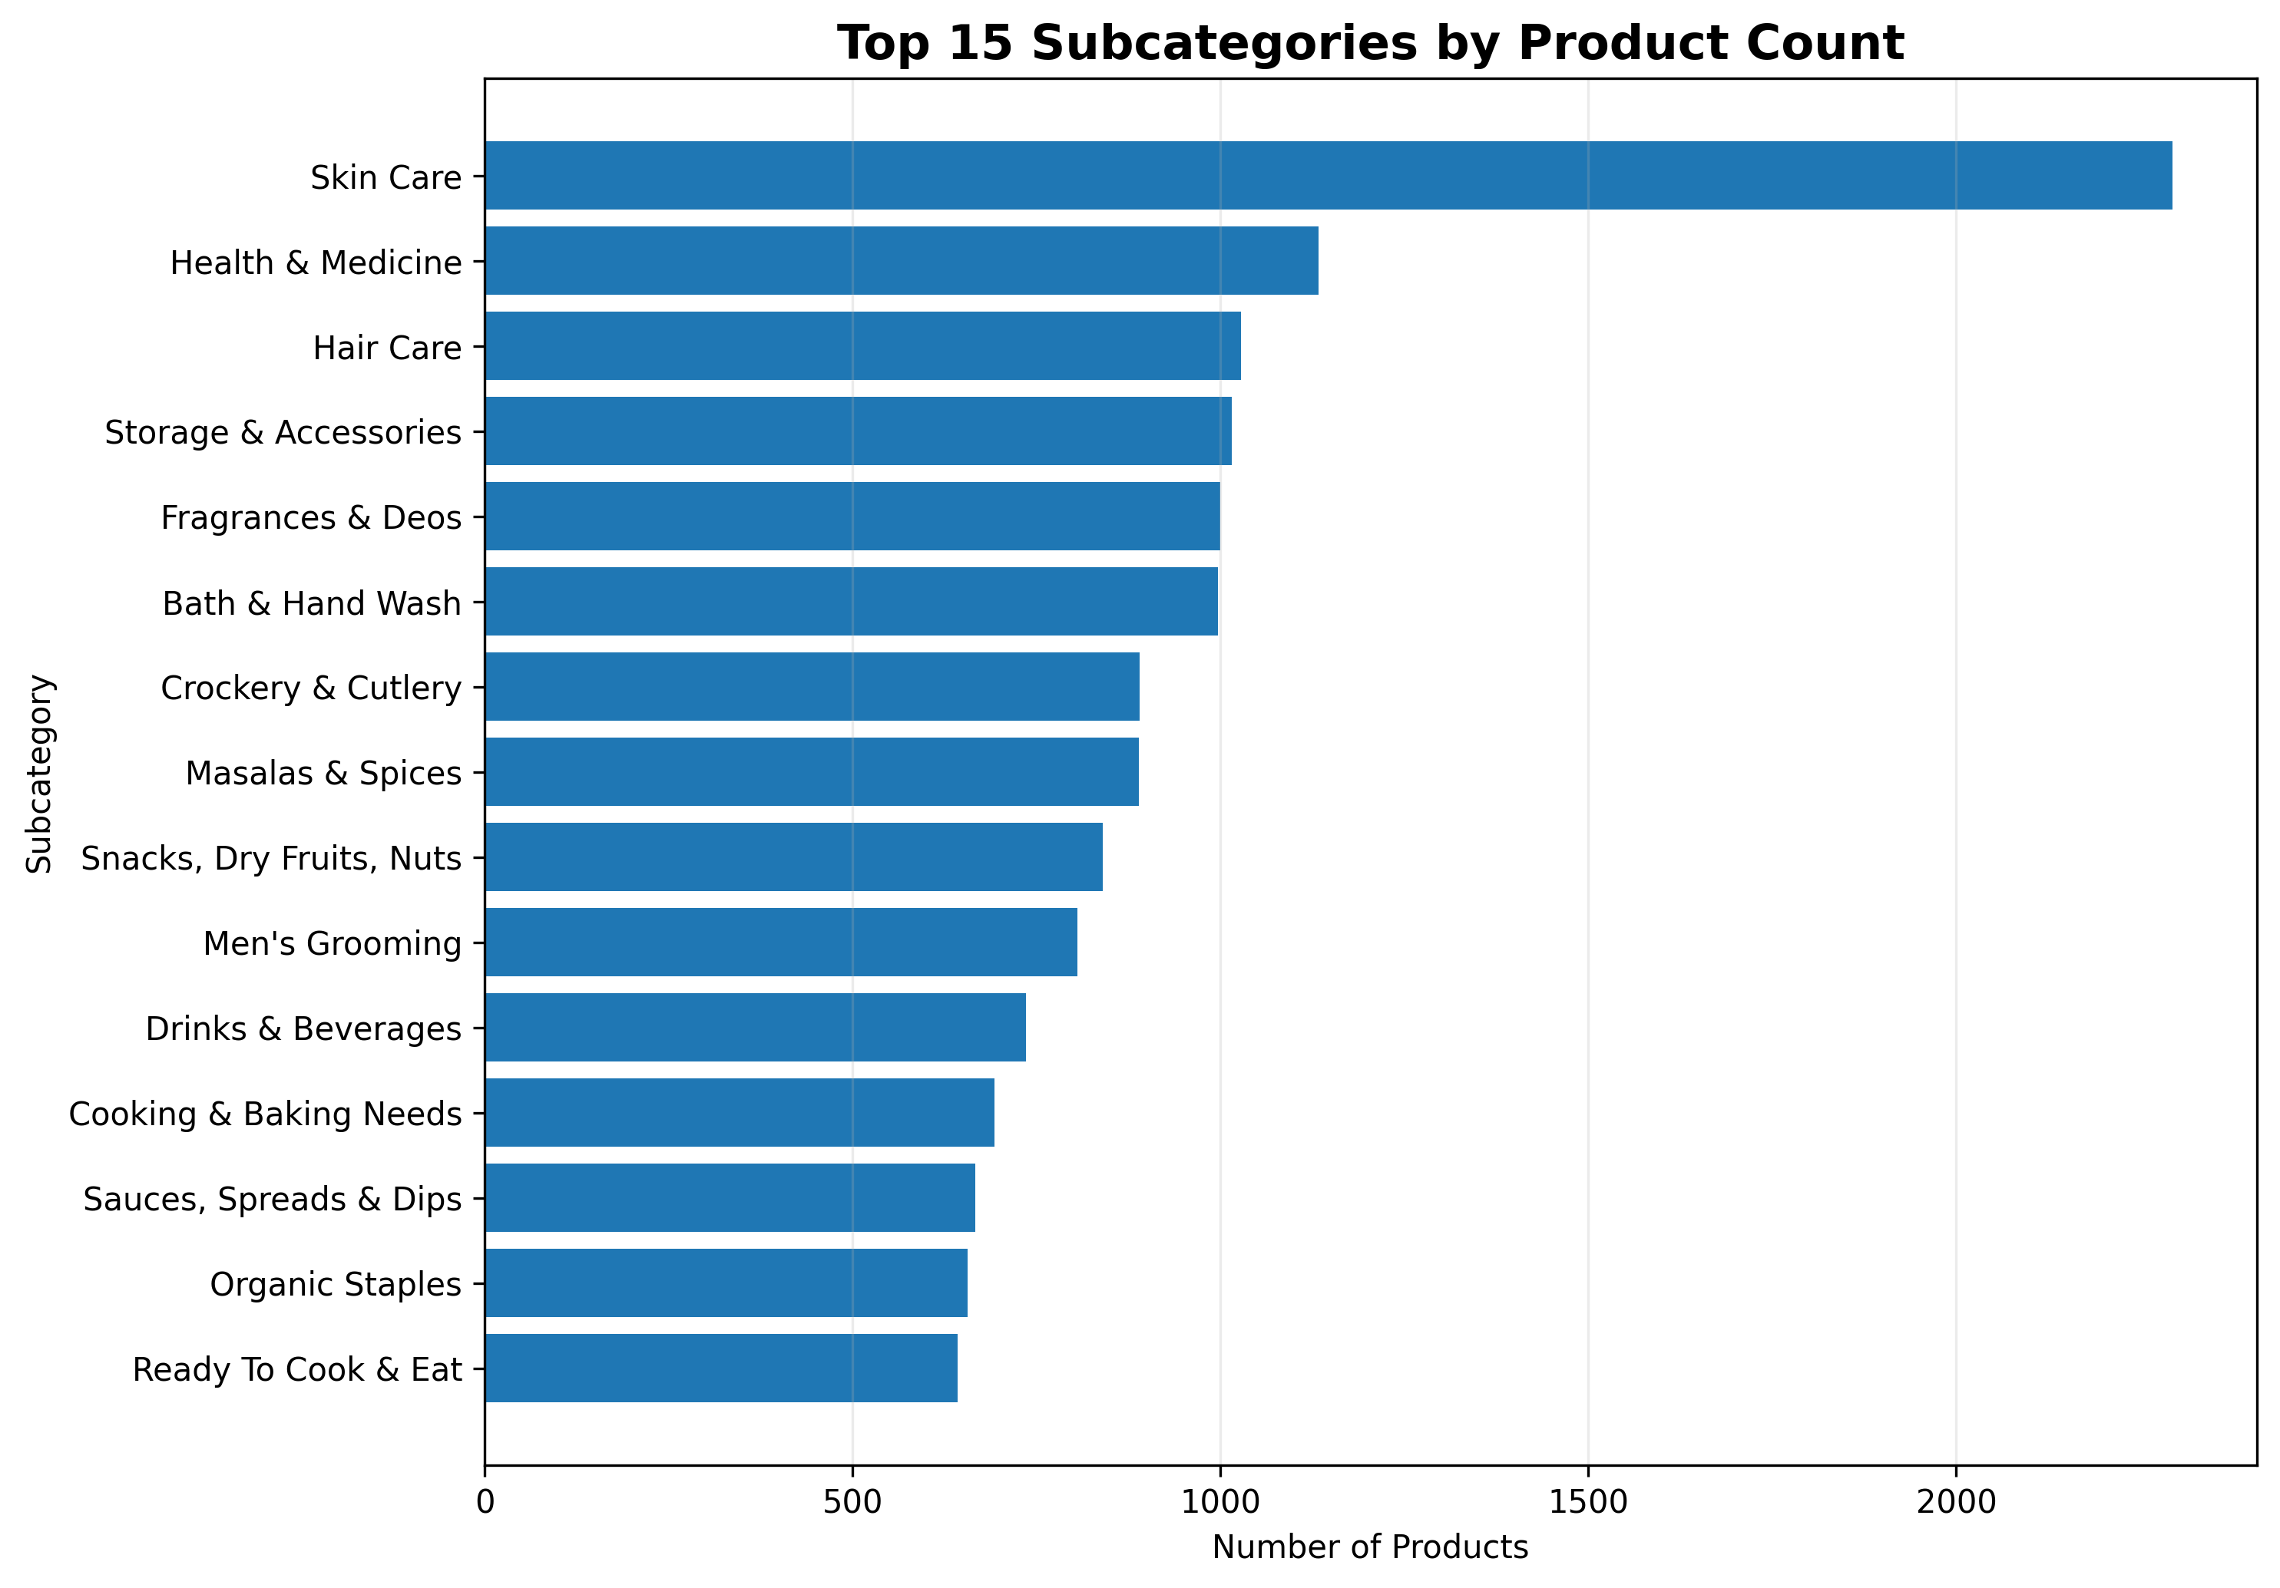
Purpose: Highlights the subcategories with the largest number of listed products.
What to look for: Which subcategories dominate the assortment and how concentrated the catalogue is among leading subcategories.
Business relevance: Supports assortment depth decisions and helps identify areas where catalogue breadth is already high.

3. Distribution of Product Sale Prices
Chart type: Histogram
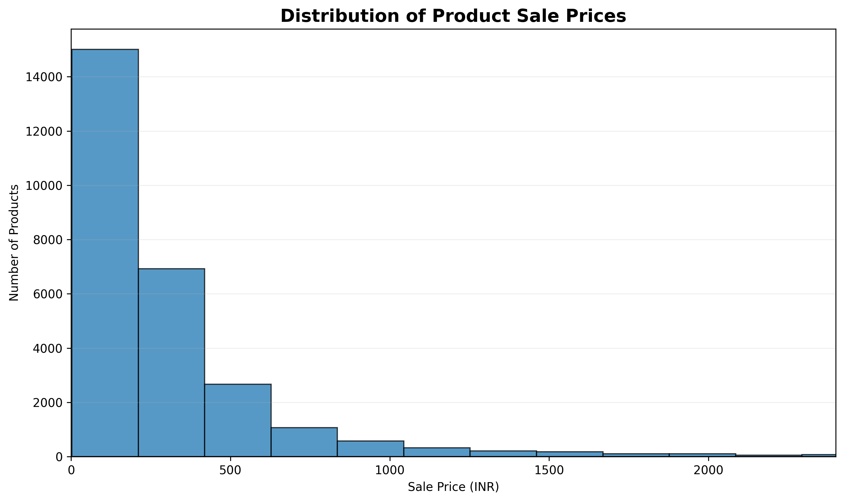
Purpose: Shows the overall spread of listed selling prices in the product catalogue.
What to look for: The concentration of products in lower, middle and higher price ranges and the degree of price skew.
Business relevance: Useful for understanding the catalogue's price architecture and identifying dominant price bands.

4. Sale Price Distribution Across Categories
Chart type: Horizontal boxplot
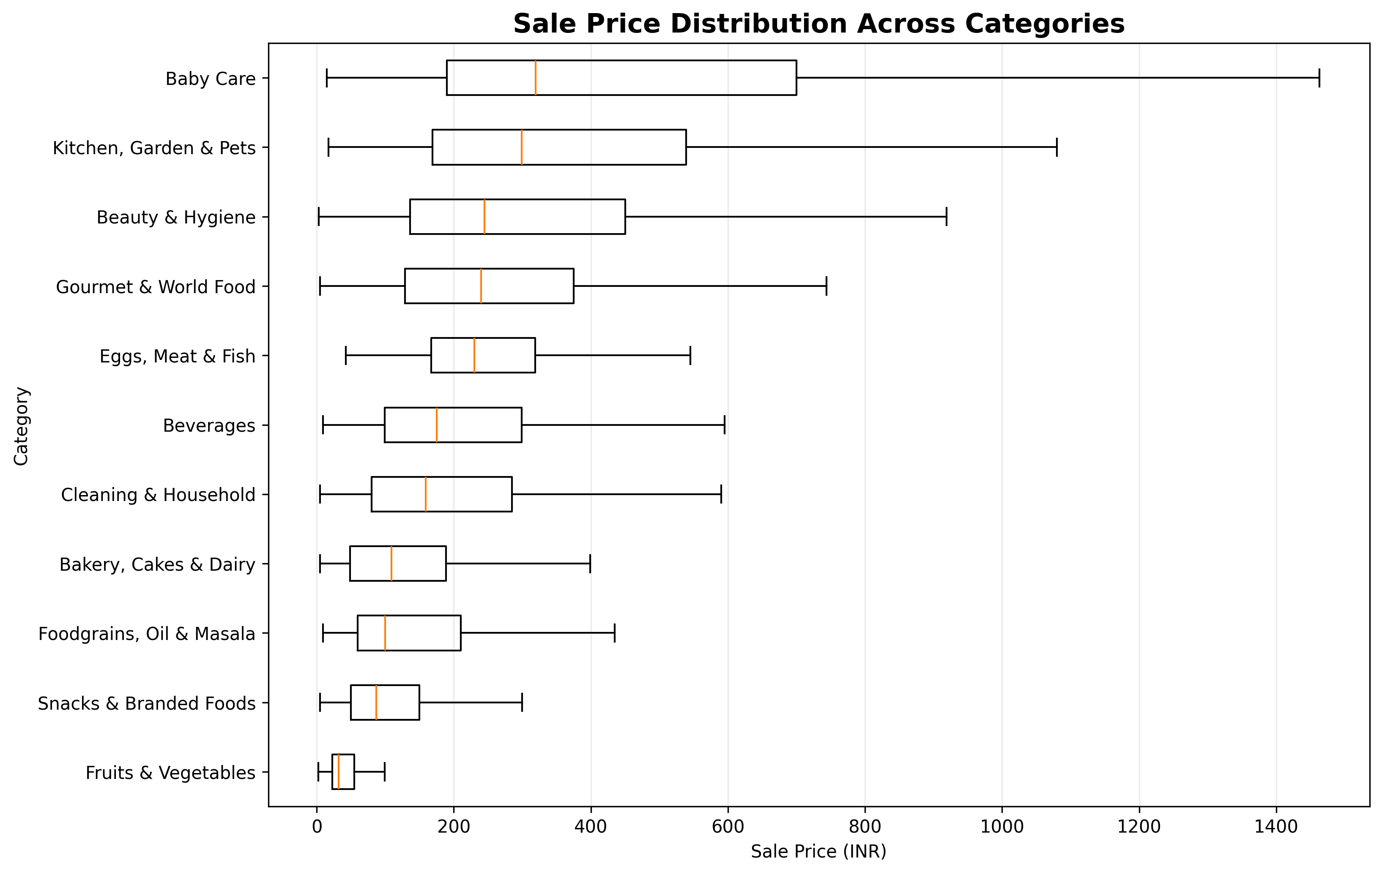
Purpose: Compares the distribution and central tendency of listed sale prices across categories.
What to look for: Differences in median prices, spread and category-level price ranges.
Business relevance: Helps compare category price positioning and identify categories with broader or narrower price structures.

5. Market Price vs Sale Price
Chart type: Scatter plot
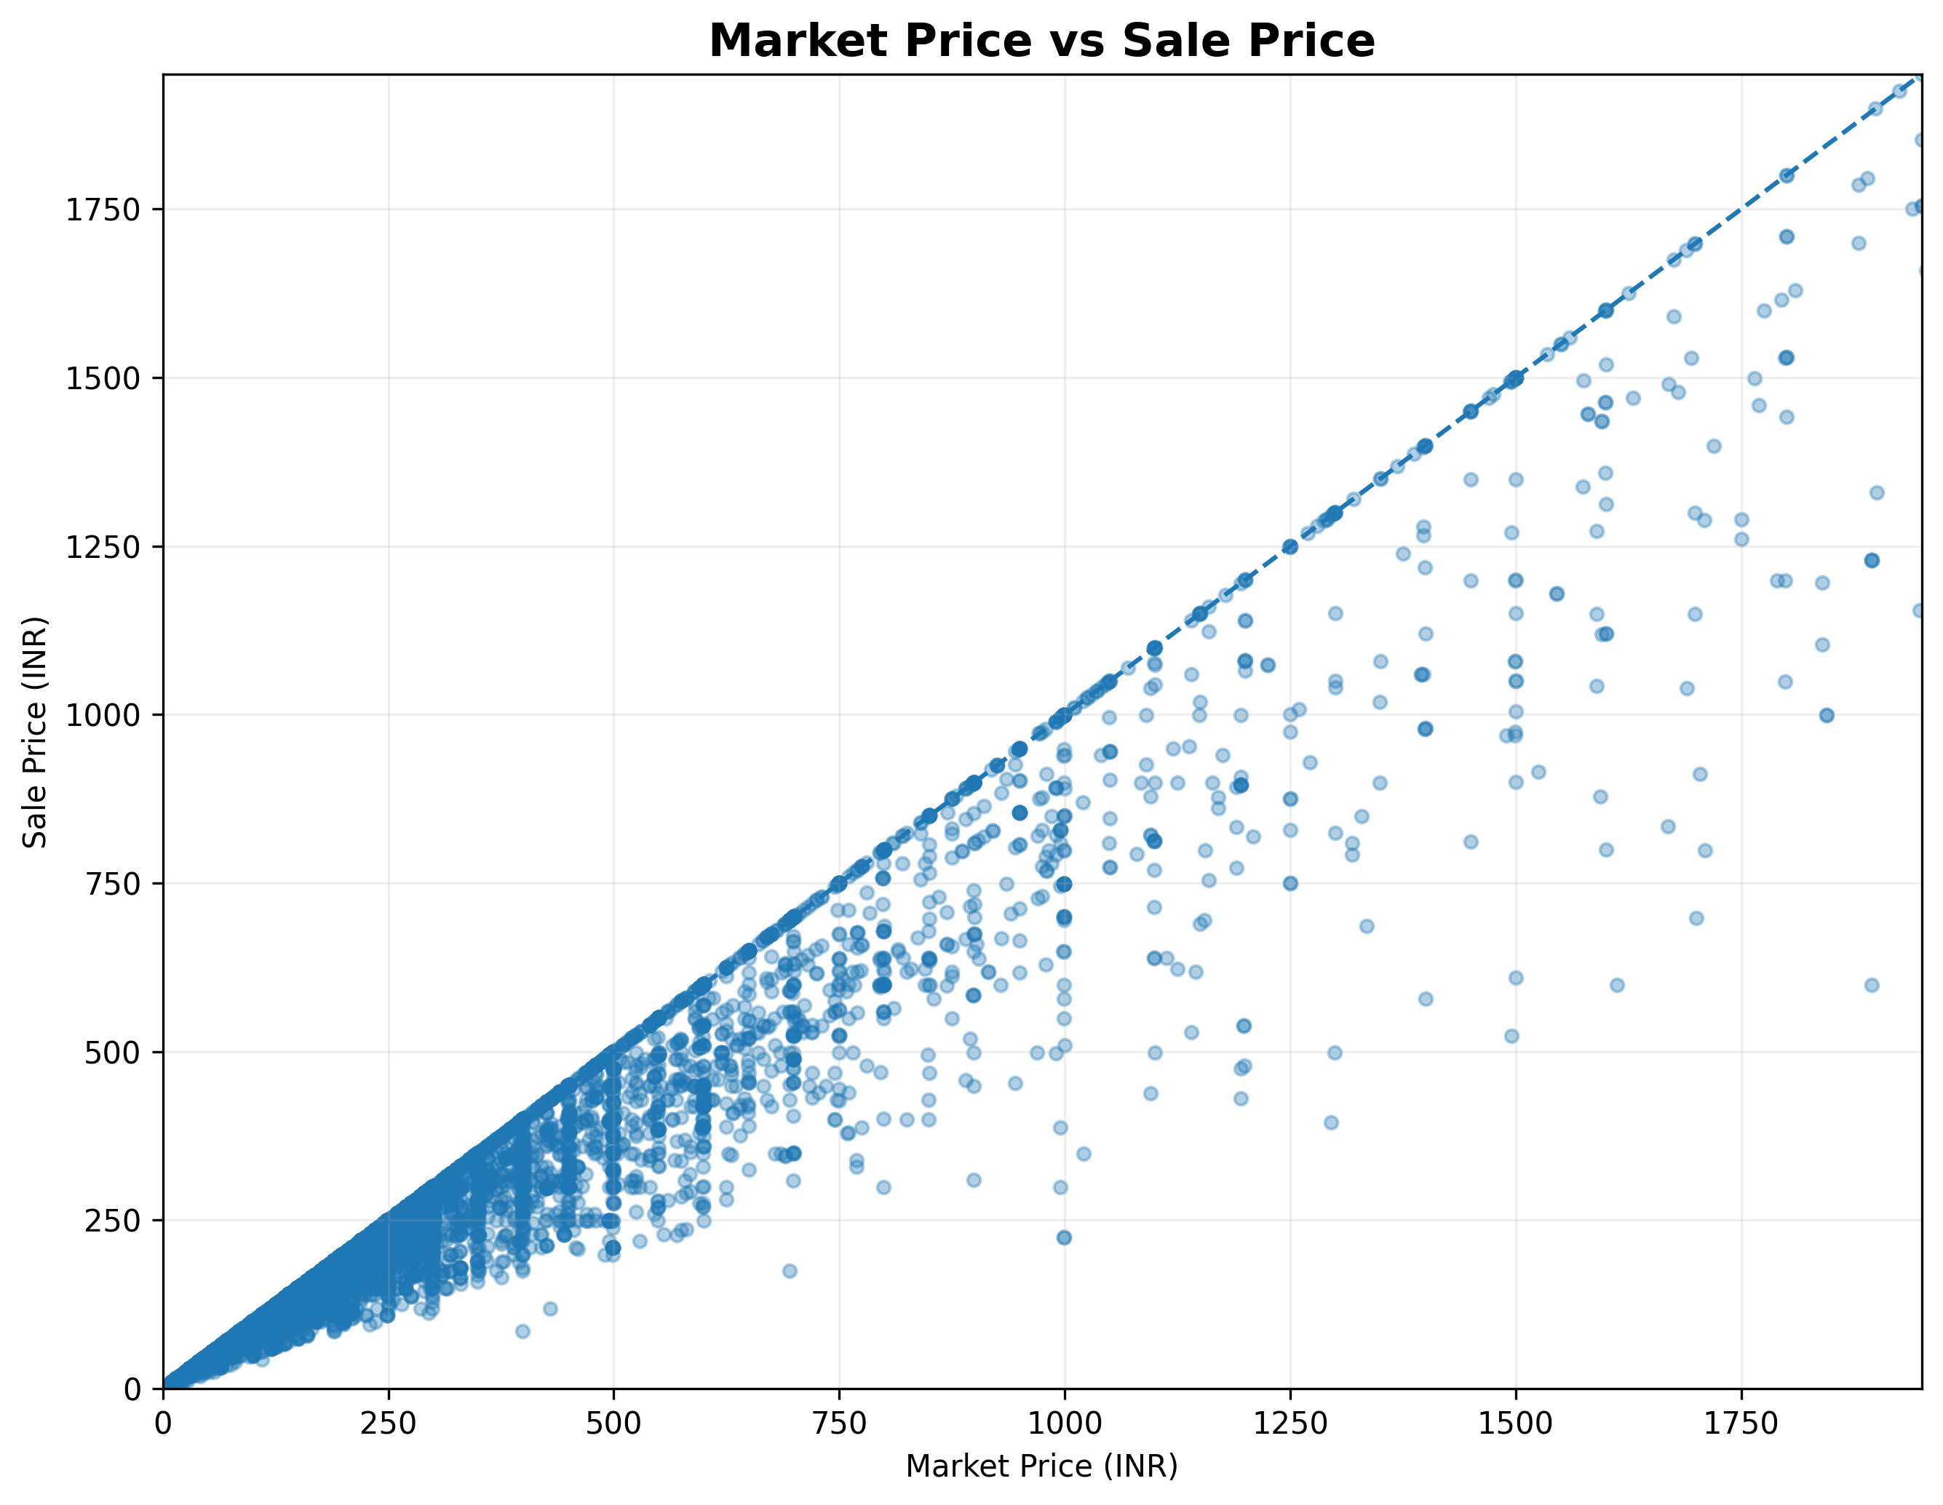
Purpose: Examines the relationship between listed market price and listed sale price.
What to look for: How closely sale prices track market prices and where larger price gaps appear.
Business relevance: Useful for reviewing pricing and discount structure across the catalogue. It should not be interpreted as actual realised sales or revenue.

6. Average Discount Percentage by Category
Chart type: Horizontal bar chart
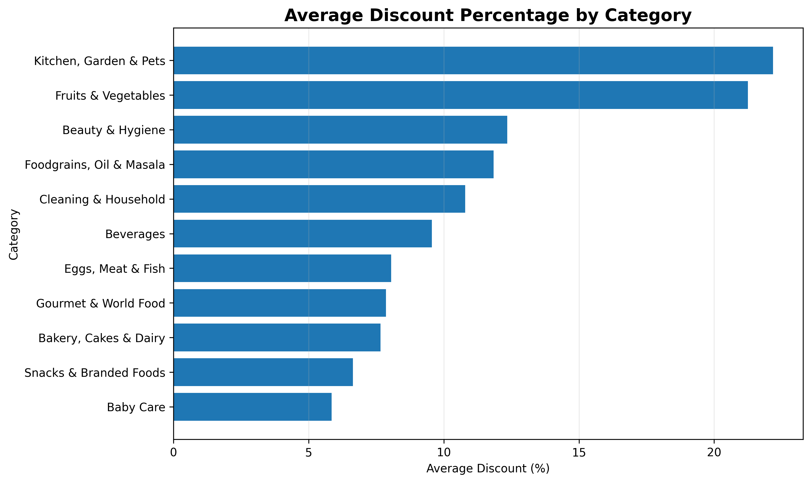
Purpose: Compares the average listed discount percentage across categories.
What to look for: Categories with relatively higher or lower discount intensity.
Business relevance: Supports category-level pricing and promotional strategy analysis using catalogue price information.

7. Distribution of Product Ratings
Chart type: Histogram
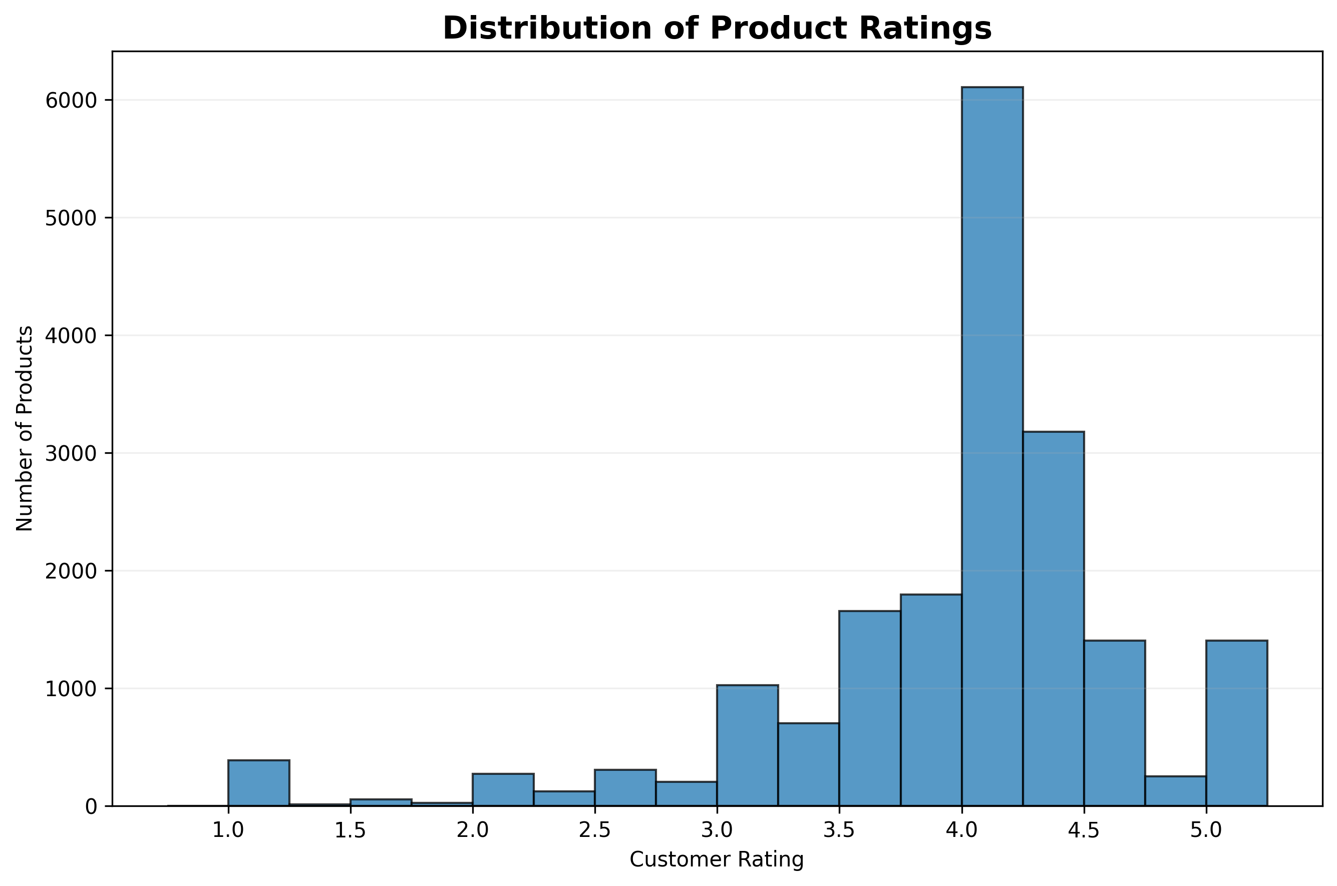
Purpose: Shows how product ratings are distributed across the catalogue.
What to look for: Whether ratings are concentrated toward higher or lower values and how widely ratings vary.
Business relevance: Provides a catalogue-level view of product rating patterns that can support assortment quality review.

8. Top 15 Brands by Product Listings
Chart type: Horizontal bar chart
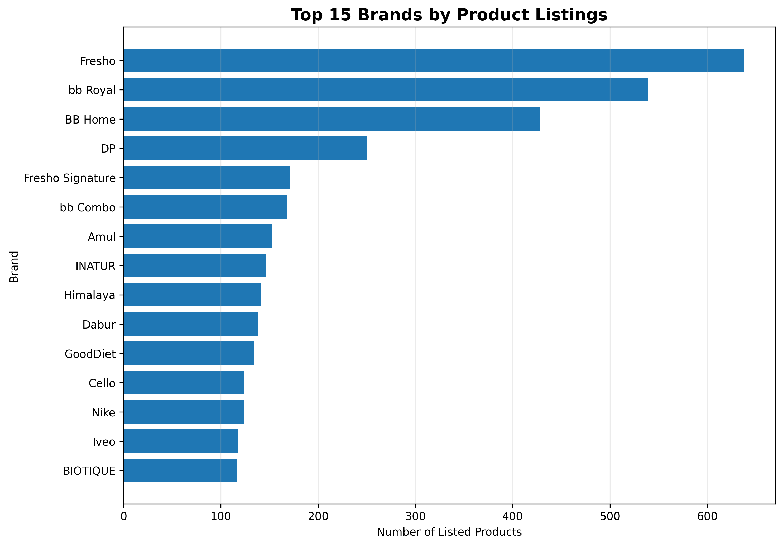
Purpose: Identifies brands with the largest number of listed products in the catalogue.
What to look for: Brands with the broadest assortment footprint.
Business relevance: Useful for understanding brand assortment concentration and catalogue representation.

9. Brand Positioning: Average Price vs Average Rating
Chart type: Scatter plot with point size representing product listings
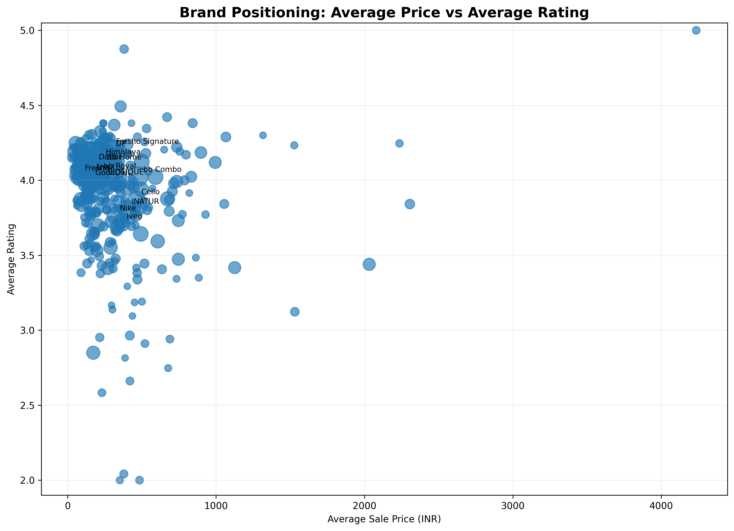
Purpose: Positions sufficiently represented brands using average listed price and average product rating.
What to look for: Brands that combine different price levels and rating levels, plus the relative size of their catalogue presence.
Business relevance: Supports brand positioning analysis without claiming actual brand sales performance.

10. Category Positioning: Price vs Discount vs Assortment
Chart type: Scatter plot with point size representing product listings
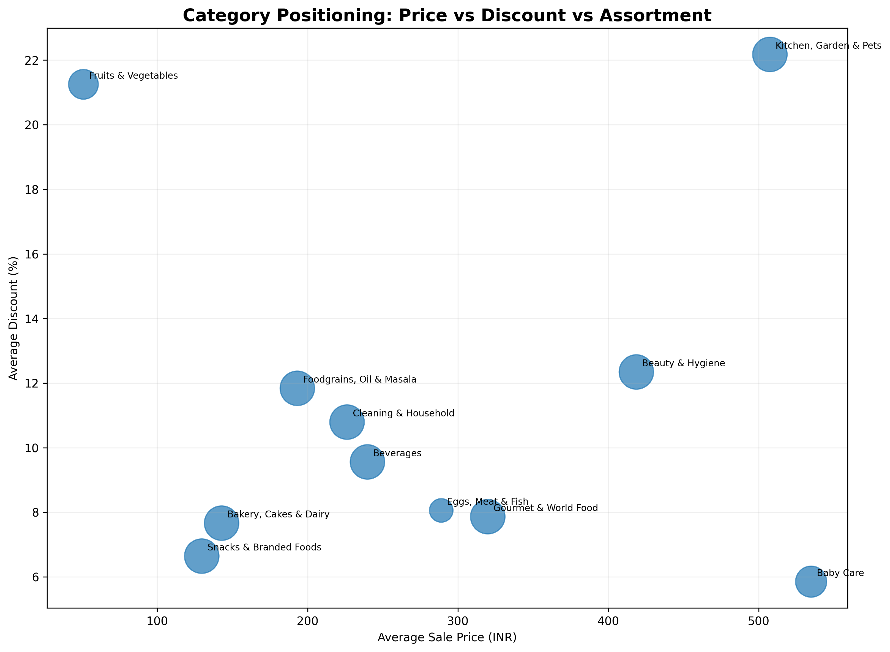
Purpose: Compares categories using average listed sale price, average discount and assortment size.
What to look for: Categories with different combinations of price level, discount intensity and catalogue breadth.
Business relevance: Provides a compact view for category assortment and pricing strategy discussions.

Final Summary
The ten charts provide a catalogue-level view of BigBasket's product assortment, pricing structure, discount patterns, ratings, brand representation and category positioning. The analysis is based on listed product information rather than transactional sales data.
Chart | Focus | Primary Use
1 | Category assortment | Assortment breadth
2 | Subcategory assortment | Assortment depth
3 | Sale price distribution | Price architecture
4 | Category price distribution | Category price positioning
5 | Market vs sale price | Pricing / discount structure
6 | Category discount | Promotional intensity
7 | Product ratings | Catalogue rating pattern
8 | Brand listings | Brand assortment footprint
9 | Brand positioning | Price vs rating positioning
10 | Category positioning | Price vs discount vs assortment

Important: This dataset does not contain transaction quantity, order history, customer IDs or transaction dates. Listed product counts, prices, discounts and ratings should therefore be interpreted as catalogue indicators, not actual sales or revenue measures.

