BASIS
BigBasket Assortment & Strategy Intelligence System

Project Overview
BASIS (BigBasket Assortment & Strategy Intelligence System) is a Data Analytics project developed to analyse the BigBasket product catalogue using Python-based data preprocessing, exploratory data analysis, statistical aggregation, and data visualization.
The project focuses on understanding product assortment, category and subcategory distribution, pricing patterns, discount structures, product ratings, brand representation, and category-level positioning.
The objective is to convert raw product catalogue data into structured analytical insights that can support better understanding of e-commerce assortment and pricing strategies.
The project has been developed as part of the:
IBMSkillsBuild – AICTE – BharatCares | Data Analytics with AI Internship

Project Repository:
BASIS – BigBasket Assortment & Strategy Intelligence System
The repository can be used to access the source code, project files, documentation and implementation details.
Project Information
Project Name:
BASIS – BigBasket Assortment & Strategy Intelligence System
Project Type:
Data Analytics / Exploratory Data Analysis / E-commerce Analytics
Technology:
Python
Core Libraries:
Pandas, NumPy, Matplotlib, Python-Docx, KaggleHub
Dataset:
BigBasket Entire Product List (~28K Datapoints)
Project By:
Bharat Agrawal
Program:
IBMSkillsBuild – AICTE – BharatCares | Data Analytics with AI Internship
Role:
Data Analyst
Location:
Surat, India – 395007
Email:
BHARATAGRAWAL.NITSURAT@GMAIL.COM
Mobile:
+91 6394665541
LinkedIn:
linkedin.com/in/bharat-agarwal-03ba23348
Website:
www.bharatagrawal.dev
GitHub:
github.com/BharatAgrawal-freelancer

How to Run the Project
Step 1: Clone the GitHub Repository
Open the project repository:
BASIS GitHub Repository
Or use Git from the terminal:
git clone https://github.com/BharatAgrawal-freelancer/BASIS-BigBasket-Assortment-Strategy-Intelligence-System.git
Move into the project directory:
cd BASIS-BigBasket-Assortment-Strategy-Intelligence-System
Step 2: Create a Virtual Environment
Recommended:
python -m venv venv
Activate it on Windows:
venv\Scripts\activate
Step 3: Install Required Libraries
The project requires Python libraries including NumPy, Pandas, Matplotlib, python-docx, and KaggleHub. These correspond to the imports and dataset-download mechanism used in the current implementation.
Install everything using:
pip install -r requirements.txt
Step 4: Run the Python Program
Run:
python main.py
The exact filename should match the Python file stored in the GitHub repository.
The program will:
- Download the BigBasket dataset from Kaggle.
- Locate the CSV automatically.
- Load the dataset.
- Clean and validate the data.
- Calculate discount-related features.
- Generate the 10 analytical charts.
- Create the Word report.
- Save the final report as:
BASIS_Final_10_Charts_Report.docx
The current code explicitly saves the generated Word document under this filename.

Project Purpose
The primary purpose of BASIS is to demonstrate how Data Analytics can be applied to an e-commerce product catalogue to identify meaningful patterns and business-oriented insights.
The project specifically analyses:
- Product distribution across categories
- Top subcategories by number of products
- Sale price distribution
- Price differences across categories
- Market price versus sale price
- Discount percentage by category
- Product rating distribution
- Brand representation
- Brand price versus rating positioning
- Category price, discount and assortment positioning
The analysis is designed to support assortment planning, pricing analysis, brand analysis and category strategy discussions.
The current implementation generates exactly 10 analytical visualizations and automatically places them into a professionally structured Word report.

Dataset Used
The project uses the BigBasket Entire Product List (~28K Datapoints) dataset available through Kaggle.
The project does not require manually downloading the CSV. It uses kagglehub to download the dataset programmatically and automatically searches the downloaded directory for the required CSV file.
Dataset Link
BigBasket Entire Product List – Kaggle
Main Dataset Fields
The analysis uses fields such as:
- product – Product name
- category – Main product category
- sub_category – Product subcategory
- brand – Product brand
- sale_price – Listed selling price
- market_price – Listed market price
- rating – Product rating
These required fields are explicitly checked by the project before analysis begins.
The project also creates additional analytical variables such as:
- discount_amount
- discount_percent
The discount percentage is calculated from market price and sale price during feature engineering.
Important Dataset Limitation
This dataset is a product catalogue snapshot, not a transactional sales database.
It does not contain information such as:
- Customer IDs
- Individual orders
- Transaction dates
- Quantity sold
- Actual revenue
Therefore, the project should not be interpreted as an actual sales forecasting, revenue analysis, customer behaviour, or price elasticity model.
Instead, the project focuses on catalogue-level assortment, listed pricing, discount structure, ratings, brands and category positioning.

What Does the Project Actually Do?
The project follows an end-to-end Data Analytics workflow:
Kaggle Dataset → Data Download → Data Cleaning → Data Validation → Feature Engineering → Exploratory Analysis → Visualization → Business Interpretation → Automated Word Report
The code first downloads the dataset using KaggleHub, identifies the CSV file and loads it into a Pandas DataFrame.
It then performs data cleaning, including:
- Column name standardization
- Removal of unnecessary index columns
- Missing-value handling
- Numeric conversion
- Invalid price removal
- Rating validation
- Text-field cleaning
After preprocessing, the project performs feature engineering and generates the analytical variables required for pricing and discount analysis.

Major Analysis Performed
1. Product Distribution Across Categories
Shows how many products are listed within each major category.
This helps understand the breadth of the catalogue across different product categories.
2. Top 15 Subcategories by Product Count
Identifies the subcategories with the largest number of listed products.
This provides an understanding of assortment depth and catalogue concentration.
3. Distribution of Product Sale Prices
Uses a histogram to analyse the overall distribution of listed selling prices.
This helps identify dominant price ranges and the overall price architecture of the catalogue.
4. Sale Price Distribution Across Categories
Uses a horizontal boxplot to compare price distributions between categories.
This allows comparison of median prices, price ranges and variation across categories.
5. Market Price vs Sale Price
Uses a scatter plot to compare listed market prices with listed sale prices.
This provides a visual understanding of pricing and discount structure.
6. Average Discount Percentage by Category
Compares the average listed discount percentage across product categories.
This helps understand differences in promotional intensity across categories.
7. Distribution of Product Ratings
Analyses how product ratings are distributed throughout the catalogue.
This provides a catalogue-level view of rating patterns.
8. Top 15 Brands by Product Listings
Identifies brands with the largest number of products listed in the catalogue.
This helps understand brand representation and assortment concentration.
9. Brand Positioning: Average Price vs Average Rating
Compares sufficiently represented brands based on average listed price and average product rating.
The size of each point represents the number of products listed by that brand.
The analysis deliberately avoids presenting this as actual brand sales performance.
10. Category Positioning: Price vs Discount vs Assortment
Compares categories using:
- Average sale price
- Average discount percentage
- Number of listed products
This provides a compact analytical view of category-level assortment and pricing positioning.

What Will You Get After Running the Project?
After successful execution, the main output is a professional Word report containing:
BASIS_Final_10_Charts_Report.docx
The report contains:
- Project title
- Dataset summary
- Dataset limitation note
- 10 analytical charts
- Chart type
- Purpose of each chart
- What to look for
- Business relevance
- Final summary
- Summary table of all 10 analyses
The code inserts each generated visualization directly into the Word document and adds an explanation below it.

What Is the Actual Use of This Project?
BASIS demonstrates how an organisation can use catalogue data to understand its product portfolio and pricing structure.
For an e-commerce business, this type of analysis can be useful for:
Assortment Planning
Understanding which categories and subcategories contain large or small numbers of products can support catalogue planning.
Pricing Analysis
Comparing sale prices and market prices can help analyse the structure of listed pricing and discounts.
Category Analysis
Category-level price and discount comparisons can help teams understand differences in catalogue positioning.
Brand Analysis
Brand listing counts and brand-level price/rating positioning can help understand how brands are represented within the catalogue.
Catalogue Management
The analysis can help identify areas with high catalogue concentration, broad assortment, different price structures, or different discount patterns.
Business Communication
Instead of presenting raw CSV data, the project converts the data into charts and a structured Word report that can be used for analytical presentations and documentation.

What Do I Gain by Doing This Project?
From a Data Analytics learning and portfolio perspective, this project demonstrates practical experience with an end-to-end analytics workflow.
You gain experience in:
- Python programming
- Pandas
- NumPy
- Matplotlib
- Data cleaning
- Data validation
- Feature engineering
- Exploratory Data Analysis
- Descriptive analytics
- Statistical aggregation
- Business-oriented visualization
- E-commerce analytics
- Pricing analysis
- Category analysis
- Brand analysis
- Automated report generation
- Kaggle dataset integration
- Git and GitHub project management
It also demonstrates the ability to move from:
Raw Dataset → Clean Data → Analysis → Visualization → Business Interpretation → Final Report
This is an important workflow for Data Analyst and Business Analyst roles.

Project Deliverables
The project provides the following major deliverables:
Deliverable | Description
Python Source Code | Complete data analysis and report-generation program
requirements.txt | Required Python dependencies
10 Analytical Charts | Visual analysis of catalogue, pricing, ratings, brands and categories
Word Report | Automatically generated professional analysis report
GitHub Repository | Source-code and project documentation
Kaggle Dataset Integration | Automated dataset download using KaggleHub

Project Summary
BASIS is a practical Data Analytics project that transforms a large BigBasket product catalogue into structured insights related to product assortment, pricing, discounts, ratings, brands and categories.
The project demonstrates an end-to-end analytical workflow using Python, beginning with automated dataset acquisition and preprocessing and ending with 10 business-oriented visualizations and an automatically generated Word report.
The key value of the project is not simply producing charts; it demonstrates how raw e-commerce catalogue data can be converted into structured information that can support assortment planning, pricing analysis, category evaluation, brand positioning and business communication.
Because the underlying dataset is catalogue-based rather than transactional, the results are appropriately interpreted as catalogue indicators rather than actual sales, revenue, demand or customer behaviour measures.

Dataset records analysed: 27,553
Categories: 11 | Subcategories: 90 | Brands: 2,313
Dataset scope note: This BigBasket dataset is a product catalogue snapshot. It does not contain customer IDs, orders, transaction dates, quantities sold, or actual revenue. Therefore, this report focuses on assortment, listed pricing, discount structure, ratings, brands and category positioning rather than claiming actual sales, revenue, demand or price elasticity.

1. Product Distribution Across Categories
Chart type: Horizontal bar chart
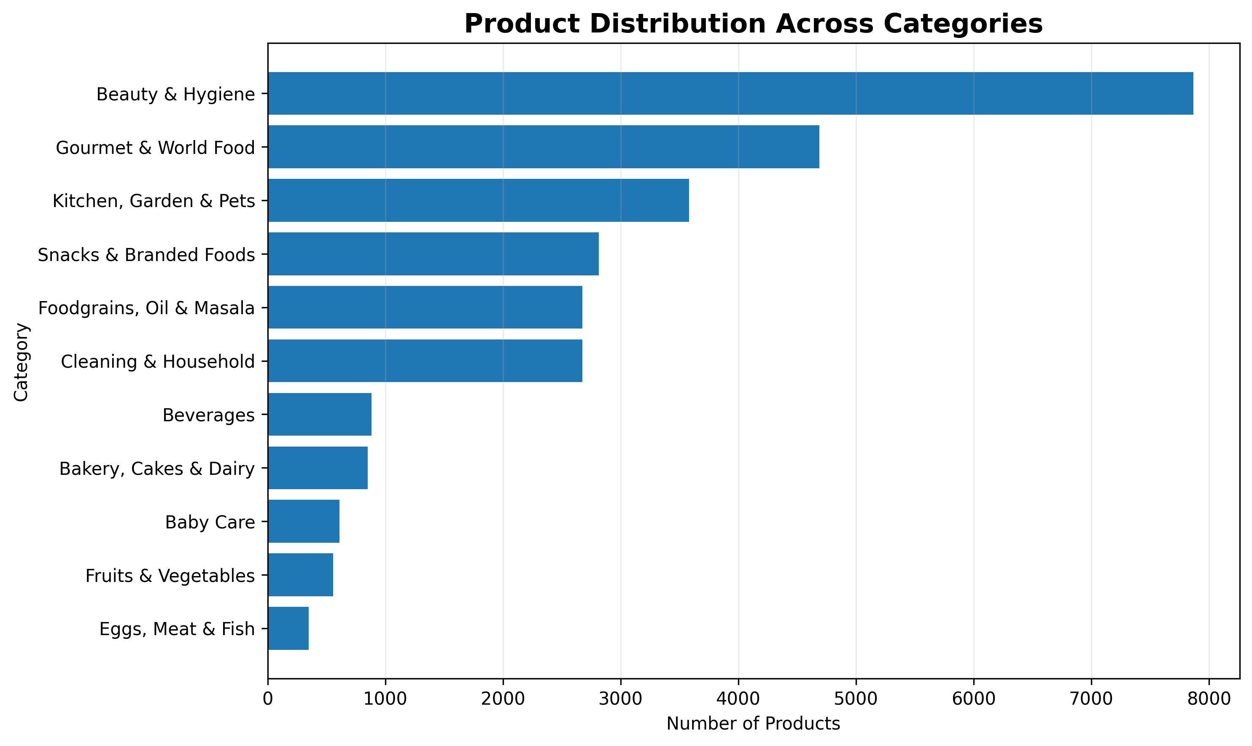
Purpose: Shows how the catalogue is distributed across major product categories.
What to look for: Categories with very large or very small assortment sizes and the relative breadth of the catalogue.
Business relevance: Useful for assortment planning and identifying categories with comparatively high or low catalogue coverage.

2. Top 15 Subcategories by Product Count
Chart type: Horizontal bar chart
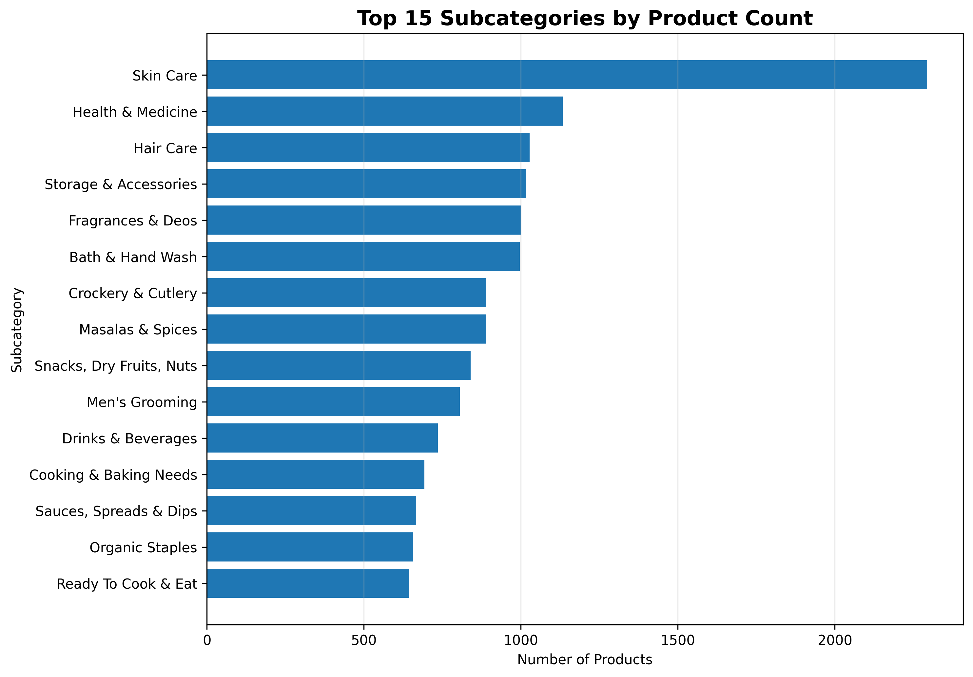
Purpose: Highlights the subcategories with the largest number of listed products.
What to look for: Which subcategories dominate the assortment and how concentrated the catalogue is among leading subcategories.
Business relevance: Supports assortment depth decisions and helps identify areas where catalogue breadth is already high.

3. Distribution of Product Sale Prices
Chart type: Histogram
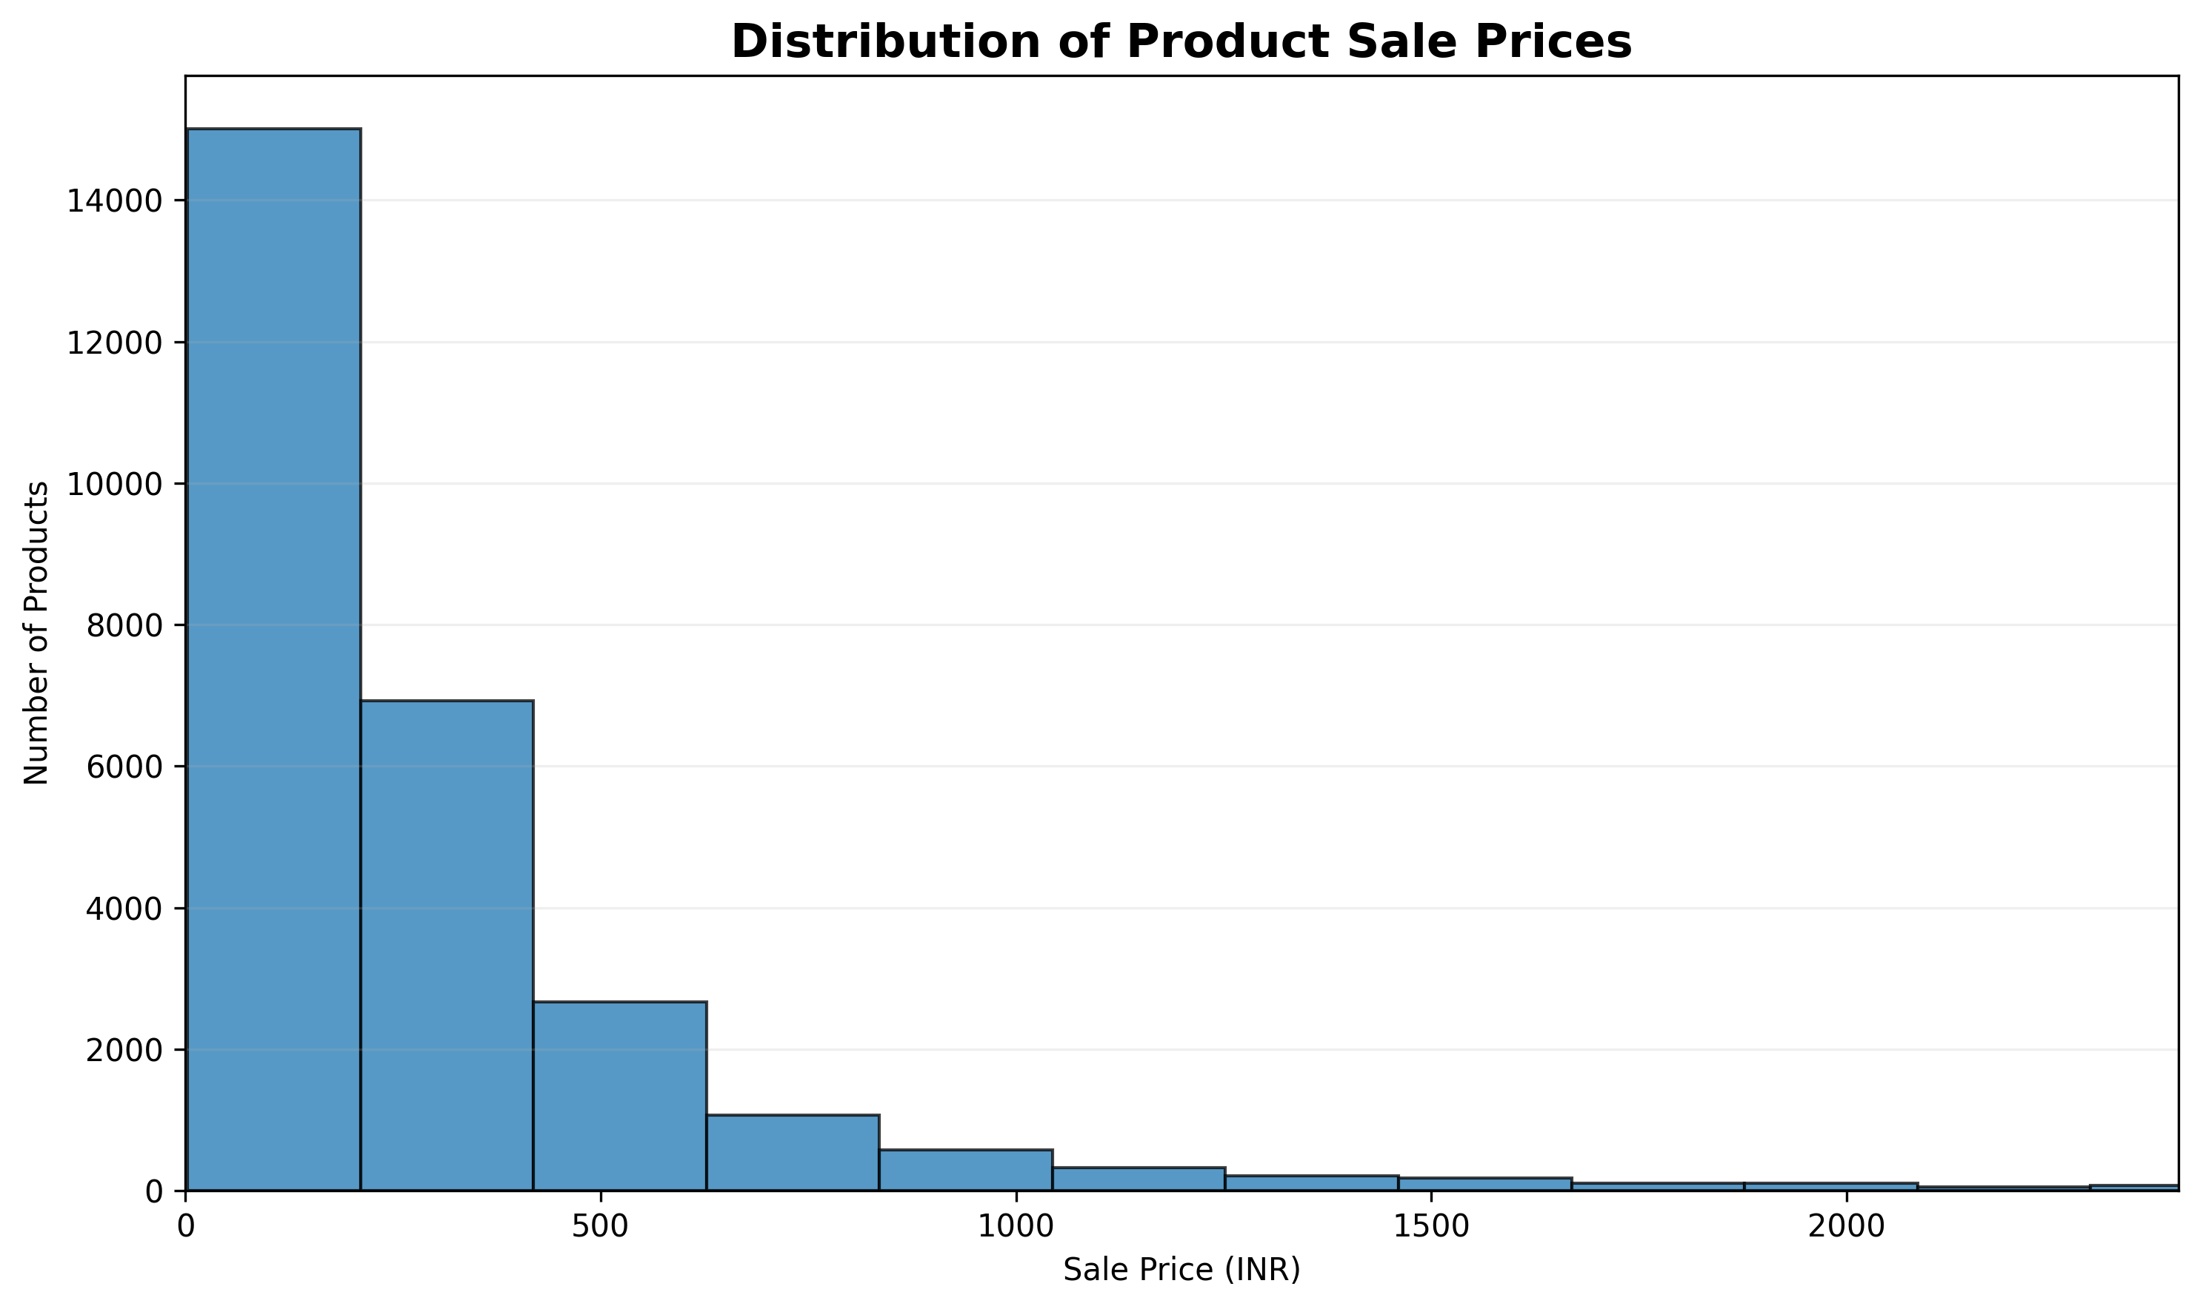
Purpose: Shows the overall spread of listed selling prices in the product catalogue.
What to look for: The concentration of products in lower, middle and higher price ranges and the degree of price skew.
Business relevance: Useful for understanding the catalogue's price architecture and identifying dominant price bands.

4. Sale Price Distribution Across Categories
Chart type: Horizontal boxplot
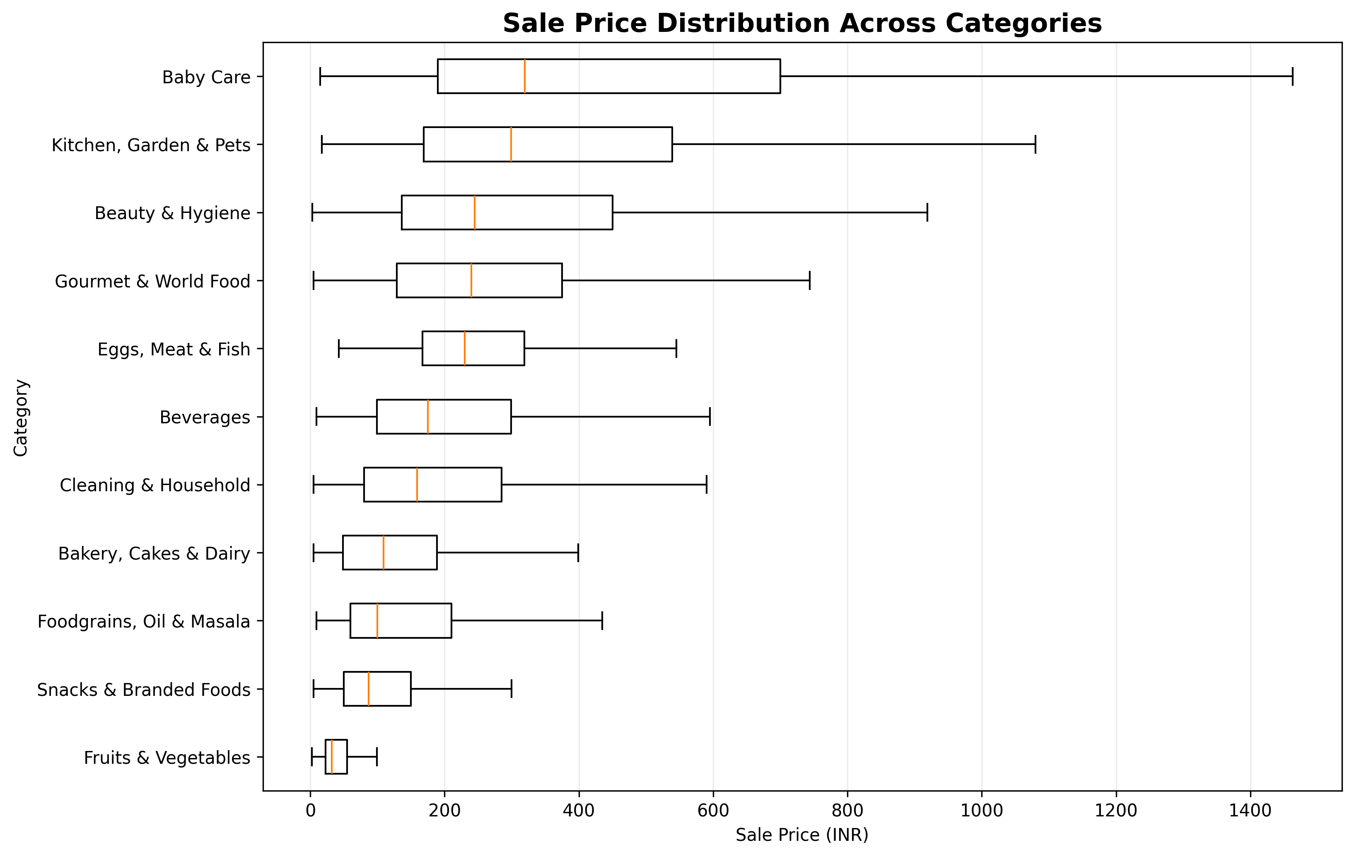
Purpose: Compares the distribution and central tendency of listed sale prices across categories.
What to look for: Differences in median prices, spread and category-level price ranges.
Business relevance: Helps compare category price positioning and identify categories with broader or narrower price structures.

5. Market Price vs Sale Price
Chart type: Scatter plot
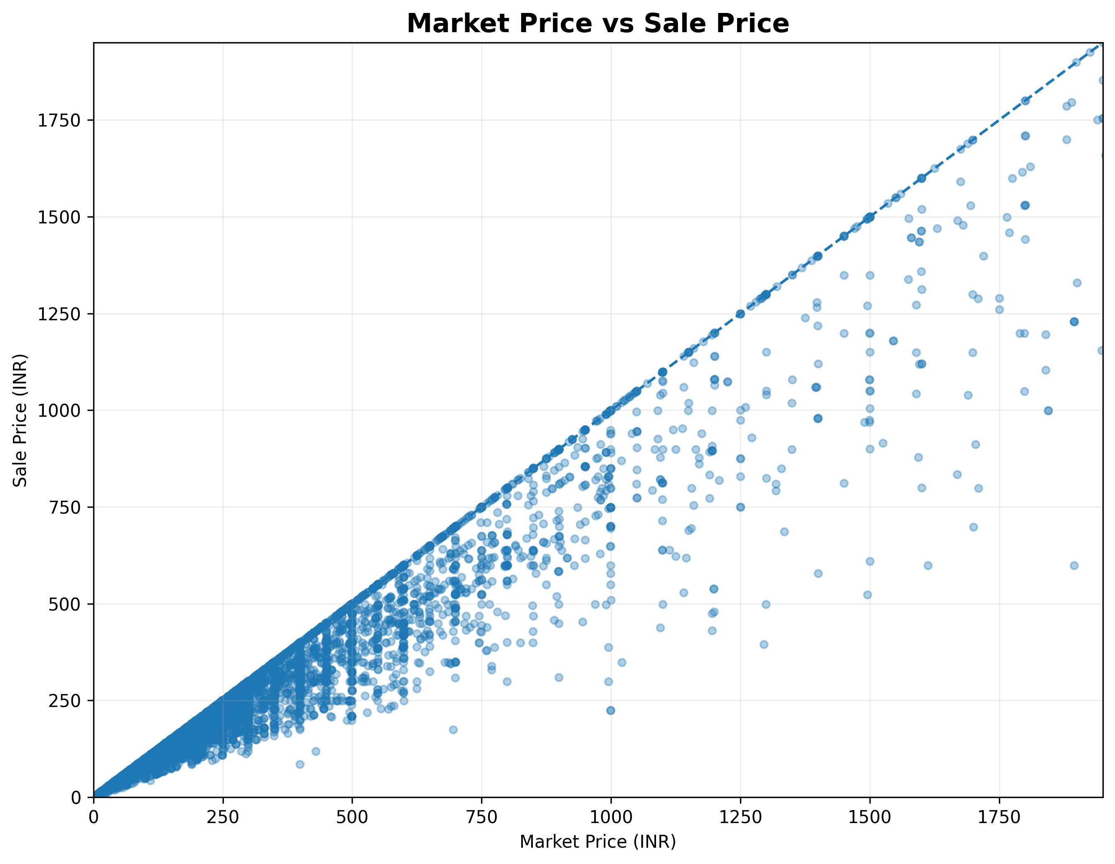
Purpose: Examines the relationship between listed market price and listed sale price.
What to look for: How closely sale prices track market prices and where larger price gaps appear.
Business relevance: Useful for reviewing pricing and discount structure across the catalogue. It should not be interpreted as actual realised sales or revenue.

6. Average Discount Percentage by Category
Chart type: Horizontal bar chart
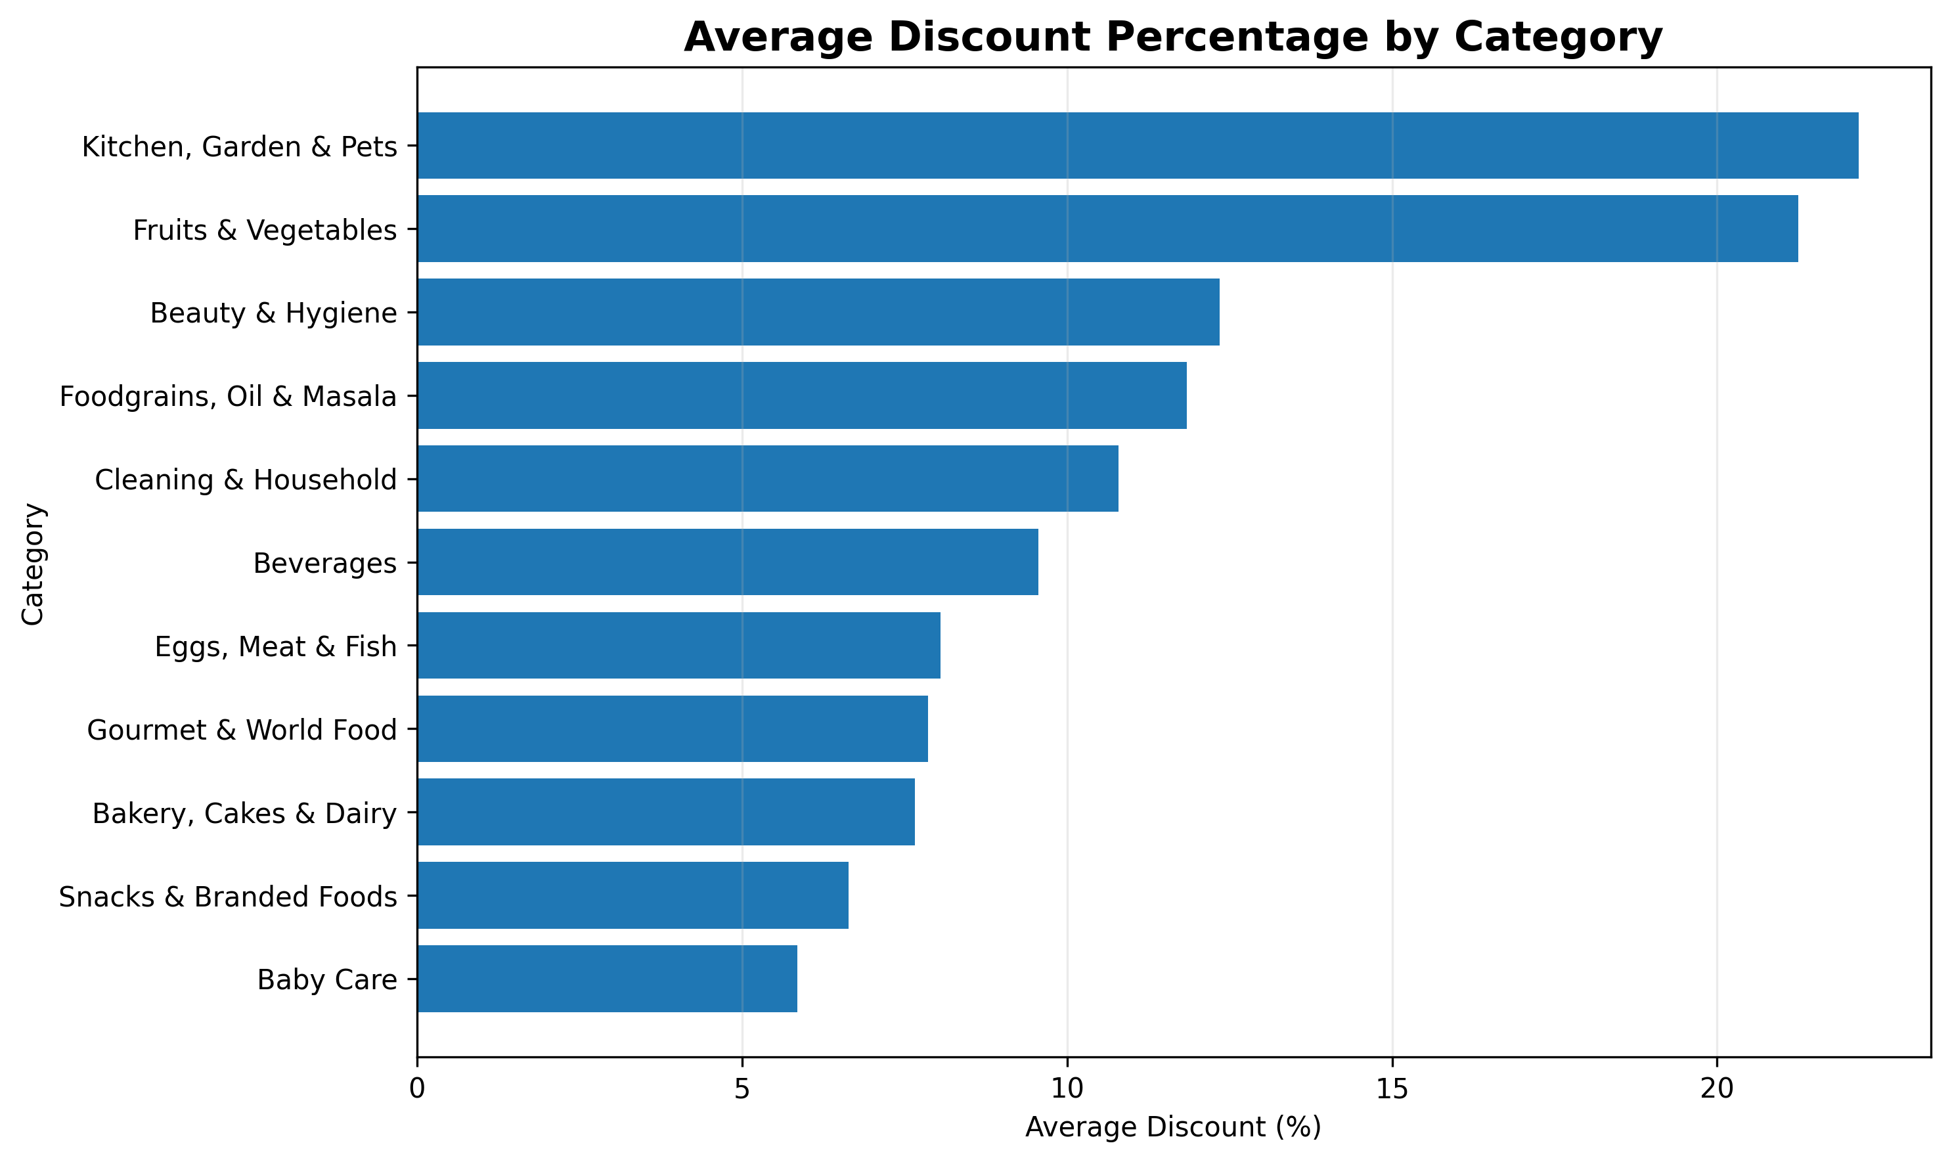
Purpose: Compares the average listed discount percentage across categories.
What to look for: Categories with relatively higher or lower discount intensity.
Business relevance: Supports category-level pricing and promotional strategy analysis using catalogue price information.

7. Distribution of Product Ratings
Chart type: Histogram
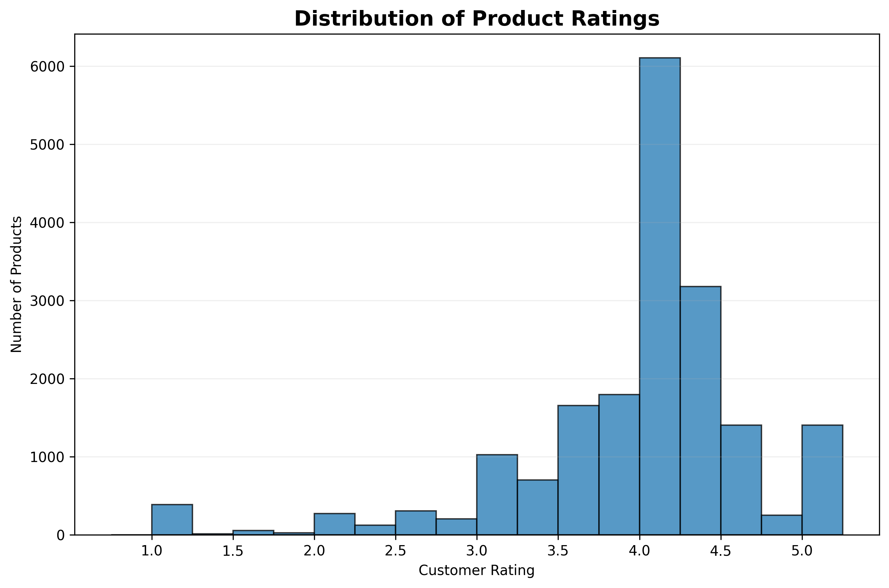
Purpose: Shows how product ratings are distributed across the catalogue.
What to look for: Whether ratings are concentrated toward higher or lower values and how widely ratings vary.
Business relevance: Provides a catalogue-level view of product rating patterns that can support assortment quality review.

8. Top 15 Brands by Product Listings
Chart type: Horizontal bar chart
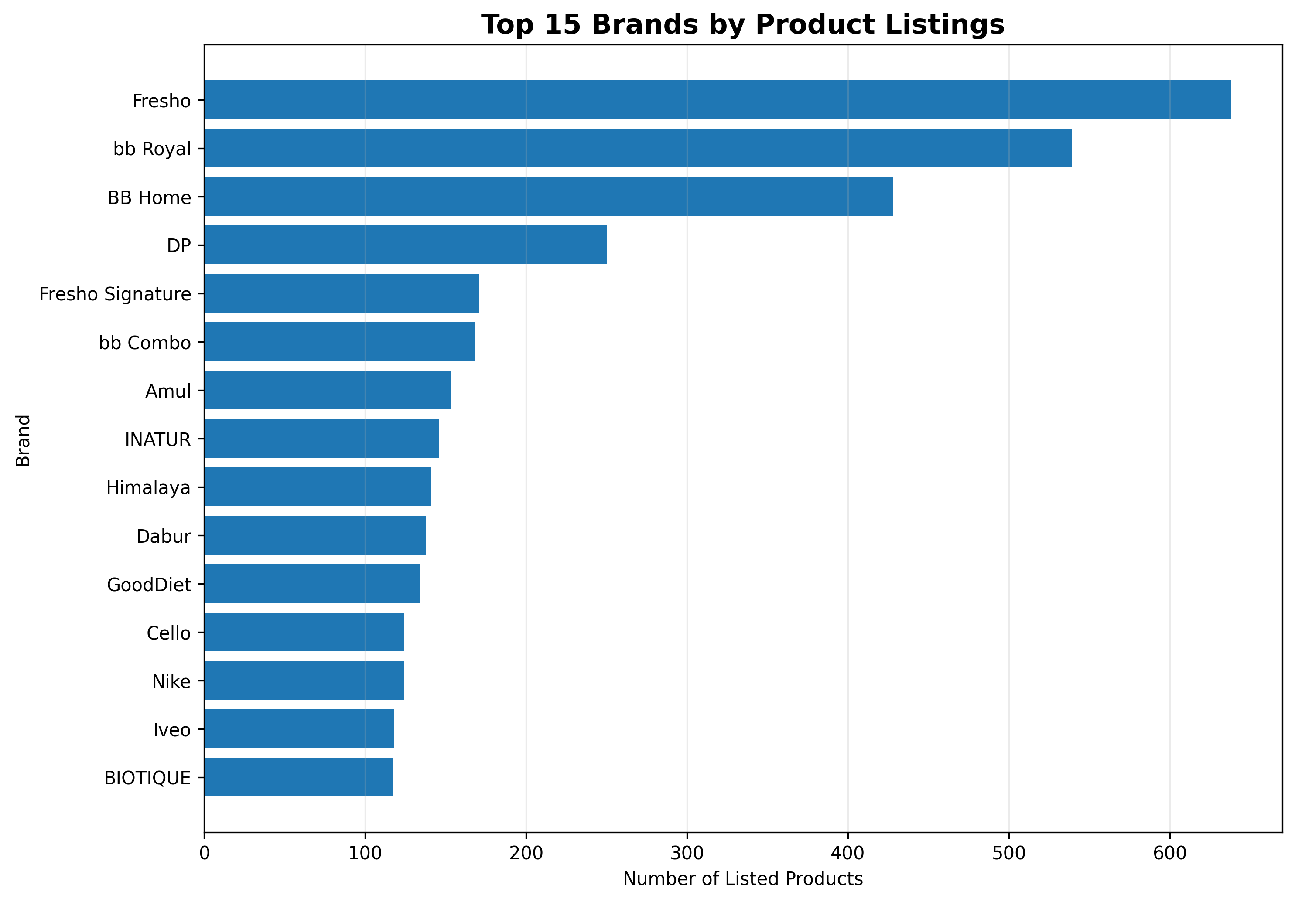
Purpose: Identifies brands with the largest number of listed products in the catalogue.
What to look for: Brands with the broadest assortment footprint.
Business relevance: Useful for understanding brand assortment concentration and catalogue representation.

9. Brand Positioning: Average Price vs Average Rating
Chart type: Scatter plot with point size representing product listings
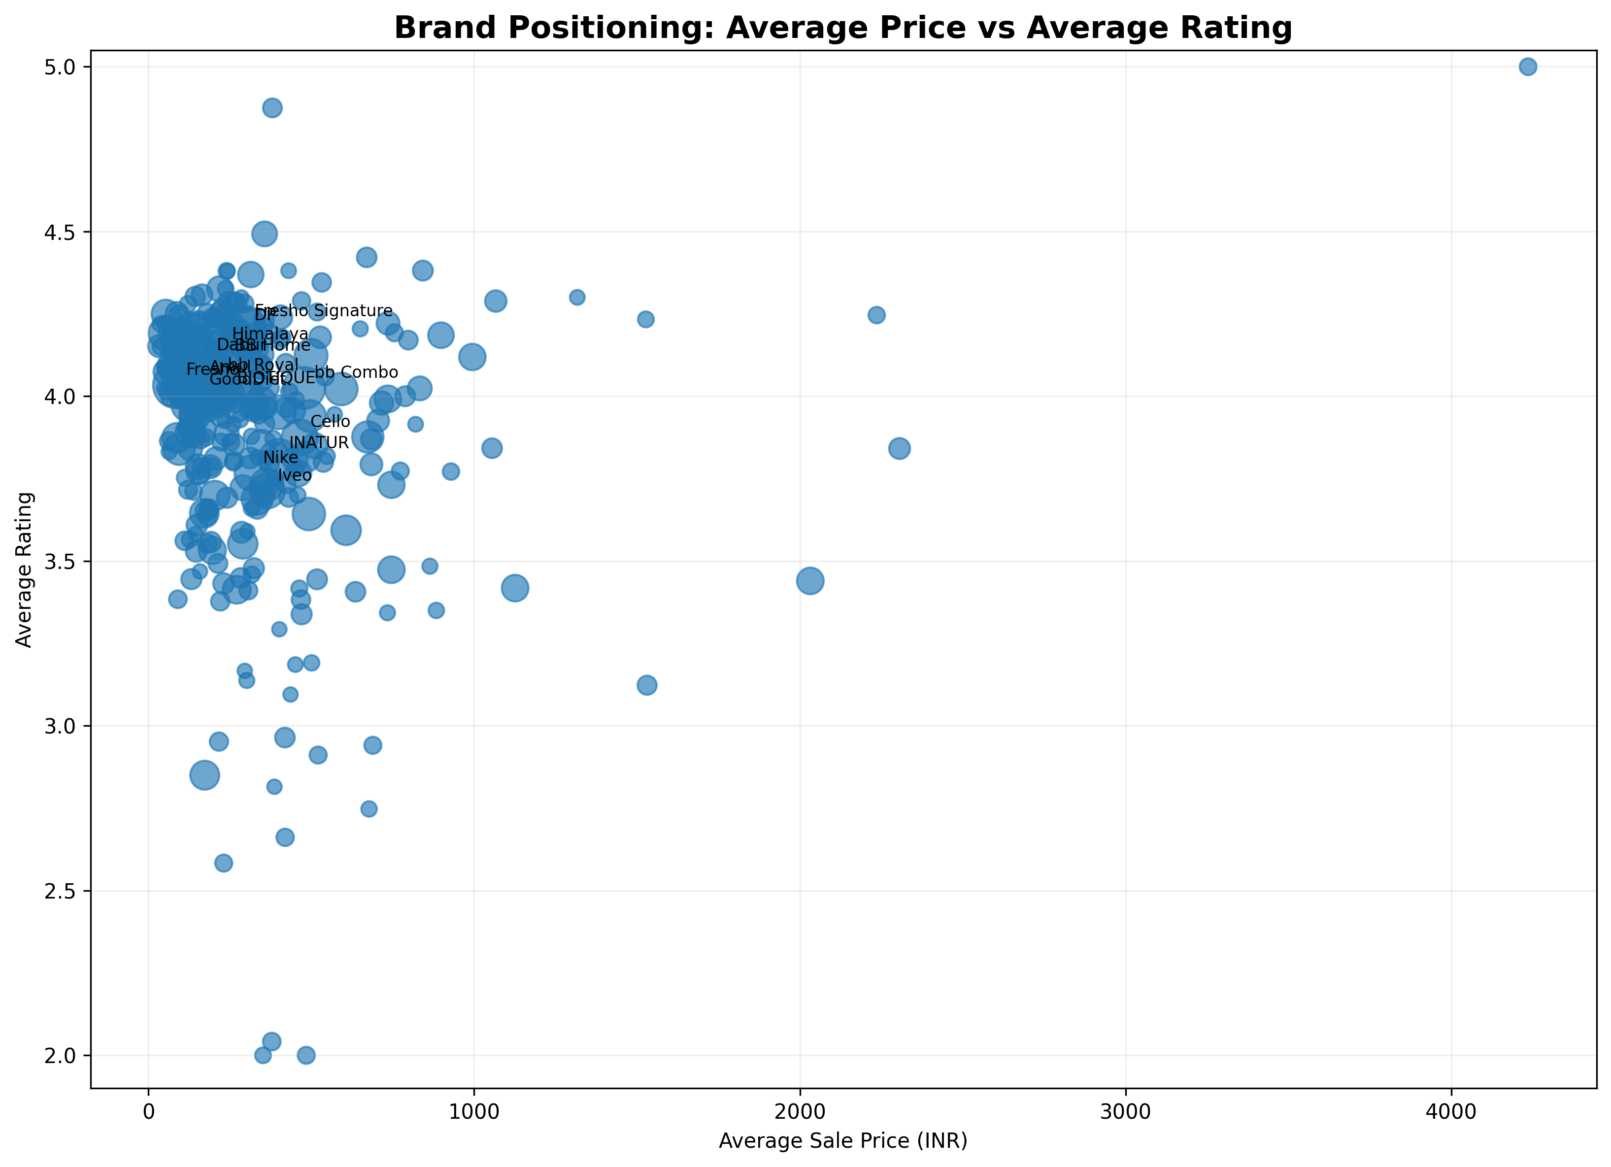
Purpose: Positions sufficiently represented brands using average listed price and average product rating.
What to look for: Brands that combine different price levels and rating levels, plus the relative size of their catalogue presence.
Business relevance: Supports brand positioning analysis without claiming actual brand sales performance.

10. Category Positioning: Price vs Discount vs Assortment
Chart type: Scatter plot with point size representing product listings
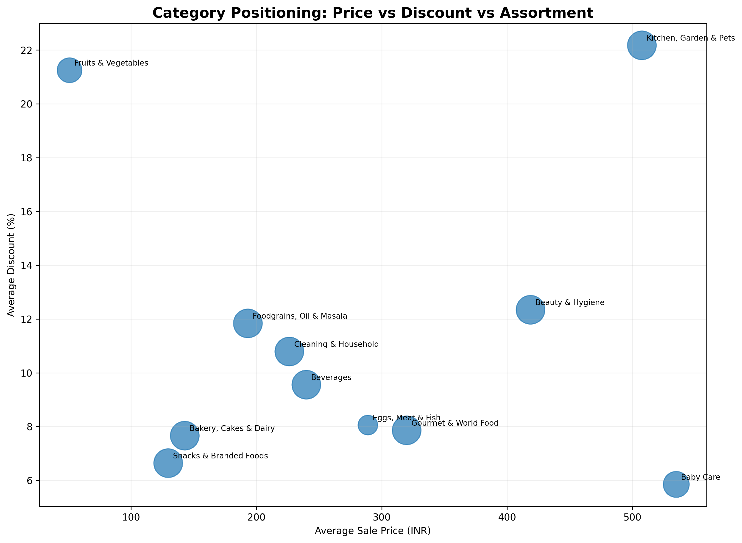
Purpose: Compares categories using average listed sale price, average discount and assortment size.
What to look for: Categories with different combinations of price level, discount intensity and catalogue breadth.
Business relevance: Provides a compact view for category assortment and pricing strategy discussions.

Final Summary
The ten charts provide a catalogue-level view of BigBasket's product assortment, pricing structure, discount patterns, ratings, brand representation and category positioning. The analysis is based on listed product information rather than transactional sales data.
Chart | Focus | Primary Use
1 | Category assortment | Assortment breadth
2 | Subcategory assortment | Assortment depth
3 | Sale price distribution | Price architecture
4 | Category price distribution | Category price positioning
5 | Market vs sale price | Pricing / discount structure
6 | Category discount | Promotional intensity
7 | Product ratings | Catalogue rating pattern
8 | Brand listings | Brand assortment footprint
9 | Brand positioning | Price vs rating positioning
10 | Category positioning | Price vs discount vs assortment

Important: This dataset does not contain transaction quantity, order history, customer IDs or transaction dates. Listed product counts, prices, discounts and ratings should therefore be interpreted as catalogue indicators, not actual sales or revenue measures.

