UGRO Capital Limited
Unit No. B-17, 4th Floor, Art Guild House,
Phoenix Market City Mall, LBS Marg,
Kurla (W), Maharashtra - 400070
CIN: L67120MH1993PLC070739

Ref No: UGRO/NDC/2026/05/12
Date: May 06, 2026

To whom so ever it may concern

Subject : NO DUES CERTIFICATE

This is to certify that Mr. Suraj Rahadve has availed a Loan, Loan Account No. 241215004489491 with UGRO Capital Limited. The loan, amount of ₹20,00,000.00 (Rupees Twenty Lakh Only), was disbursed on February 05, 2025, and currently active.
We further confirm that all loan installments were punctually remitted via NACH/Standing Instruction from the customer's Punjab National Bank Savings Account No. 0506010400403325.
As of this date there are no outstanding dues or liabilities pending against the aforementioned loan account in our records.
This certificate is issued upon the customer's request.

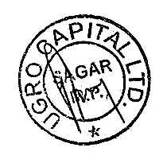
For UGRO Capital Limited,

(Signature & Seal)
Branch Manager

