INTERNSHIP REVIEW REPORT AT INCEDO



BY:-

**Name:** Satvik Proach  
**Roll Number:** 102117014  
**College:** Thapar University, Patiala  
**Branch:** COPC (Computer Science and Engineering)  
**Semester:** 8th  
**Internship Duration:** 8th January 2025 – 8th July 2025  
**Total Duration:** 6 Months

### ****2. Organization Details****

# ****Company Name:**** Incedo Inc. ****Location:**** Gurgaon, Haryana ****Department:**** Hi-Tech ****Industry:**** Technology Consulting and Services ****Mentor:**** Mr. Manjot Singh ****Project Manager:**** Mr. Manish Tank ****Internship Designation:**** Process Automation Intern

### ****3. Internship Objective****

The primary objective of the internship was to gain hands-on industry experience and apply academic knowledge to real-world enterprise systems, specifically within the scope of the project. The internship began with the development of a Proof of Concept (PoC) to explore the feasibility of automating network anomaly detection test cases. This initial phase involved understanding the existing test workflows, evaluating automation tools, and presenting a functional prototype to the team for validation.

Upon successful approval of the PoC, the focus shifted to full-scale automation, where over 200 test cases were automated using Robot Framework and Python scripting. The goal was to enhance the reliability, consistency, and efficiency of the testing process while minimizing manual intervention. The internship provided valuable exposure to structured project execution, collaboration within cross-functional teams, and adherence to timelines in a professional work environment.

### ****4. Project Overview – Process Automation****

**Project Title:** Streamlining and Automating Processes in Project

**Description:**  
As part of my internship at Incedo Inc., I was assigned to the Network Insight project. The primary goal of the project was to enhance operational efficiency by automating key workflows and reducing manual intervention in the testing lifecycle.

The project initially began with the creation of a Proof of Concept (PoC) to evaluate automation feasibility. Once validated, the focus shifted to developing and implementing a robust test automation framework using **Python** and **Robot Framework**. A significant component of this effort involved automating over **200 test cases** related to network anomaly detection.

The test automation was designed to work with data collected from devices in the form of .txt and .pcap files. These files were parsed and analyzed to capture anomalies within network traffic patterns. To make the solution scalable and adaptive, several test cases were customized to handle different types of network behavior, ensuring broader anomaly coverage and improving detection reliability.

Additionally, I contributed to the development and automation of **Kafka producer/consumer** test scenarios, integrated the framework for **CI/CD readiness**, and aligned the solution with Network Insight’s goal of proactive network health monitoring.

This project provided valuable experience in enterprise-level process automation, test framework design, and working with real-world data formats in a production-oriented setting.

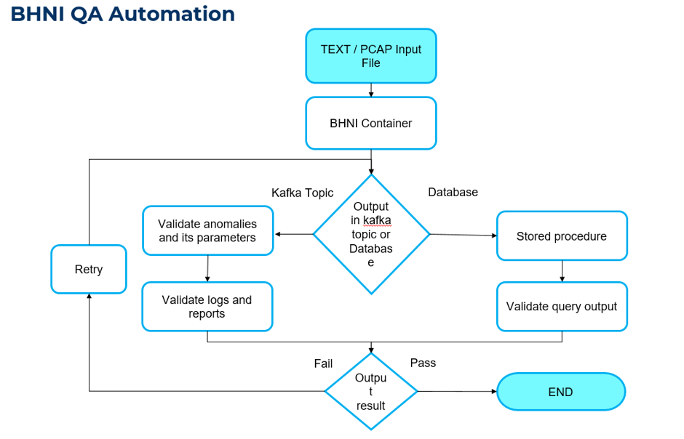

### ****5. My Contributions****

During the internship, I made several key contributions toward the success of the project, particularly in the automation and anomaly detection track. My efforts were focused on transforming manual workflows into reliable, scalable automated processes that supported the project's broader goals. Notable contributions include:

* Played an integral role in the successful execution of the initial **Proof of Concept (PoC)** for automating anomaly detection.
* Developed Python and Robot Framework-based automation scripts to parse and validate .txt files containing captured network data with known anomaly patterns.
* Built reusable and modular test suites capable of handling various formats of anomaly data provided by the devices.
* Automated test scenarios for **Kafka producer/consumer** message flows to ensure the reliability of streaming pipelines.
* Designed and implemented data validation logic to inspect message payloads and verify integrity across microservices.
* Contributed to the creation of a scalable framework for integrating test automation with CI/CD pipelines.
* Assisted in debugging and refining test cases to improve coverage, execution time, and maintainability.

These contributions helped reduce manual testing efforts, enhanced detection accuracy for network anomalies, and laid the foundation for further automation.

### ****6. Tools & Technologies Used****

**Programming Languages:**

* Python
* Shell Scripting

**Automation Tools:**

* Robot Framework

**DevOps Tools:**

* Docker

**Message Queueing Systems:**

* Apache Kafka

**Others:**

* Confluence (Documentation and Collaboration)
* Jira (Agile Task and Project Management)

### ****7. Skills Acquired****

During the course of the internship, I developed both technical and collaborative skills that enhanced my ability to contribute effectively in a real-world enterprise environment. Key skills acquired include:

* **Kafka Automation & Monitoring:**  
  Gained hands-on experience in automating and validating Kafka producer/consumer message flows and monitoring stream-based data pipelines.
* **Robot Framework for Microservices Testing:**  
  Learned to design and implement test cases using Robot Framework for validating microservices operating in containerized environments.
* **CI/CD Fundamentals and Containerization:**  
  Understood the basics of continuous integration and deployment workflows, along with exposure to Docker-based containerization practices.
* **Log Debugging & Business Logic Validation:**  
  Developed the ability to analyze application logs, trace issues, and validate functional workflows against business logic requirements.
* **Agile Collaboration:**  
  Participated actively in Agile practices including daily stand-ups, sprint planning, and review meetings, enhancing my team collaboration and communication skills.

### ****8. Challenges Faced****

During the internship, I encountered several technical and operational challenges while working on the project:

* **Epoch Time Alignment for Anomaly Detection:**  
  One of the major challenges was aligning the timestamps in the anomaly detection logic. Initially, we were unable to detect specific anomalies due to mismatches in epoch time. After multiple test iterations and deep analysis, we discovered that a consistent **+8 minute offset** was required to correctly align the anomaly events. Implementing this adjustment significantly improved detection accuracy.
* **Unhealthy Containers & Process Failures:**  
  Another critical issue was the container running the test framework frequently becoming **unhealthy** and terminating processes unexpectedly after Kafka consumer messages were received. This was caused by **buffer memory overflow**, which led to process crashes. The issue was mitigated by optimizing memory usage, managing buffer sizes, and applying controlled batch processing during test execution.
* **Understanding Legacy Systems and Integration:**  
  Integrating automation scripts into existing legacy workflows without disrupting existing functionalities posed a considerable learning curve.
* **Debugging Kafka-Based Microservice Flows:**  
  Troubleshooting Kafka message flow and consumer validation was difficult due to limited access to source application logs and transient data issues.
* **Synchronizing Test Logic with Sprint Deliveries:**  
  With evolving requirements across Agile sprints, test logic and test data often needed realignment, which demanded frequent communication with development teams.

**Resolution:**  
Through continuous discussions with mentors, collaborative debugging, and iterative testing, I was able to resolve these challenges and contribute to a more stable and scalable automation pipeline.

### ****9. Learning Outcomes****

The internship at Incedo Inc. as part of the project was an invaluable learning experience that helped bridge the gap between academic concepts and real-world enterprise practices. The following are the key learning outcomes from the internship:

* **Real-Time Exposure to Enterprise Workflows:**  
  Gained a clear understanding of how large-scale enterprise projects are structured, managed, and executed — from requirement gathering to testing and deployment.
* **Proficiency in Automation Frameworks:**  
  Acquired hands-on experience with Robot Framework and Python scripting to build robust test automation pipelines. I learned how to modularize test cases, handle dynamic data, and integrate tests with real-time systems.
* **Strengthened Problem-Solving and Debugging Abilities:**  
  Faced multiple real-world challenges such as time synchronization issues, container instability, and log analysis. These experiences sharpened my analytical thinking and troubleshooting skills under time constraints.
* **Understanding Agile Methodology in Practice:**  
  Participated in daily stand-ups, sprint planning, and review meetings, which gave me a strong understanding of Agile workflows. I learned how iterative development cycles work, how tasks are tracked using Jira, and how cross-functional teams collaborate effectively to meet sprint goals.
* **Improved Collaboration and Communication Skills:**  
  Regular communication with team members, mentors, and stakeholders helped me develop the ability to articulate technical problems clearly, seek help when required, and contribute meaningfully during discussions.
* **CI/CD and DevOps Exposure:**  
  Gained basic understanding of Continuous Integration and Continuous Deployment (CI/CD) pipelines, containerization using Docker, and how automated tests fit into the DevOps lifecycle.
* **Working with Real-World Data & Tools:**  
  Gained practical experience in handling .txt and .pcap files for network anomaly analysis, and learned to work with industry-standard tools like Kafka, Jira, and Confluence.

### ****10. Feedback and Conclusion****

This internship with Incedo Inc. has been a truly transformational learning journey. It provided me with the opportunity to work on a real-world enterprise project and apply my academic knowledge to solve complex and meaningful challenges. The experience of contributing to the project not only enhanced my technical skills in automation and system validation but also taught me the value of collaboration, agility, and continuous improvement in a professional work environment.

I gained a deeper appreciation for how large-scale systems function, how Agile methodologies guide software development, and how communication plays a critical role in team success. The challenges I faced helped me become more confident in my ability to think critically, troubleshoot efficiently, and adapt to new situations with a problem-solving mindset.

**I would also like to extend my sincere gratitude to Mr. Manish Tank, Project Manager**, for placing his trust in me and for consistently helping me navigate every obstacle with clarity and encouragement. His leadership and support were instrumental in my successful contribution to the project.

This internship has been an inspiring and enriching experience that has equipped me with the tools, mindset, and confidence to move forward in my professional journey.

**Special thanks to my mentor, Mr. Manjot Singh**, for his continuous support, guidance, and constructive feedback throughout the internship. His mentorship played a pivotal role in shaping my technical and professional growth.