Working Directory
Create Private-Key

IL@ve2nu69
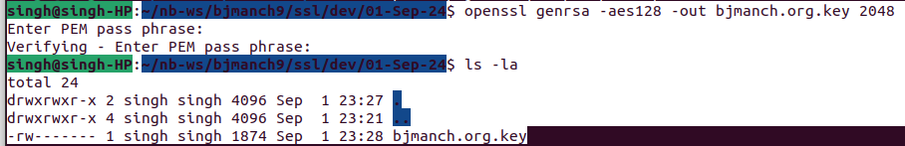
Generate Public-Key

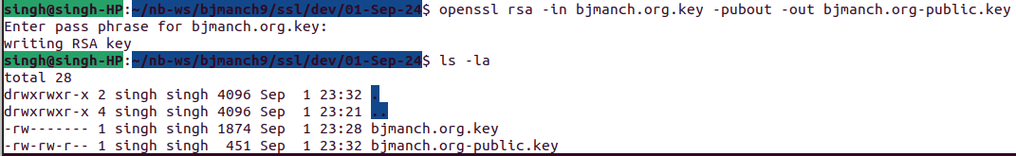
View Public-Key

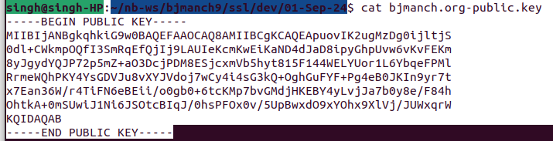
Create CSR

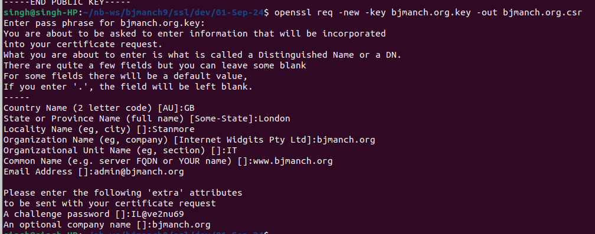

View CSR
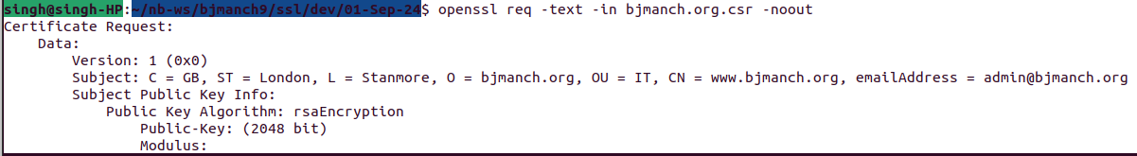
Self Signed Certificate

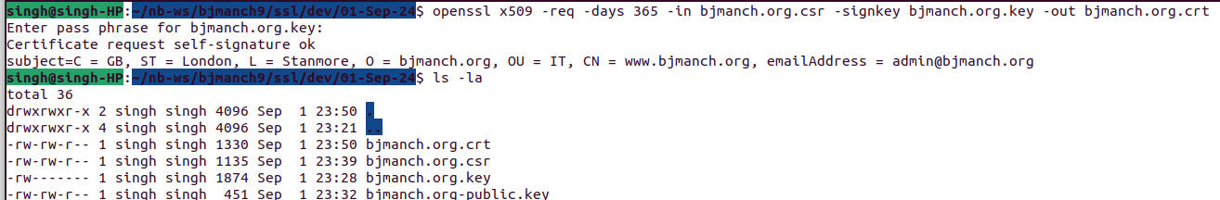

Convert to PKCS12

