Source: https://tomcat.apache.org/tomcat-10.0-doc/ssl-howto.html

Create a keystore file to store the server's private key and self-signed certificate by executing the following command:

Download KeyStore Explorer from https://keystore-explorer.org/downloads.html


And install it

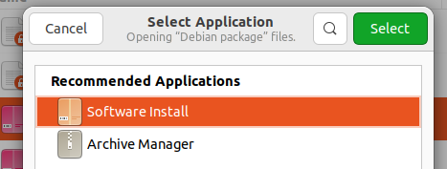

Open it from Desktop


And manually explore the .keystore

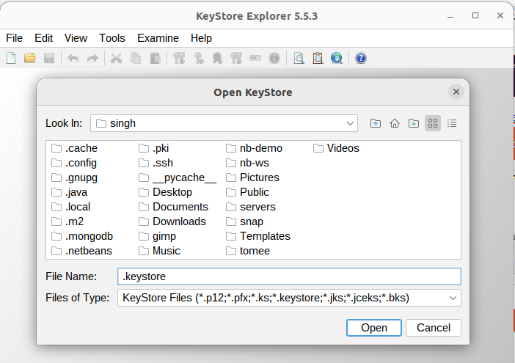
After entering the password
