**Reflection**

Describe the effect each of the P, I, D components had in your implementation.

Student describes the effect of the P, I, D component of the PID algorithm in their implementation. Is it what you expected?

Visual aids are encouraged, i.e. record of a small video of the car in the si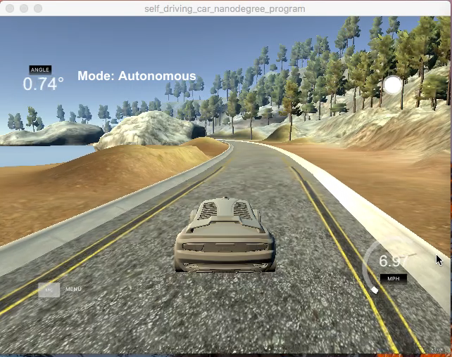mulator and describe what each component is set to.

PID stands for proportional, integral and differential components.

Here is video with P controller only implemented.

The car starts of ok but then go into oscillations and it goes offtrack.

Please check P4_only_Pcontroller video as below

Next implemented P and D controller and the car completed the track without falling off the track and mostly keeping in centre.

For this simulator we can get away without implementing “I” controller as it looks like car has no systematic bias.

Implemented small value for “I” and the car still completes the track without falling off the track.

Describe how the final hyperparameters were chosen.

Student discusses how they chose the final hyperparameters (P, I, D coefficients). This could be have been done through manual tuning, twiddle, SGD, or something else, or a combination!

The hyper parameters were same as from the lecture video.

Kp = 0.2

Kd = 3.0

Ki = 0.004

With Kp and Kd values as above the car was stable and could finish the track ok.

With Ki = 0.004 it fell off track; so changed this to low value of ‘0.001’ and the car could finish the track successfully.

The car oscillates little bit more than I expect. Looks like I need to find some method to tune these parameters to get better results.

**Simulation**

The vehicle must successfully drive a lap around the track.

No tire may leave the drivable portion of the track surface. The car may not pop up onto ledges or roll over any surfaces that would otherwise be considered unsafe (if humans were in the vehicle).