Practical 4

Aim : man in meddle attack using kali linus also know as arp poison ☠ tool Ettercap

1. Check the interface of network
2. Scan the all connected device to router ip and device info

192.169.64.1 this is a default ip of router

And 192.168.64.132 this is a ip con victim machine

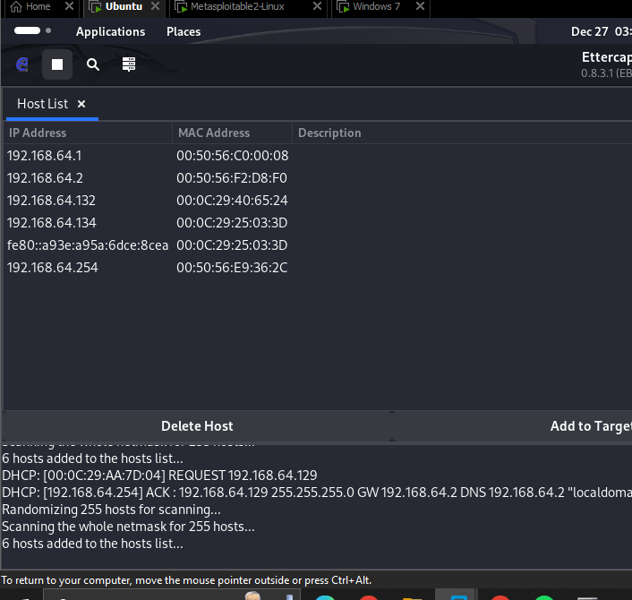

Now here we selected the both ip as a target 1 and target 2 becouse we are here in meddle that’s y we have two victim ips

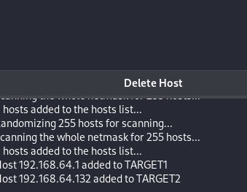

Now after defining the two target have to start poisoning using arm positioning

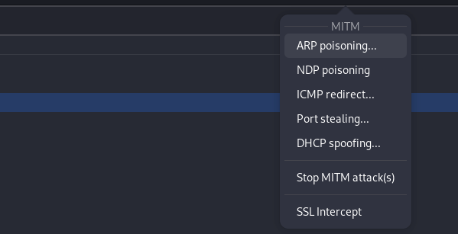

After that we have to open the terminal and give root permission and type

Kali > urlsnarf –ieth0

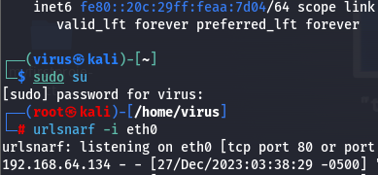

Now check here when target open the browser we got all access information

